**CSE237A - FINAL PROJECT REPORT**

1. **TITLE**: **AUDIO BASED ACTIVITY RECOGNITION**
2. **MEMBERS**: Sivasankar Palaniappan -spalania@ucsd.edu, A53275703

Chandhini Grandhi – [cgrandhi@ucsd.edu](mailto:cgrandhi@ucsd.edu), A53272378

1. **MOTIVATION:** Smart home is a large and upcoming field, with vast number of applications. They are mainly divided into activity recognition and actuation/automation. Large amount of work has been done in the field of automation. Activity recognition on the other hand, is an upcoming field. Most of the work present today has been performed using smart watch or wearable sensor to detect basic activities. This can yield good results but involves large number of sensors, along with large amount of processing of data originating with different sensors present. Moreover, the cost is high and also power dissipated will be very large. The subject may be uncomfortable wearing too many sensors or wearables. A Fitbit is not affordable by all. Even with large number of sensors, some of the activities cannot be detected. A person may just be sitting but it is not possible to find out if he or she is drinking water or eating. To detect such activities, we propose a model of using microphone which will detect the noise or the sound and find out the activity using an appropriate training model. On the system end, using a raspberry pi makes the entire setup as portable, reducing space complexity and avoiding reducing cost as the system is cheaper than using a standalone CPU or a laptop.
2. **RELATED WORK:** In general, there are large number of academic works related to activity recognition using various sensors such as accelerometer, gyro meter, smart watch, Fitbit. To compare our work, with the previous work, only academic papers pertaining activity recognition using audio was considered.

In this field, the amount of work done has been minimal compared to the method mentioned above.

(i)- “Audio-Based Activities of Daily Living (ADL) Recognition with Large-Scale Acoustic Embeddings from Online Videos “performs audio detection but uses audio from online videos, and does not manually obtain data sets.

(ii)-“A Similarity Analysis of Audio Signal to Develop a Human Activity Recognition Using Similarity Networks” uses mobile phones to obtain the audio files and obtains the activity using similarity analysis by calculating Euclidean Distances.

(iii)-"Audio-based human activity recognition using Non-Markovian Ensemble Voting," manages to classify large number of activities by using a sound book which consists of bag of sounds (similar to bag of words) and detects activities using a voting process by comparing with entries from sound book.

1. **HARDWARE COMPONENTS:**

Raspberry Pi and microphone – Less and cheap hardware is the novelty of our project. We have been able to successfully connect the microphone to the raspberry pi and take clean audio samples.

Microphone: We used Plug and Play USB Microphone which can be bought from [here](https://www.amazon.com/gp/product/B077VNGVL2/ref=ppx_yo_dt_b_asin_title_o04_s00?ie=UTF8&psc=1). Raspberry Pi: Raspberry Pi3 Model B Quad-Core 1.2 GHz 1GB RAM.

Power Supply for Raspberry Pi: Official Raspberry Pi Power Supply of 5V, 2.5A.

Below is the picture of the Hardware setup we used:

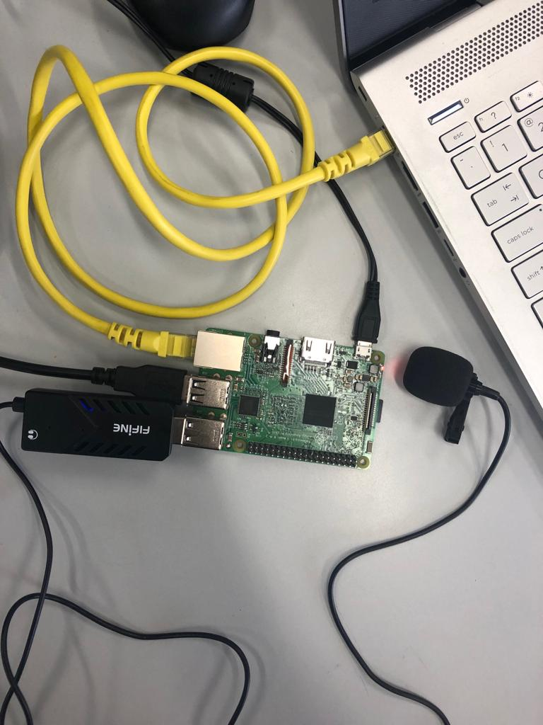

Hardware Design choices:

* We used this because it was the cheapest and supports a wide range of frequencies (50-16000 Hz) for sound reproduction.
* We chose Raspberry Pi Model 3 because we had already bought it for Individual Project 1 and used the same setup.
* We chose the official power supply to prevent under volting since we are dealing with large amounts of data, to be on the safer side.

1. **SOFTWARE COMPONENTS:**

* Python – Version 3.5
* Raspberry Pi3 Kernel – Raspbian version 4.14
* Scikit-Learn – Version 0.21
* Numpy – Version 1.10.1
* TKinter – Version 8.6
* Pyaudio -
* Alsa Audio **-**