# Savoro Site Plan

## Camila Rojas

## WDD 130

## Overview

### Purpose

***Savoro*** is a cooking website that helps people cook quick, healthy, and flavorful meals with ingredients they already have. It offers a mix of simple recipes for beginners and more cultural dishes for those wanting to explore and learn.

### Audience

To make cooking easy, fun, and accessible for college students and beginners, while also inspiring users to try new dishes from diverse cultures like Latin American, Asian, and Mediterranean cuisine.

## Branding

### Website Logo

## Style Guide

### Color Palette

| **Primary** | **Secondary** | **Accent 1** | **Accent 2** |
| --- | --- | --- | --- |
| #A8C686 | #FFF9F0 | #E2725B | #444444 |

### Typography

#### Heading Font: Poppins (Bold)

#### Paragraph Font: Quicksand (Regular)

### Navigation

Home Page2 Page3

**Content**

[put all content for the pages here, including written text and images]

**Homepage**

* Header Navigation

Savoro

- Home

- Explore Recipes

- What’s in Your Kitchen?

- Meal Planner

- Community

- Log In Sign Up

* Hero Section

Headline: Discover fast, healthy, and budget-friendly meals made for you.

Button: Find Recipes

* Latest Recipes

Chickpea Salad

Chickpeas, curry tomato – 15 min

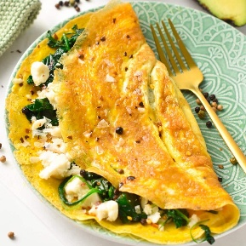

Omelette

Eggs, spinach, cheese – 10 min

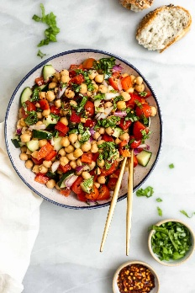

Explore by Culture

- Latin American

- Asian

- Mediterranean

- American

Footer

2025 Savoro

**Child Page 1 (Omelette)**

Omelette

Cook Time: 10 minutes

Servings: 1

Tags: Vegetarian · Breakfast · Quick · 5-Minute Meal

Ingredients

- 2 eggs

- ¼ cup fresh spinach (chopped)

- ¼ cup shredded cheese (cheddar or your choice)

- 1 teaspoon oil or butter

- Salt and pepper to taste

Video Tutorial

<https://www.youtube.com/watch?v=ixpYIgHlU60&pp=ygURb21lbGV0dGUgdHV0b3JpYWw%3D>

Instructions

1. Crack the eggs into a bowl. Add a pinch of salt and pepper, then whisk until well combined.
2. Heat oil or butter in a nonstick pan over medium heat.
3. Pour in the eggs and swirl the pan so the mixture spreads evenly.
4. Once the edges begin to set, sprinkle spinach and cheese evenly over one half.
5. Carefully fold the omelette in half and let cook for another 1–2 minutes.
6. Slide it onto a plate and serve hot.

Final Result

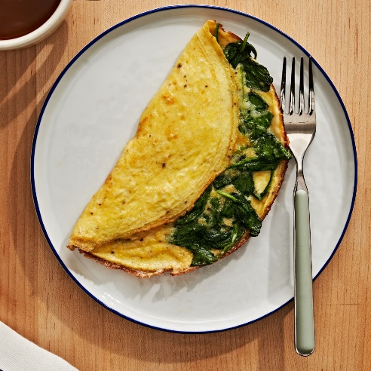

**Child Page 2**

Chickpea Salad

Cook Time: 15 minutes  
Servings: 2  
Tags: Vegetarian · High-Protein · Pantry-Friendly · 5-Minute

Ingredients

* 1 can (15 oz) chickpeas, drained and rinsed
* 1 small tomato, diced
* ¼ red onion, finely chopped
* 2 tablespoons chopped fresh cilantro
* 1 tablespoon olive oil
* 1 teaspoon curry powder
* Juice of ½ lime
* Salt and pepper to taste

Video Tutorial

<https://www.youtube.com/watch?v=lGBaLIB_aZE&t=145s&pp=ygUXY2hpY2twZWEgc2FsZGEgdHV0b3JpYWw%3D>

Instructions

1. In a large bowl, combine chickpeas, tomato, onion, and cilantro.
2. In a small bowl, whisk together olive oil, curry powder, lime juice, salt, and pepper.
3. Pour the dressing over the chickpea mixture.
4. Toss everything together until well coated.
5. Chill for 10 minutes if desired, or serve immediately.

Final Result

**Wireframes**

### Home

**Child Page 1**

**Child Page 2**

