IP Interfaces: Part 1

**Part 0: Warm Up (not for credit)**

1. What is the slash notation representation of 255.255.255.0?

255.255.255.0/24

1. What is the dot-decimal representation of /30?

255.255.255.252

1. What is the smallest subnet size that would accommodate 5 hosts?

Size 8, netmask: 255.255.255.248/29

1. Fill in the blank cells in the table below (R1 eth0 filled in by Vital system)

|  |  |
| --- | --- |
| VM (Interface) | IP Address (CIDR Notation) |
| R1 (eth1) | 10.10.10.1/29 |
| R2 (eth0) | 10.10.10.2/29 |
| Kali (eth0) | 10.10.10.3/29 |

**Part1**

For R1

Configuration processing and the ifconfig double check

Screenshot of .conf file under /etc/frr/frr.conf

For R2

Configuration processing and the ifconfig double check

Screenshot of .conf file under /etc/frr/frr.conf

**Part 2**

Auto eth0

iface eth0 inet static

address 10.10.10.3

netmask 255.255.255.248

network 10.10.10.0

broadcast 10.10.10.7

Configuration processing and the ifconfig double check

First screenshot is the code write into the interfaces

Second screenshot is after reboot and the ifconfig

**Part 3**

**Q a) Why did we choose the /29 subnet mask for Area 0? (10 points)**

because in area 0 we have 3 ip address need to be assigned. And with netmask 255.255.255.248 or /29, we can have a working range of 6 machine》

Netmask: 255.255.255.248 or /29 Starts with multiple of 8;

|  |  |  |
| --- | --- | --- |
| Network | Range | Broadcast |
| 0 | 1-6 | 7 |

So I take out the first 3 from the range of /29 and assign to R1, R2 and Kali.

If we choose Netmask: 255.255.255.252 or /30, it only contains 2 work ip except broadcast which is not large enough here. And Netmask: 255.255.255.240 or /28 was unnecessary large for the Area 0 networking.

**Q b)** **The Linux ARP (see man ARP) command will print the current entries in the**

**machine’s address resolution protocol table. Now that you have configured Area 0,**

**what entries are currently in R1, R2, and Kali? (10 points)**

ARP before ping for R1, R2 and Kali

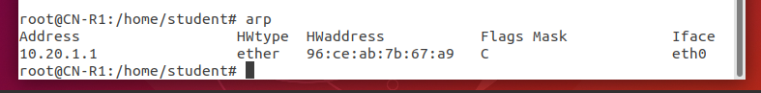



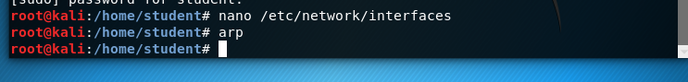

Currently R1, R2 and Kali’s addresses are not in each other’s ARP table.

**Q c)** **Now ping both R2 and Kali from R1. Note the changes on each machine’s ARP**

**tables. At this point, R2 should be aware of R1, but why doesn’t R2 have a table**

**entry for Kali? (10 points)**

Under R1, ping R2

The first ARP cmd shows that R2/10.10.10.2 is not in the ARP table, and after pinging, R2’s address is in the ARP table.

Under R1, ping Kali

The first ARP shows that Kali machine /10.10.10.3 is not in the ARP table, and after pinging, Kali’s address is in the ARP table.

Screenshot from R2 and Kali (the ARP table before and after pinged from R1)

Both machines are aware of R1

The Reason that R2 ARP table doesn’t contain an entry for Kali is because either Kali or R2 doesn’t send out any ARP request to each out so for now R2 doesn’t have a table entry for Kali. But if I directly ping from R2 to Kali or reversely ping from Kali to R2. Both Kali and R2’s ARP table will have the entry for each other.

Below is I use R2 to ping Kali, and ARP table is being updated, Kali now is in R2’s ARP table after pinging, they are aware of each other.

And after ping, Kali’s ARP table is also being updated with R2’s information.

Screenshot of ping between R1, R2 and Kali

