IP Interfaces: Part 2

Instructions

For the second lab, you will select IP addresses from 10.10.11.0/24 to configure R2, R3, and R4 in Area 1 as shown in the network diagram. Since R2, R3, and R4 are connected by different hubs, they are not in the same broadcast and collision domain, and therefore do not have direct access to each other via Ethernet.

You will configure four different subnets so that each pair of directly connected routers can communicate with each other. But you also must make sure that your subnets do not overlap.

Before configuring your VMs, fill in the table and verify that you have assigned appropriate subnets for all three VMs. Each subnet should be large enough to accommodate its routers, but no larger than necessary.

Note that you will assign a /28 on R4 (eth2) to be used later for a subsequent DHCP assignment.

|  |  |  |  |  |
| --- | --- | --- | --- | --- |
| VM (interface) | IP Address | Network  Address | Broadcast  Address | Range (usable  addresses) |
| R2 (eth1) | 10.10.11.1 | 10.10.11.0/30 | 10.10.11.3 | 10.10.11.1 -  10.10.11.2 |
| R3 (eth0) | 10.10.11.2 |
| R2 (eth2) | 10.10.11.5 | 10.10.11.4/30 | 10.10.11.7 | 10.10.11.5 -  10.10.11.6 |
| R4 (eth1) | 10.10.11.6 |
| R3 (eth1) | 10.10.11.9 | 10.10.11.8/30 | 10.10.11.11 | 10.10.11.9 -  10.10.11.10 |
| R4 (eth0) | 10.10.11.10 |
| R4 (eth2) | 10.10.11.17 | 10.10.11.16/28 | 10.10.11.31 | 10.10.11.17 -  10.10.11.31 |

Part 1: Configuring Network Interfaces

Use **vtysh** to do the configurations (See Interface Commands under Zebra in the frrouting manual). Don’t forget to write to memory or your changes will be lost.

You may use Linux’s **ifconfig** command in order to verify that you have saved your network configuration (see man ifconfig).

R2 frr.conf and ifconfig confirmation of ip address

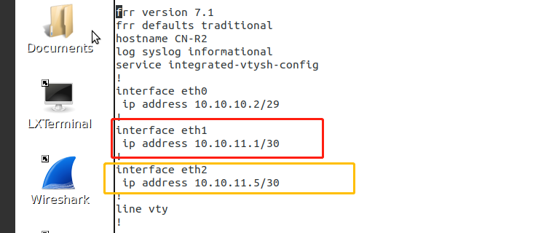

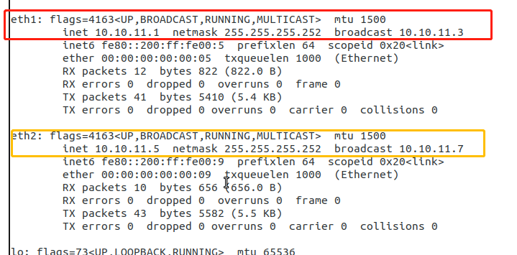

R3 frr.conf and ifconfig confirmation of ip address

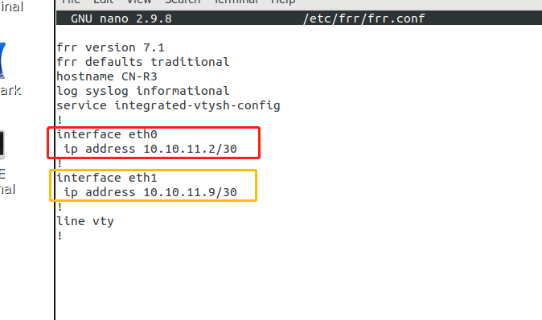

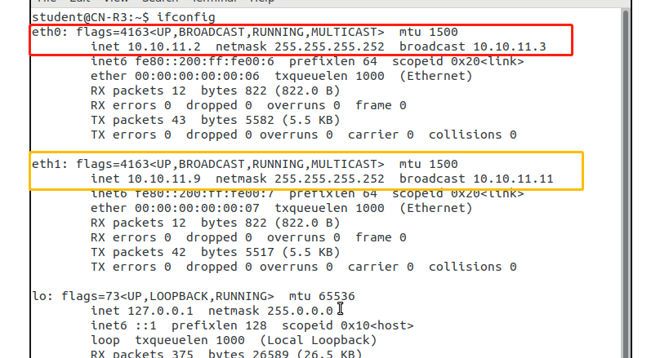

R4 frr.conf and ifconfig confirmation of ip address

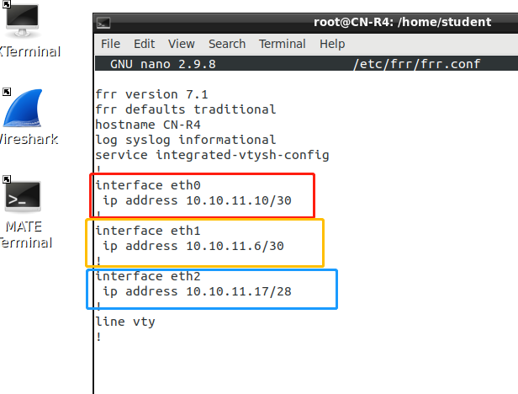

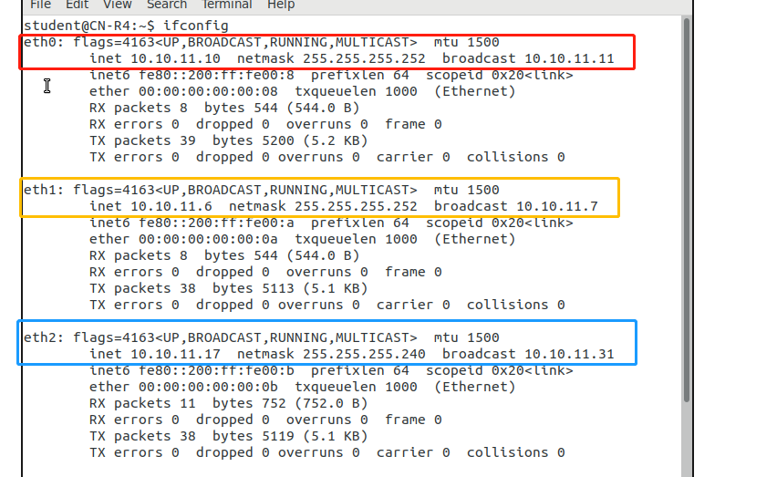

Ping from R2, and Updated ARP table

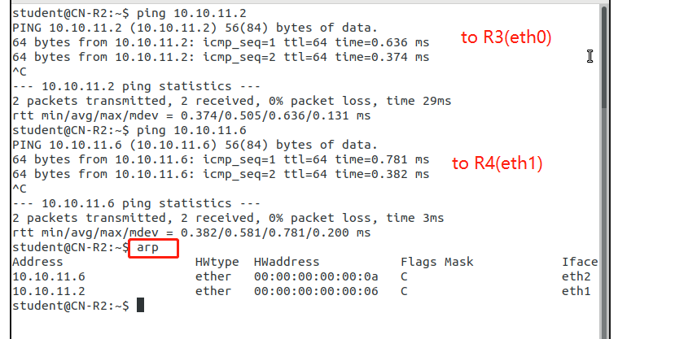

Ping from R3, and Updated ARP table

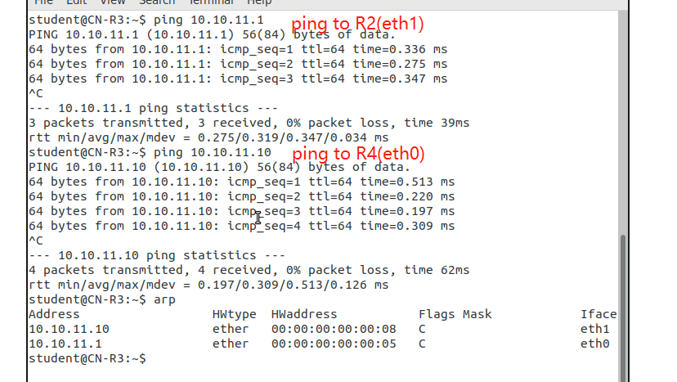

Ping from R4, and Updated ARP table

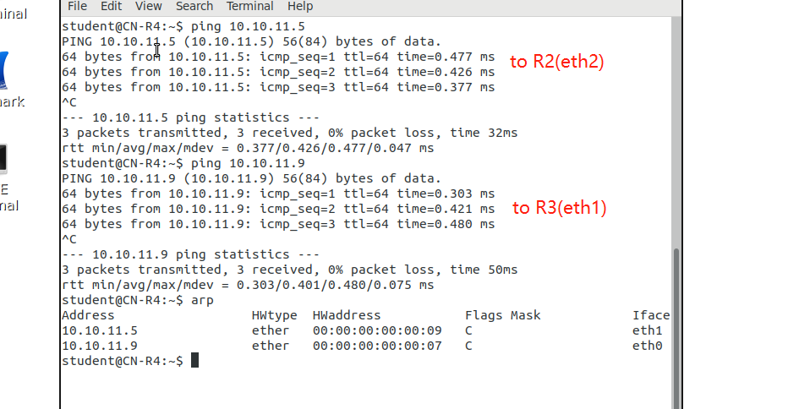

Part 2: Questions

a) Why must we ensure that our subnets do not overlap? Discuss one example of something that could go wrong. (10 points)

Because if there is an overlap between subnets then messages can go to the wrong destination address.

For e.g. assume two routers R1 and R2 have different subnets but the same IP address and the their subnets overlap. Then the message intended for R2 might go to R1 instead.

b) Suppose there is another Router (R5) directly connected to the HUB between R3 and R4. Explain whether or not we would need to reconfigure the IP subnets on R3 and R4 in order to communicate with R5. (10 points)

Yes, we would need to reconfigure the subnets. Because the current subnet /30 only allows for 2 hosts, if R5 is coming in there will be 3 hosts at the same time. So to accommodate another host we will need to reconfigure the subnet to for example, /29.

c) Run Wireshark on R2 (eth1). Now *ping* R3(eth1) from R2. Identify what type of packet is used in *ping.* Why is R2 unable to reach R3 (eth1)? (10 points)

No packets are used in this ping from R2 (eth1) to R3(eth1) . When we try to connect to R3(eth1) we get Network is unreachable. R2(eth1) is unable to reach R3(eth1) because they have different broadcast addresses /subnets.

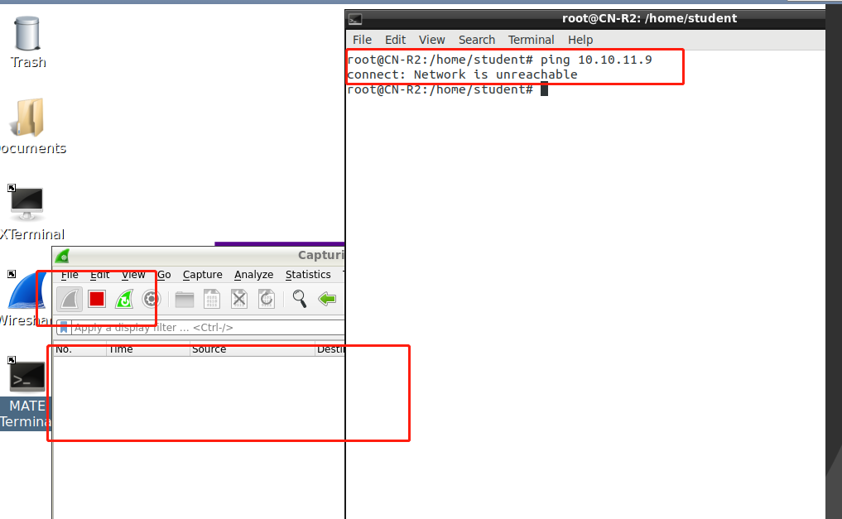

d) Briefly describe how Wireshark results compare when you *ping* R3 (eth0) from R2 (eth1). (5 points)

When we ping R3(eth0) from R2 unlike R3(eth1) we will get a successful connection as R2(eth1) and R3(eth0) they are in the same broadcast address.

At the Wireshark, R2(eth1) first sends R3(eth0) an ARP request asking who has that IP address of 10.10.11.2(which is R3 eth0). When R3 detects that the request is meant for it, R3 sends R2 it’s Mac address back. Then they start communicating using ICMP packets (request and reply)

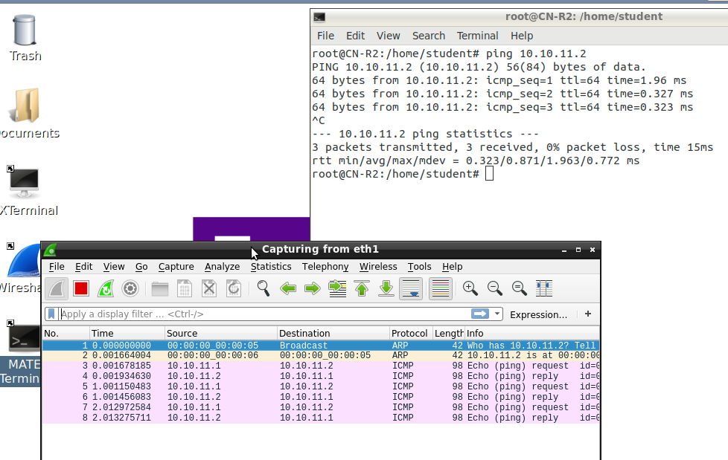

Submissions

[30 pts] Screenshot of the .conf file under /etc/frr/frr.conf from R2, R3, and R4 [20 pts] Your IP subnet table

[10 pts] Screenshot showing that pinging works between R2, R3, and R4

[5 pts] Screenshot of the ARP tables on R2, R3, and R4

[35 pts] Answers to questions 2a-2d.