Dynamic Host Configuration Protocol Instructions

Set up a DHCP server on R4 (eth2) such that it leases IP addresses from the 10.10.11.X/28 subnet to the Ubuntu VM. Calculate the network, broadcast, and useable range of IP addresses for your address range. Select the first useable IP address as the static address for the R4 interface (remember that we cannot use the network and broadcast). The remaining addresses will go into the pool that the DHCP server will lease and manage.

Before starting this lab, please read RFC 2131.

Note: Please make any necessary changes to the */etc/network/interfaces* file of Ubuntu before you proceed. The file should already have an existing entry for DHCP which includes:

iface eth0 inet dhcp

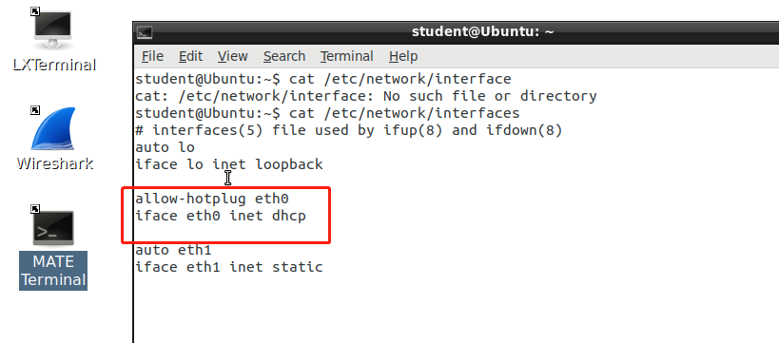

Part 1: Configuring DHCP

The first step is to configure the dhcpd.conf (DHCP daemon configuration) file in router R4. This file is present in the */etc/dhcp* directory. You can make edits to this file using any text editor.

Consult the example configuration options in the dhcpd.conf file to configure your DHCP server on R4. Make sure to set default-lease-time to 300.

Note that you do not need to provide configurations for the option domain-name or domain name-servers.

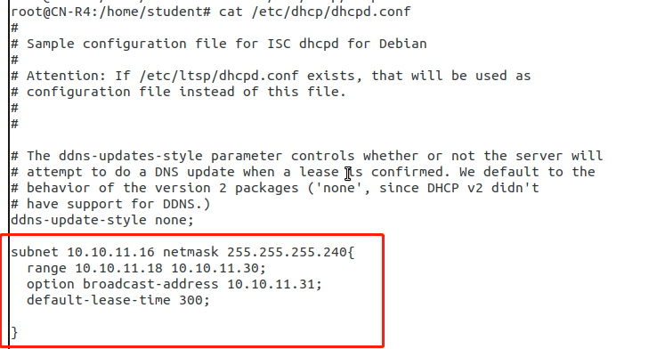

Part 2: Server Interface

Check the */etc/default/isc-dhcp-server* file on R4. This file has to be changed so the DHCP server knows which interface it should listen on for serving IP addresses.

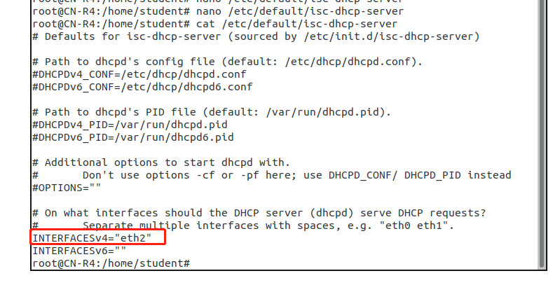

Part 3: Verifying DHCP and Wireshark

We will verify that Ubuntu has obtained an IP address.

1. Shutdown R4 and Ubuntu.

2. Power on Ubuntu and run Wireshark via the terminal: *sudo wireshark* 3. Monitor incoming traffic on the appropriate interface.

4. Now power on R4 and view Wireshark traffic on Ubuntu.

5. Use the following filter to show DHCP messages: udp.port == 67 6. Take a screenshot showing all captured DHCP messages.

Before R4 turn on , only DHCPDISCOVER packets, because the Ubuntu system is broadcasting DHCPDISCOVER for asking itself for an IP address.

Note: Verify that the DHCP server is running properly on R4 by using the following command:

*sudo systemctl status isc-dhcp-server.service*

*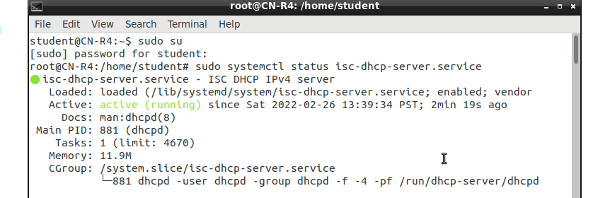*

Submissions

[20 points] The leases file on R4 found in */var/lib/dhcp/dhcpd.leases*

*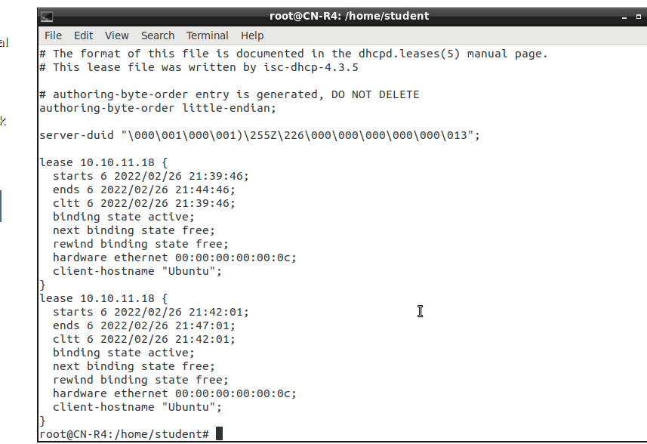*

[20 points] Your configuration for the DHCP server.



[20 points] Screenshot of ifconfig on Ubuntu.

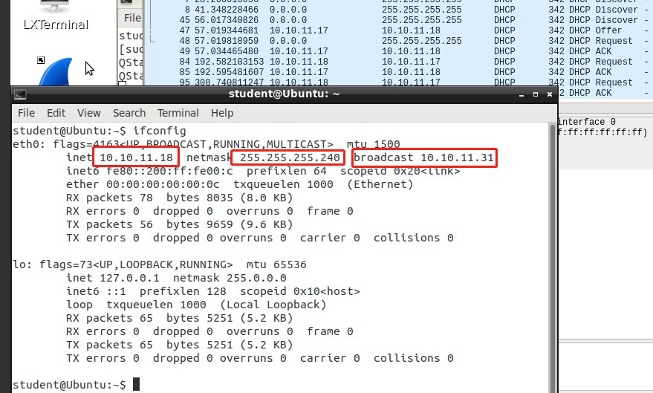

[20 points] Screenshot showing Ubuntu pinging R4.

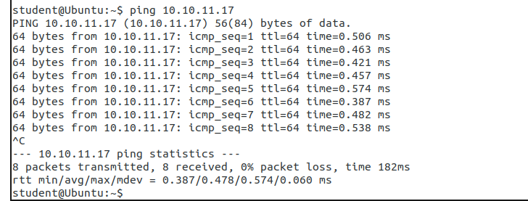

[20 points] Screenshot showing Wireshark DHCP messages (4 Types).

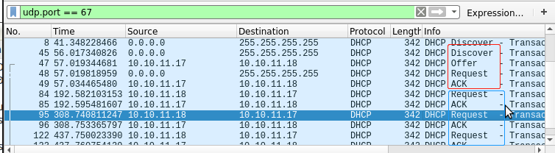

Please remember to submit your lab results as a single PDF document. While you may work in groups, you MUST submit your own work.

