ENPM667 Final Project
Consider a crane that moves along a one-dimensional track. It behaves as a frictionless cart with mass $M$ actuated by an external force $F$ that constitutes the input of the system. There are two loads suspended from cables attached to the crane. The loads have mass $m_{1}$ and $m_{2}$, and the lengths of the cables are $l_{1}$ and $l_{2}$, respectively. Figure 1 depicts the crane and associated variables used throughout this project.
Figure 1 System Diagram
- (25 points) Obtain the equations of motion for the system and the corresponding nonlinear state-space representation.

Objective: Find the Equations of Motion using Lagrange’s Equations

$$L=KE_{M}+KE_{m_{1}}+KE_{m_{2}}-PE_{m_{1}}-PE_{m_{2}}$$

$$\frac{d}{dt}\frac{∂L}{∂\dot{x}}-\frac{∂L}{∂x}=F$$
$$\frac{d}{dt}\frac{∂L}{∂\dot{θ_{1}}}-\frac{∂L}{∂θ_{1}}=0$$
$$\frac{d}{dt}\frac{∂L}{∂\dot{θ_{2}}}-\frac{∂L}{∂θ_{2}}=0$$
Choose $PE_{mi}=0 \text{when} θ_{i}=0$
$$KE_{M}=\frac{1}{2}M{\dot{x}}^{2}, KE_{m_{i}}=\frac{1}{2}m_{i}v_{i}^{2}, PE_{m_{i}}=-m_{i}gl_{i}\left(\cos\left(θ_{i}\right)-1\right)$$
$$v_{i}=\sqrt{{\left(\dot{x}-{\dot{θ}}_{i}l_{i}\cos{θ_{i}}\right)}^{2}+{\left({\dot{θ}}_{i}l_{i}\sin{θ_{i}}\right)}^{2}}$$
$$∴L=\frac{1}{2}M{\dot{x}}^{2}+\frac{1}{2}m_{1}\left[{\left(\dot{x}-{\dot{θ}}_{1}l_{1}\cos{θ_{1}}\right)}^{2}+{\left({\dot{θ}}_{1}l_{1}\sin{θ_{1}}\right)}^{2}\right]+\frac{1}{2}m_{2}\left[{\left(\dot{x}-{\dot{θ}}_{2}l_{2}\cos{θ_{2}}\right)}^{2}+{\left({\dot{θ}}_{2}l_{2}\sin{θ_{2}}\right)}^{2}\right]+m_{1}gl_{1}\left(\cos\left(θ_{1}\right)-1\right)+m_{2}gl_{2}\left(\cos\left(θ_{2}\right)-1\right)$$
$$\frac{∂L}{∂\dot{x}}=M\dot{x}+m_{1}\left(\dot{x}-{\dot{θ}}_{1}l_{1}\cos{θ_{1}}\right)+m_{2}\left(\dot{x}-{\dot{θ}}_{2}l_{2}\cos{θ_{2}}\right)$$
$$\frac{d}{dt}\frac{∂L}{∂\dot{x}}=M\ddot{x}+m_{1}\left(\ddot{x}+{{\dot{θ}}_{1}}^{2}l_{1}\sin{θ_{1}}-{\ddot{θ}}_{1}l_{1}\cos{θ_{1}}\right)+m_{2}\left(\ddot{x}+{{\dot{θ}}_{2}}^{2}l_{2}\sin{θ_{2}}-{\ddot{θ}}_{2}l_{2}\cos{θ_{2}}\right)$$
$$=\left(M+m_{1}+m_{2}\right)\ddot{x}+m_{1}l_{1}\left({{\dot{θ}}_{1}}^{2}\sin{θ_{1}}-{\ddot{θ}}_{1}\cos{θ_{1}}\right)+m_{2}l_{2}\left({{\dot{θ}}_{2}}^{2}\sin{θ_{2}}-{\ddot{θ}}_{2}\cos{θ_{2}}\right)$$
$$\frac{∂L}{∂x}=0$$
$$\frac{∂L}{∂{\dot{θ}}_{i}}=m_{i}\left[{\dot{θ}}_{i}{\left(l_{i}\cos{θ_{i}}\right)}^{2}-\dot{x}l_{i}\cos{θ_{i}}+{\dot{θ}}_{i}{\left(l_{i}\sin{θ_{i}}\right)}^{2}\right]$$
$$=m_{i}\left[{\dot{θ}}_{i}l_{i}^{2}\left({\left(\cos{θ_{i}}\right)}^{2}+{\left(\sin{θ_{i}}\right)}^{2}\right)-\dot{x}l_{i}\cos{θ_{i}}\right]=m_{i}\left({\dot{θ}}_{i}l_{i}^{2}-\dot{x}l_{i}\cos{θ_{i}}\right)$$
$$\frac{d}{dt}\frac{∂L}{∂{\dot{θ}}_{i}}=m_{i}l_{i}\left({\ddot{θ}}_{i}l_{i}+{\dot{θ}}_{i}\dot{x}\sin{θ_{i}}-\ddot{x}\cos{θ_{i}}\right)$$
$$\frac{∂L}{∂θ_{i}}=m_{i}\left[{\dot{θ}}_{i}l_{i}\sin{θ_{i}}\left(\dot{x}-{\dot{θ}}_{i}l_{i}\cos{θ_{i}}\right)+\left({\dot{θ}}_{i}l_{i}\sin{θ_{i}}\right)\left({\dot{θ}}_{i}l_{i}\cos{θ_{i}}\right)\right]-m_{i}gl_{i}\sin\left(θ_{i}\right)$$
$$=m_{i}l_{i}\sin{θ_{i}}\left(\dot{x}{\dot{θ}}_{i}-g\right)$$
$$\frac{d}{dt}\frac{∂L}{∂\dot{x}}-\frac{∂L}{∂x}=F$$
$$\frac{d}{dt}\frac{∂L}{∂\dot{θ_{i}}}-\frac{∂L}{∂θ_{i}}=0$$
$$\left(M+m_{1}+m_{2}\right)\ddot{x}+m_{1}l_{1}\left({{\dot{θ}}_{1}}^{2}\sin{θ_{1}}-{\ddot{θ}}_{1}\cos{θ_{1}}\right)+m_{2}l_{2}\left({{\dot{θ}}_{2}}^{2}\sin{θ_{2}}-{\ddot{θ}}_{2}\cos{θ_{2}}\right)=F$$
$$m_{i}l_{i}\left({\ddot{θ}}_{i}l_{i}+{\dot{θ}}_{i}\dot{x}\sin{θ_{i}}-\ddot{x}\cos{θ_{i}}\right)-m_{i}l_{i}\sin{θ_{i}}\left(\dot{x}{\dot{θ}}_{i}-g\right)=0$$
$$∴{\ddot{θ}}_{i}l_{i}-\ddot{x}\cos{θ_{i}}+g\sin{θ_{i}}=0$$
The three equations in the end are:
$$\boxed{\begin{matrix}\left(M+m_{1}+m_{2}\right)\ddot{x}+m_{1}l_{1}\left({{\dot{θ}}_{1}}^{2}\sin{θ_{1}}-{\ddot{θ}}_{1}\cos{θ_{1}}\right)+m_{2}l_{2}\left({{\dot{θ}}_{2}}^{2}\sin{θ_{2}}-{\ddot{θ}}_{2}\cos{θ_{2}}\right)=F \\ {\ddot{θ}}_{1}l_{1}-\ddot{x}\cos{θ_{1}}+g\sin{θ_{1}}=0 \\ {\ddot{θ}}_{2}l_{2}-\ddot{x}\cos{θ_{2}}+g\sin{θ_{2}}=0\end{matrix}}$$

Objective: Show the Non-Linear State Space Representation:
$$\dot{X}\left(t\right)=F\left(X\left(t\right),U\left(t\right)\right)$$
$$X\left(t\right)=\left[\begin{aligned}x\left(t\right) \\ \dot{x}\left(t\right) \\ θ_{1}\left(t\right) \\ {\dot{θ}}_{1}\left(t\right) \\ θ_{2}\left(t\right) \\ {\dot{θ}}_{2}\left(t\right)\end{aligned}\right], U\left(t\right)=F\left(t\right)$$
Same three equations written in form $f\left(θ_{1},θ_{2}\right)\ddot{x}+g\left(θ_{1},θ_{2}\right){\ddot{θ}}_{1}+h\left(θ_{1},θ_{2}\right){\ddot{θ}}_{2}=F\left(X\left(t\right),U\left(t\right)\right)$
$$\left(M+m_{1}+m_{2}\right)\ddot{x}-m_{1}l_{1}\cos{θ_{1}}{\ddot{θ}}_{1}-m_{2}l_{2}\cos{θ_{2}}{\ddot{θ}}_{2}=F-m_{1}l_{1}{{\dot{θ}}_{1}}^{2}\sin{θ_{1}}-m_{2}l_{2}{{\dot{θ}}_{2}}^{2}\sin{θ_{2}}$$
$$\cos{θ_{1}}\ddot{x}-l_{1}{\ddot{θ}}_{1}=g\sin{θ_{1}}$$
$$\cos{θ_{2}}\ddot{x}-l_{2}{\ddot{θ}}_{2}=g\sin{θ_{2}}$$
$$\left[\begin{matrix}M+m_{1}+m_{2} & -m_{1}l_{1}\cos{θ_{1}} & -m_{2}l_{2}\cos{θ_{2}} \\ \cos{θ_{1}} & -l_{1} & 0 \\ \cos{θ_{2}} & 0 & -l_{2}\end{matrix}\right]\left[\begin{aligned}\ddot{x} \\ {\ddot{θ}}_{1} \\ {\ddot{θ}}_{2}\end{aligned}\right]=\left[\begin{aligned}F-m_{1}l_{1}{{\dot{θ}}_{1}}^{2}\sin{θ_{1}}-m_{2}l_{2}{{\dot{θ}}_{2}}^{2}\sin{θ_{2}} \\ g\sin{θ_{1}} \\ g\sin{θ_{2}}\end{aligned}\right]$$
Multiple Eq. 2 by $-m_{1}\cos{θ_{1}}$ and Eq. 3 by $-m_{2}\cos{θ_{2}}$
$$\left[\begin{matrix}M+m_{1}+m_{2} & -m_{1}l_{1}\cos{θ_{1}} & -m_{2}l_{2}\cos{θ_{2}} \\ -m_{1}\cos^{2}{θ_{1}} & m_{1}l_{1}\cos{θ_{1}} & 0 \\ -m_{2}\cos^{2}{θ_{2}} & 0 & m_{2}l_{2}\cos{θ_{2}}\end{matrix}\right]\left[\begin{aligned}\ddot{x} \\ {\ddot{θ}}_{1} \\ {\ddot{θ}}_{2}\end{aligned}\right]=\left[\begin{aligned}F-m_{1}l_{1}{{\dot{θ}}_{1}}^{2}\sin{θ_{1}}-m_{2}l_{2}{{\dot{θ}}_{2}}^{2}\sin{θ_{2}} \\ -m_{1}g\sin{θ_{1}}\cos{θ_{1}} \\ -m_{2}g\sin{θ_{2}}\cos{θ_{2}}\end{aligned}\right]$$
Add Eq. 2 and Eq. 3 to Eq. 1, and replace Eq. 2 and Eq. 3 with original equations
$$\left[\begin{matrix}M+m_{1}\sin^{2}{θ_{1}}+m_{2}\sin^{2}{θ_{2}} & 0 & 0 \\ \cos{θ_{1}} & -l_{1} & 0 \\ \cos{θ_{2}} & 0 & -l_{2}\end{matrix}\right]\left[\begin{aligned}\ddot{x} \\ {\ddot{θ}}_{1} \\ {\ddot{θ}}_{2}\end{aligned}\right]=\left[\begin{aligned}F-m_{1}\sin{θ_{1}}\left(l_{1}{{\dot{θ}}_{1}}^{2}+g\cos{θ_{1}}\right)-m_{2}\sin{θ_{2}}\left(l_{2}{{\dot{θ}}_{2}}^{2}+g\cos{θ_{2}}\right) \\ g\sin{θ_{1}} \\ g\sin{θ_{2}}\end{aligned}\right]$$
Let $J_{i}=m_{i}\sin{θ_{i}}\left(l_{i}{{\dot{θ}}_{i}}^{2}+g\cos{θ_{i}}\right)$
$$\left[\begin{matrix}M+m_{1}\sin^{2}{θ_{1}}+m_{2}\sin^{2}{θ_{2}} & 0 & 0 \\ \cos{θ_{1}} & -l_{1} & 0 \\ \cos{θ_{2}} & 0 & -l_{2}\end{matrix}\right]\left[\begin{aligned}\ddot{x} \\ {\ddot{θ}}_{1} \\ {\ddot{θ}}_{2}\end{aligned}\right]=\left[\begin{aligned}F-J_{1}-J_{2} \\ g\sin{θ_{1}} \\ g\sin{θ_{2}}\end{aligned}\right]$$
Divide Eq. 1 by Coefficient of $\ddot{x}$
$$\left[\begin{matrix}1 & 0 & 0 \\ \cos{θ_{1}} & -l_{1} & 0 \\ \cos{θ_{2}} & 0 & -l_{2}\end{matrix}\right]\left[\begin{aligned}\ddot{x} \\ {\ddot{θ}}_{1} \\ {\ddot{θ}}_{2}\end{aligned}\right]=\left[\begin{aligned}\frac{F-J_{1}-J_{2}}{M+m_{1}\sin^{2}{θ_{1}}+m_{2}\sin^{2}{θ_{2}}} \\ g\sin{θ_{1}} \\ g\sin{θ_{2}}\end{aligned}\right]$$
Subtract Eq. 2 by $\left(Eq. 1\right)*\cos{θ_{1}}$, and divide by $-l_{1}$. Also subtract Eq. 3 by $\left(Eq. 1\right)*\cos{θ_{2}}$, and divide by $-l_{2}$
$$\left[\begin{matrix}1 & 0 & 0 \\ 0 & 1 & 0 \\ 0 & 0 & 1\end{matrix}\right]\left[\begin{aligned}\ddot{x} \\ {\ddot{θ}}_{1} \\ {\ddot{θ}}_{2}\end{aligned}\right]=\left[\begin{aligned}\ddot{x} \\ {\ddot{θ}}_{1} \\ {\ddot{θ}}_{2}\end{aligned}\right]=\left[\begin{aligned}\frac{F-J_{1}-J_{2}}{M+m_{1}\sin^{2}{θ_{1}}+m_{2}\sin^{2}{θ_{2}}} \\ -\frac{g\sin{θ_{1}}}{l_{1}}+\left(\frac{\cos{θ_{1}}}{l_{1}}\right)\frac{F-J_{1}-J_{2}}{M+m_{1}\sin^{2}{θ_{1}}+m_{2}\sin^{2}{θ_{2}}} \\ -\frac{g\sin{θ_{2}}}{l_{2}}+\left(\frac{\cos{θ_{2}}}{l_{2}}\right)\frac{F-J_{1}-J_{2}}{M+m_{1}\sin^{2}{θ_{1}}+m_{2}\sin^{2}{θ_{2}}}\end{aligned}\right]$$
$$\dot{X}\left(t\right)=F\left(X\left(t\right),U\left(t\right)\right)$$
Non-Linear State Space Representation
$$\boxed{\begin{aligned}\dot{X}\left(t\right)=\left[\begin{aligned}\dot{x}\left(t\right) \\ \ddot{x}\left(t\right) \\ {\dot{θ}}_{1}\left(t\right) \\ {\ddot{θ}}_{1}\left(t\right) \\ {\dot{θ}}_{2}\left(t\right) \\ {\ddot{θ}}_{2}\left(t\right)\end{aligned}\right]=\left[\begin{aligned}\dot{x}\left(t\right) \\ \frac{F-J_{1}-J_{2}}{M+m_{1}\sin^{2}{θ_{1}}+m_{2}\sin^{2}{θ_{2}}} \\ {\dot{θ}}_{1}\left(t\right) \\ -\frac{g\sin{θ_{1}}}{l_{1}}+\left(\frac{\cos{θ_{1}}}{l_{1}}\right)\frac{F-J_{1}-J_{2}}{M+m_{1}\sin^{2}{θ_{1}}+m_{2}\sin^{2}{θ_{2}}} \\ {\dot{θ}}_{2}\left(t\right) \\ -\frac{g\sin{θ_{2}}}{l_{2}}+\left(\frac{\cos{θ_{2}}}{l_{2}}\right)\frac{F-J_{1}-J_{2}}{M+m_{1}\sin^{2}{θ_{1}}+m_{2}\sin^{2}{θ_{2}}}\end{aligned}\right], \\ where J_{i}=m_{i}\sin{θ_{i}}\left(l_{i}{{\dot{θ}}_{i}}^{2}+g\cos{θ_{i}}\right)\end{aligned}}$$

B) (25 points) Obtain the linearized system around the equilibrium point specified by $x=0$ and $θ_{1}=θ_{2}=0$. Write the state-space representation of the linearized system.

Using the three equation of motion, make the following substitutions:
$$\sin{θ_{i}}≈θ_{i}, \cos{θ_{i}}≈1, {\dot{θ}}_{i}^{2}≈0$$
$$\left(M+m_{1}+m_{2}\right)\ddot{x}-m_{1}l_{1}{\ddot{θ}}_{1}-m_{2}l_{2}{\ddot{θ}}_{2}=F$$
$$\ddot{x}-l_{1}{\ddot{θ}}_{1}=gθ_{1}$$
$$\ddot{x}-l_{2}{\ddot{θ}}_{2}=gθ_{2}$$
Matrix Form:
$$\left[\begin{matrix}M+m_{1}+m_{2} & -m_{1}l_{1} & -m_{2}l_{2} \\ 1 & -l_{1} & 0 \\ 1 & 0 & -l_{2}\end{matrix}\right]\left[\begin{aligned}\ddot{x} \\ {\ddot{θ}}_{1} \\ {\ddot{θ}}_{2}\end{aligned}\right]=\left[\begin{aligned}F \\ gθ_{1} \\ gθ_{2}\end{aligned}\right]$$
Goal: Perform basic functions on the three equations to solve for $\left[\begin{aligned}\ddot{x} \\ {\ddot{θ}}_{1} \\ {\ddot{θ}}_{2}\end{aligned}\right]$.
Multiply 2nd equation by $-m_{1}$ and 3rd equation be $-m_{2}$
$$\left[\begin{matrix}M+m_{1}+m_{2} & -m_{1}l_{1} & -m_{2}l_{2} \\ -m_{1} & m_{1}l_{1} & 0 \\ -m_{2} & 0 & m_{2}l_{2}\end{matrix}\right]\left[\begin{aligned}\ddot{x} \\ {\ddot{θ}}_{1} \\ {\ddot{θ}}_{2}\end{aligned}\right]=\left[\begin{aligned}F \\ -gm_{1}θ_{1} \\ -gm_{2}θ_{2}\end{aligned}\right]$$
Add 2nd and 3rd equation to 1st equation.
$$\left[\begin{matrix}M & 0 & 0 \\ -m_{1} & m_{1}l_{1} & 0 \\ -m_{2} & 0 & m_{2}l_{2}\end{matrix}\right]\left[\begin{aligned}\ddot{x} \\ {\ddot{θ}}_{1} \\ {\ddot{θ}}_{2}\end{aligned}\right]=\left[\begin{aligned}F-gm_{1}θ_{1}-gm_{2}θ_{2} \\ -gm_{1}θ_{1} \\ -gm_{2}θ_{2}\end{aligned}\right]$$
Divide 1st equation by $M$, and replace 2nd and 3rd equations with original equations.
$$\left[\begin{matrix}1 & 0 & 0 \\ 1 & -l_{1} & 0 \\ 1 & 0 & -l_{2}\end{matrix}\right]\left[\begin{aligned}\ddot{x} \\ {\ddot{θ}}_{1} \\ {\ddot{θ}}_{2}\end{aligned}\right]=\left[\begin{aligned}\frac{F-gm_{1}θ_{1}-gm_{2}θ_{2}}{M} \\ gθ_{1} \\ gθ_{2}\end{aligned}\right]$$
Subtract 1st equation from 2nd and 3rd equations.
$$\left[\begin{matrix}1 & 0 & 0 \\ 0 & -l_{1} & 0 \\ 0 & 0 & -l_{2}\end{matrix}\right]\left[\begin{aligned}\ddot{x} \\ {\ddot{θ}}_{1} \\ {\ddot{θ}}_{2}\end{aligned}\right]=\left[\begin{aligned}\frac{F-gm_{1}θ_{1}-gm_{2}θ_{2}}{M} \\ gθ_{1}-\frac{F-gm_{1}θ_{1}-gm_{2}θ_{2}}{M} \\ gθ_{2}-\frac{F-gm_{1}θ_{1}-gm_{2}θ_{2}}{M}\end{aligned}\right]$$
Divide 2nd equation be $-l_{1}$ and 3rd equation by $-l_{2}$ to obtain identity matrix.
$$\left[\begin{matrix}1 & 0 & 0 \\ 0 & 1 & 0 \\ 0 & 0 & 1\end{matrix}\right]\left[\begin{aligned}\ddot{x} \\ {\ddot{θ}}_{1} \\ {\ddot{θ}}_{2}\end{aligned}\right]=\left[\begin{aligned}\frac{F-gm_{1}θ_{1}-gm_{2}θ_{2}}{M} \\ \frac{F-gm_{1}θ_{1}-gm_{2}θ_{2}-gMθ_{1}}{Ml_{1}} \\ \frac{F-gm_{1}θ_{1}-gm_{2}θ_{2}-gMθ_{2}}{Ml_{2}}\end{aligned}\right]$$
Using last equation from previous page, written in the form $\ddot{Var}=Aθ_{1}+Bθ_{2}+CF$
$$\ddot{x}=-\frac{gm_{1}}{M}θ_{1}-\frac{gm_{2}}{M}θ_{2}+\frac{1}{M}F$$
$${\ddot{θ}}_{1}=-\frac{g\left(M+m_{1}\right)}{Ml_{1}}θ_{1}-\frac{gm_{2}}{Ml_{1}}θ_{2}+\frac{1}{Ml_{1}}F$$
$${\ddot{θ}}_{2}=-\frac{gm_{1}}{Ml_{2}}θ_{1}-\frac{g\left(M+m_{2}\right)}{Ml_{2}}θ_{2}+\frac{1}{Ml_{2}}F$$
State-Space Representation:
$$\dot{X}\left(t\right)=A_{F}X\left(t\right)+B_{F}F\left(t\right)$$
$$X\left(t\right)=\left[\begin{aligned}x\left(t\right) \\ \dot{x}\left(t\right) \\ θ_{1}\left(t\right) \\ {\dot{θ}}_{1}\left(t\right) \\ θ_{2}\left(t\right) \\ {\dot{θ}}_{2}\left(t\right)\end{aligned}\right], A_{F}=\left[\begin{matrix}0 & 1 & 0 & 0 & 0 & 0 \\ 0 & 0 & -\frac{gm_{1}}{M} & 0 & -\frac{gm_{2}}{M} & 0 \\ 0 & 0 & 0 & 1 & 0 & 0 \\ 0 & 0 & -\frac{g\left(M+m_{1}\right)}{Ml_{1}} & 0 & -\frac{gm_{2}}{Ml_{1}} & 0 \\ 0 & 0 & 0 & 0 & 0 & 1 \\ 0 & 0 & -\frac{gm_{1}}{Ml_{2}} & 0 & -\frac{g\left(M+m_{2}\right)}{Ml_{2}} & 0\end{matrix}\right], B_{F}=\left[\begin{aligned}0 \\ 1/M \\ 0 \\ 1/{Ml_{1}} \\ 0 \\ 1/{Ml_{2}}\end{aligned}\right]$$

Linear State-Space Representation:
$$\text{Expanded: }\boxed{\left[\begin{aligned}\dot{x}\left(t\right) \\ \ddot{x}\left(t\right) \\ {\dot{θ}}_{1}\left(t\right) \\ {\ddot{θ}}_{1}\left(t\right) \\ {\dot{θ}}_{2}\left(t\right) \\ {\ddot{θ}}_{2}\left(t\right)\end{aligned}\right]=\left[\begin{matrix}0 & 1 & 0 & 0 & 0 & 0 \\ 0 & 0 & -\frac{gm_{1}}{M} & 0 & -\frac{gm_{2}}{M} & 0 \\ 0 & 0 & 0 & 1 & 0 & 0 \\ 0 & 0 & -\frac{g\left(M+m_{1}\right)}{Ml_{1}} & 0 & -\frac{gm_{2}}{Ml_{1}} & 0 \\ 0 & 0 & 0 & 0 & 0 & 1 \\ 0 & 0 & -\frac{gm_{1}}{Ml_{2}} & 0 & -\frac{g\left(M+m_{2}\right)}{Ml_{2}} & 0\end{matrix}\right]\left[\begin{aligned}x\left(t\right) \\ \dot{x}\left(t\right) \\ θ_{1}\left(t\right) \\ {\dot{θ}}_{1}\left(t\right) \\ θ_{2}\left(t\right) \\ {\dot{θ}}_{2}\left(t\right)\end{aligned}\right]+\left[\begin{aligned}0 \\ 1/M \\ 0 \\ 1/{Ml_{1}} \\ 0 \\ 1/{Ml_{2}}\end{aligned}\right]F\left(t\right)}$$

C) (25 points) Obtain conditions on $M,m_{1},m_{2},l_{1},l_{2}$ for which the linearized system is controllable.
$$\text{Controllability Matrix }=\left[\begin{matrix}B_{F} & A_{F}B_{F} & ⋯ & A_{F}^{5}B_{F}\end{matrix}\right]$$
$$=\left[\begin{matrix}0 & \frac{1}{M} & 0 & -\frac{g\left(l_{1}m_{2}+l_{2}m_{1}\right)}{M^{2}l_{1}l_{2}} & 0 & C_{16} \\ \frac{1}{M} & 0 & -\frac{g\left(l_{1}m_{2}+l_{2}m_{1}\right)}{M^{2}l_{1}l_{2}} & 0 & C_{16} & 0 \\ 0 & \frac{1}{Ml_{1}} & 0 & -\frac{g\left(Ml_{2}+l_{1}m_{2}+l_{2}m_{1}\right)}{M^{2}l_{1}^{2}l_{2}} & 0 & C_{36} \\ \frac{1}{Ml_{1}} & 0 & -\frac{g\left(Ml_{2}+l_{1}m_{2}+l_{2}m_{1}\right)}{M^{2}l_{1}^{2}l_{2}} & 0 & C_{36} & 0 \\ 0 & \frac{1}{Ml_{2}} & 0 & -\frac{g\left(Ml_{1}+l_{1}m_{2}+l_{2}m_{1}\right)}{M^{2}l_{1}l_{2}^{2}} & 0 & C_{56} \\ \frac{1}{Ml_{2}} & 0 & -\frac{g\left(Ml_{1}+l_{1}m_{2}+l_{2}m_{1}\right)}{M^{2}l_{1}l_{2}^{2}} & 0 & C_{56} & 0\end{matrix}\right]$$
$$C_{16}=\frac{g^{2}\left(l_{1}^{2}m_{2}^{2}+Ml_{1}^{2}m_{2}+2l_{1}l_{2}m_{1}m_{2}+l_{2}^{2}m_{1}^{2}+Ml_{2}^{2}m_{1}\right)}{M^{3}l_{1}^{2}l_{2}^{2}}$$
$$C_{36}=\frac{g^{2}\left(M^{2}l_{2}^{2}+Ml_{1}^{2}m_{2}+Ml_{1}l_{2}m_{2}+2Ml_{2}^{2}m_{1}+l_{1}^{2}m_{2}^{2}+2l_{1}l_{2}m_{1}m_{2}+l_{2}^{2}m_{1}^{2}\right)}{M^{3}l_{1}^{3}l_{2}^{2}}$$
$$C_{56}=\frac{g^{2}\left(M^{2}l_{1}^{2}+2Ml_{1}^{2}m_{2}+Ml_{1}l_{2}m_{1}+Ml_{2}^{2}m_{1}+l_{1}^{2}m_{2}^{2}+2l_{1}l_{2}m_{1}m_{2}+l_{2}^{2}m_{1}^{2}\right)}{M^{3}l_{1}^{2}l_{2}^{3}}$$
$$\det\left[Controllability Matrix\right]=-{\left(\frac{g}{Ml_{1}l_{2}}\right)}^{6}{\left(l_{1}-l_{2}\right)}^{2}$$
$$\boxed{\begin{aligned}\text{Assuming }M,l_{1},l_{2}≠0, \text{the linearized system is controllable when }l_{1}≠l_{2}, \text{and } \\ g≠0,\text{ because the rank of the Controllability Matrix is 6 (full rank).}\end{aligned}}$$

D) (25 points) Choose $M=1000kg,m_{1}=m_{2}=100kg,l_{1}=20m, \text{and} l_{2}=10m$. Check that
the system is controllable and obtain an LQR controller. Simulate the resulting response to initial
conditions when the controller is applied to the linearized system and also to the original nonlinear
system. Adjust the parameters of the LQR cost until you obtain a suitable response. Use Lyapunov’s
indirect method to certify stability (locally or globally) of the closed-loop system.
$$\det\left[Controllability Matrix\right]=-{\left(\frac{g}{Ml_{1}l_{2}}\right)}^{6}{\left(l_{1}-l_{2}\right)}^{2}=-{\left(\frac{g}{\left(1000\right)\left(20\right)\left(10\right)}\right)}^{6}{\left(20-10\right)}^{2}$$
$$=-\frac{g^{6}}{6.4*{10}^{29} }∴\text{Controllable when gravity is non-zero}$$

Designing an LQR Controller
We designed an LQR controller to reach the steady-state $\dot{x}=θ_{1}={\dot{θ}}_{1}=θ_{2}={\dot{θ}}_{2}=0, x∈R$. The value of $x$ is being controlled, but the user may input any target position for $x$, and the system remains stable. Controlling he large mass $M$ is relatively easy, as it can be brought to any desired position simply and quickly since the input force acts directly on it. However, controlling the two smaller masses at the end of long cables is much more difficult, so this task drives the time it takes to reach a steady state.
The LQR controller was adjusted by changing parameters $R∈R,R>0$ and $Q∈R^{6},Q_{ij}=0 for all i≠j, and Q_{ij}>0 for all i=j$. $R$ weighs the cost function based on how much input force is required to control the system, which directly affects the actuator sizing and power consumption. $Q$ weighs the cost of each element in the state vector, for example $Q_{11}$ weighs state variable 1’s response time, which is the position of the large mass $M$. Since this is a simulated environment, $R$ was chosen to be small to increase response time, since we have ‘infinite’ power. Since the large mass is easily controlled, the 1st two values in $Q$, which weigh the position and velocity of the large mass, can be relatively small. The 3rd and 5th values of $Q$, which weigh the angles the two small masses are held at, must be larger since they are more difficult to control, and the 4th and 6th values of $Q$, which weigh the angular velocities of the masses, should be even larger than the 3rd and 5th to suppress the oscillations that drive the steady state time.
Many combinations were tested for $R$ and $Q$, ranging as far as our simulation was capable of processing. In the end, we chose $R=0.00001$, and $Q=diag\left[1, 1, 10, 1000, 10, 1000\right]$. The resulting gain matrix $K=\left[\begin{matrix}316 & 1263 & 2846 & 8611 & 8565 & 3017\end{matrix}\right]$ was obtained using MATLAB’s build-in $lqr$ function to solve the cost function and Riccati equation. Using Lyapunov’s indirect method, the resulting poles of the function $A_{F}-B_{F}K$ are shown in Figure 2. Since all the poles have negative real parts, the system is locally stable.
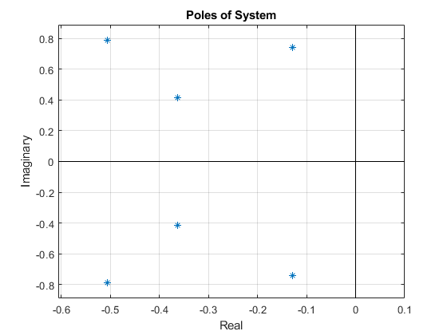
Figure 2 Poles of Controlled System
Two sets of initial conditions were used to test the response of the system. The first set of conditions was designed to test a large initial velocity. The initial state for this input was $x=θ_{1}=θ_{2}=0, \dot{x}=10\text{m/s},{\dot{θ}}_{1}=-{\dot{θ}}_{2}=\frac{π}{8}\text{rad/s}$. The second set of conditions was designed to start in a steady condition but target a large position difference, which would be comparable to the crane moving from a pickup location to its drop-off point. The initial state for this input was $x=θ_{1}=θ_{2}=\dot{x}={\dot{θ}}_{1}={\dot{θ}}_{2}=0$, and the commanded position was $x_{final}=50m.$
The response to a large initial velocity is shown below. The position of the uncontrolled system linearly drifts as it experiences no resistance, but the controller is able to bring its position back to $0$. The two smaller masses’ angles continuously oscilate in the uncontrolled system, but are made steady in the controllable system, even though they start off oscilating in opposite directions. We noticed during our tests that the two masses oscilating in opposite directions was one of the most difficult initial conditions to stabilize. This makes sense, since a motion that steadies one mass would amplify the other’s motion. Ignoring the initial force calculation, which lasts for less than $0.5$ seconds, the force exherted on the large mass was less than $4000$ newtons. Even though our chosen $R$ value was extremely small, this force isn’t entirely unreasonable for a crane to exhert, considering the weight of the large mass is greater than 9000 newtons.
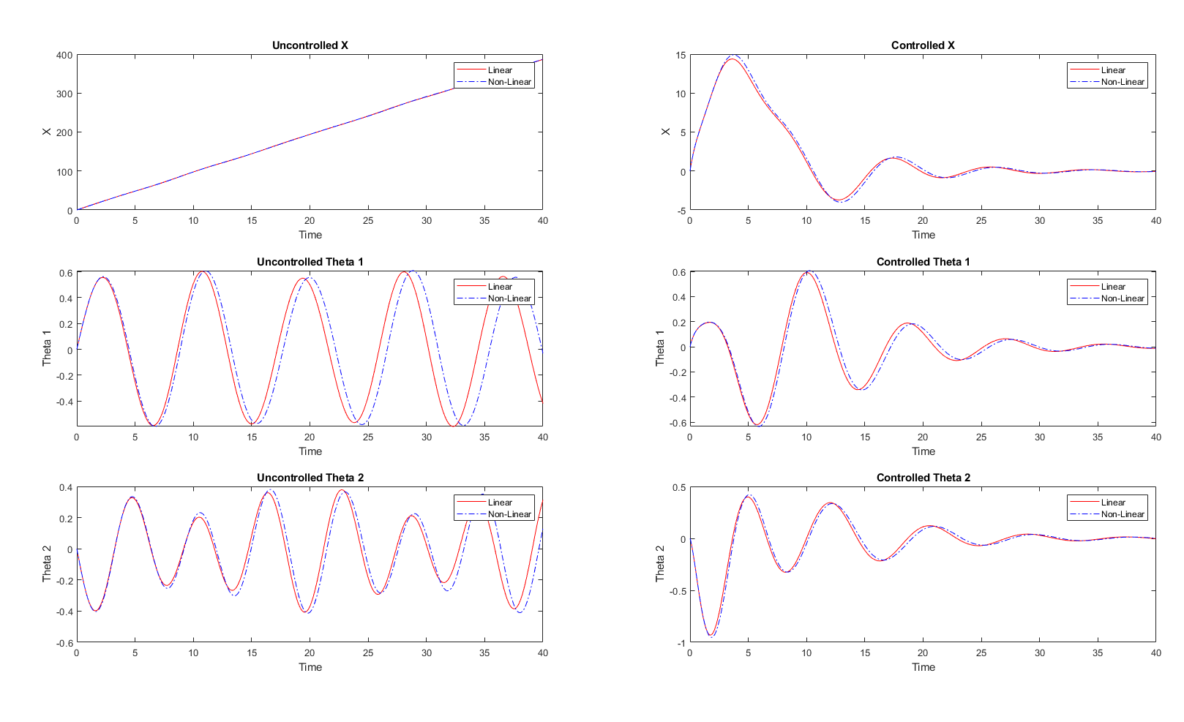
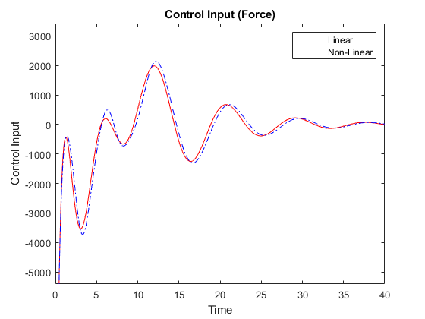

The response to a steady initial condition with a commanded movement is shown below. The uncontrolled system remains at its initial steady condition throughout the simulation, but the controlled system becomes unsteady as it moves the crane to get to its final position. It reaches its desired location at around 10 seconds but takes around 35 seconds to steady the two hanging masses. Again, ignoring the initial calculated input force, the force exherted on the large mass was less than 25$00$ newtons.
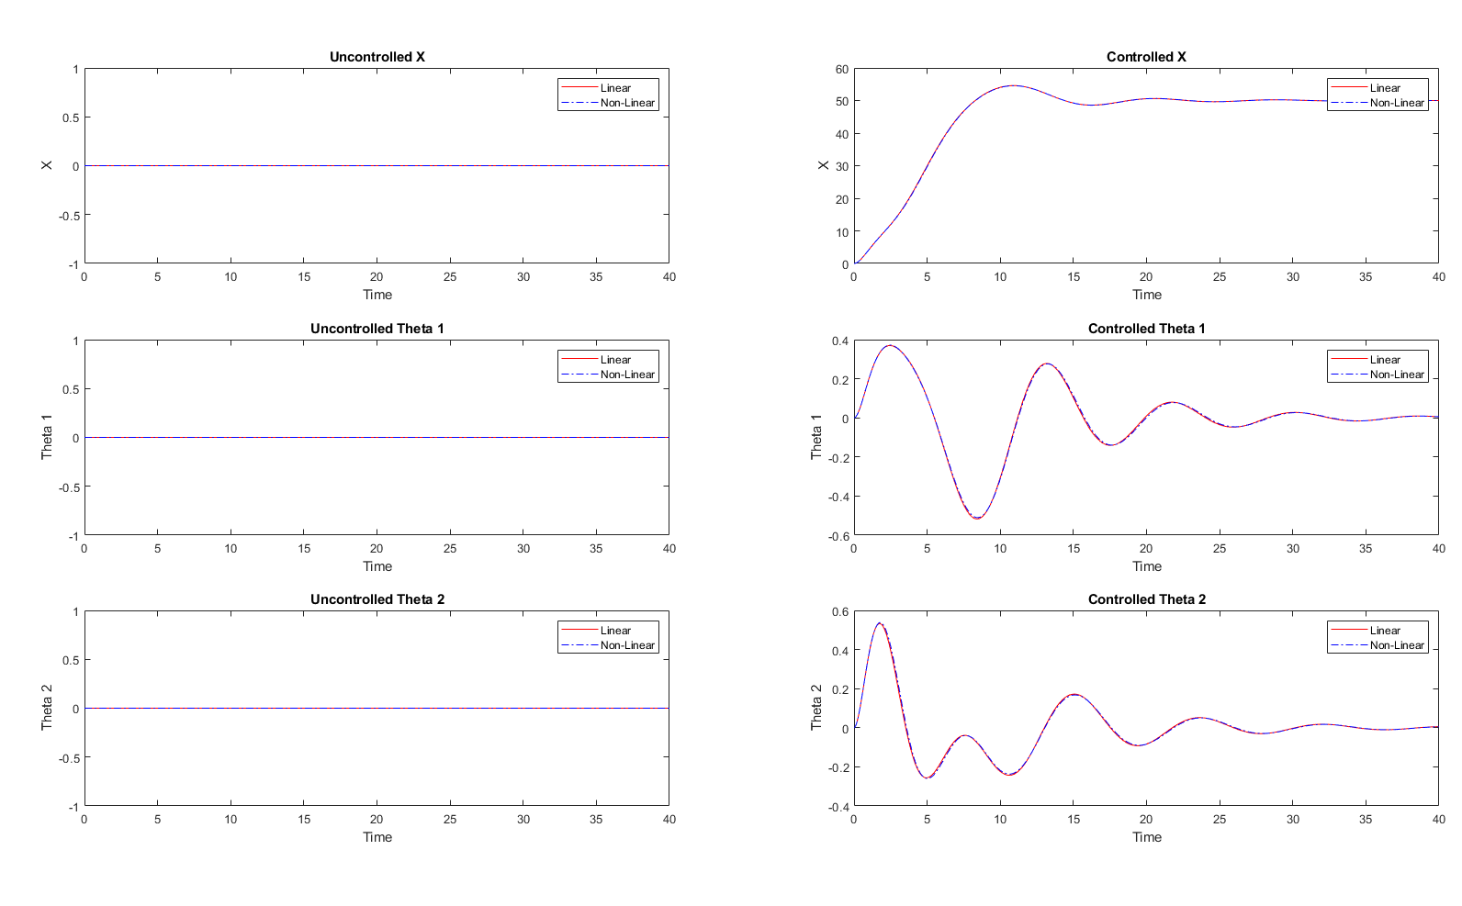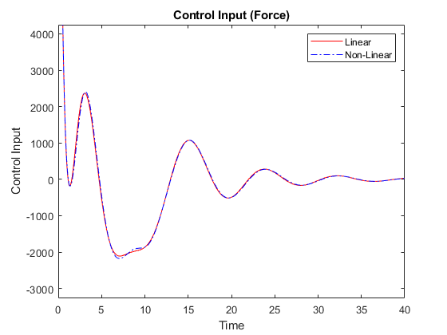

E) Suppose that you can select the following output vectors: $a)x\left(t\right), b)\left(θ_{1}\left(t\right),θ_{2}\left(t\right)\right), c)\left(x\left(t\right),θ_{2}\left(t\right)\right), or d)(x\left(t\right),θ_{1}\left(t\right),θ_{2}\left(t\right))$ Determine for which output vectors the linearized system is observable.

$$Y\left(t\right)=C_{F}X\left(t\right)+D_{F}F\left(t\right)$$
$$X\left(t\right)=\left[\begin{aligned}x\left(t\right) \\ \dot{x}\left(t\right) \\ θ_{1}\left(t\right) \\ {\dot{θ}}_{1}\left(t\right) \\ θ_{2}\left(t\right) \\ {\dot{θ}}_{2}\left(t\right)\end{aligned}\right], \text{Observability Matrix }= O_{F}=\left[\begin{aligned}C_{F} \\ C_{F}A_{F} \\ ⋮ \\ {C_{F}A}_{F}^{5}\end{aligned}\right]$$
$$\text{Observable if and only if} Rank\left[O_{Fa}\right]=6 \text{(full rank)}$$

- $Y\left(t\right)=x\left(t\right), C_{F}=\left[1,0,0,0,0,0\right], D_{F}=0$
$$O_{Fa}=\left[\begin{matrix}1 & 0 & 0 & 0 & 0 & 0 \\ 0 & 1 & 0 & 0 & 0 & 0 \\ 0 & 0 & -\frac{gm_{1}}{M} & 0 & -\frac{gm_{2}}{M} & 0 \\ 0 & 0 & 0 & -\frac{gm_{1}}{M} & 0 & -\frac{gm_{2}}{M} \\ 0 & 0 & O_{53} & 0 & O_{55} & 0 \\ 0 & 0 & 0 & O_{64} & 0 & O_{66}\end{matrix}\right]$$
$$O_{53}= O_{64}=\frac{g^{2}m_{1}\left(M + m_{1}\right)}{M^{2}l_{1}}+\frac{g^{2}m_{1}m_{2}}{M^{2}l_{2}}$$
$$O_{55}= O_{66}= \frac{g^{2}m_{2}\left(M + m_{2}\right)}{M^{2}l_{2}}+\frac{g^{2}m_{1}m_{2}}{M^{2}l_{1}}$$
$Consider the parameters selected in D); M=1000kg,m_{1}=m_{2}=100kg,l_{1}=20m, \text{and} l_{2}=10m$.
$$\text{Using MATLAB 'rank' Function,} Rank\left[O_{Fa}\right]=6, ∴Observable$$

- $Y\left(t\right)=\left[θ_{1}\left(t\right),θ_{2}\left(t\right)\right], C_{F}=\left[0,0,1,0,1,0\right], D_{F}=0$
$$O_{Fb}=\left[\begin{matrix}0 & 0 & 1 & 0 & 1 & 0 \\ 0 & 0 & 0 & 1 & 0 & 1 \\ 0 & 0 & -\frac{g\left(M+m_{1}\right)}{Ml_{1}}-\frac{gm_{1}}{Ml_{2}} & 0 & -\frac{g\left(M+m_{2}\right)}{Ml_{2}}-\frac{gm_{2}}{Ml_{1}} & 0 \\ 0 & 0 & 0 & -\frac{g\left(M+m_{1}\right)}{Ml_{1}}-\frac{gm_{1}}{Ml_{2}} & 0 & -\frac{g\left(M+m_{2}\right)}{Ml_{2}}-\frac{gm_{2}}{Ml_{1}} \\ 0 & 0 & O_{53} & 0 & O_{55} & 0 \\ 0 & 0 & 0 & O_{64} & 0 & O_{66}\end{matrix}\right]$$
$$O_{53}= O_{64}=\frac{g^{2}{\left(M + m_{1}\right)}^{2}}{M^{2}l_{1}^{2}}+\frac{g^{2}m_{1}\left(M + m_{2}\right)}{M^{2}l_{2}^{2}}+\frac{g^{2}m_{1}m_{2}}{M^{2}l_{1}l_{2}}+\frac{g^{2}m_{1}\left(M + m_{1}\right)}{M^{2}l_{1}l_{2}}$$
$$O_{55}= O_{66}= \frac{g^{2}{\left(M + m_{2}\right)}^{2}}{M^{2}l_{2}^{2}}+\frac{g^{2}m_{2}\left(M + m_{1}\right)}{M^{2}l_{1}^{2}}+\frac{g^{2}m_{1}m_{2}}{M^{2}l_{1}l_{2}}+\frac{g^{2}m_{2}\left(M + m_{2}\right)}{M^{2}l_{1}l_{2}}$$
$$Rank\left[O_{Fb}\right]=4,∴\text{Not} Observable$$

- $Y\left(t\right)=\left[x\left(t\right),θ_{2}\left(t\right)\right], C_{F}=\left[1,0,0,0,1,0\right], D_{F}=0$
$$O_{Fc}=\left[\begin{matrix}1 & 0 & 0 & 0 & 0 & 0 \\ 0 & 1 & 0 & 0 & 0 & 0 \\ 0 & 0 & -\frac{gm_{1}\left(l_{2} + 1\right)}{Ml_{2}} & 0 & -\frac{g\left(M + m_{2} + l_{2}m_{2}\right)}{Ml_{2}} & 0 \\ 0 & 0 & 0 & -\frac{gm_{1}\left(l_{2} + 1\right)}{Ml_{2}} & 0 & -\frac{g\left(M + m_{2} + l_{2}m_{2}\right)}{Ml_{2}} \\ 0 & 0 & O_{53} & 0 & O_{55} & 0 \\ 0 & 0 & 0 & O_{64} & 0 & O_{66}\end{matrix}\right]$$
$$O_{53}= O_{64}=\frac{g^{2}m_{1}\left(Ml_{1} + Ml_{2} + l_{1}m_{2} + l_{2}m_{1} + Ml_{2}^{2} + l_{2}^{2}m_{1} + l_{1}l_{2}m_{2}\right)}{M^{2}l_{1}l_{2}^{2}}$$
$$O_{55}= O_{66}=\frac{g^{2}\left(l_{1}M^{2} + l_{1}Ml_{2}m_{2} + 2l_{1}Mm_{2} + m_{1}l_{2}^{2}m_{2} + l_{1}l_{2}m_{2}^{2} + m_{1}l_{2}m_{2} + l_{1}m_{2}^{2}\right)}{M^{2}l_{1}l_{2}^{2}}$$
$$Rank\left[O_{Fc}\right]=6,∴Observable$$

- $Y\left(t\right)=\left[x\left(t\right),θ_{1}\left(t\right),θ_{2}\left(t\right)\right], C_{F}=\left[1,0,1,0,1,0\right], D_{F}=0$
$$O_{Fd}=\left[\begin{matrix}1 & 0 & 0 & 0 & 0 & 0 \\ 0 & 1 & 0 & 0 & 0 & 0 \\ 0 & 0 & O_{33} & 0 & O_{35} & 0 \\ 0 & 0 & 0 & O_{44} & 0 & O_{46} \\ 0 & 0 & O_{53} & 0 & O_{55} & 0 \\ 0 & 0 & 0 & O_{64} & 0 & O_{66}\end{matrix}\right]$$
$$O_{33}=O_{44}=-\frac{g\left(Ml_{2} + l_{1}m_{1} + l_{2}m_{1} + l_{1}l_{2}m_{1}\right)}{Ml_{1}l_{2}}$$
$$O_{53}= O_{64}=\frac{g^{2}\left(M^{2}l_{2}^{2} + Ml_{1}^{2}m_{1} + Ml_{1}l_{2}^{2}m_{1} + Ml_{1}l_{2}m_{1} + 2Ml_{2}^{2}m_{1} + m_{2}l_{1}^{2}l_{2}m_{1} + m_{2}l_{1}^{2}m_{1} + l_{1}l_{2}^{2}m_{1}^{2} + l_{1}l_{2}m_{1}^{2} + m_{2}l_{1}l_{2}m_{1} + l_{2}^{2}m_{1}^{2}\right)}{M^{2}l_{1}^{2}l_{2}^{2}}$$
$$O_{35}=O_{46}=-\frac{g\left(Ml_{2} + l_{1}m_{1} + l_{2}m_{1} + l_{1}l_{2}m_{1}\right)}{Ml_{1}l_{2}}$$
$$O_{55}= O_{66}=\frac{g^{2}\left(M^{2}l_{1}^{2} + Ml_{1}^{2}l_{2}m_{2} + 2Ml_{1}^{2}m_{2} + Ml_{1}l_{2}m_{2} + Ml_{2}^{2}m_{2} + l_{1}^{2}l_{2}m_{2}^{2} + l_{1}^{2}m_{2}^{2} + m_{1}l_{1}l_{2}^{2}m_{2} + l_{1}l_{2}m_{2}^{2} + m_{1}l_{1}l_{2}m_{2} + m_{1}l_{2}^{2}m_{2}\right)}{M^{2}l_{1}^{2}l_{2}^{2}}$$
$$Rank\left[O_{Fd}\right]=6, ∴Observable$$

F) Obtain your "best" Luenberger observer for each one of the output vectors for which the system is
observable and simulate its response to initial conditions and unit step input. The simulation should
be done for the observer applied to both the linearized system and the original nonlinear system.

We can design a Luenberger observer by making a copy of the system, however we use an estimator $\hat{x}$ since we do not know the actual states of the real system, we only know the output $y=Cx$.
We use this know output to correct the estimator with a gain L.
$$\dot{\hat{x}}=A\hat{x}+BF\left(t\right)+L\left(y-\hat{y}\right) and \hat{y}=C\hat{x}+DF(t)$$
The observer error $\dot{e}=\left(A-LC\right)e$
For the observer to be stable the poles of $\left(A-LC\right)$ must be in the left half plane. For a simple case the $\det\left(\left(A-LC\right)-λI\right)$ can be found, and the poles placed as desired. For our system we do this by running the MATLAB function $L=place\left(A_{F}^{'},C^{'},L_{poles}\right);$ where $C$ is a row vector of $1$’s and $0$’s, describing which state variables we are able to observe. This allows us to arbitrarily place the poles of the observer.

The response of the observer should also be faster than the response of the system, this means the observers’ least negative real pole must be significantly more negative than the system’s least negative pole. It is also noted that having large imaginary components of the poles results in high oscillations in the observer’s error. Having large negative real components reduces response time but increases initial estimation errors and can cause a peaking phenomenon and erratic motions of the system. A balance must be made between response time and erratic motions, which we did using trial and error, comparing the observer error for each state variable. We started with multiples of the LQR-controlled system’s real pole components, which resulted in an error placing the poles due to a conflict in multiplicity and rank of C. We then used both the real and imaginary components, which resulted in small oscillations in the error. Finally, we removed the imaginary components and made “pairs” of poles that were all real negative such as [-20 -19 -10 -9 -5 -4], which resulted in a good response time but large initial estimation errors, so we reduced the magnitude and did some fine manual tuning to come up with our “best” Luenberger observer for each output vector. The following poles were determined to give us our best results.
$$L_{poles}=\left[-3,-2.85,-1.5,-1.35,-0.75,-0.6\right]$$

$$L=place\left(A_{F}^{'},C^{'},L_{poles}\right)$$
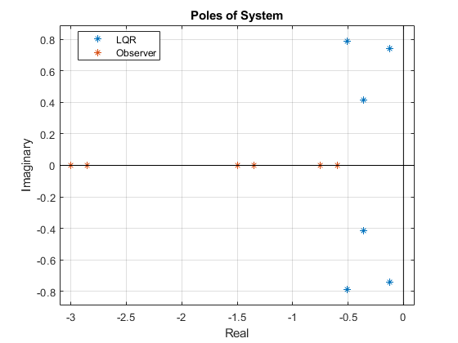
The initial conditions and unit step parameters use for the observer design are as follows:

Initial conditions test
$$x_{o}=\left[\begin{matrix}0 & 1 & 0 & π/{16} & 0 & {-π}/{16}\end{matrix}\right]$$
Unit step test
$$x_{o}=\left[\begin{matrix}0 & 0 & 0 & 0 & 0 & 0\end{matrix}\right]$$
$$F(t)=\left\{\begin{aligned}0, &t<20 \\ 100, &t≥20\end{aligned}\right.$$

The observer was built for each observable output vector a, c, and d. The linear and nonlinear simulations of the observer were run for the sated initial conditions and unit step tests.

- $Y\left(t\right)=x\left(t\right) ; C_{F}=\left[1,0,0,0,0,0\right]$

$$∴L={\left[\begin{matrix}10.05 & 37.82 & -8.56 & 46.18 & -53.25 & -63.16\end{matrix}\right]}^{'}$$
Initial conditions test
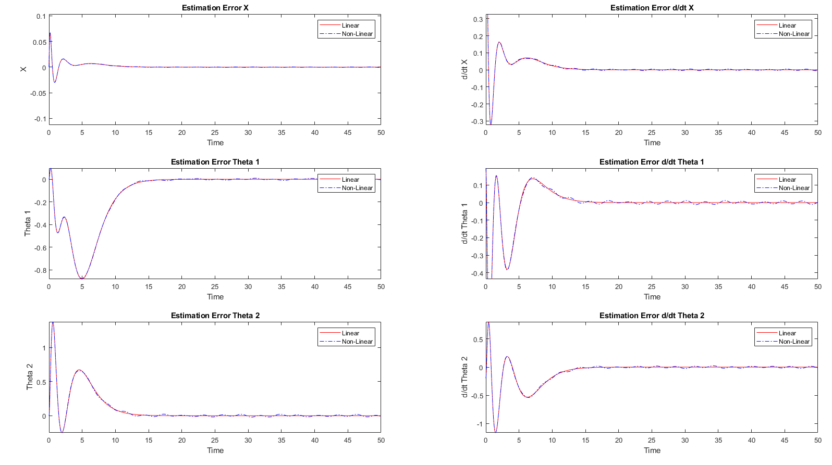
The plots show good estimation errors after approximately 15 seconds. As compared to the 30 second system response time.
Unit step test
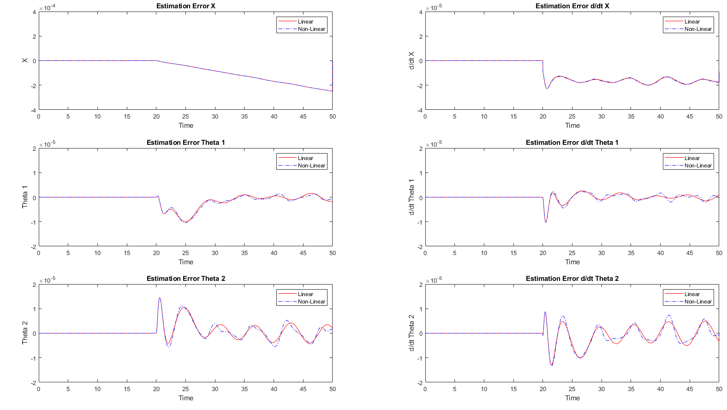
The plots show estimation errors after the unit step begin to oscillate but have a very small error.
- $Y\left(t\right)=\left[x\left(t\right),θ_{2}\left(t\right)\right]; C_{F}=\left[1,0,0,0,1,0\right]$

$$∴L={\left[\begin{matrix}36.01 & 74.95 & -6.62 & 55.43 & -25.96 & -37.12\end{matrix}\right]}^{'}$$
Initial conditions test
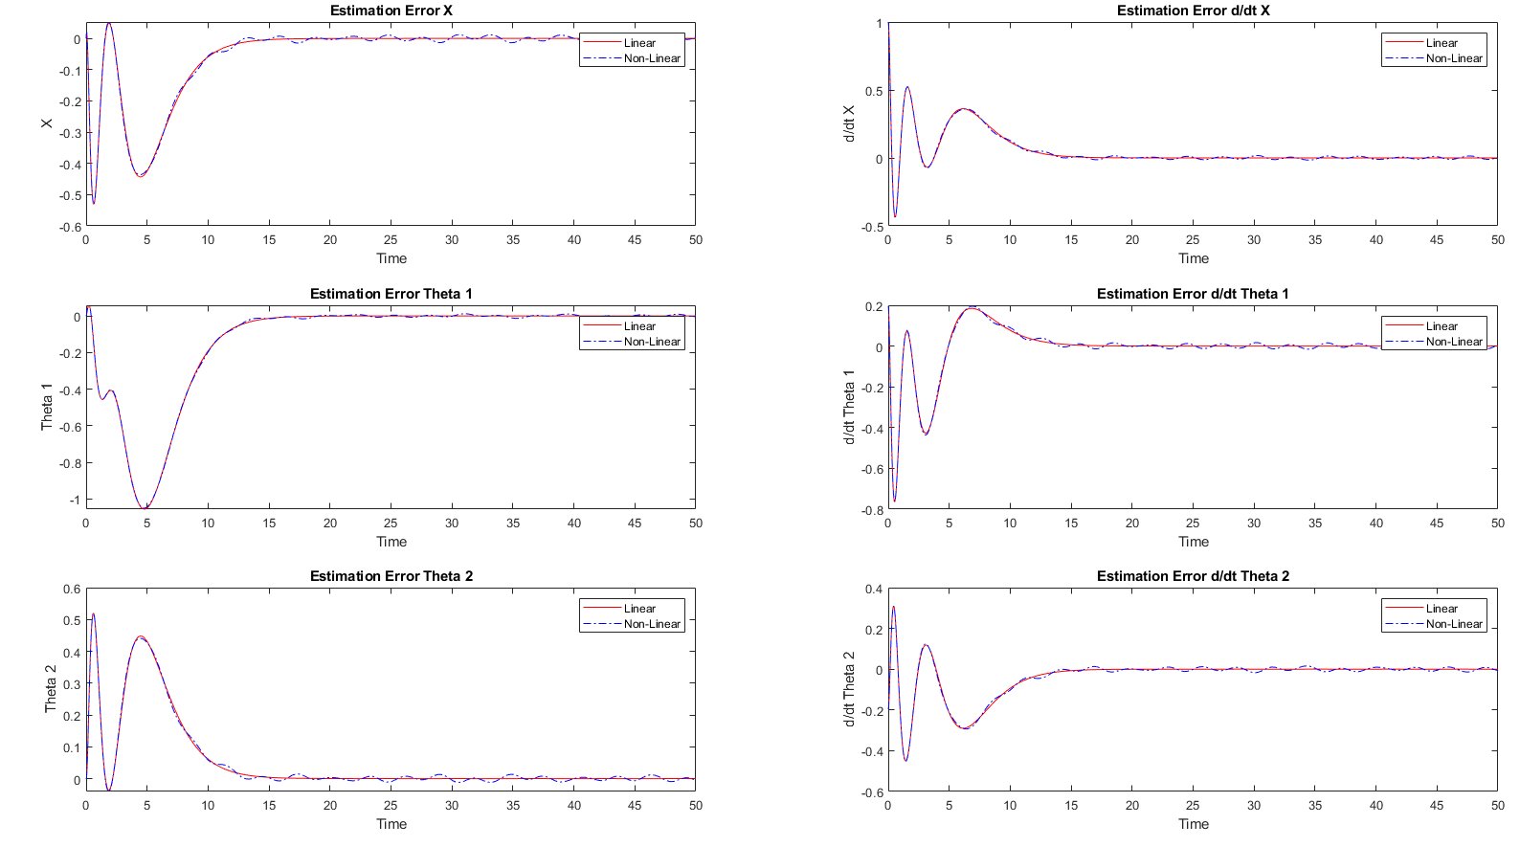
The plots show good estimation errors after approximately 15 seconds. As compared to the 30 second system response time.
Unit step test
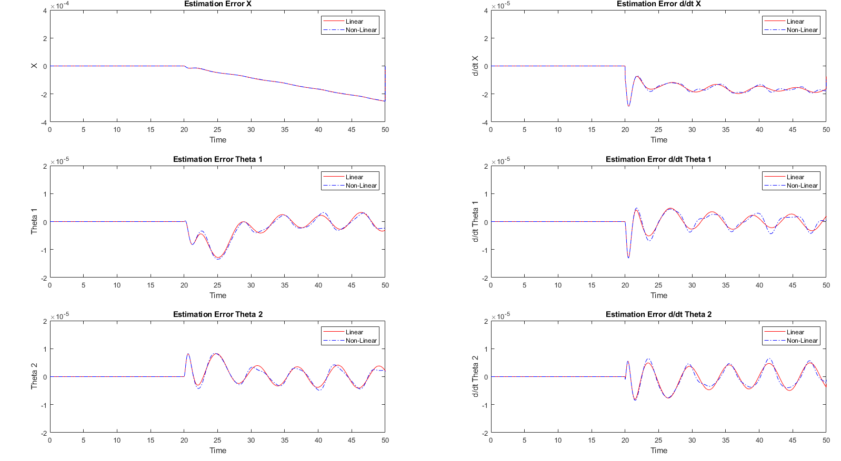
The plots show estimation errors after the unit step begin to oscillate but have a very small error.
- $Y\left(t\right)=\left[x\left(t\right),θ_{1}\left(t\right),θ_{2}\left(t\right)\right]; C_{F}=\left[1,0,1,0,1,0\right]$

$$∴L={\left[\begin{matrix}39.89 & 38.55 & -4.71 & 30.81 & -25.13 & -31.54\end{matrix}\right]}^{'}$$
Initial conditions test
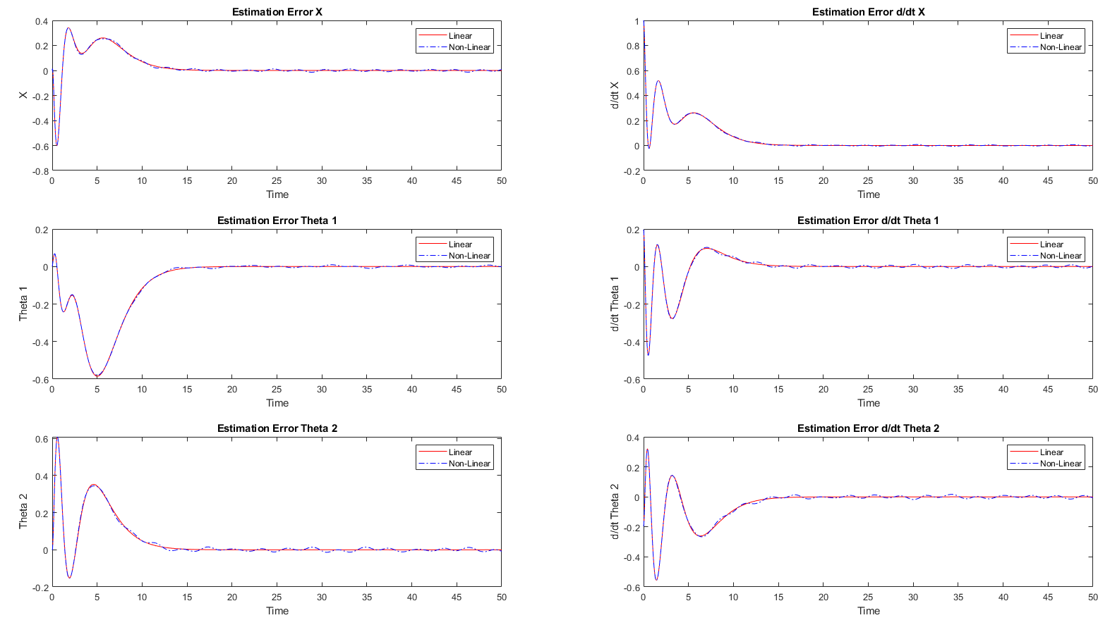
The plots show good estimation errors after approximately 15 seconds. As compared to the 30 second system response time.
Unit step test
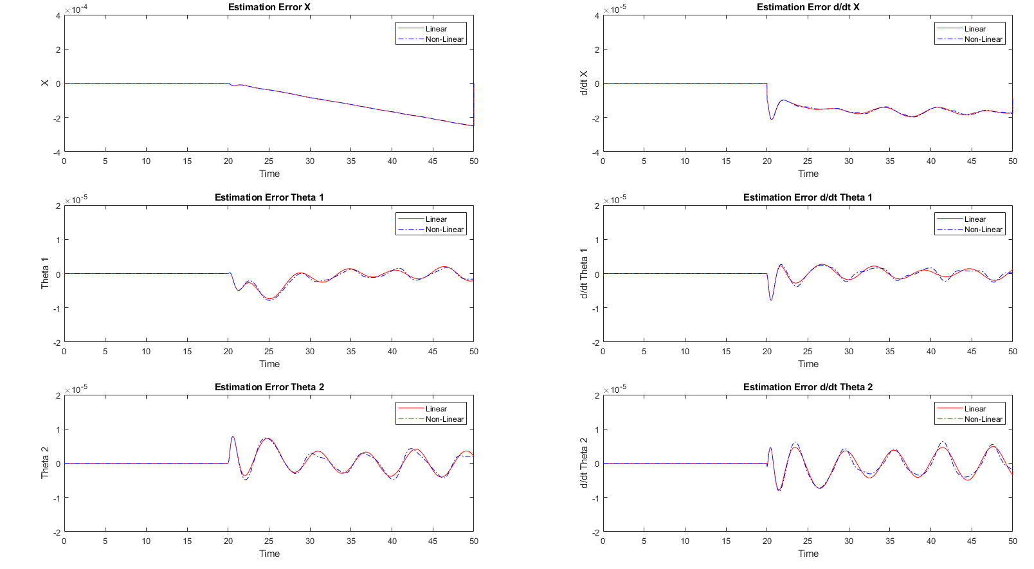
The plots show estimation errors after the unit step begin to oscillate but have a very small error.
All three observers have very similar performance.
G) Design an output feedback controller for your choice of the "smallest" output vector. Use the LQG
method and apply the resulting output feedback controller to the original nonlinear system. Obtain your best design and illustrate its performance in simulation. How would you reconfigure your controller to asymptotically track a constant reference on$x$? Will your design reject constant force disturbances applied on the cart?

The system is observable for cases a, c, and d. The “smallest” output vector is case a, $C=\left[1,0,0,0,0,0\right]$. However, all output vectors were used, and the characteristics are discussed.
Case ‘a’ was used because it was able to be controlled and had a reasonable response. It also is the most realistic, since the crane’s position along the gantry, $x\left(t\right)$, is much easier to measure than the angle of the cable hanging from it. We would not expect the crane to have measurements of the cable angles with respect to the gantry.
The LQG feedback controller was designed such that the LQR controller previously developed in part D was used, with the modification of using the estimated state $\hat{x}$ from the observer rather than the real states $x$. Since both the observer and the LQR controller are stable independently, the separation principle shows that the combined feedback controller is also stable.
Our controller can track a desired constant reference x position $x_{d}$, which is done by incorporating the desired finals state into the output force.
$$F=K\left(X-X_{d}\right), \text{where} X_{d}=\left[x_{d} 0 0 0 0 0\right]'$$
$X_{d}$ is a vector of the reference state variables, however, the system only remains stable when all state variables, except for $x\left(t\right)$, are 0. Our controller is almost capable of rejecting constant force disturbances, however there is a resultant steady state error on the x position of the system. This error is due to an error in the observer. The estimated state is based on the previous state, and the output error as described in part F. With a constant disturbance, the real output will always differ from the predicted output, so the observer has a steady state error in its estimated value for $\dot{x}\left(t\right),$ $θ_{1}\left(t\right),$ ${\dot{θ}}_{1}\left(t\right),$ $θ_{2}\left(t\right),$ and ${\dot{θ}}_{2}\left(t\right)$, and $x\left(t\right)$ grows in error at a steady rate over time. This error could be a problem for a crane, since windy conditions could cause steady-state errors in the system.
The following pages illustrate the full LQG controller’s performance in various situations.
- An initial position of $x=θ_{1}=θ_{2}=0$, and initial velocities $\dot{x}=1 \text{m/s}, {\dot{θ}}_{1}=\frac{pi}{16}\text{rad/s},{\dot{θ}}_{2}=-\frac{π}{16}\text{rad/s}$, with no disturbance force and a commanded position $x=0$.
- An initial position and initial velocities of $x=θ_{1}=θ_{2}=\dot{x}={\dot{θ}}_{1}={\dot{θ}}_{2}=0$, with no disturbance force and a commanded position $x=50 \text{m}$.
- An initial position of $x=θ_{1}=θ_{2}=0$, and initial velocities $\dot{x}=1 \text{m/s}, {\dot{θ}}_{1}=\frac{pi}{16}\text{rad/s},{\dot{θ}}_{2}=-\frac{π}{16}\text{rad/s}$, with no disturbance force and a commanded position $x=50 \text{m}$.
- An initial position and initial velocities of $x=θ_{1}=θ_{2}=\dot{x}={\dot{θ}}_{1}={\dot{θ}}_{2}=0$, with a constant disturbance force of $100 N$, and a commanded position $x=0$.
- An initial position of $x=θ_{1}=θ_{2}=0$, and initial velocities $\dot{x}=1 \text{m/s}, {\dot{θ}}_{1}=\frac{pi}{16}\text{rad/s},{\dot{θ}}_{2}=-\frac{π}{16}\text{rad/s}$, with no disturbance force and a commanded position $x=0$.
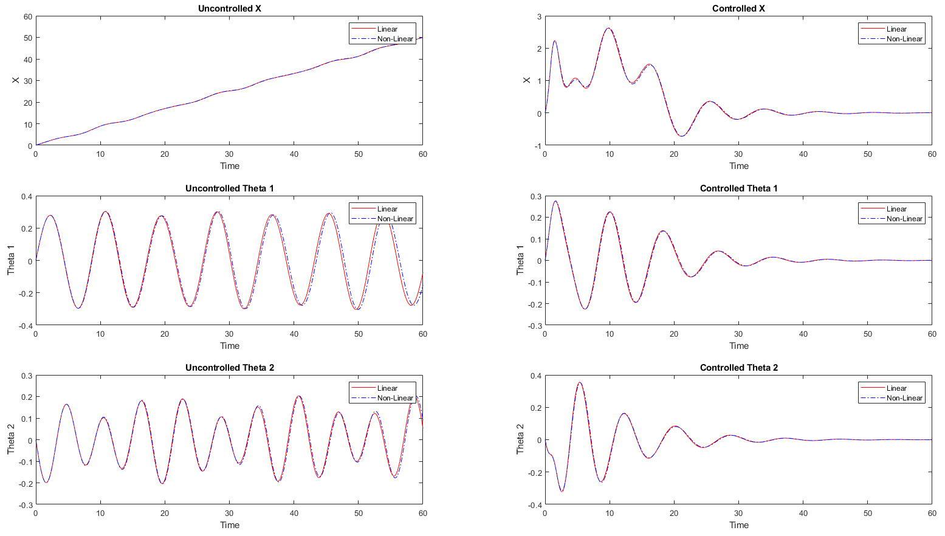
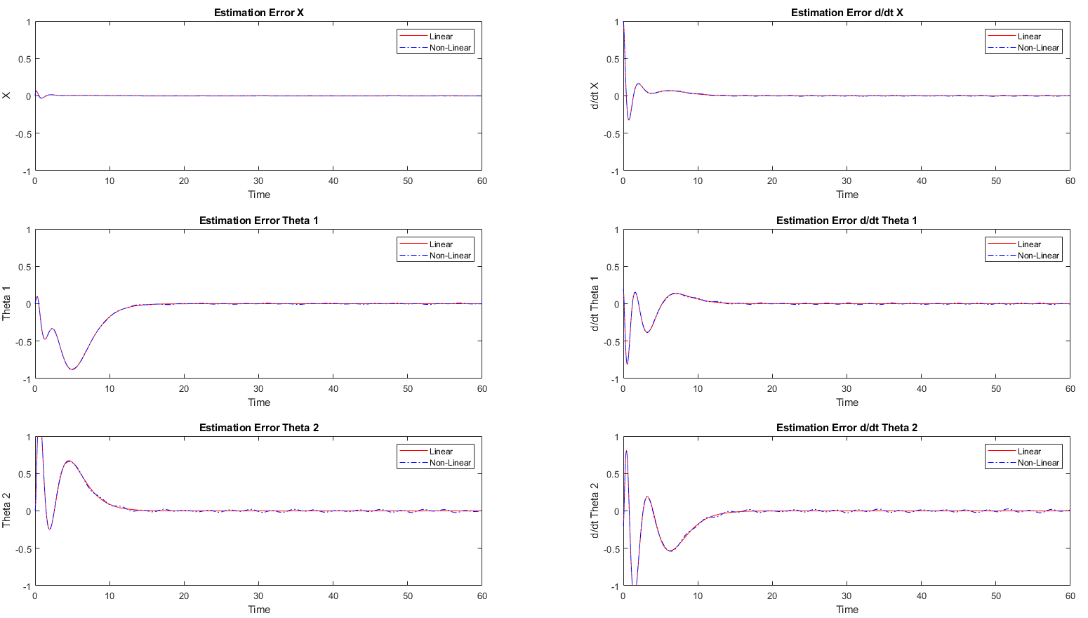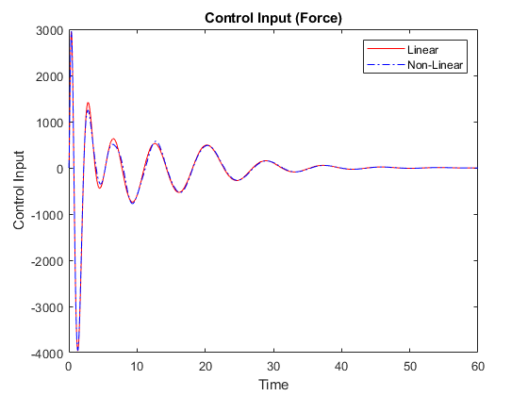
- An initial position and initial velocities of $x=θ_{1}=θ_{2}=\dot{x}={\dot{θ}}_{1}={\dot{θ}}_{2}=0$, with no disturbance force and a commanded position $x=50 \text{m}$.
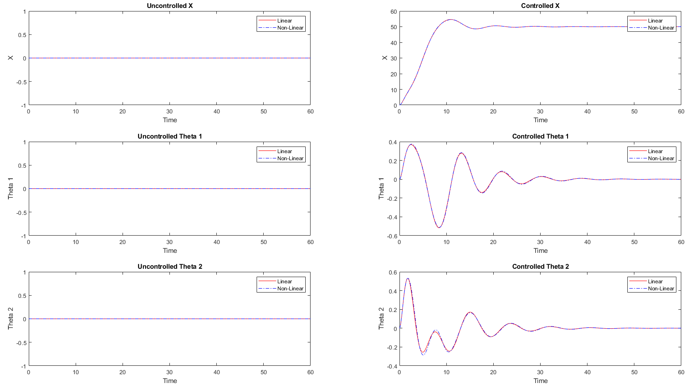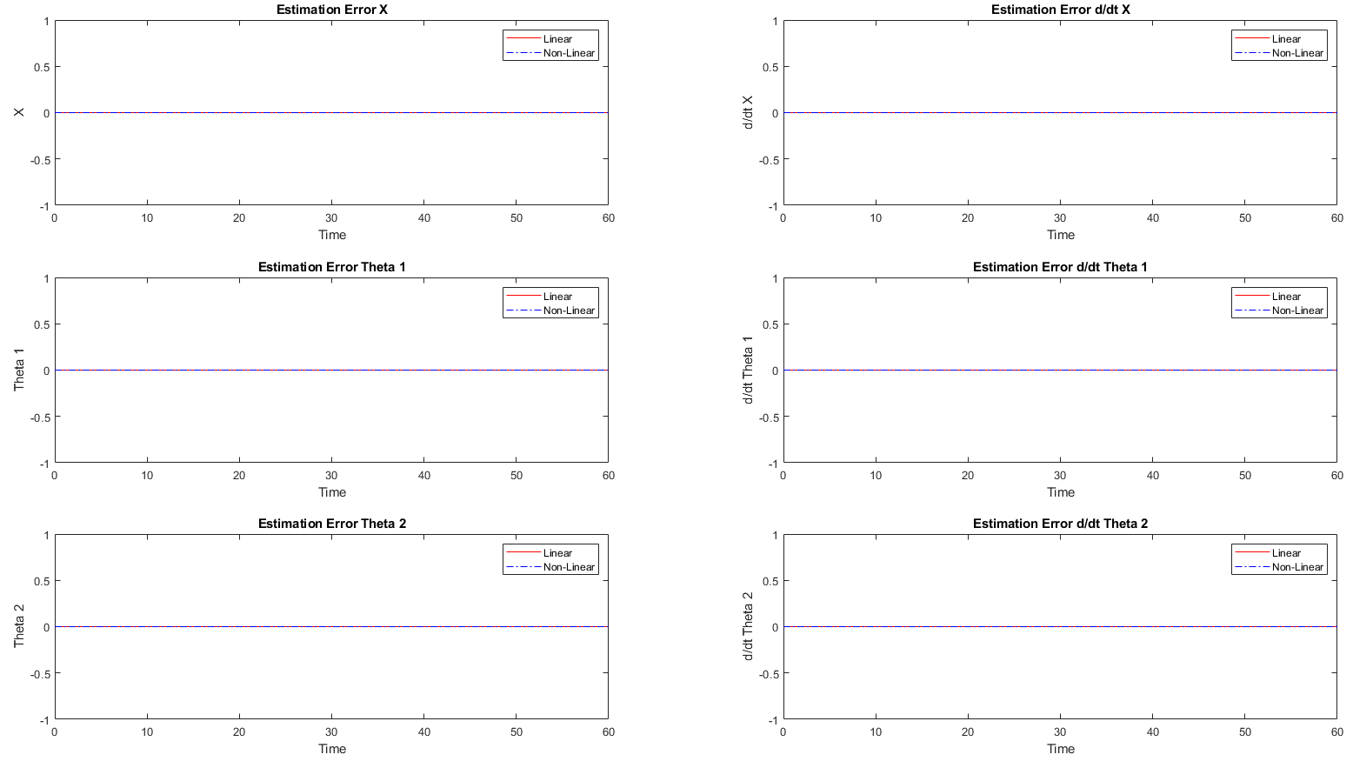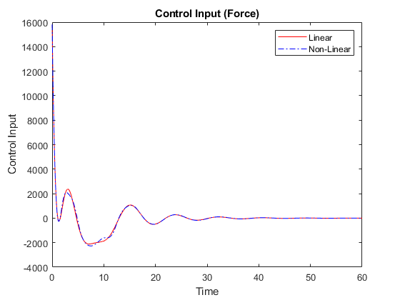
- An initial position of $x=θ_{1}=θ_{2}=0$, and initial velocities $\dot{x}=1 \text{m/s}, {\dot{θ}}_{1}=\frac{pi}{16}\text{rad/s},{\dot{θ}}_{2}=-\frac{π}{16}\text{rad/s}$, with no disturbance force and a commanded position $x=50 \text{m}$.
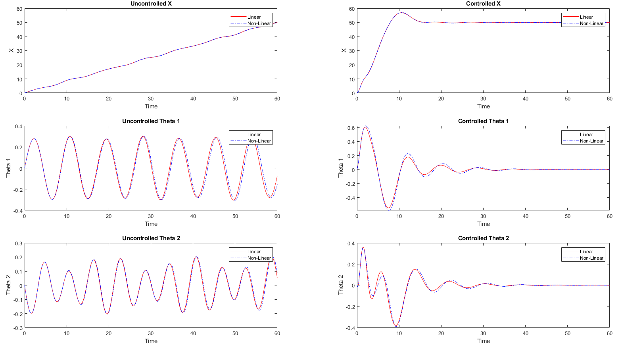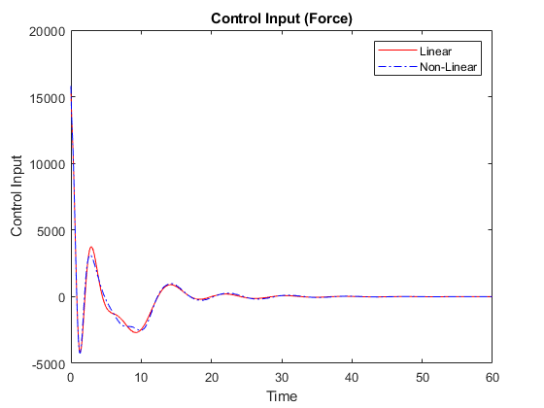
- An initial position and initial velocities of $x=θ_{1}=θ_{2}=\dot{x}={\dot{θ}}_{1}={\dot{θ}}_{2}=0$, with a constant disturbance force of $100 N$, and a commanded position $x=0$.
