The GUI for the my sample program

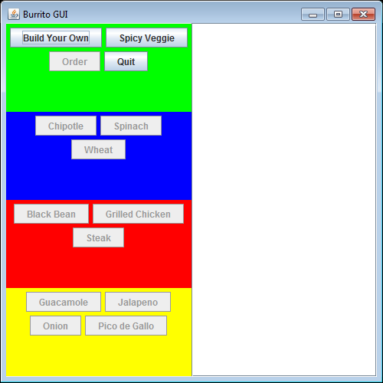

Your GUI does not have to look exactly the same as mine, but it needs to provide enough buttons to exercise the classes that you wrote for program 1, and prevent the user from making mistakes, and it needs a scrollable text area to display the ordering information. You also need another button for your custom burrito that you developed for program 1.

My interface after the “Build Your Own” button is clicked:
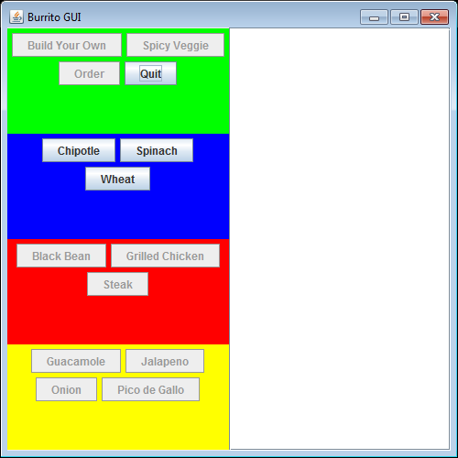

After a tortilla is selected:
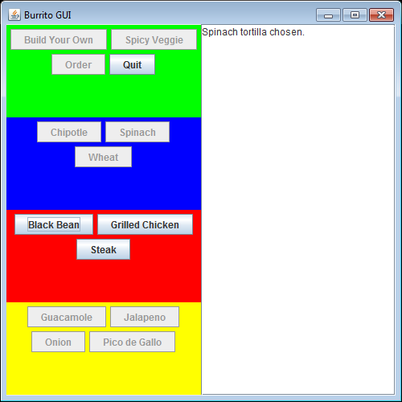

After the first topping is selected:
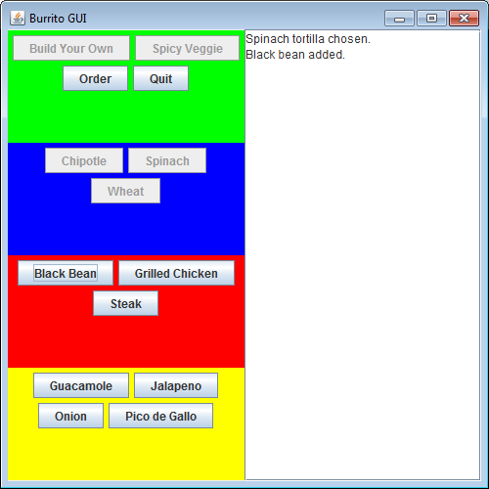

After the first condiment is selected:
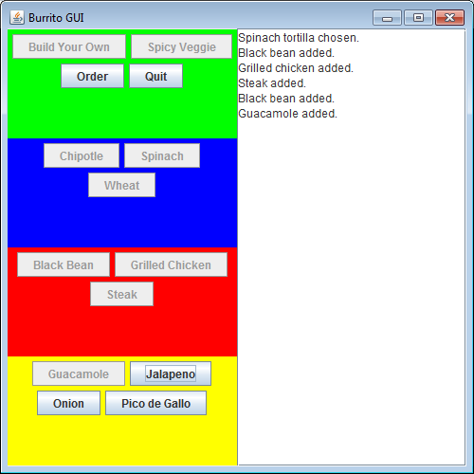

After all condiments are selected:
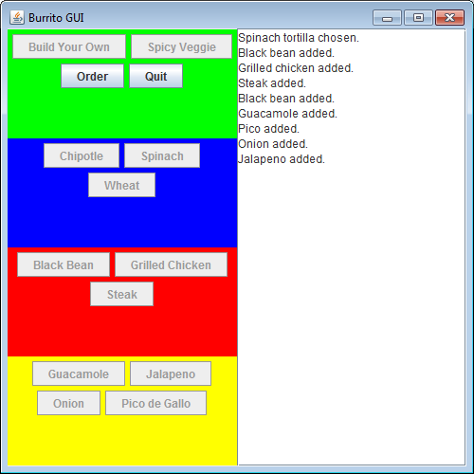

After the “Order” button is clicked:
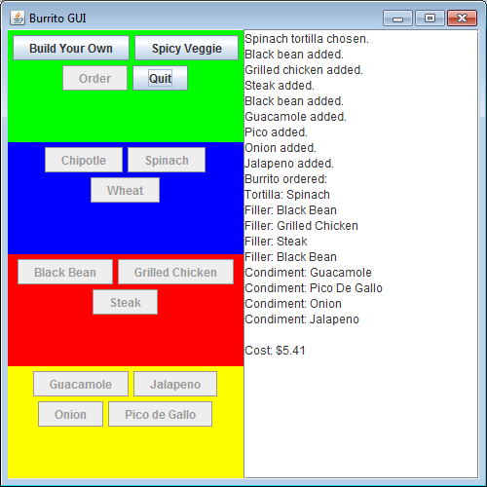

After the “Spicy Veggie” button is clicked:
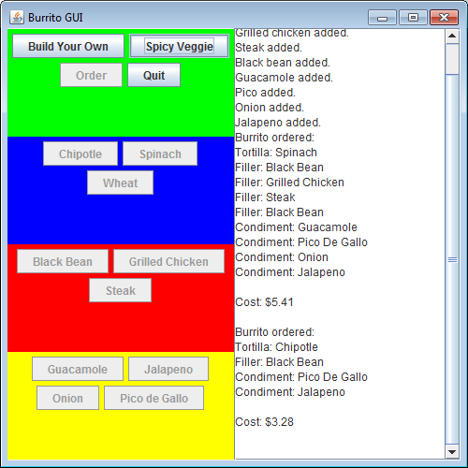

After the “Quit” button is clicked, a JFileChooser is displayed for the user to select where the output should be saved.

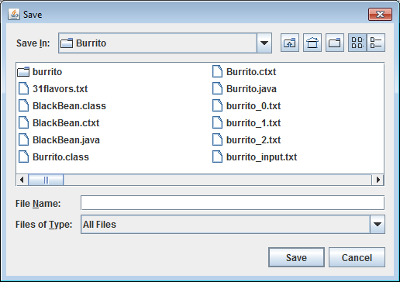

The contents of the output file after the program finishes:

Spinach tortilla chosen.
Black bean added.
Grilled chicken added.
Steak added.
Black bean added.
Guacamole added.
Pico added.
Onion added.
Jalapeno added.
Burrito ordered:
Tortilla: Spinach
Filler: Black Bean
Filler: Grilled Chicken
Filler: Steak
Filler: Black Bean
Condiment: Guacamole
Condiment: Pico De Gallo
Condiment: Onion
Condiment: Jalapeno

Cost: $5.41

Burrito ordered:
Tortilla: Chipotle
Filler: Black Bean
Condiment: Pico De Gallo
Condiment: Jalapeno

Cost: $3.28

You ordered 2 burrito(s) for a grand total of $8.69.

