# CS 255 System Design Document

This template lays out all the different sections that you need to complete for Project Two. Each section has guidance to prompt your thinking. You will need to continually reference the interview transcript as you work to make sure that you are addressing your client’s needs. There is no required length for the final document. Instead the goal is to complete each section based on what your client’s needs are. Remove this note when you are finished, and replace all bracketed text with the relevant information.

## UML Diagrams

### UML Use Case Diagram

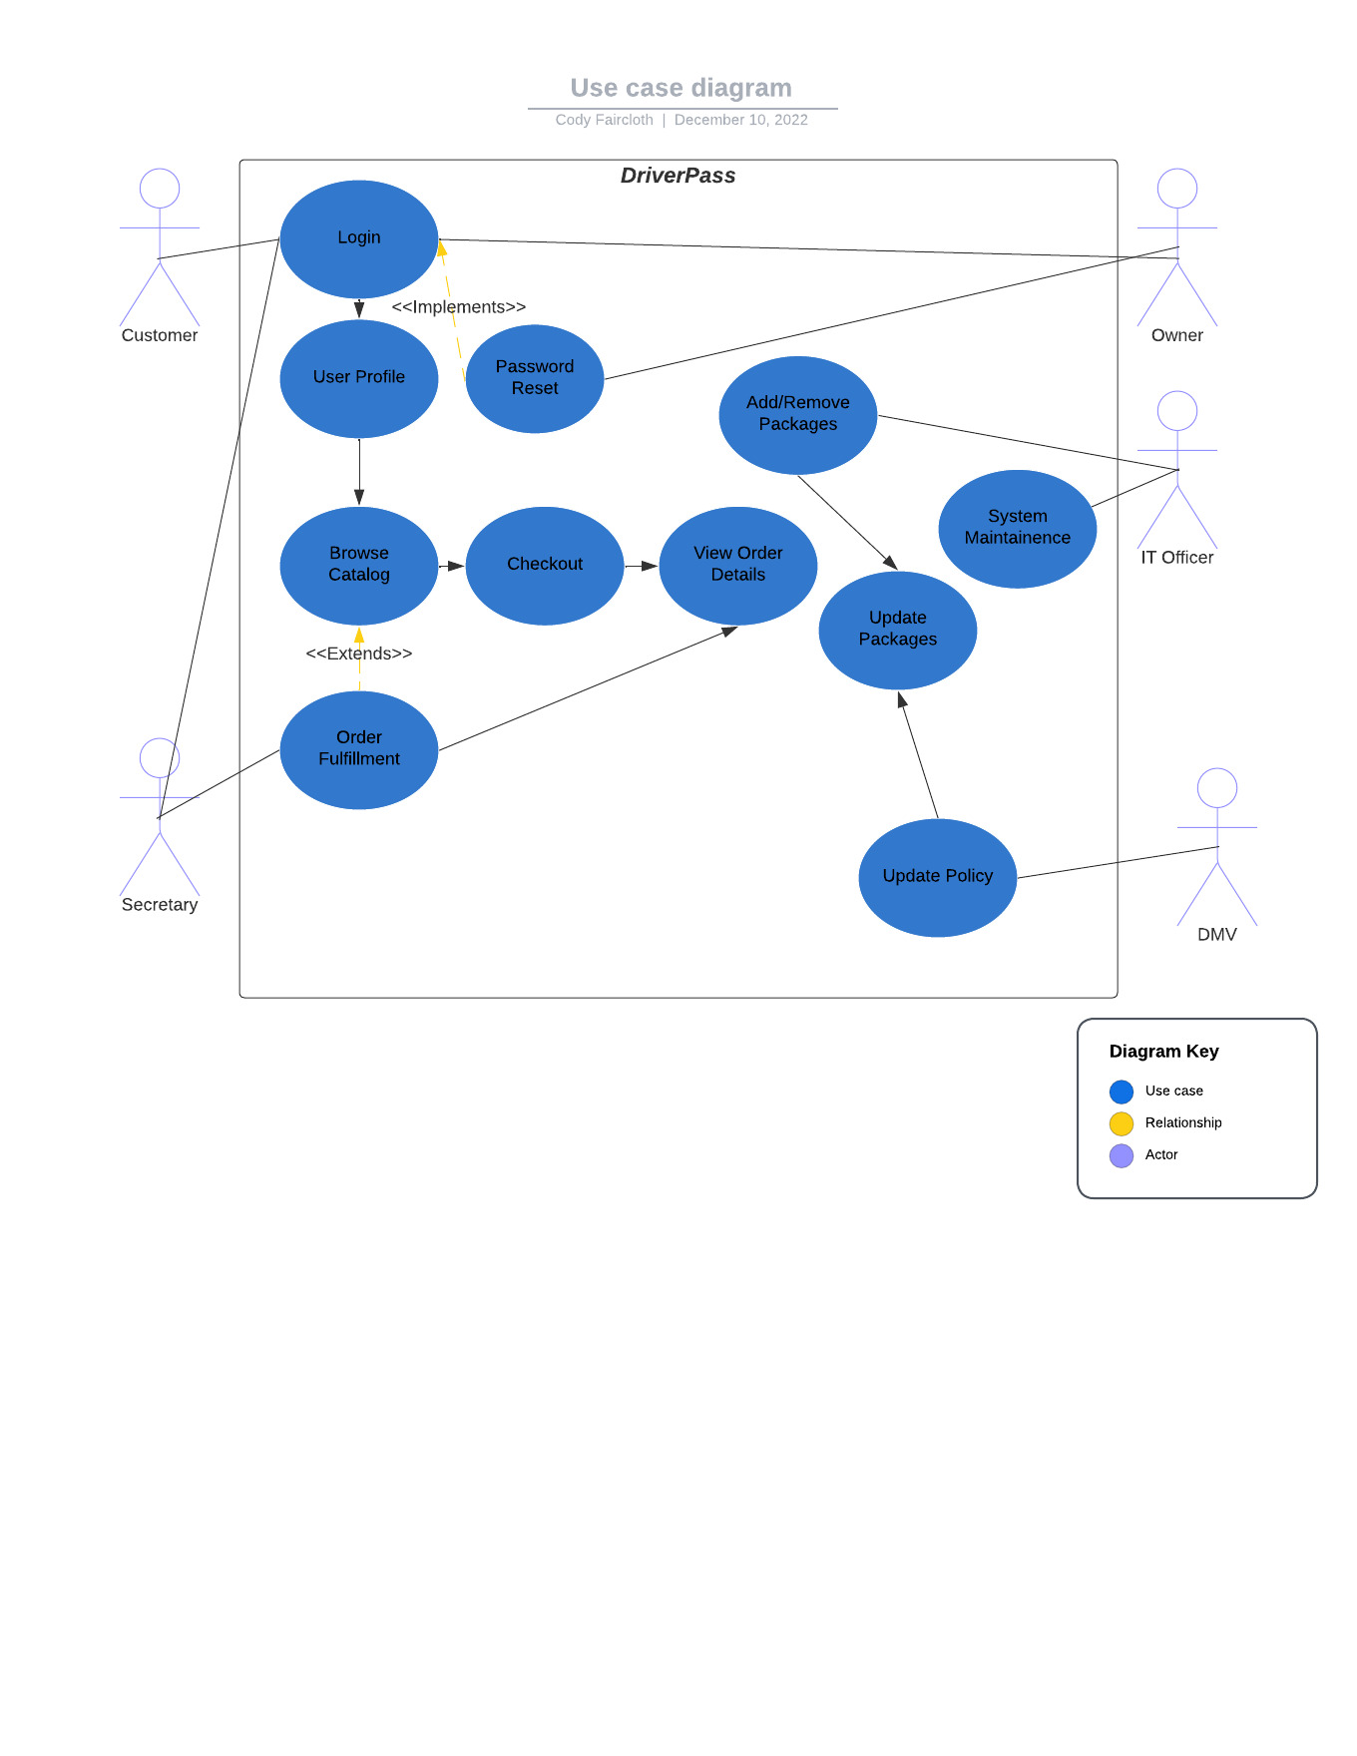

### UML Activity Diagrams

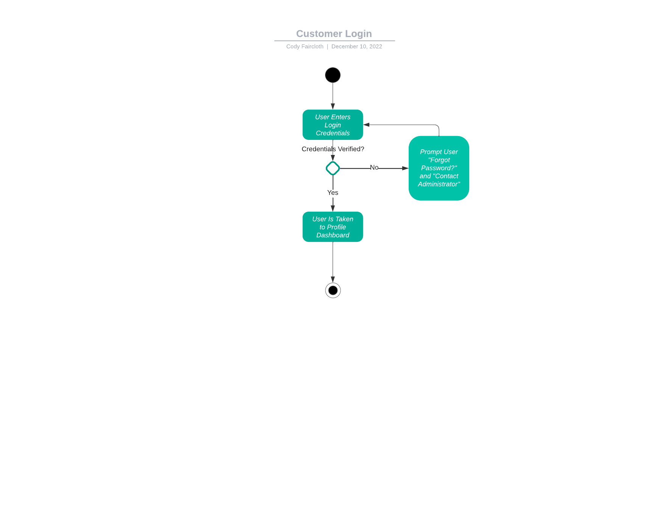

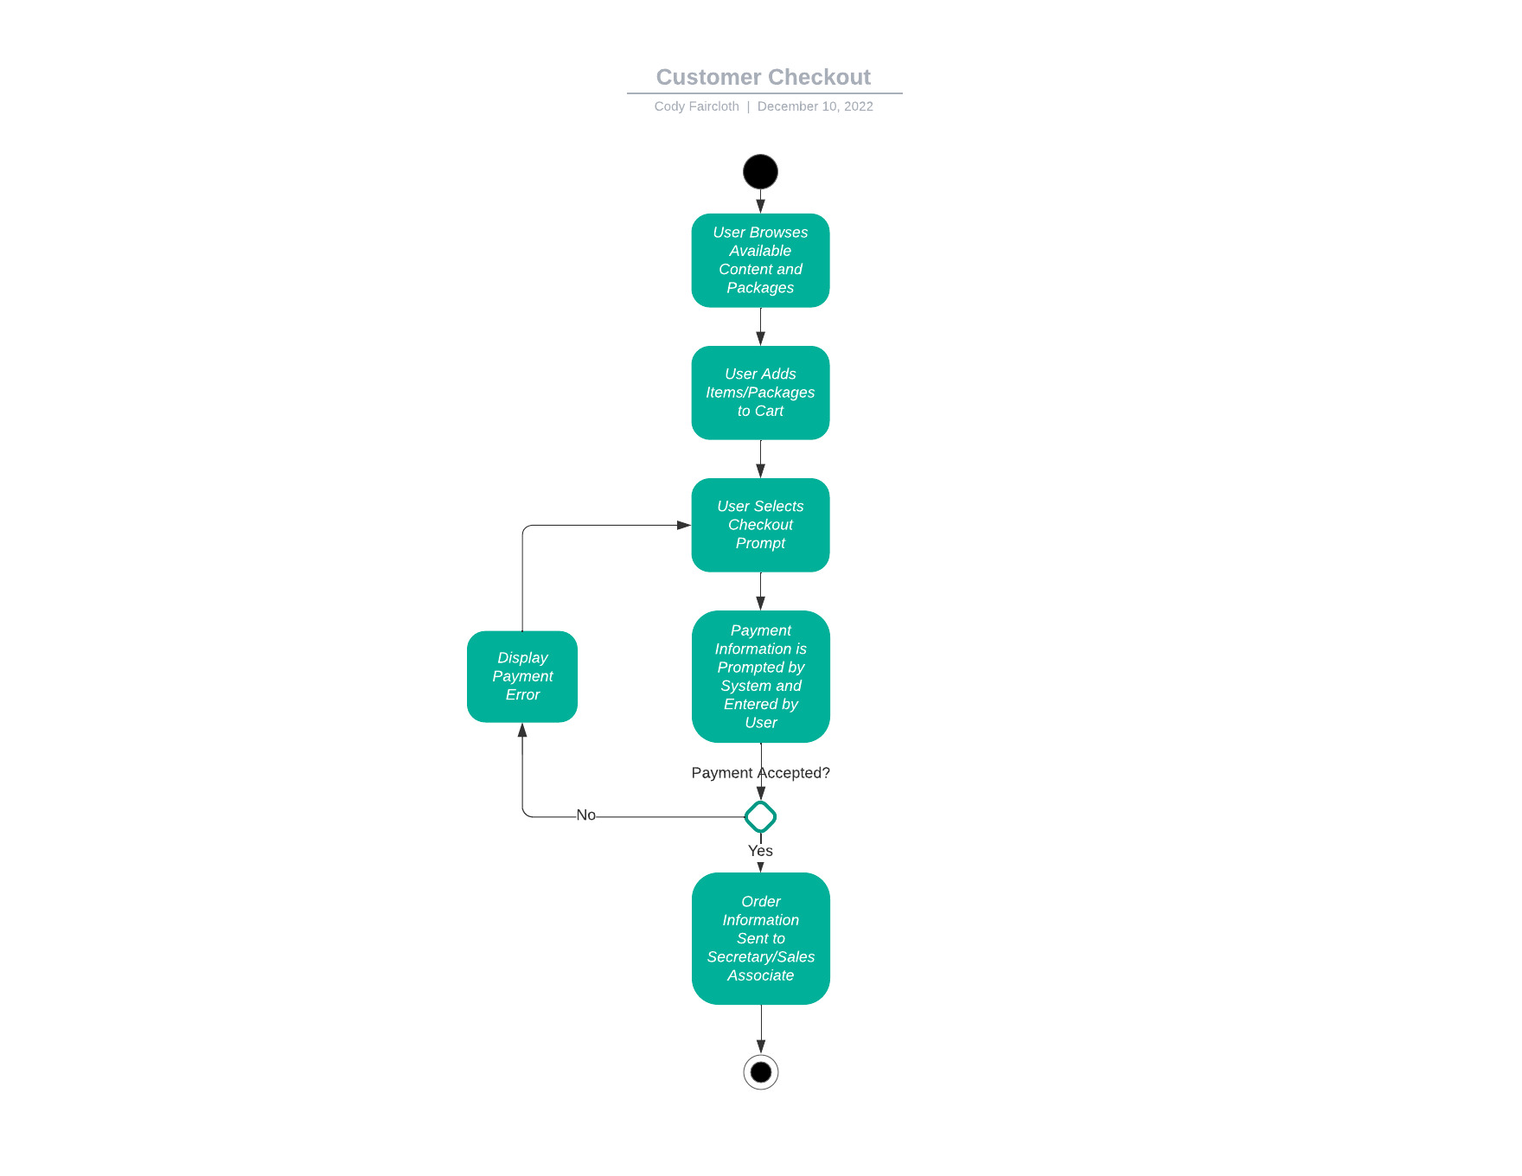

### UML Sequence Diagram

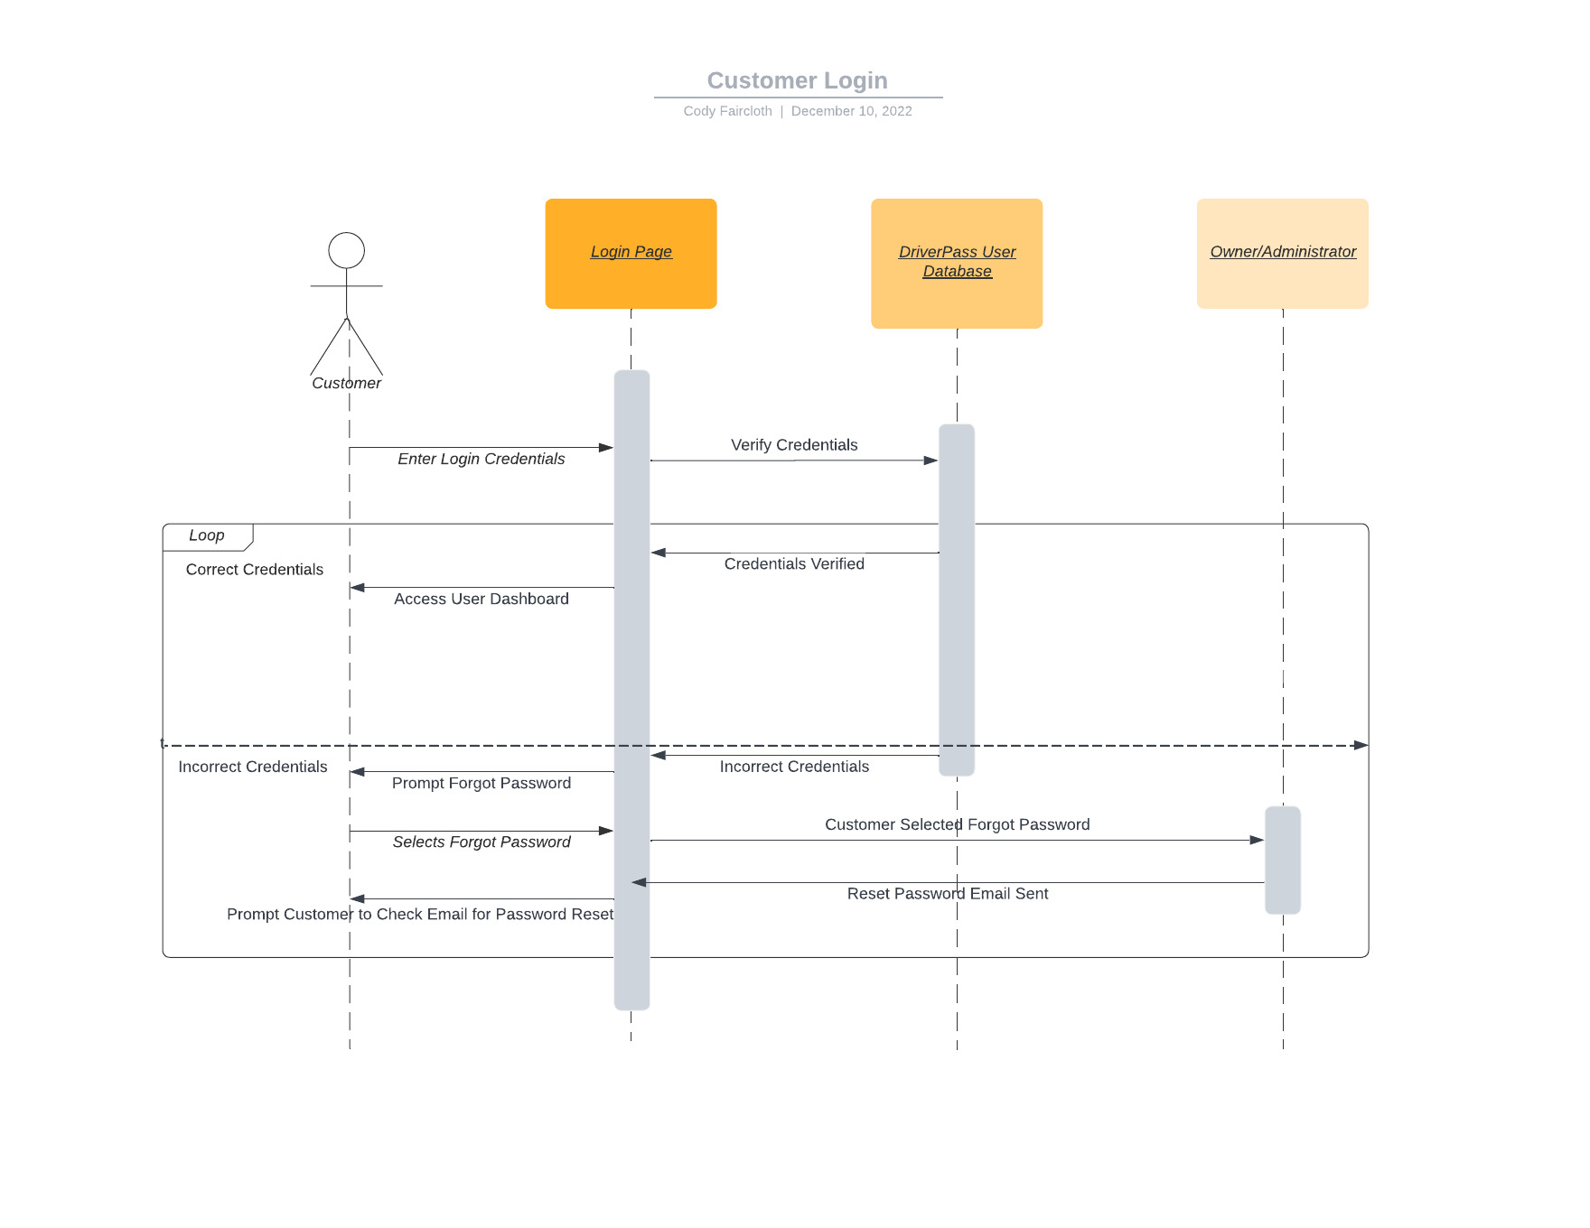

### UML Class Diagram

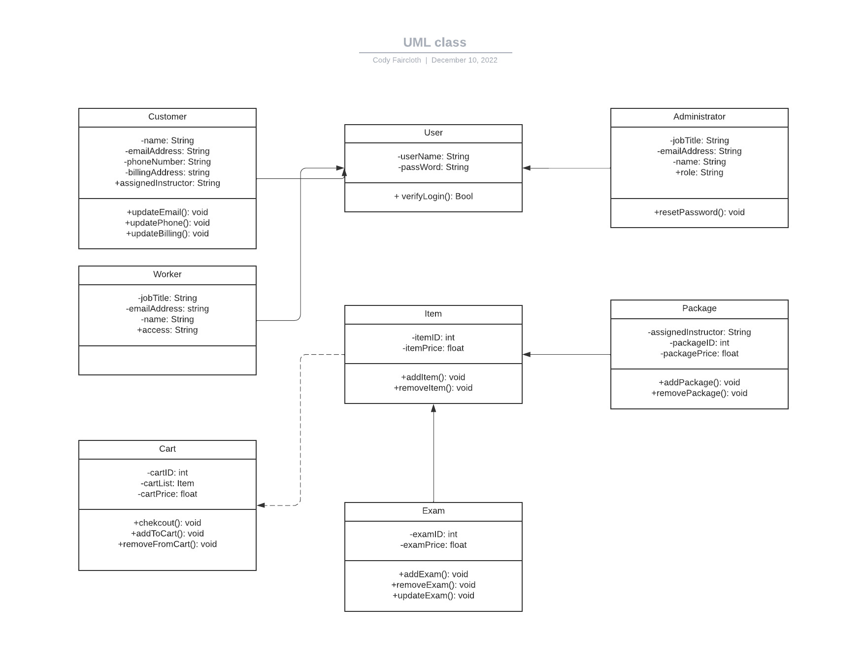

## Technical Requirements

*This system will require the implementation of multiple databases to hold user information for customers and employees as well as available products and up-to-date DMV policy. A server must be allocated to host these databases and products to the customer. The end-user will require an active internet connection to access purchased content as well as an internet browser capable of meeting system requirements for the use of purchased products.*