Lab 02

Cody Frisby

Francisco Robles

**Activity 1**

1) Between t=1 and t = 1.5 seconds.

2) Between t=1.5 and t = 2 seconds

3) The acceleration is around zero near the two peaks. The velocity is zero at these two peaks so the acceleration must be zero as well. There is no acceleration in the horizontal direction acting on the object.

**Activity 2**

NOTE: Height of the ramp at the top is 80 cm and at the bottom is 5 cm. The angle of the ramp relative to the table is 3.58 degrees.

**Our calculation for A is -0.306**

**Our calculation for acceleration is -0.612**

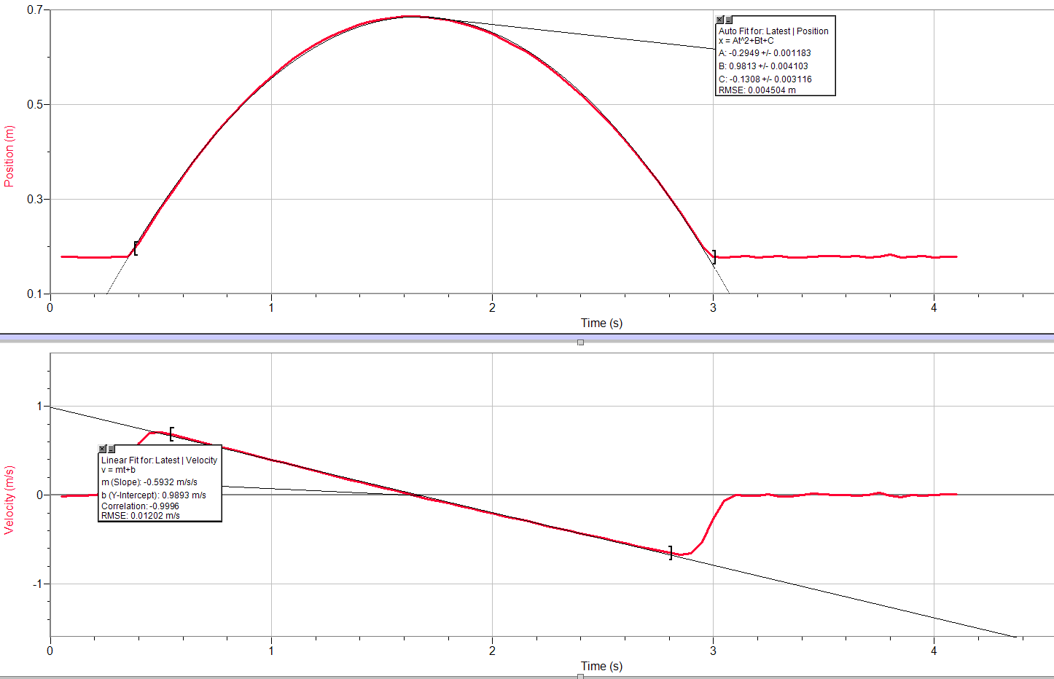

1. **Our predicted acceleration is -0.612**
2. **From the software 2A is -0.5898**
3. **The slope from the velocity curve is -0.5932**
4. **Percent error from position graph: 3.27%**
5. **Percent error from velocity graph: 3.07%**

Summary:

The acceleration appears to remain mostly constant since the only forces acting on the car are gravity (ignoring friction).

**Activity 3**

