Cody Frisby

Francisco Robles

Sungjin Mo

Lab 03

Weight of the cart = 5 N

Weight of m2 = N

The equation for the sum of the forces in the X direction:

$$∑F_{x}=w_{m}\sin\left(θ\right)-T=Ma$$

$$∑F_{m}=T-W_{m}=ma$$

Solving for **a** (we used R rather than excel) we get **-0.2385857**

Using Logger pro we get 0.2079.

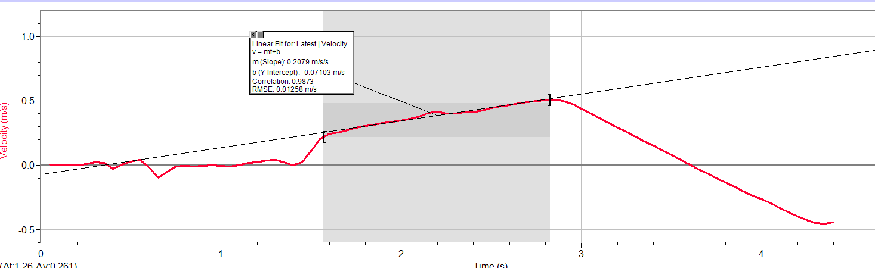



Results of 5 runs with force probe:

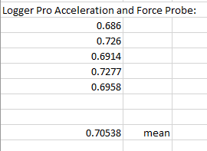

Example run with force probe:

