Cody Frisby

Francisco Robles

Lab04

**Activity 1)**

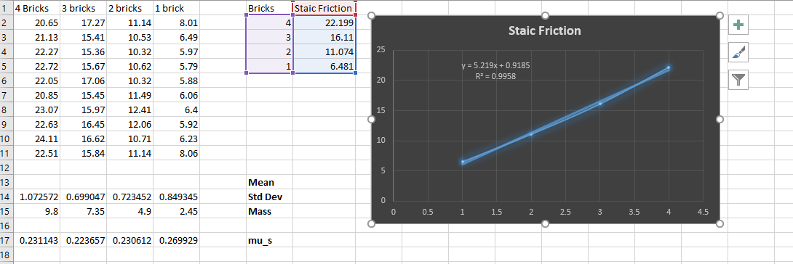

**Activity 2)**

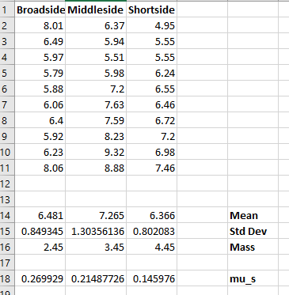

**Activity 3)**

