Cody Frisby

STAT 4200 Project 1

I asked questions about some of the “hot button” current issues and events attempting to measure the UVU student’s opinions and understanding of these topics. The number one issue with this data will be sample size. My response rate was 33/250 or 13.2%. And of these respondents, only 82% of them finished the survey. I was unable to come up with a way in time to resend the survey to the email addresses that had not responded. So, I’m stuck with inferring things about the UVU freshman population from ~~33,~~ no 27, completed surveys.

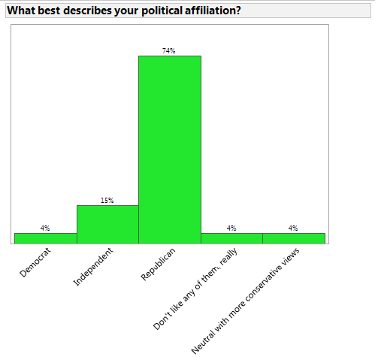I asked some potentially politically charged questions so I’ll start with the breakdown of the respondent’s political affiliation.

Not unexpected, the large majority of respondents said they affiliated with the Republican Party. Two respondents didn’t affiliate with any of the choices listed so they wrote in. They are shown on the far right of the graph. The estimated proportion of UVU freshman who identify with the Republican Party is 0.74 with a bound on this estimation equal to B = $2*\sqrt{\frac{(.74)(.26)*(4000-27)}{26*4000}}$ = 0.1715. This is a fairly large bound on an estimate for proportion. Again, this is due the small sample size from a large population of 4000. We could go through this same calculation for the other political parties of interest. Interestingly, when comparing how Utahans voted in the last election, 72.8% [1]of voters chose Romney. Although, all Utah voters voting for Romney were not Republican the proportions are similar to this sample. Moving on.

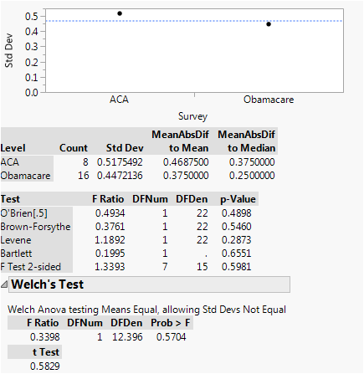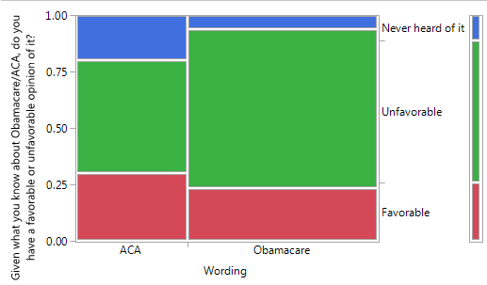I wanted to estimate the opinion the UVU freshman have towards the Affordable Care Act (or Obamacare) based on a difference in wording of the question. The question was the same in all respects except for one word. One survey asked their opinion regarding the Affordable Care Act and the other used the word Obamacare. I created a mosaic plot using JMP to illustrate the data. The horizontal axis show the separation based on the wording of the question. As you can see there is a slight increase in favorability when “Affordable Care Act” is used instead of Obamacare. But the proportion of respondents who have “Never Heard of it” increases as well. When ACA was used 30% responded “Favorable” when Obamacare was used 23.5% responded “Favorable”. It’s difficult to infer that there is a difference between these two estimates. For one, the sample size of the groups are vastly different. The ACA version had 10 total responses. The Obamacare had 17 total responses. If we ignore the “Never heard of it” and attempt a statistical test where 1 = “Favorable” and 0 = “Unfavorable”, checking for unequal variances since n in both groups is different, we cannot conclude that there is evidence to suggest that wording of the question has an effect on the response. The JMP generated unequal variances test is pictured on the right. As you can see, the Welch’s Test shows a p-value of 0.5704.

With one of the last questions on the survey I wanted to measure not only the populations understanding of the Citizens United Supreme Court decision but also compare it to the overall United States population’s opinion using recent national surveys for comparison. The proportion that respond “Never heard of it” was 77%. Luckily there was a follow up question to this one if the respondent had not heard of it. After giving the reader a short description about citizens united they were asked their opinion again. I have combined the “Favorable” “Unfavorable” responses to the first question with the ones from the second question to gain an understanding of the overall opinion. Also of interest to me was the opinion of citizens united based on the respondents’ political affiliation I have included two plots of the data. One is a simple distribution of the responses. The other is a mosaic plot looking at the response against the 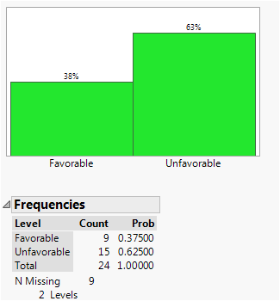political affiliation. Again, similar to the results above, there is not a significant correlation to political party and the person’s opinion of Citizens United. This wasn’t too surprising to me since recent surveys have suggested a very similar view irrespective of party lines. A recent Bloomberg survey inferred that 78% of Americans thought that the Supreme Court “Ruled that Corporations and unions may spend unlimited amounts on political causes” was a bad decision[2]. The quoted section above was the wording of the Bloomberg survey. It did not refer to the ruling by name. So, approximately 0.625 ± $2* \sqrt{\frac{0.625*0.375}{23}* \frac{4000-24}{4000}}$ = 0.2 people have an unfavorable opinion of the Citizens United decision. Similar to the bound from above this one is much too 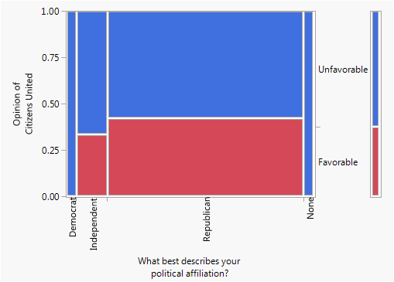wide to be of much use to anyone who desires to infer something about the population. For this question it may be more useful for our estimate to be within ± 0.03 of the true proportion. To accomplish this we would need to get a sample size of *n* = $\frac{4000*0.625*0.375}{3999*\left(\frac{{0.03}^{2}}{4}\right)+0.625*0.375}$ = 827. I would need to increase my sample size by more then 3400%!

I ended up not using some of the questions. When I revisited the question I had posed on global warming I realized how poorly worded it was and how it could very easy lead to confusion either by the resonder or by the person conducting analysis on the resoponses. Another thing I didn’t realize beforehand is how difficult it can be to run statistical tests on survey data, especially when a question could have 5-6 different response options. Handling the analysis is definitely something I would consider a lot more when designing my next survey.

1. https://en.wikipedia.org/wiki/United_States_presidential_election_in_Utah,_2012#cite_note-5
2. http://www.bloomberg.com/politics/articles/2015-09-28/bloomberg-poll-americans-want-supreme-court-to-turn-off-political-spending-spigot