Cody Frisby

STAT 4200 Project 2

Procedure:

Using google maps[1] I saved an image of the main UVU campus. I then used windows paint to remove the areas that were not part of the main UVU campus. This image was 1328 x 848 pixels. Using an open source free application called ImageMagick[2] I divided the image into equal sized rectangles. After removing all the images that were only white space (the boarders of the image) 196 “pieces” of UVU main campus remained.

Using R software[3] I then took a random sample of size 20 from these 196 files. The size of the individual rectangles were 53 x 59 pixels. To the best of my ability I drew a rectangle of that same size on my main map image of the 20 random samples. See below for the image. I then went to campus, and using the landmarks on the image below, made the best approximation of which trees were in my sample and I counted them. My results and data are to follow.

Analysis:

The following table contains my sample data.

|  |  |  |  |  |  |  |  |  |  |
| --- | --- | --- | --- | --- | --- | --- | --- | --- | --- |
| 29 | 22 | 23 | 17 | 0 | 27 | 29 | 8 | 38 | 8 |
| 17 | 34 | 6 | 14 | 25 | 35 | 25 | 31 | 37 | 45 |

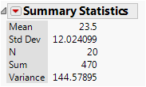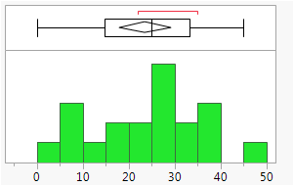A histogram of the sample data and the summary of the data are pictured here. It is immediately apparent that our standard deviation is a big percentage of our mean. This means our sample data is highly variable which is going to have an effect on the bound of our estimate of the total trees on campus. The computation for the approximate total number of trees on UVU campus is as follows: . The computation for the bound on the error of the approximation of τ is:

B = = 998.739. This means, with 95% confidence, that the actual number of trees on UVU’s main campus resides somewhere between 3,600 and 5,604 trees.

Although I think this is a decent estimate for the total number of trees, there are a few concerns. There are many opportunities for error to be introduced. One is the samples themselves. It was very difficult to divide the campus into 200 equal pieces. Although my 196 pieces were of equal size, many of the boarder pieces had white space as well as UVU campus in them. Although, when I went and counted the trees in these plots there were still a decent number of trees in them. Another opportunity for error was in the actual counting. While I did my best to count the trees, for some plots it was really difficult to accurately determine where the boundary was. Opportunities to miss trees and/or double count trees were plentiful. Finally, the standard deviation being approximately 12 with the mean being only 23.5 is the biggest reason why the bound on the estimate is so large. The range of my samples were from 45 to 0 trees. Also, some of the plots were mostly building with very few trees. If we desired a bound on the estimate to be more like 100 trees this would require counting nearly 180 plots out of 196. This also isn’t very feasible and would lead to a lot of counting error. At that point you may as well count all the trees on campus.

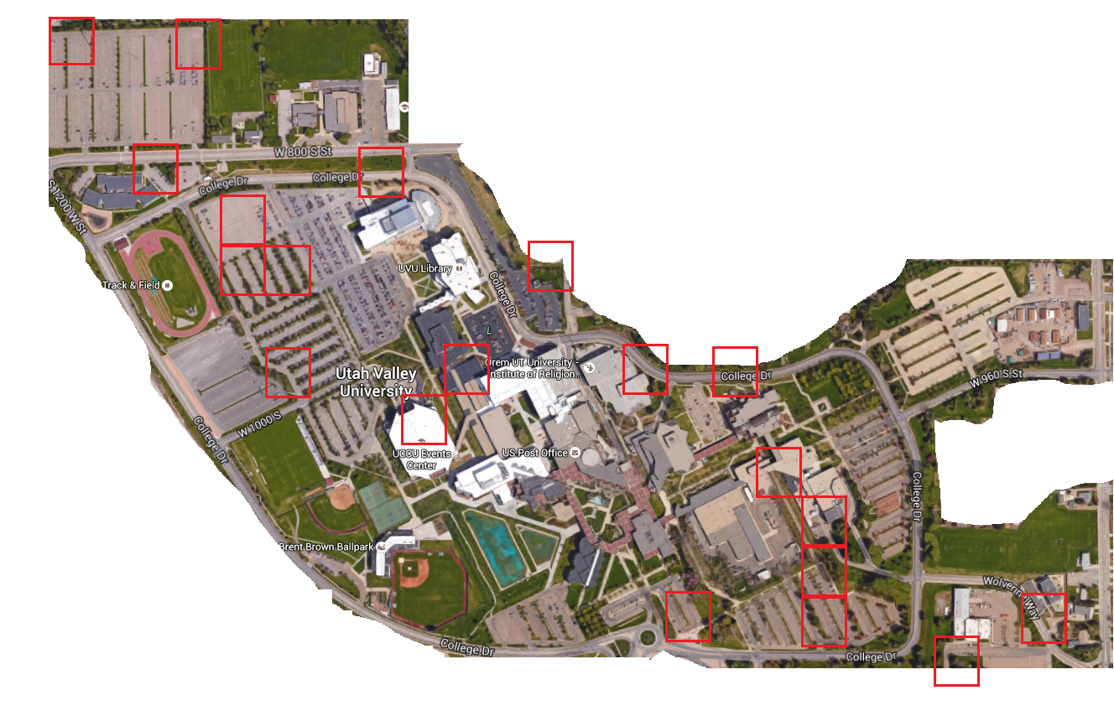

1. https://www.google.com/maps?hl=en&tab=wl
2. http://www.imagemagick.org/script/index.php
3. https://www.r-project.org/