Project 3

Cody Frisby

November 30, 2015

This is an exercise using resampling that I thought would be fun. This is being done in addition to the original project three.

Here is a summary of my data from project 3.

## Source: local data table [3 x 5]  
##   
## Stratum mean sd N Tao  
## (int) (dbl) (dbl) (dbl) (dbl)  
## 1 1 18.25000 12.080090 59 1076.750  
## 2 2 23.00000 15.019987 66 1518.000  
## 3 3 29.66667 3.614784 67 1987.667

And here is a plot of the data by stratum.

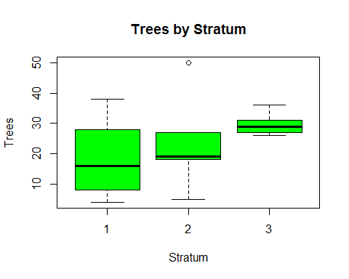

Now I am going to resample from each stratum individually. Then I will combine the all the resampled data and look at the results.

a <- trees[Stratum == 1]  
b <- trees[Stratum == 2]  
c <- trees[Stratum == 3]  
#I will get estimates on the bound by bootstrapping the data without Strata  
na <- length(a$Trees)  
rfs <- 1000  
xa <- a$Trees   
A <- matrix(sample(xa, na * rfs, replace = TRUE), rfs, na)  
Tao_1 <- apply(A, 1, mean) * 59  
  
nb <- length(b$Trees)  
rfs <- 1000  
xb <- b$Trees   
B <- matrix(sample(xb, nb * rfs, replace = TRUE), rfs, nb)  
Tao_2 <- apply(B, 1, mean) * 66  
  
nc <- length(c$Trees)  
rfs <- 1000  
xc <- c$Trees   
C <- matrix(sample(xc, nc * rfs, replace = TRUE), rfs, nc)  
Tao_3 <- apply(C, 1, mean) * 67  
# I did the above threes times. One for each stratum.  
D <- cbind(Tao_1, Tao_2, Tao_3)  
D <- as.data.frame(D)  
D$Tao <- D$Tao_1 + D$Tao_2 + D$Tao_3  
#Now we have a column that estimates trees using the strata data.

This is a view of the result

head(D)

## Tao_1 Tao_2 Tao_3 Tao  
## 1 929.250 1375 2010.000 4314.250  
## 2 1489.750 1661 1954.167 5104.917  
## 3 744.875 1342 1864.833 3951.708  
## 4 833.375 1254 2099.333 4186.708  
## 5 516.250 1595 1976.500 4087.750  
## 6 944.000 1067 2032.333 4043.333

tail(D)

## Tao_1 Tao_2 Tao_3 Tao  
## 995 885.000 1617 2032.333 4534.333  
## 996 921.875 1540 2099.333 4561.208  
## 997 951.375 1331 1987.667 4270.042  
## 998 1076.750 1452 2188.667 4717.417  
## 999 1180.000 1001 1954.167 4135.167  
## 1000 1047.250 1518 1898.333 4463.583

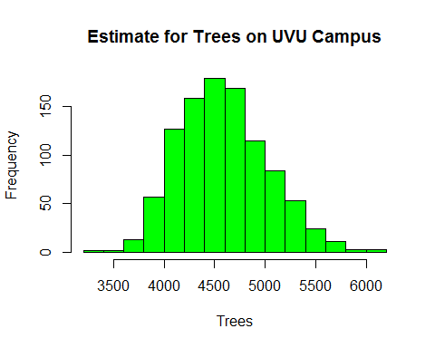

mean(D$Tao)

## [1] 4584.29

quantile(D$Tao, c(0.025, 0.975))

## 2.5% 97.5%   
## 3849.744 5488.618