**Conway’s Game of Life**

The Game of Life is not your typical computer game. It is a 'cellular automaton', and was invented by Cambridge mathematician John Conway.

This game became widely known when it was mentioned in an article published by Scientific American in 1970. It consists of a collection of cells which, based on a few mathematical rules, can live, die or multiply. Depending on the initial conditions, the cells form various patterns throughout the course of the game.

**The Rules:**

For a space that is 'populated':

Each cell with one or no neighbors dies, as if by loneliness.

Each cell with four or more neighbors dies, as if by overpopulation.

Each cell with two or three neighbors survives.

For a space that is 'empty' or 'unpopulated'

Each cell with three neighbors becomes populated.

**a - Gosper Glider Gun**

[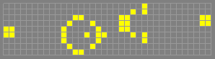](http://www.bitstorm.org/gameoflife/lexicon/cells/Gosper_glider_gun.cells)

**b - Traffic Circle**

[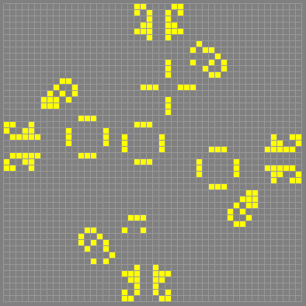](http://www.bitstorm.org/gameoflife/lexicon/cells/traffic_circle.cells)

**c - Kok’s Galaxy**

[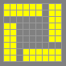](http://www.bitstorm.org/gameoflife/lexicon/cells/Koks_galaxy.cells)

**d - Hivenudger**

[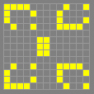](http://www.bitstorm.org/gameoflife/lexicon/cells/hivenudger.cells)

**e - Loaflipflop**

[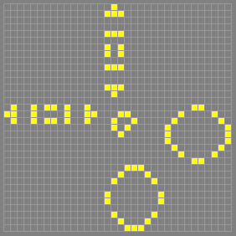](http://www.bitstorm.org/gameoflife/lexicon/cells/loaflipflop.cells)

**f - Monkey**

[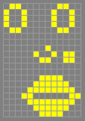](http://www.bitstorm.org/gameoflife/lexicon/cells/Jolson.cells)

**g - Boatstretcher**

[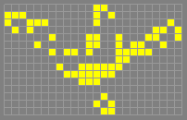](http://www.bitstorm.org/gameoflife/lexicon/cells/boatstretcher.cells)

**h - Rabbits**

[http://www.bitstorm.org/gameoflife/lexicon/cells/rabbits.png](http://www.bitstorm.org/gameoflife/lexicon/cells/rabbits.cells)

**i - Puffer**

[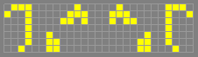](http://www.bitstorm.org/gameoflife/lexicon/cells/puffer.cells)

**j - Pi Orbital**

[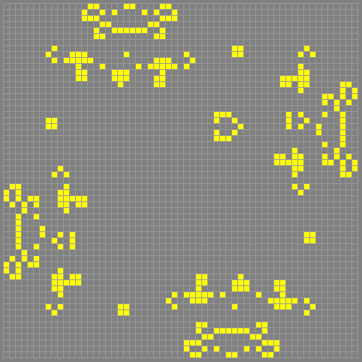](http://www.bitstorm.org/gameoflife/lexicon/cells/pi_orbital.cells)

**k - Total Aperiodic**

[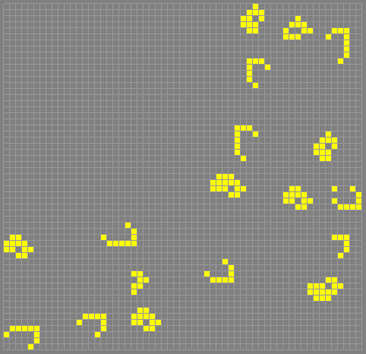](http://www.bitstorm.org/gameoflife/lexicon/cells/total_aperiodic.cells)

**l - True Gun**

[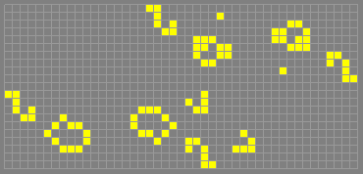](http://www.bitstorm.org/gameoflife/lexicon/cells/true.cells)

**m - Puffer Train**

[http://www.bitstorm.org/gameoflife/lexicon/cells/puffer_train.png](http://www.bitstorm.org/gameoflife/lexicon/cells/puffer_train.cells)

**n - Ray Gun**

[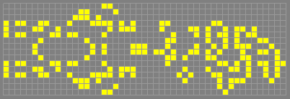](http://www.bitstorm.org/gameoflife/lexicon/cells/wickstretcher.cells)

**o - Infinite Growth**

[http://www.bitstorm.org/gameoflife/lexicon/cells/infinite_growth3.png](http://www.bitstorm.org/gameoflife/lexicon/cells/infinite_growth3.cells)

**p - Noah’s Ark**

[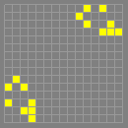](http://www.bitstorm.org/gameoflife/lexicon/cells/Noahs_ark.cells)

**q - Spacefiller**

[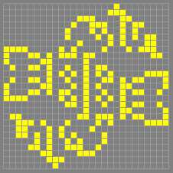](http://www.bitstorm.org/gameoflife/lexicon/cells/spacefiller.cells)

**r - Fuse**

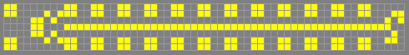

**s - MWSS Out of the Blue**

[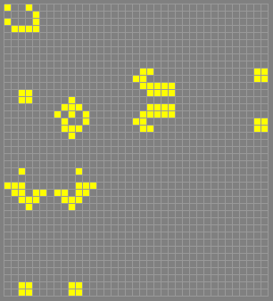](http://www.bitstorm.org/gameoflife/lexicon/cells/MWSS_out_of_the_blue.cells)

**t - New Gun**

[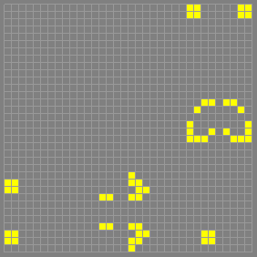](http://www.bitstorm.org/gameoflife/lexicon/cells/new_gun.cells)

**u - Phase Change 2**

[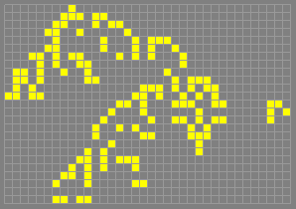](http://www.bitstorm.org/gameoflife/lexicon/cells/phase_change2.cells)

**v - Puff Suppressor**

[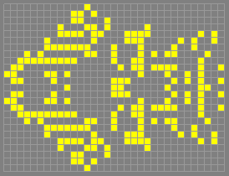](http://www.bitstorm.org/gameoflife/lexicon/cells/puff_suppressor.cells)

**w - Relay**

[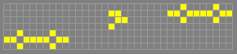](http://www.bitstorm.org/gameoflife/lexicon/cells/relay.cells)

**x - Sailboat**

[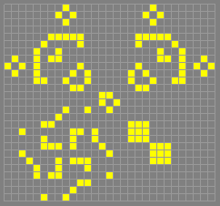](http://www.bitstorm.org/gameoflife/lexicon/cells/sailboat.cells)

**y - Snail**

[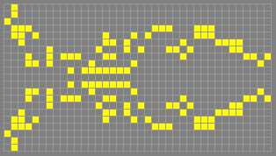](http://www.bitstorm.org/gameoflife/lexicon/cells/snail.cells)

z **- Spaceship**

[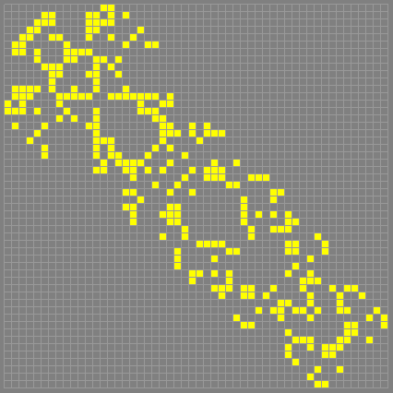](http://www.bitstorm.org/gameoflife/lexicon/cells/spaceship.cells)