Benjamin Benoit, Cody Higdon, Allen Larmee, and Roby Pile

March 5, 2018

CIS 310-02

A6

Dr. Guan

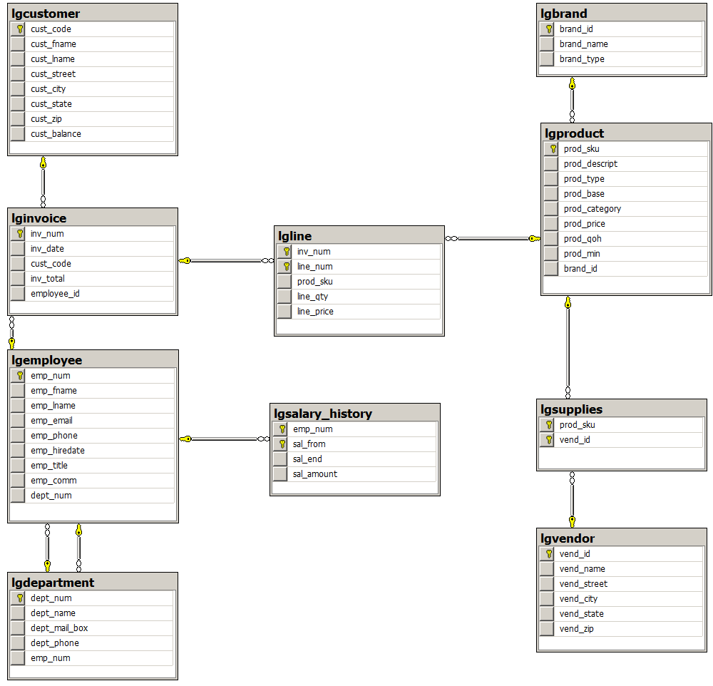

**44. Write a query to display the eight departments in the LGDEPARTMENT table.**

SELECT *

FROM LGDEPARTMENT;

**45. Write a query to display the SKU (stock keeping unit), description, type, base, category, and price for all products that have a PROD_BASE of water and a PROD_CATEGORY of sealer.**

SELECT PROD_SKU, PROD_DESCRIPT, PROD_TYPE, PROD_BASE, PROD_CATEGORY, PROD_PRICE

FROM LGPRODUCT

WHERE PROD_BASE='Water' And PROD_CATEGORY='Sealer';

**46. Write a query to display the first name, last name, and e-mail address of employees hired from January 1, 2003, to December 31, 2012. Sort the output by last name and then by first name.**

SELECT EMP_FNAME, EMP_LNAME, EMP_EMAIL

FROM LGEMPLOYEE

WHERE EMP_HIREDATE Between ‘1/1/2003’ And ‘12/31/2012’

ORDER BY EMP_LNAME, EMP_FNAME

**47. Write a query to display the first name, last name, phone number, title, and department number of employees who work in department 300 or have the title “CLERK I.” Sort the output by last name and then by first name.**

SELECT EMP_FNAME, EMP_LNAME, EMP_PHONE, EMP_TITLE, DEPT_NUM

FROM LGEMPLOYEE

WHERE DEPT_NUM=300 Or EMP_TITLE='CLERK I'

ORDER BY EMP_LNAME, EMP_FNAME;

**48. Write a query to display the employee number, last name, first name, salary “from” date, salary end date, and salary amount for employees 83731, 83745, and 84039. Sort the output by employee number and salary “from” date.**

SELECT E.EMP_NUM, E.EMP_LNAME, E.EMP_FNAME, S.SAL_FROM, S.SAL_END, S.SAL_AMOUNT

FROM LGEMPLOYEE E INNER JOIN LGSALARY_HISTORY S

ON E.EMP_NUM = S.EMP_NUM

WHERE E.EMP_NUM = 83731 OR

E.EMP_NUM = 83745 OR

E.EMP_NUM = 84039

ORDER BY E.EMP_NUM, S.SAL_FROM

**49. Write a query to display the first name, last name, street, city, state, and zip code of any customer who purchased a Foresters Best brand top coat between July 15, 2015, and July 31, 2015. If a customer purchased more than one such product, display the customer’s information only once in the output. Sort the output by state, last name, and then first name.**

SELECT DISTINCT CUST_FNAME, CUST_LNAME, CUST_STREET, CUST_CITY, CUST_STATE, CUST_ZIP

FROM LGCUSTOMER AS C, LGINVOICE AS I, LGLINE AS L, LGPRODUCT AS P, LGBRAND AS B

WHERE C.CUST_CODE = I.CUST_CODE AND I.INV_NUM = L.INV_NUM AND L.PROD_SKU = P.PROD_SKU AND P.BRAND_ID = B.BRAND_ID AND BRAND_NAME = 'FORESTERS BEST' AND PROD_CATEGORY = 'Top Coat' AND INV_DATE BETWEEN '15-JUL-2015' AND '31-JUL-2015'

ORDER BY CUST_STATE, CUST_LNAME, CUST_FNAME

**50. Write a query to display the employee number, last name, e-mail address, title, and department name of each employee whose job title ends in the word “ASSOCIATE.” Sort the output by department name and employee title.**

SELECT E.EMP_NUM, E.EMP_LNAME, E.EMP_FNAME, E.EMP_EMAIL, E.EMP_TITLE, D.DEPT_NAME

FROM LGEMPLOYEE E INNER JOIN LGDEPARTMENT D

ON E.DEPT_NUM = D.DEPT_NUM

WHERE E.EMP_TITLE LIKE '%ASSOCIATE'

ORDER BY D.DEPT_NAME, E.EMP_TITLE

**51. Write a query to display a brand name and the number of products of that brand that are in the database. Sort the output by the brand name.**

SELECT B.BRAND_NAME, COUNT(P.PROD_SKU) AS 'PRODCOUNT'

FROM LGBRAND B INNER JOIN LGPRODUCT P

ON B.BRAND_ID = P.BRAND_ID

GROUP BY B.BRAND_NAME

ORDER BY B.BRAND_NAME

**52. Write a query to display the number of products in each category that have a water base.**

SELECT PROD_CATEGORY, Count(*) AS NUMPRODUCTS

FROM LGPRODUCT

WHERE PROD_BASE = 'Water'

GROUP BY PROD_CATEGORY;'

**53. Write a query to display the number of products within each base and type combination.**

SELECT PROD_BASE, PROD_TYPE, COUNT(PROD_SKU)

FROM LGPRODUCT

GROUP BY PROD_BASE, PROD_TYPE

**54. Write a query to display the total inventory—that is, the sum of all products on hand for each brand ID. Sort the output by brand ID in descending order.**

SELECT BRAND_ID, SUM(PROD_QOH) AS TOTALINVENTORY

FROM LGPRODUCT

GROUP BY BRAND_ID

ORDER BY BRAND_ID DESC

**55. Write a query to display the brand ID, brand name, and average price of products of each brand. Sort the output by brand name. (Results are shown with the average price rounded to two decimal places.)**

SELECT B.BRAND_ID, B.BRAND_NAME, ROUND(AVG(P.PROD_PRICE), 2) AS AVERAGEPRICE

FROM LGBRAND B INNER JOIN LGPRODUCT P

ON B.BRAND_ID = P.BRAND_ID

GROUP BY B.BRAND_ID, B.BRAND_NAME

ORDER BY B.BRAND_NAME

**56. Write a query to display the department number and most recent employee hire date for each department. Sort the output by department number.**

SELECT E.DEPT_NUM, MAX(E.EMP_HIREDATE)

FROM LGEMPLOYEE E

GROUP BY E.DEPT_NUM

ORDER BY E.DEPT_NUM

**57. Write a query to display the employee number, first name, last name, and largest salary amount for each employee in department 200. Sort the output by largest salary in descending order**

SELECT E.EMP_NUM, E.EMP_FNAME, E.EMP_LNAME, MAX(S.SAL_AMOUNT) AS 'LARGESTSALARY', E.DEPT_NUM

FROM LGEMPLOYEE E INNER JOIN LGSALARY_HISTORY S

ON E.EMP_NUM = S.EMP_NUM

WHERE E.DEPT_NUM = 200

GROUP BY E.EMP_NUM, E.EMP_FNAME, E.EMP_LNAME, E.DEPT_NUM

ORDER BY LARGESTSALARY DESC

**58. Write a query to display the customer code, first name, last name, and sum of all invoice totals for customers with cumulative invoice totals greater than $1,500.Sort the output by the sum of invoice totals in descending order.**

SELECT C.CUST_CODE, CUST_FNAME, CUST_LNAME, Sum(INV_TOTAL) AS TOTALINVOICES

FROM LGCUSTOMER AS C, LGINVOICE AS I

WHERE C.CUST_CODE = I.CUST_CODE

GROUP BY C.CUST_CODE, CUST_FNAME, CUST_LNAME

HAVING Sum(INV_TOTAL) > 1500

ORDER BY Sum(INV_TOTAL) DESC;

**59. Write a query to display the department number, department name, department phone number, employee number, and last name of each department manager. Sort the output by department name.**

SELECT D.DEPT_NUM, DEPT_NAME, DEPT_PHONE, D.EMP_NUM, EMP_LNAME

FROM LGDEPARTMENT AS D, LGEMPLOYEE AS E

WHERE D.EMP_NUM = E.EMP_NUM

ORDER BY DEPT_NAME;

**60. Write a query to display the vendor ID, vendor name, brand name, and number of products of each brand supplied by each vendor.Sort the output by vendor name and then by brand name.**

SELECT V.VEND_ID, VEND_NAME, BRAND_NAME, Count(*) AS NUMPRODUCTS

FROM LGBRAND AS B, LGPRODUCT AS P, LGSUPPLIES AS S, LGVENDOR AS V

WHERE B.BRAND_ID = P.BRAND_ID AND P.PROD_SKU = S.PROD_SKU AND S.VEND_ID = V.VEND_ID

GROUP BY V.VEND_ID, VEND_NAME, BRAND_NAME

ORDER BY VEND_NAME, BRAND_NAME;

**61. Write a query to display the employee number, last name, first name, and sum of invoice totals for all employees who completed an invoice. Sort the output by employee last name and then by first name.**

SELECT EMP_NUM, EMP_LNAME, EMP_FNAME, Sum(INV_TOTAL) AS TOTALINVOICES

FROM LGINVOICE, LGEMPLOYEE

WHERE EMP_NUM = EMPLOYEE_ID

GROUP BY EMP_NUM, EMP_LNAME, EMP_FNAME

ORDER BY EMP_LNAME, EMP_FNAME;

**62. Write a query to display the largest average product price of any brand.**

SELECT MAX(AVG_PRICE) AS LARGEST_AVG

FROM (SELECT BRAND_ID, ROUND(AVG(PROD_PRICE), 2) AS AVG_PRICE

FROM LGPRODUCT

GROUP BY BRAND_ID)

AVG_PRICE

**63. Write a query to display the brand ID, brand name, brand type, and average price of products for the brand that has the largest average product price.**

SELECT P.BRAND_ID, BRAND_NAME, BRAND_TYPE, ROUND(AVG(PROD_PRICE), 2) AS AVG_PRICE

FROM LGPRODUCT P INNER JOIN LGBRAND B ON P.BRAND_ID = B.BRAND_ID

GROUP BY P.BRAND_ID, BRAND_NAME, BRAND_TYPE

HAVING ROUND(AVG(PROD_PRICE), 2) =

(SELECT MAX(AVG_PRICE) AS LARGEST_AVG

FROM (SELECT BRAND_ID, ROUND(AVG(PROD_PRICE), 2) AS AVG_PRICE

FROM LGPRODUCT

GROUP BY BRAND_ID) AVG_PRICE)

**64. Write a query to display the manager name, department name, department phone number, employee name, customer name, invoice date, and invoice total for the department manager of the employee who made a sale to a customer whose last name is Hagan on May 18, 2015. For all person names, concatenate the first and last names into a single field.**

SELECT DE.EMP_FNAME, DE.EMP_LNAME, DEPT_NAME, DEPT_PHONE, E.EMP_FNAME, E.EMP_LNAME, CUST_FNAME, CUST_LNAME, INV_DATE, INV_TOTAL

FROM LGEMPLOYEE DE INNER JOIN LGDEPARTMENT D ON DE.EMP_NUM = D.EMP_NUM

INNER JOIN LGEMPLOYEE E ON D.DEPT_NUM = E.DEPT_NUM

INNER JOIN LGINVOICE I ON E.EMP_NUM = I.EMPLOYEE_ID

INNER JOIN LGCUSTOMER C ON I.CUST_CODE = C.CUST_CODE

WHERE CUST_LNAME = 'HAGAN' AND INV_DATE = '2015-05-18'