Benjamin Benoit, Cody Higdon, Allen Larmee, and Roby Pile

April 11, 2018

CIS 310-02

A8

Dr. Guan

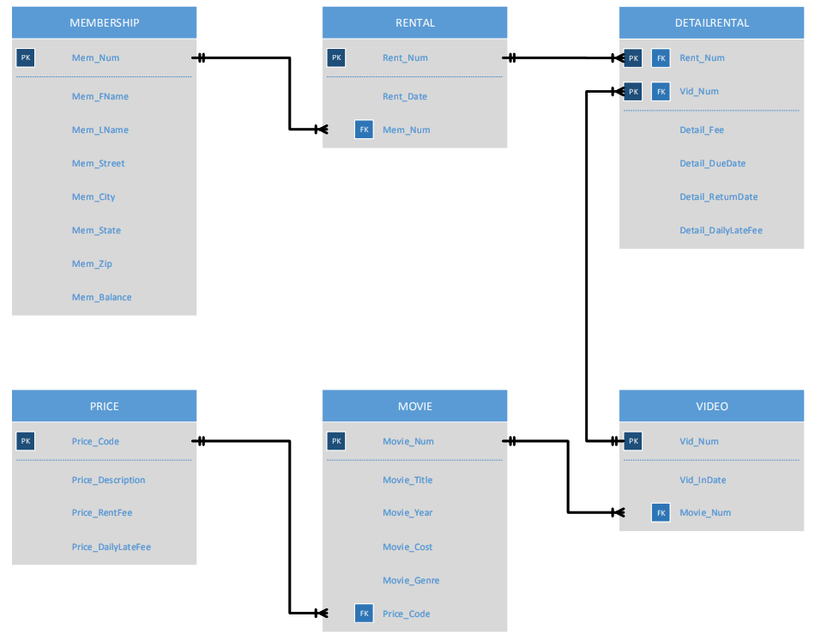

CREATE TRIGGER A8

ON DETAILRENTAL

AFTER UPDATE

AS

SELECT *

FROM INSERTED AS [CONTENTS OF INSERTED]

SELECT *

FROM DELETED AS [CONTENTS OF DELETED]

IF (EXISTS (SELECT * FROM INSERTED) AND EXISTS (SELECT * FROM DELETED))

BEGIN

DECLARE MEM_BALANCE_UPDATE_CURSOR CURSOR FOR

SELECT I.RENT_NUM, I.DETAIL_DUEDATE, I.DETAIL_RETURNDATE, I.DETAIL_DAILYLATEFEE, D.DETAIL_DUEDATE, D.DETAIL_RETURNDATE, D.DETAIL_DAILYLATEFEE

FROM INSERTED I INNER JOIN DELETED D ON I.RENT_NUM = D.RENT_NUM

AND I.VID_NUM = D.VID_NUM

DECLARE @RENT_NUM INT

DECLARE @CURRENT_DUEDATE DATETIME

DECLARE @PAST_DUEDATE DATETIME

DECLARE @CURRENT_RETURNDATE DATETIME

DECLARE @PAST_RETURNDATE DATETIME

DECLARE @CURRENT_LATEFEE DECIMAL (3,2)

DECLARE @PAST_LATEFEE DECIMAL (3,2)

DECLARE @BEFORE_LATEFEE DECIMAL (3,2)

DECLARE @AFTER_LATEFEE DECIMAL (3,2)

DECLARE @CHANGE_IN_LATEFEE DECIMAL (3,2)

DECLARE @NEW_BALANCE DECIMAL (3,2)

OPEN MEM_BALANCE_UPDATE_CURSOR

FETCH NEXT FROM MEM_BALANCE_UPDATE_CURSOR

INTO @RENT_NUM, @CURRENT_DUEDATE, @PAST_DUEDATE, @CURRENT_RETURNDATE, @PAST_RETURNDATE, @CURRENT_LATEFEE, @PAST_LATEFEE

WHILE (@@FETCH_STATUS = 0)

BEGIN

IF (@PAST_RETURNDATE > @PAST_DUEDATE)

BEGIN

SELECT @BEFORE_LATEFEE = DATEDIFF (DAY, @PAST_DUEDATE, @PAST_RETURNDATE) * @PAST_LATEFEE

END

ELSE

SELECT @BEFORE_LATEFEE = 0

IF (@CURRENT_RETURNDATE > @CURRENT_DUEDATE)

BEGIN

SELECT @AFTER_LATEFEE = DATEDIFF(DAY, @CURRENT_DUEDATE, @CURRENT_RETURNDATE) * @CURRENT_LATEFEE

END

ELSE

SELECT @AFTER_LATEFEE = 0

SELECT @CHANGE_IN_LATEFEE = @AFTER_LATEFEE - @BEFORE_LATEFEE

IF (@CHANGE_IN_LATEFEE <> 0)

BEGIN

DECLARE @MEM_NUM INT

SELECT @MEM_NUM = M.MEM_NUM, @NEW_BALANCE = M.MEM_BALANCE

FROM RENTAL R INNER JOIN MEMBERSHIP M ON R.MEM_NUM = M.MEM_NUM

AND @RENT_NUM = R.RENT_NUM

IF (@NEW_BALANCE IS NULL)

UPDATE MEMBERSHIP

SET Mem_Balance = @CHANGE_IN_LATEFEE

WHERE MEM_NUM = @MEM_NUM

ELSE

UPDATE MEMBERSHIP

SET MEM_BALANCE = MEM_BALANCE + @CHANGE_IN_LATEFEE

WHERE MEM_NUM = @MEM_NUM

UPDATE MEMBERSHIP

SET MEM_BALANCE = MEM_BALANCE + @CHANGE_IN_LATEFEE

WHERE MEM_NUM = @MEM_NUM

FETCH NEXT FROM MEM_BALANCE_UPDATE_CURSOR

INTO @RENT_NUM, @CURRENT_DUEDATE, @CURRENT_RETURNDATE, @CURRENT_LATEFEE, @PAST_DUEDATE, @PAST_RETURNDATE, @PAST_LATEFEE

END

END

CLOSE MEM_BALANCE_UPDATE_CURSOR

DEALLOCATE MEM_BALANCE_UPDATE_CURSOR

END

UPDATE DETAILRENTAL

SET Detail_DueDate = '2013-02-04'

WHERE RENT_NUM = 1006 OR RENT_NUM = 1007