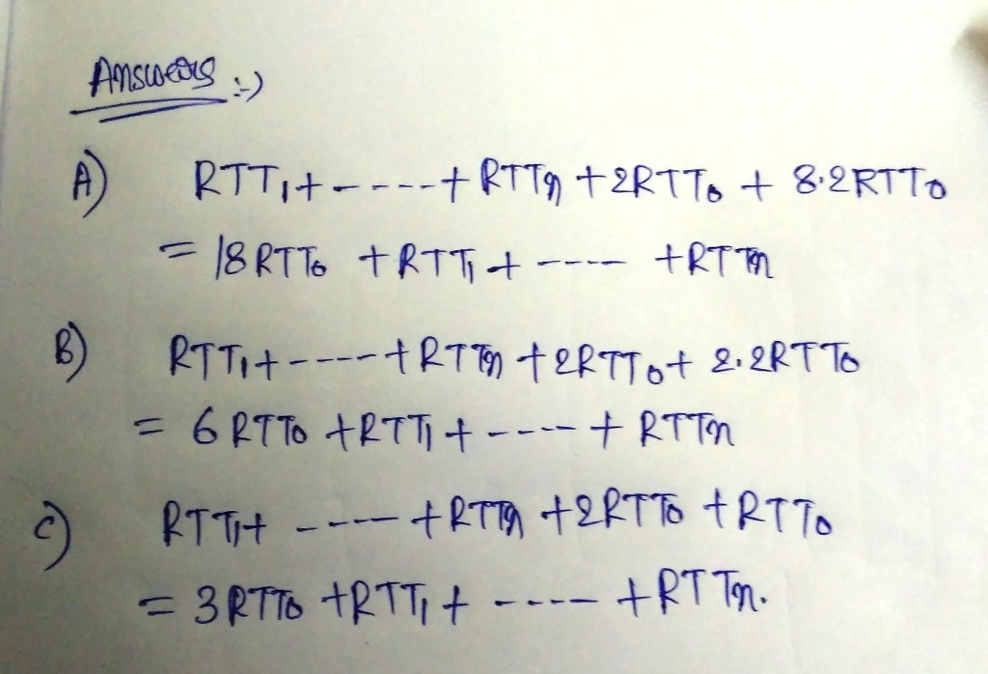

provided u=1000 and r=600

for day time

HTTP requests generated per second =0.5 \* 1000=500 requests/sec

Respone size per second= 500Kbits

for night time

HTTP requests generated per second =0.5 \* 600=300 requests/sec

Respone size per second= 500Kbits

a) for day time:

per second accessed data = (no of request)\*(response size)=500\*500=250000kb=250000/1024 mb=244.14mb

that is access link’s capacity consumed by the HTTP response messages during the day=(244.14/700)\*100 %=34.88%

for night time:

per second accessed data = (no of request)\*(response size)=300\*500kb=150000/1024 mb=146.48 mb

that is access link’s capacity consumed by the HTTP response messages during the day=(146.48 /700)\*100 %=20.92%

b)

the probablity of finding the request in the cache is h.

so probablity of not finding the request in the cache is (1-h).

so in this scenerio the the answer will be =(1-h)\*34.88%.

because we need consider only the non hit cases of the requests in the cache.

)\*500\*500