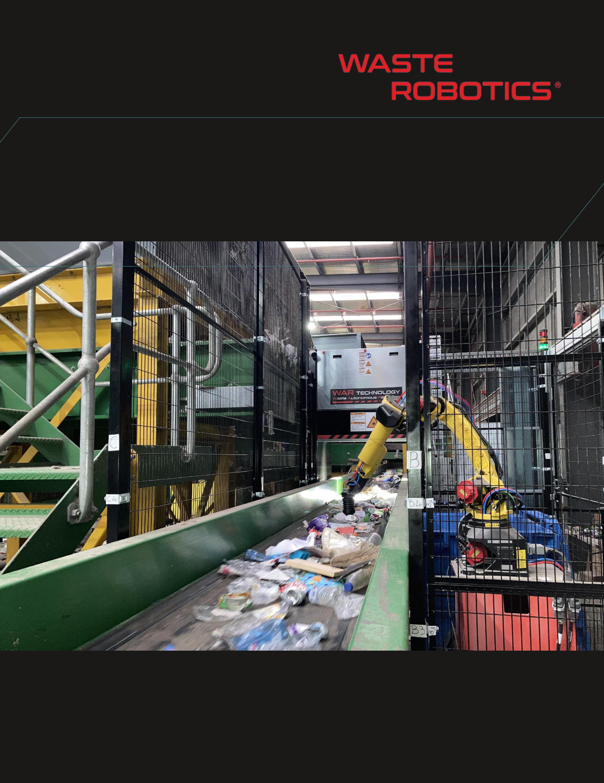

VALUE PROPOSITION:

{{value_proposition}}

|  |  |  |
| --- | --- | --- |
| **Presented to: {{client_name}}** | {{quote_date}} | |
| **{{client_company}}** |  |  |
|  | CONFIDENTIAL | |

**APPLICATION OVERVIEW**

{{application_overview}}

**PRELIMINARY LAYOUT DESIGN ({{robot_bases}}-ARM SYSTEM)**

**{{layout_image}}**



CONFIDENTIAL – PAGE 3/7

**LAYOUT OVERVIEW ({{robot_bases}}-ARM SYSTEM)**

**{{layout_overview_image}}**



CONFIDENTIAL – PAGE 4/7

**ROBOT ARMS MODEL**

**{% for img in robot_arm_images %}**

**{{ img }}**

**{% endfor %}**

**GRIPPER MODEL: {{gripper_type}}**

**{% for img in gripper_images %}**

**{{ img }}**

**{% endfor %}**



CONFIDENTIAL – PAGE 5/8



**ROBOT VISION SYSTEM SENSOR FUSION**

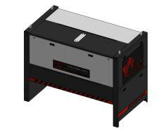

**Deepvision**

**COLOR** **3D** **AI**

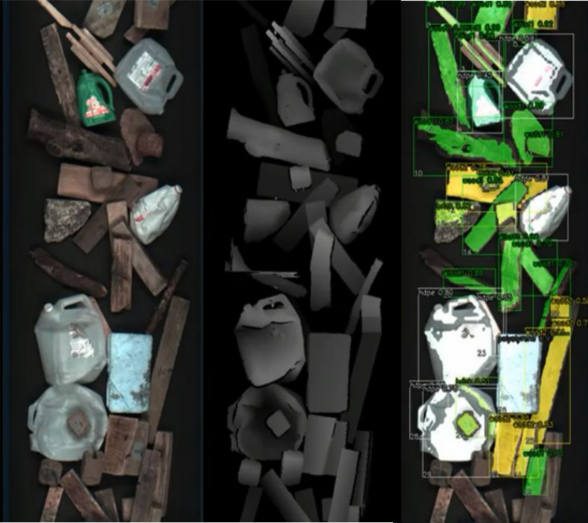

CONFIDENTIAL – PAGE 6/8

**SPECIFICATIONS:**

* Up to {{pick_rate}}
* Maximum object weight per robot: {{max_object_weight}} kg
  + Robots operating conditions: 5°C to 45 °C

**BUDGET**



|  |  |  |  |  |
| --- | --- | --- | --- | --- |
|  | **Includes** |  | **Excludes** |  |
| - {{robot_bases}} robots Fanuc M-20iD-25 | | - | Mechanical installation |  |
|  |  |  |
| - | {{robot_bases}} robot base | - | All modifications required on current equipment to integ |  |
| - | {{robot_bases}} AI gripper | the robotic system | |  |
| - Robot Vision System: {{vision_system}}) | | - Electrical hookup in client’s facility | |  |
| - | AI Software licence | - Total input power {{input_power_kva}} kVA | |  |
| - | AI custom training | - Average Power Consumption {{avg_consumption_kw}} kW | |  |
| - Factory pre-assembling and testing | | - Internet hookup in client’s facility | |  |
| - | Shipping to {{site_location}} |  | (up/down 100 Mbits/sec) |  |
| - Installation supervision on site | | - Compressed air hookup in client’ facility | |  |
| - | Security perimeter |  | (total air consumption: {{air_consumption_lpm}} L/min |  |
|  |  | - Taxes, customs and/or duty charges | |  |

**BUYING PRICE\***

Robotic sorting system:

{{total_price}}

Additional robot arm:

{{additional_arm_price}}

*\* Prices may vary due to exchange rates, inflation, and integration engineering. Valid for 30 days.*



CONFIDENTIAL – PAGE 7/8

**DELIVERY**

24-30 weeks (to be confirmed at order time)

**Price Breakdown and Project Timeline:**

{{ price_table_img }}

|  |  |  |  |  |  |  |
| --- | --- | --- | --- | --- | --- | --- |
| {{order_confirmation_project_kickoff}} | {{detailed_engineering}} | {{engineering_review}} | {{procurement_fabrication}} | {{fat_shipping}} | {{retrofit_installation}} | {{commissioning_and_SAT}} |



CONFIDENTIAL – PAGE 8/8

