Comparative Evaluation of General Machine Learning and Physics-Informed Models for Battery Health Diagnostics and Remaining Useful Life Prediction

Cody McDonald
M.S.E.E. Candidate
University of Nevada LasVegas
Las Vegas, United States
mcdonc4@unlv.nevada.edu

The growing ubiquity of rechargeable batteries across consumer, industrial, and grid applications has created a critical need for accurate and scalable battery health diagnostics. While physics-informed machine learning (PIML) and physics-informed neural networks (PINNs) have demonstrated strong performance in predicting degradation and remaining useful life (RUL), their highly customized nature often limits accessibility and broad adoption. In this study, we evaluate the performance of more general-use machine learning models implemented in Python using the scikit-learn (SKLearn) library. These models are applied to a publicly available battery degradation dataset that has also been used to benchmark several PIML and PINN approaches.

We assess the predictive capability of standard ML techniques including ensemble regressors and support vector models, for estimating key indicators such as capacity fade and internal resistance. Model performance is evaluated against published results from physics-informed methods, with particular attention to extrapolation accuracy in late-life battery stages. By comparing general-purpose models with domain-informed architectures, this work aims to assess whether accessible, reproducible ML pipelines can deliver comparable accuracy for battery health monitoring and RUL prediction. Our findings could support broader adoption of machine learning tools in battery research and diagnostics, especially in scenarios where domain-specific model tuning is impractical.

Keywords—battery degradation, remaining useful life, machine learning, physics-informed machine learning, PINN, RUL prediction, capacity fade, state of health, PI-LTSM.

Introduction
Rechargeable lithium-ion batteries have become indispensable across a wide range of applications, including consumer electronics, electric vehicles, renewable energy storage, and critical infrastructure. As their use scales, the need for accurate and reliable battery health monitoring becomes increasingly essential. Understanding and forecasting battery degradation not only improves reliability and performance but also enables more efficient maintenance and second-life utilization strategies.

Battery degradation tends to be a complex, nonlinear process that is influenced by various factors such as temperature, state-of-charge (SOC), current load, and usage cycles. Traditional approaches to degradation modeling have included electrochemical models and equivalent circuit models [1]. While these methods are grounded in the physics of the hardware, they often require extensive measurements, and their accuracy may be limited by simplified assumptions.

In recent years, machine learning (ML) has emerged as a powerful alternative for battery health diagnostics [1], offering the ability to learn degradation patterns directly from data without explicit physical modeling. General-purpose ML techniques such as support vector machines (SVM), ensemble regressors, and neural networks have been successfully applied to predict battery capacity fade and remaining useful life (RUL). However, these models are often criticized for their non-specific nature and limited extrapolation capability, particularly when applied to unseen conditions or in the later stages of battery life [1].

To address these limitations, physics-informed machine learning (PIML) and physics-informed neural networks (PINNs) [1, 2] have gained attention. These hybrid methods utilize battery physics knowledge, such as aging equations or differential constraints, into the learning process to improve predictions. While promising, such models often involve significant customization and may be difficult to reproduce or extend for new applications. The barrier to entry to employ these methods requires extensive knowledge of the intrinsic physics of these batteries. With such difficulties, these more tailored approaches will probably not reach wide-spread adoption.

This paper contributes to the ongoing conversation by benchmarking conventional ML models, implemented using Python’s scikit-learn (SKLearn v1.6.1) library, against a published PIML/PINN method on a shared, publicly available battery degradation dataset. More specifically, this study will compare the results published by J. Shi, A. Rivera, and D. Wu [2]. By evaluating RUL forecasting, this study aims to determine whether standard, reproducible ML models can achieve comparable accuracy to more tailored physics-informed approaches.

The remainder of this paper is structured as follows: Section II reviews related work in battery health prediction using ML and physics-informed methods. Section III describes basic battery degradation metrics fundamental to this study. Section IV discusses the dataset and preprocessing methods. Section V presents the ML models being evaluated. Section VI introduces the training and tuning involved with the models in Section V. Section VII presents the feature extraction utilized in the chosen models. Section VIII summarizes PIML/PINN models from the literature [1, 2]. Section IX presents the experimental results and comparative analysis. Section X discusses the implications and limitations, and outlines future directions.

Related Work
Accurate prediction of battery health metrics such as capacity fade, internal resistance, and remaining useful life (RUL) is central to improving the reliability and safety of lithium-ion battery systems. Traditional physics-based models including electrochemical, thermal, and equivalent circuit models have long served as the foundation for battery state estimation [2]. However, such models often require extensive parameter identification, simplifying assumptions, and may lack the flexibility to adapt to real-world variations in operating conditions.

In response to these challenges, data-driven machine learning approaches have gained significant traction. Early works employed support vector regression (SVR), decision trees, and Gaussian process regression to predict capacity and RUL based on historical cycle data [1]. Additionally, deep learning techniques such as convolutional neural networks (CNNs) and long short-term memory (LSTM) networks have demonstrated strong performance in modeling nonlinear degradation trends [2]. These models are typically trained using voltage, current, and temperature time-series data, which enables cycle-to-cycle prediction without the need for extensive measurements.

Despite their promise, general-purpose ML models often lack physical interpretability and can struggle with extrapolation beyond the training distribution. To address this, a growing body of research has explored physics-informed machine learning (PIML), which embeds physical constraints into ML model structures or loss functions. For instance, J. Shi, A. Rivera, and D. Wu [2] proposed a hybrid architecture that couples a calendar and cycle aging model with an LSTM network (PI-LSTM) to improve online RUL prediction. This approach combines the advantages of deep learning with the structure of known degradation processes.

Another popular category, physics-informed neural networks (PINNs), utilizes network training using governing equations such as differential relations or aging laws. S. Navidi, A. Thelen, T. Li, and C. Hu [1] benchmark several PINN and PIML models using a standardized long-duration dataset of lithium-ion cells [3]. Their work highlights the performance achievable when integrating physics into the machine learning process. This is especially evident under limited or irregular data conditions.

In parallel, theoretical work by Aykol [3] has categorized integration strategies between physics-based and data-driven models into sequential and hybrid approaches. Sequential architectures use physical models to generate synthetic data or residual corrections, while hybrid models embed physics laws directly into ML algorithms. These insights have shaped the emerging consensus that model interpretability and generalization can be improved through such integration.

While physics-informed models show high accuracy, they often require significant customization, limiting ease of deployment and reproducibility. This study evaluates whether more accessible general-use ML models, built with open-source, widely available tools such as scikit-learn, can offer similar accuracy in estimating battery health and RUL particularly when trained and tested on the same benchmark datasets used by PIML and PINN models. This analysis aims to bridge the gap between usability and performance, therefore contributing to the broader adoption of battery health analytics.

Battery Degradation Metrics
Quantifying battery degradation is essential for monitoring state of health (SoH), predicting remaining useful life (RUL), and ensuring the safe and efficient operation of lithium-ion batteries. As batteries age, their electrochemical, thermal, and mechanical characteristics evolve [6]. To track this degradation accurately, a set of performance metrics is used across both experimental studies and model-based diagnostics. The following metrics serves as required foundational knowledge for this study.

Types of Battery Life
Battery life is commonly classified as calendar life, cycle life, and dynamic condition life. Calendar life measures aging over time in storage, cycle life counts full charge-discharge cycles, and dynamic condition life reflects real-world EV usage with variable loads, often measured using Equivalent Full Cycles (EFCs) [6].

State of Health (SOH)
State of Health (SoH) indicates the remaining life of a battery and is commonly defined based on either capacity fade or power fade. Capacity-based SoH compares the current full charge capacity to the original nominal capacity. Power-based SoH uses changes in internal resistance, with some definitions indicating end-of-life when resistance doubles from its initial value [6].

Remaining Useful Life (RUL)
Remaining Useful Life (RUL) is the estimated number of cycles left before a battery reaches end-of-life. Unlike SoH, it cannot be measured directly and must be predicted based on the current state and projected future capacity degradation [6].

Dataset and Preprocessing
The dataset used in this analysis is derived from the publicly available battery aging datasets published by the NASA Ames Prognostics Center of Excellence (PCoE) [4]. These datasets consist of long-term cycling experiments conducted on 18,650 commercial lithium-ion batteries under various load, temperature, and state-of-charge (SOC) conditions. Each battery was cycled until it reached the end-of-life (EOL) threshold (30% fade in rated capacity).

The dataset includes time-series measurements such as voltage, current, and temperature, recorded at sampling rates of approximately 10 Hz. The experiments encompass multiple charge discharge cycles and reflect a range of operational profiles, making them suitable for modeling battery degradation behavior and estimating remaining useful life (RUL).

To allow for interfacing with the Python-based machine learning package, the original MATLAB-formatted data files were preprocessed using a custom MATLAB script. This script extracted relevant variables such as cycle number, average current, and temperature, and exported them to .xlsx format. The structured spreadsheet data was then accessed by the Python script for feature engineering, model training, and evaluation.

Key preprocessing steps included:
- Filtering and aligning discharge cycle data.
- Removal of charging cycles due to inconsistent battery metrics.
- Removing cycles with missing or corrupted readings.
- Labeling RUL targets.

This preprocessing ensured compatibility with scikit-learn models and developed cycle consistency across cycle-level features. The resulting dataset serves as the foundation for evaluating the performance of standard ML regressors in predicting battery health metrics and RUL.

General Machine Learning Models
To evaluate the effectiveness of general-purpose machine learning (ML) algorithms for battery degradation and RUL prediction, this study implements a range of regression models available within the scikit-learn (SKLearn v1.6.1) [5] library. These models provide a wide array of linear models, tree-based ensembles, kernel methods, and shallow neural networks.

There are a multitude of various ML models available with the SKLearn library, however this study focuses on the following models: which includes linear, ensemble, and support vector machines. Each model is trained on battery markers obtained at the per cycle level.
A brief description of each model has been provided.

- Linear Regression - Linear: A standard least-squares linear regression model typically used as a performance baseline.
- Random Forest Regressor - Ensemble: A collection of decision trees with bootstrapped aggregation.
- Gradient Boosting Regressor - Ensemble: A boosting ensemble that sequentially fits regression trees to residual errors.
- AdaBoost Regressor- Ensemble: A boosting algorithm that sequentially combines weak learners to reduce bias and variance.
- Ridge Regression - Linear: A linear regression model with L2 regularization. L2 characterizing the ridge regularization.
- Lasso Regression - Linear: A linear regression model with L1 regularization. Similar to L2, L1 is a specific characteristic of the L1 regularization that prevent overfitting through “least absolute shrinkage and selection operator”.
- Support Vector Regressor (SVR) - SVM: A kernel-based model using the radial basis function (RBF) kernel.

The machine learning models selected for this study were chosen based on three primary criteria: availability within the scikit-learn library, selection of diverse modeling algorithms (e.g., linear, ensemble, SVM), and practicality for deployment and reproducibility in research or industrial settings due the ease of use associated with these models.

Random Forest and Gradient Boosting are widely used tree-based ensemble methods known for their robustness to nonlinearity and interpretability through feature importance.

AdaBoost was included to evaluate the performance of a boosting strategy with simpler base estimators compared to Gradient Boosting.

Linear Regression, Ridge, and Lasso were selected to assess baseline performance and examine the impact of L1/L2 regularization on model generalization. These models are efficient, interpretable, and provide a solid comparison against more complex learners.

The exclusion of deep learning models or more complex architectures was intentional to maintain focus on accessible, lightweight models that require minimal customization, which is consistent with the goal of assessing whether general-use methods can provide comparable results to more specialized physics-informed approaches.

General ML Model Tuning and Training
All models were trained using an 80/20 train-test split with stratification on cycle count and capacity degradation. Feature scaling was applied using the function StandardScaler, which standardizes features by removing the mean and scaling to unit variance.

Each machine learning model evaluated in this study includes a collection of its own individual hyperparameters that influence its performance. Some of these hyperparameters include the number of estimators in ensemble models or regularization strength in linear models.

To ensure fair and optimized comparison, a Python script was developed to systematically loop through multiple combinations of hyperparameters for each model, using a grid search approach. The optimal combination of hyperparameters for each model was selected based on minimizing the root mean squared error (RMSE). This automated model tuning framework allowed for consistent and reproducible comparison across all models. Table I shows the tabulation of hyperparameters and ranges for the systematic looping process.

- Hyperparameter Selection
Model | Hyperparameter | Range / Options | Step Size / Notes
Random Forest | n_estimators | [50, 100, 200] | Step size: 50
Random Forest | max_depth | [None, 10, 20, 30] | 'None' allows unlimited depth
Random Forest | min_samples_split | [2, 5, 10] | Step size: 3-5
Random Forest | min_samples_leaf | [1, 2, 4] | Step size: 1-2
Gradient Boosting | n_estimators | [50, 100, 200] | Step size: 50
Gradient Boosting | learning_rate | [0.01, 0.1, 0.3] | Custom steps
Gradient Boosting | max_depth | [3, 5, 7] | Step size: 2
AdaBoost | n_estimators | [50, 100, 200] | Step size: 50
AdaBoost | learning_rate | [0.1, 0.5, 1.0] | Step size: 0.1
Ridge | alpha | [0.1, 1.0, 10.0] | Log-scale variation
Lasso | alpha | [0.1, 1.0, 10.0] | Log-scale variation
SVR | kernel | ['rbf', 'linear', 'poly'] | Categorical options
SVR | C | [0.1, 1.0, 10.0] | Log-scale variation
SVR | epsilon | [0.1, 0.2, 0.3] | Step size: 0.1
SVR | gamma | ['scale', 'auto'] | Predefined options

Feature Extraction
Feature extraction is a critical step in the machine learning workflow, as it directly influences the quality, interpretability, and predictive performance of the model. In this study, feature extraction was performed on cycle-level discharge data from lithium-ion battery datasets. The goal was to derive meaningful indicators of battery state that could inform machine learning models in predicting remaining useful life (RUL).

The discharge data was extracted separately from the charging data of the battery cells due to the consistency of the battery metrics within each battery set [4]. Across all discharge data set, voltage, current, temperature, and cycle index were recorded. It was important to maintain consistency during the feature extraction for all data sets for comparison amongst the various ML models.

Physics-Informed Models
To provide context to the performance of general-purpose machine learning models, this study benchmarks results against a published PIML model that has been previously applied to the same battery degradation dataset.

PI-LSTM Model
J. Shi, A. Rivera, and D. Wu [2] proposed a hybrid model known as Physics-Informed Long Short-Term Memory (PI-LSTM), which combines a calendar and cycle aging (CCA) model with an LSTM network. The CCA model captures linear degradation due to factors such as temperature, SOC, and C-rate, while the LSTM learns nonlinear deviations driven by actual operational dynamics.

The model was trained on voltage, current, temperature, and derived degradation features across multiple batteries from the NASA PCoE dataset [4]. Reported performance achieved MAPE values as low as 1.17%–3.39% for capacity estimation and ~5% for RUL prediction. PI-LSTM outperformed both conventional LSTM and CNN baselines, especially in extrapolating end-of-life behavior.

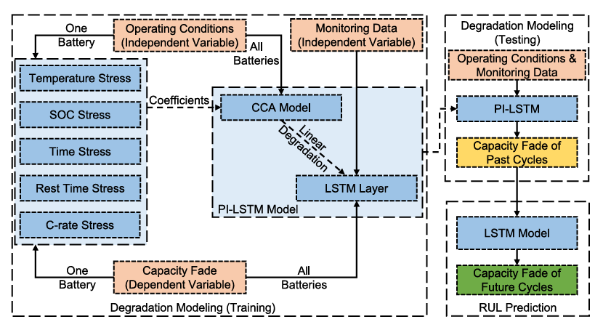
- PI-LSTM Methodology .from Shi, A. Rivera, and D. Wu [2]

PIML/PINN and Hybrid Architectures
S. Navidi, A. Thelen, T. Li, and C. Hu [1] proposed multiple physics-informed neural network (PINN) architectures. These models incorporate electrochemical degradation equations into the network training process by adding them as constraints in the loss function. Their implementation included: Delta learning with residual physics correction, Co-kriging for multi-task battery behavior estimation, PINN with differentiable aging dynamics.

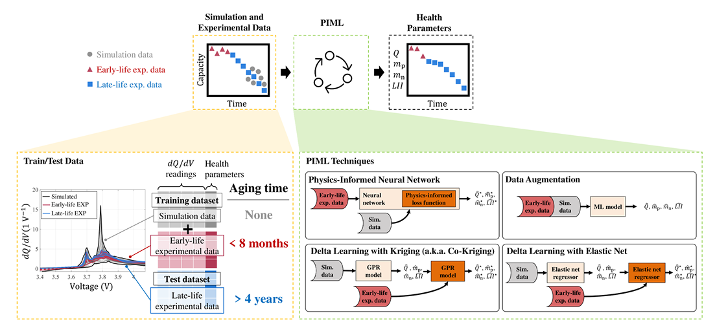
- PIML/PINN Methodology framework . S. Navidi, A. Thelen, T. Li, and C. Hu [1]

Integration Strategies
Aykol [3] provided a conceptual framework for categorizing physics-informed modeling strategies into two main types

Sequential architectures (e.g., PI-LSTM), where physics and ML models are trained separately and integrated through feature exchange.

Hybrid architectures (e.g., PINNs), where physics constraints are embedded directly into the learning objective.

These categories detail the positioning of our study: while physics-informed models offer high accuracy and generalization, they often require complex customization, physical knowledge, and specialized training. In contrast, the general ML models explored in this work are lightweight, broadly accessible, and require no specific adaptation

Results and Discussion
This section presents a comparative analysis of the machine learning models described in Section V. Their predictive performance was evaluated on the NASA battery aging dataset described in Section IV. Results are presented for remaining useful life (RUL) estimation, and are benchmarked against published results from physics-informed models including PI-LSTM and PINNs.

Visualization of RUL Predictions

Figures 2 through 8 display RUL predictions generated by each of the six evaluated scikit-learn models: Linear Regression, Ridge Regression, Lasso Regression, Random Forest, Gradient Boosting, AdaBoost, and SVR.

Figures 2–4 (Random Forest, Gradient Boosting, AdaBoost):
Ensemble models provided significantly improved RUL estimates, closely aligning with the true EOL point. Random Forest and Gradient Boosting in particular demonstrated strong performance across early, mid, and late-cycle test points.

Figures 5-7(Linear, Ridge, Lasso):
Linear and regularized linear models consistently underestimated RUL, particularly in the early degradation phase. The inability to capture nonlinear capacity decline trends resulted in late EOL predictions and overexaggerated degradation curves trending upwards.

Figure 8 (Support Vector Regression):
The SVR model performed with varied results, capturing nonlinear degradation trends more effectively than linear models, but with less accuracy than ensemble methods.

Each model was trained on 80% of the cycle data and tested on the remaining 20%. RUL predictions were determined based on when the predicted discharge capacity dropped below 80% of the initial rated capacity

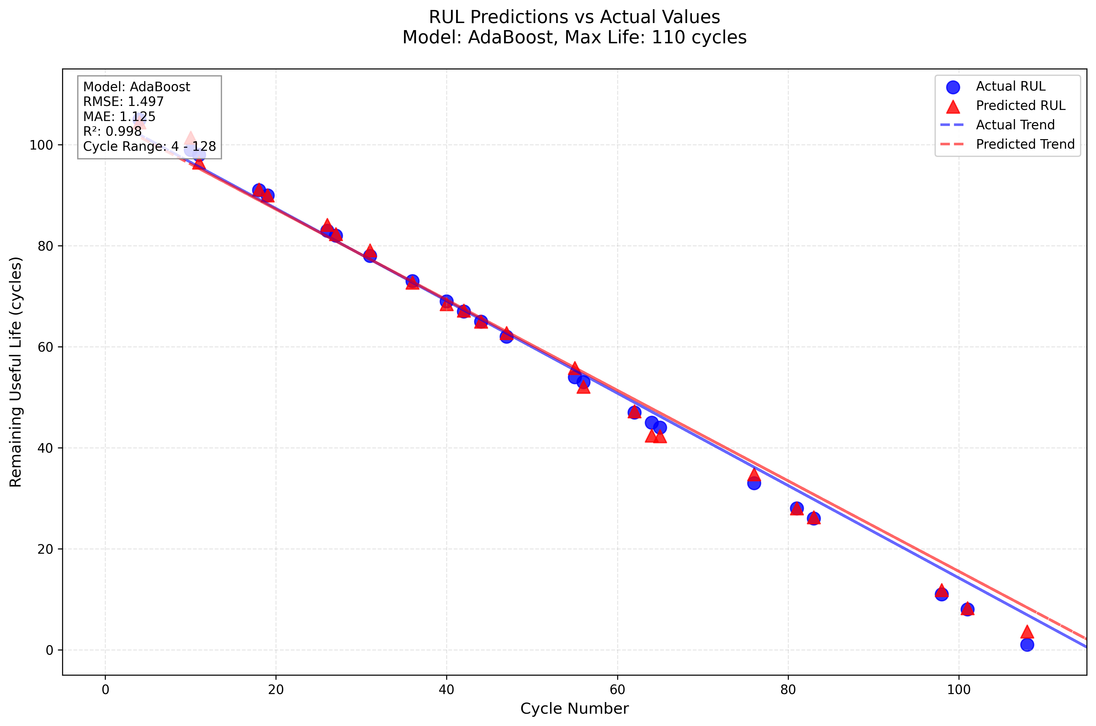
- (Battery #18 using the AdaBoost Model with optimized model parameters)
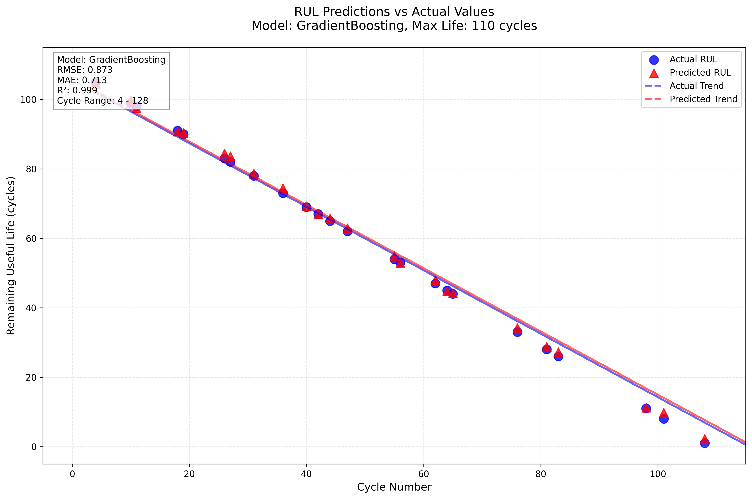
- (Battery #18 using the GradientBoosting Model with optimized model parameters)
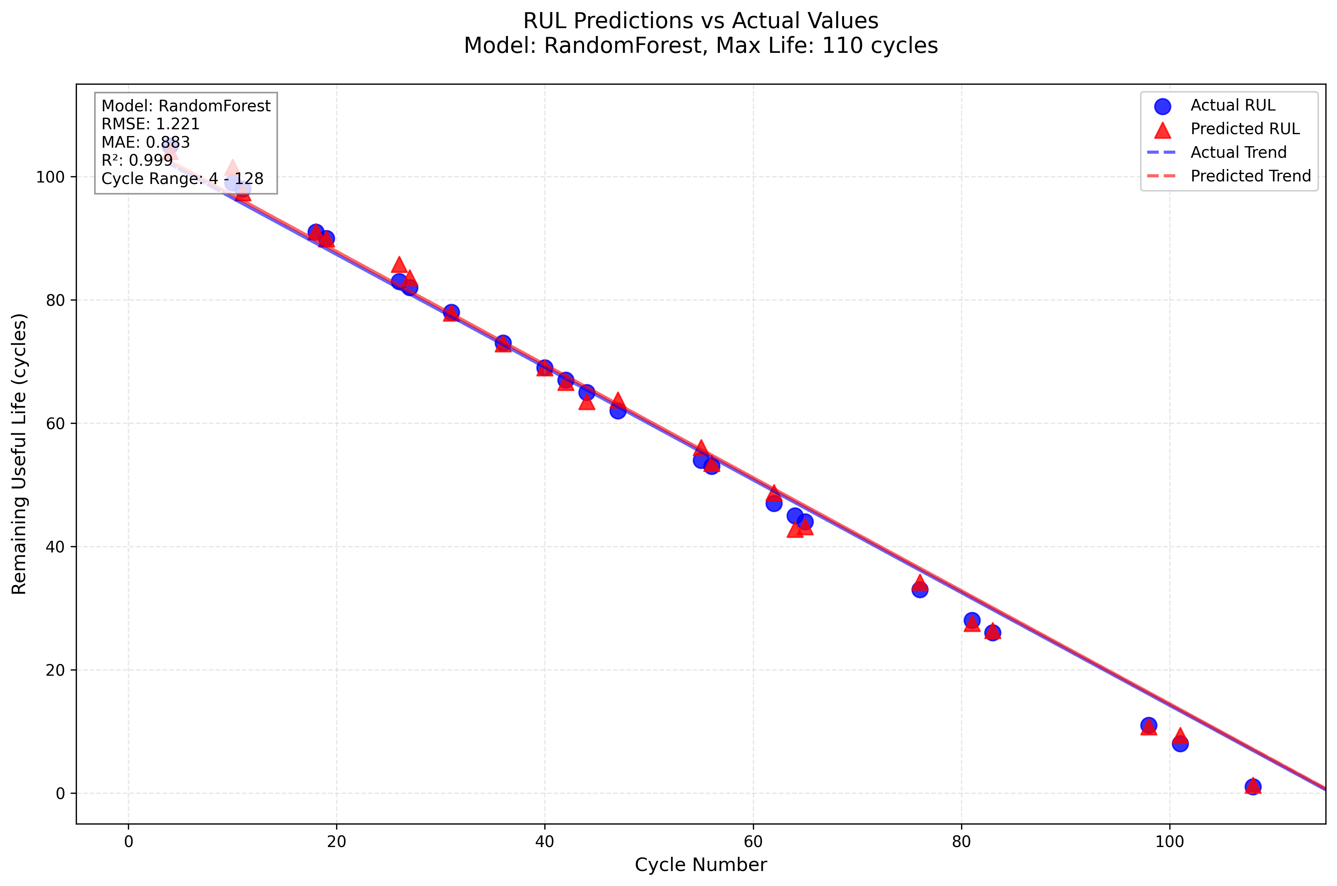
- (Battery #18 using the Random Forest Model with optimized model parameters)
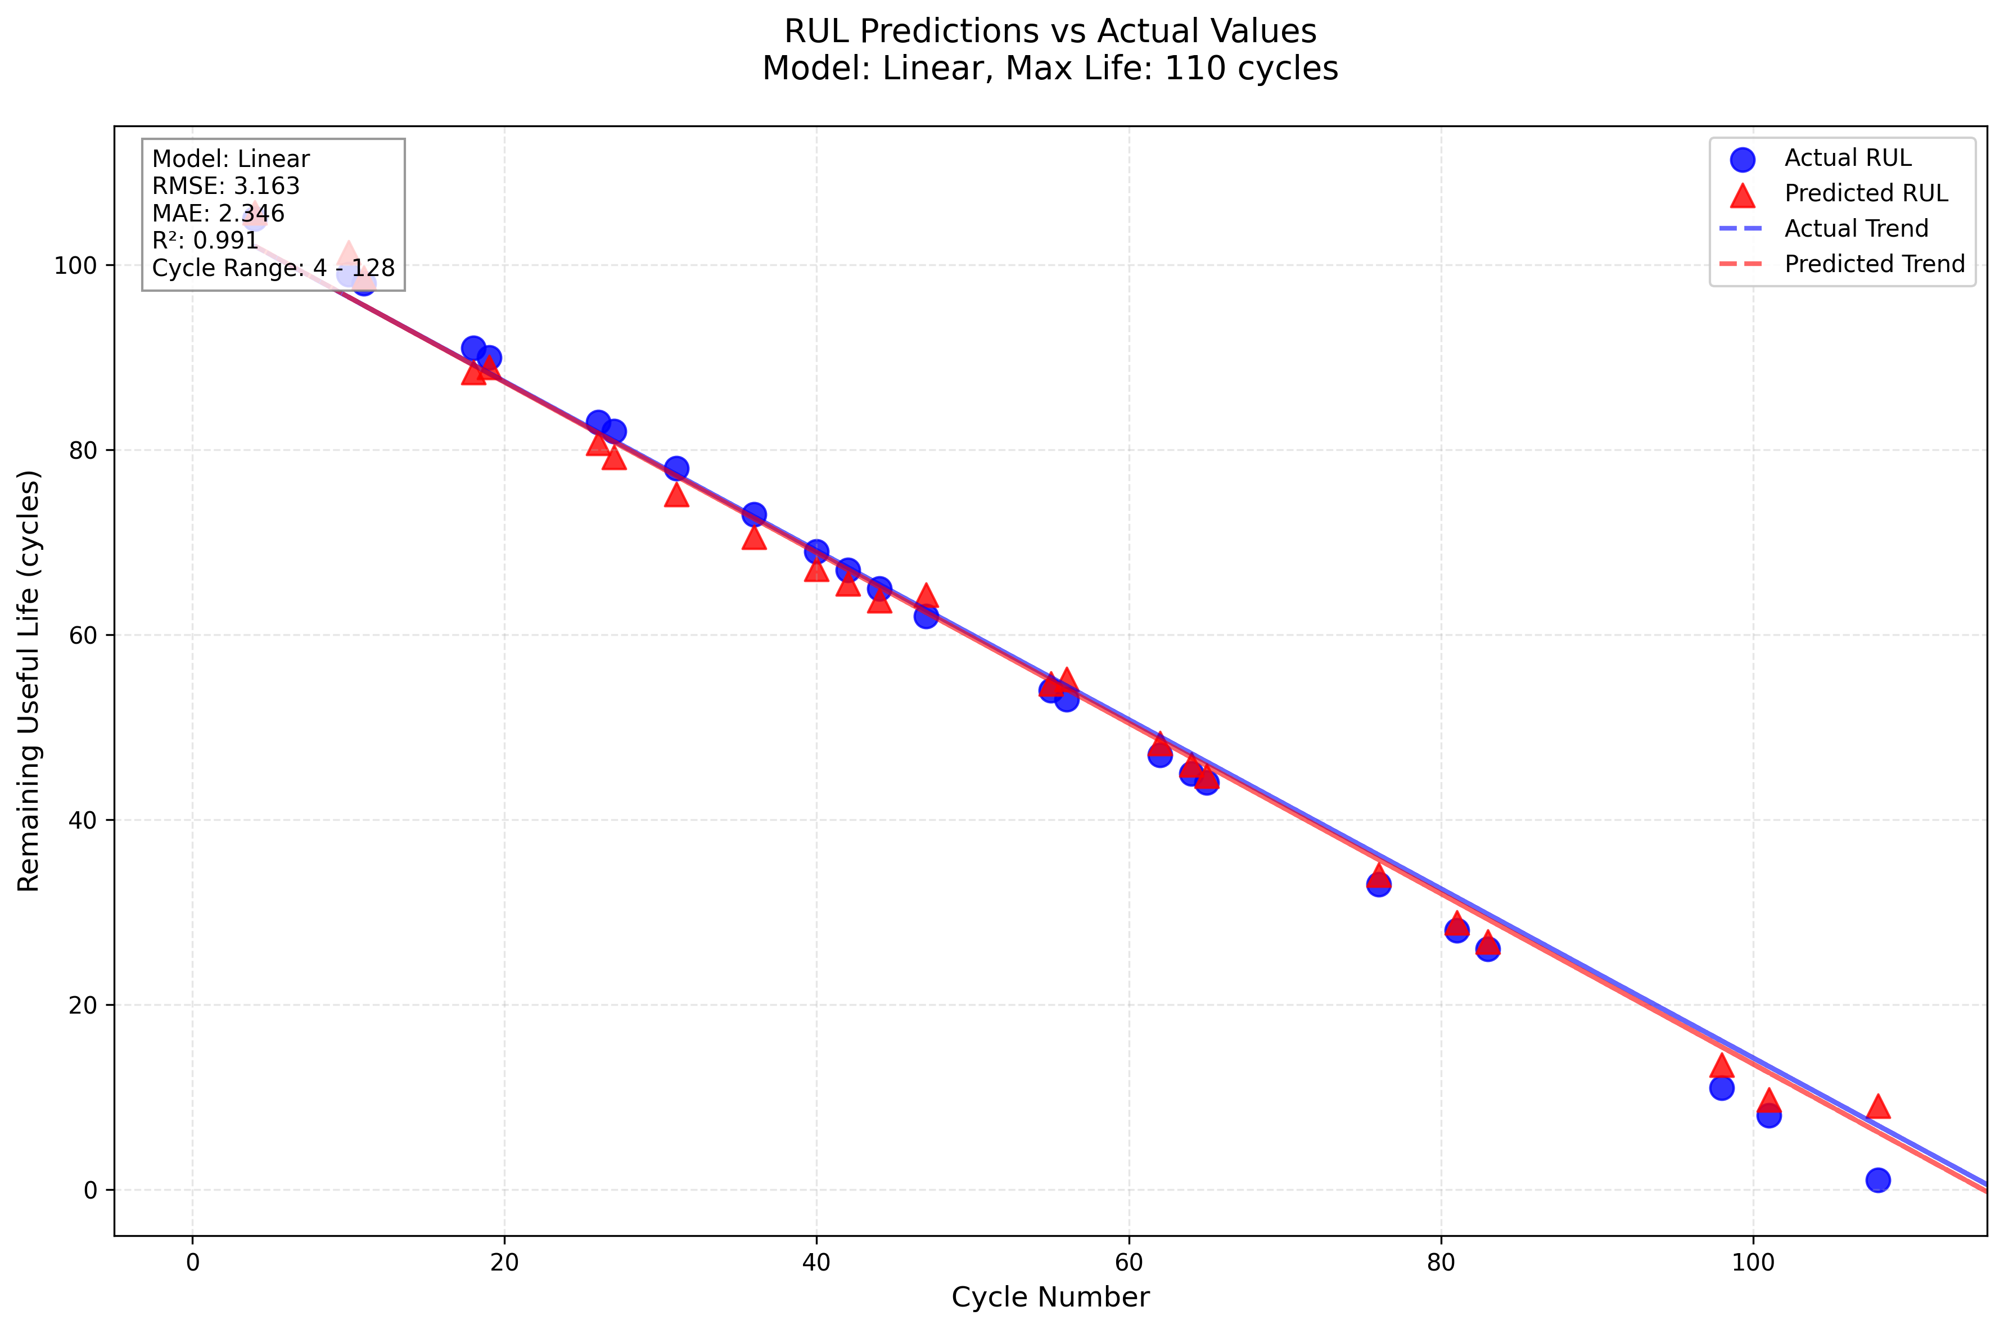
- (Battery #18 using the Linear Model with optimized model parameters)
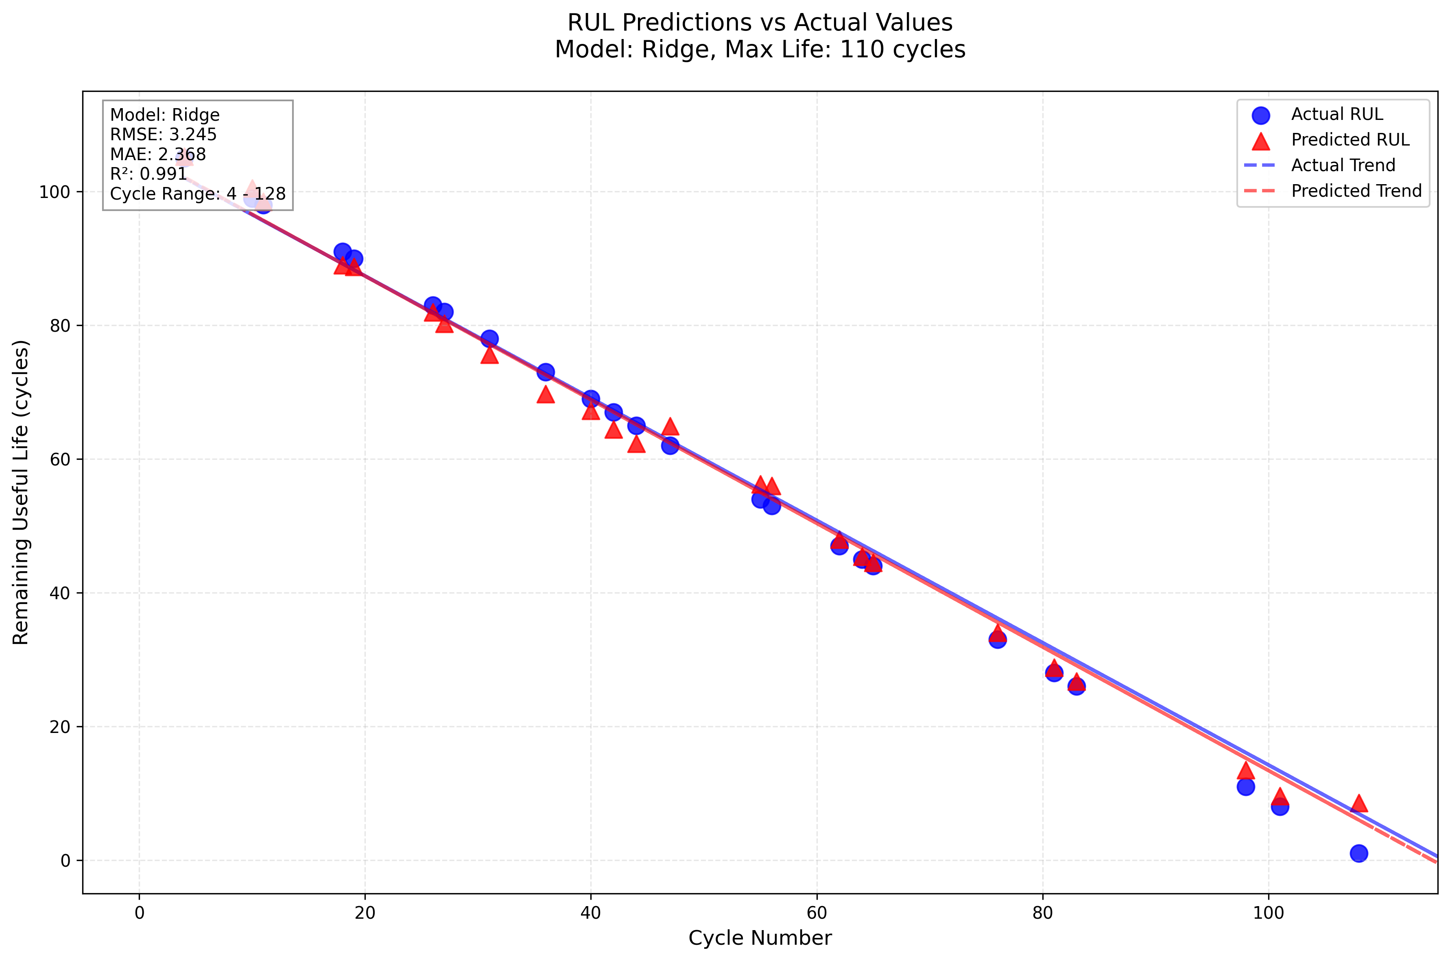
- (Battery #18 using the Ridge Model with optimized model parameters)
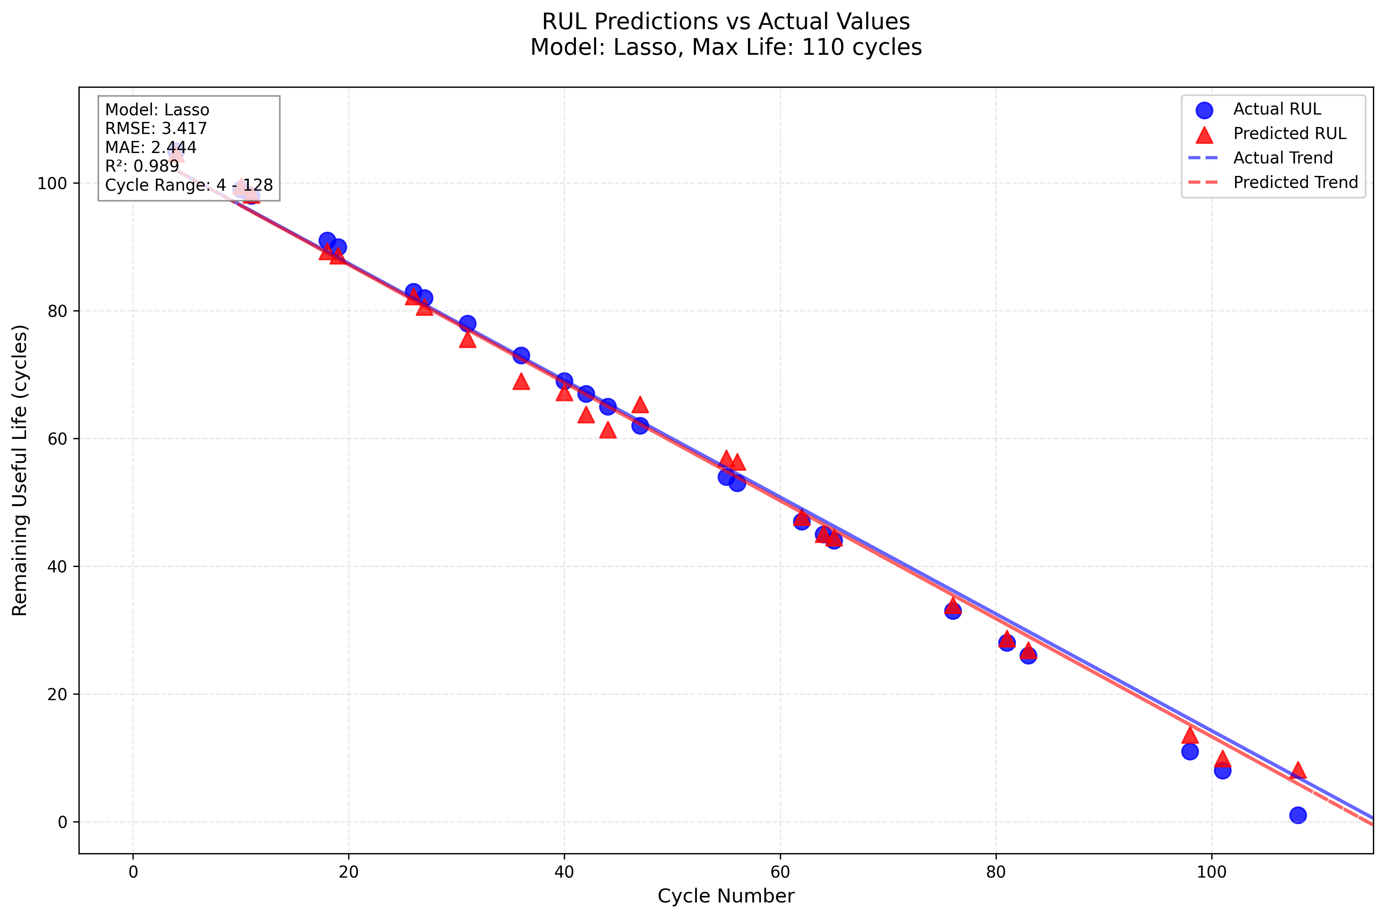
- (Battery #18 using the Lasso Model with optimized model parameters)
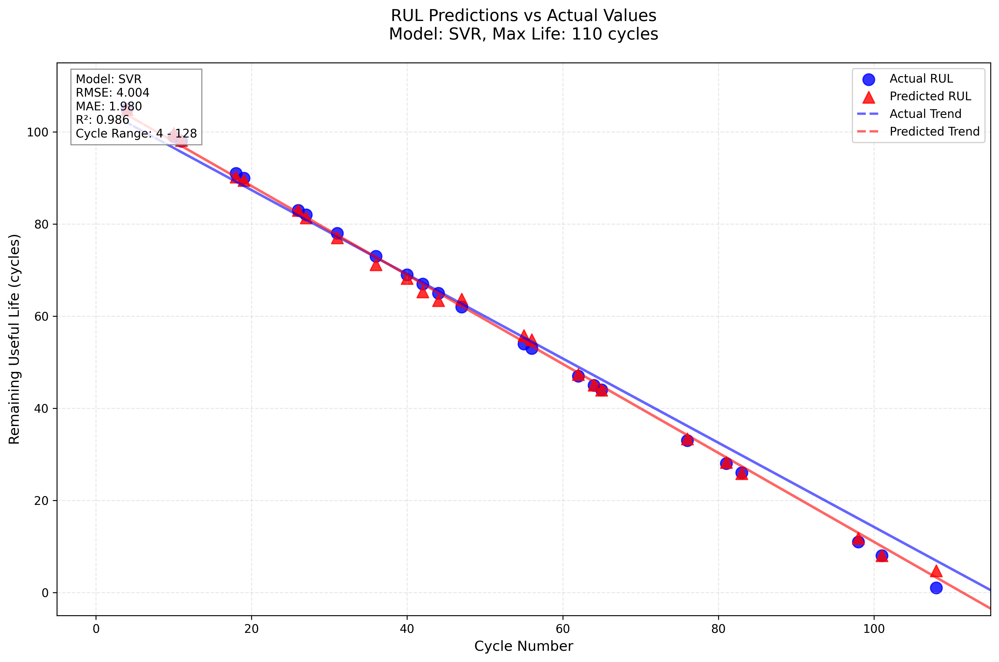
- (Battery #18 using the SVR Model with optimized model parameters)

- Battery #18 Model Comparison
Model | RMSE | MAE | R2
GradientBoosting | 0.873 | 0.713 | 0.999
RandomForest | 1.221 | 0.883 | 0.999
AdaBoost | 1.497 | 1.125 | 0.998
Linear | 3.163 | 2.346 | 0.991
Ridge | 3.245 | 2.368 | 0.991
Lasso | 3.417 | 2.444 | 0.989
SVR | 4.004 | 1.980 | 0.986

Interpretation of RUL Predictions

As shown in Table II, ensemble models significantly outperformed linear and support vector regression methods in predicting the remaining useful life (RUL) of Battery #18. Gradient Boosting achieved the best overall performance with the lowest RMSE (0.873), MAE (0.713), and the highest R² score (0.999), indicating the strongest fit and minimal prediction error. Random Forest followed closely with similarly strong results.

In contrast, linear models—including Linear, Ridge, and Lasso regression—produced notably higher errors and lower R² values, with Lasso regression yielding the highest RMSE (3.417) among the linear methods. The Support Vector Regression (SVR) model, while more flexible than linear models, also underperformed relative to ensemble methods, producing the highest RMSE overall (4.004) and the lowest R² (0.986), despiste achieving a MAE (1.98) lower than the linear models.

These findings reaffirm that ensemble learning techniques, particularly Gradient Boosting, are well-suited for modeling the nonlinear degradation behavior in battery life cycle data.

For reference, the physics-informed PI-LSTM model reported in J. Shi, A. Rivera, and D. Wu [2] achieved a mean absolute error (MAE) of 1.17 when applied to the same dataset. Notably, both Gradient Boosting (MAE = 0.713) and Random Forest (MAE = 0.833) outperformed the PI-LSTM in this test case, demonstrating that general-use ensemble models can achieve comparable or even superior accuracy in RUL prediction when trained on well-structured cycle data.

Comparison of Several Battery Data Sets Against PI-LSTM

To further validate the performance of general-use machine learning models, their results were compared across multiple battery data sets from the NASA PCoE repository and benchmarked against the PI-LSTM model reported in J. Shi, A. Rivera, and D. Wu [2].

- Battery #18 Model Comparison
Best Performing Model | MAE | PI-LSTM (MAE) | Battery #
GradientBoosting | 0.745 | 1.41 | 7
GradientBoosting | 0.713 | 1.17 | 18
Random Forest | 1.00 | 1.72 | 29
SVR | 1.29 | 1.66 | 30
GradientBoosting | 0.8 | 3.39 | 31
Linear | 0.36 | 4.19 | 25
Ridge | 0.21 | 5.59 | 26

As presented in Table III, general-purpose machine learning models, particularly ensemble methods, consistently outperformed the physics-informed PI-LSTM benchmark in terms of mean absolute error (MAE) across multiple batteries in the NASA dataset.

Gradient Boosting yielded the lowest MAE for Batteries #7 (0.745), #18 (0.713), and #31 (0.800), all lower than their corresponding PI-LSTM MAE’s, demonstrating strong predictive accuracy for nonlinear degradation trends.

Support Vector Regression (SVR) showed slightly improved performance over PI-LSTM for Battery #30, with an MAE of 1.29 compared to 1.66.

Interestingly, non-ensemble models such as Linear Regression and Ridge Regression achieved the lowest MAEs for Batteries #25 (0.36) and #26 (0.21), respectively despite typically being less effective on nonlinear degradation problems. However, this likely reflects the linearity detected specifically within batteries #25 and #26.

Overall, these findings show that general-purpose ML models, especially Gradient Boosting, can consistently match or exceed the accuracy of physics-informed methods, offering a scalable and accessible approach for RUL estimation when sufficient data is available.

Limitations and Future Work
While this study demonstrates that general-purpose machine learning models, particularly ensemble methods, can effectively predict battery health metrics and remaining useful life (RUL), several limitations should be acknowledged

Dataset Limitations
The analysis was conducted exclusively on lithium-ion batteries from the NASA Ames Prognostics Center of Excellence (PCoE), which, while publicly available and used in various literature, only represents a limited range of chemistries, manufacturers, and operating conditions. As a result, the models developed may not generalize well to other battery types or solid-state chemistries, or to systems operating in highly dynamic real-world environments like electric vehicles.

Feature Scope
The features used in model training were derived from cycle-level metrics (e.g., voltage, current, temperature). Additional signals, such as electrochemical impedance spectroscopy (EIS), coulombic efficiency, or cell impedance growth, were not available in the dataset [6]. These could provide richer physical context and improve model accuracy, especially in early-life prediction where changes are more subtle.

Model Transferability
Each model was trained and tested independently on single batteries. No attempt was made to train a general model across multiple batteries. No attempt was also made to transfer learning from one cell to another. While this approach improves model fit, it limits scalability in production where models must carry representation across batches of cells.

Justification for Physics Informed Modeling
An important research question is whether the added complexity of physics-informed methods (e.g., PIML and PINNs) is justified when compared to high-performing general-purpose machine learning models. Our findings complicate the assumption that physics-informed models inherently outperform general ML approaches.
In our case, the optimal general-purpose achieved better overall predictive accuracy than the PIML-LSTM model, as measured by metrics such as MAE, RMSE and R². However, this result does not undervalue the merit of physics-informed approaches. Instead, it highlights the nuanced tradeoffs between empirical accuracy and physics, grounded robustness.
Physics-informed models showed increased consistency when trained on limited or nonstationary subsets of the data and demonstrated better extrapolation behavior in edge-case/extreme scenarios [2]. Additionally, by embedding physical constraints or known degradation mechanisms into the learning process, these models offer improved interpretability and greater trustworthiness for safety-critical applications like battery health diagnostics [2].
This exploration underscores that while general ML models may offer strong short-term performance, the integration of physics-informed structures has longer-term potential, especially when paired with techniques such as attention mechanisms or transfer learning. These insights respond directly to prior feedback and contribute to the innovative framing of this work, positioning it as a step toward more robust, hybrid modeling strategies for battery health estimation.

Future Work
This study exclusively utilized discharge cycle data for feature extraction and model training. This decision was made to ensure consistency across all batteries in the dataset, as discharge profiles remained uniform and complete across test units, whereas charge cycles often varied in duration, protocol, or had missing measurements. Furthermore, critical health indicators such as capacity fade and internal resistance are typically more pronounced and measurable during discharge, making it a reliable basis for model development.
However, future work should explore the integration of charge cycle data and other operational segments, which could provide insight into battery aging, especially in systems where partial charge/discharge cycles occur. Additionally, including features derived from rest periods, impedance measurements, or full-cycle analysis may improve model robustness and early-stage degradation detection.
Expanding the feature space to include these attributes while maintaining preprocessing consistency will be essential for deploying more generalizable models across varied real-world duty cycles.

References
- S. Navidi, A. Thelen, T. Li, and C. Hu, “Physics-informed machine learning for battery degradation diagnostics: A comparison of state-of-the-art methods,” Energy Storage Materials, vol. 68, p. 103343, Mar. 2024. doi: 10.1016/j.ensm.2024.103343
- J. Shi, A. Rivera, and D. Wu, “Battery health management using physics-informed machine learning: Online degradation modeling and remaining useful life prediction,” Mech. Syst. Signal Process., vol. 179, p. 109347, Jun. 2022. doi: 10.1016/j.ymssp.2022.109347.
- M. Aykol, “Perspective—Combining physics and machine learning to predict battery lifetime,” J. Electrochem. Soc., vol. 168, no. 3, p. 030525, Mar. 2021. doi: 10.1149/1945-7111/abec55K. Elissa, “Title of paper if known,” unpublished.
- Y. Chen, “NASA lithium-ion battery dataset,” IEEE DataPort, Apr. 28, 2024. [Online].Available:https://ieee-dataport.org/documents/nasa-lithium-ion-battery-dataset
- F. Pedregosa, G. Varoquaux, A. Gramfort, V. Michel, B. Thirion, O. Grisel, M. Blondel, P. Prettenhofer, R. Weiss, V. Dubourg, J. Vanderplas, A. Passos, D. Cournapeau, M. Brucher, M. Perrot, and E. Duchesnay, “Scikit-learn: Machine Learning in Python,” Journal of Machine Learning Research, vol. 12, pp. 2825–2830, 2011
- Y. Chen, “Overview of Li-ion battery degradation,” in Advances in Lithium-Ion Batteries for Electric Vehicles, 1st ed., Y. Wang, Ed. Amsterdam, Netherlands: Elsevier, 2024, ch. 1, pp. 1–13. doi: 10.1016/B978-0-443-15543-7.00002-9

