CPE301 – SPRING 2019

Design Assignment 1

Student Name: Cody McDonald

Student #: 5000382538

Student Email: mcdonc4@unlv.nevada.edu

Primary Github address: https://github.com/elev8rProcrastinator/submission_da.git

Directory:

Submit the following for all Labs:

1. In the document, for each task submit the modified or included code (only) with highlights and justifications of the modifications. Also, include the comments.
2. Use the previously create a Github repository with a random name (no CPE/301, Lastname, Firstname). Place all labs under the root folder ESD301/DA, sub-folder named LABXX, with one document and one video link file for each lab, place modified asm/c files named as LabXX-TYY.asm/c.
3. If multiple asm/c files or other libraries are used, create a folder LabXX-TYY and place these files inside the folder.
4. The folder should have a) Word document (see template), b) source code file(s) and other include files, c) text file with youtube video links (see template).

1. **COMPONENTS LIST AND CONNECTION BLOCK DIAGRAM w/ PINS**

Atmel Studio 7 Software

1. **INITIAL/MODIFIED/DEVELOPED CODE OF TASK 1/A**

;

; CPE301_A1.asm

;

; Created: 2/7/2019 1:18:10 PM

; Author : Cody McDonald

.include<m328pdef.inc>

.cseg

.org 0x00

.EQU MULTIPLICAND = 0x25 ;Set a value to the multiplicand

.EQU MULTIPLIER = 0x2 ;Set value for the multiplier

.EQU ZERO = 0x0000 ;Set universal zero value

LDI R25, HIGH(MULTIPLICAND) ;load R25 with higher bit Multiplicand

LDI R24, LOW(MULTIPLICAND) ;load R24 with lower Multiplicand

LDI R22, MULTIPLIER ;Multiplier value will remain same

LDI R16, MULTIPLIER ;This register's value will keep changing

LDI R17, ZERO

;Set up MUL test

LDI R28, 0X25

MUL R28, R22

L1:

ADD R18, R24 ;Add value of register 24 to 18

ADC R19, R25 ;Add value of register 25 to 19 plus any carry

ADC R20, R17 ;Add any remaining carry to register 20

DEC R16 ;Decrease the index

BRNE L1 ;Loop back to L1 until index is zero

;End program sequence

jmp end

end: rjmp end

1. **DEVELOPED MODIFIED CODE OF TASK 2/A from TASK 1/A**

N/A

1. **SCHEMATICS**

N/A

1. **SCREENSHOTS OF EACH TASK OUTPUT (ATMEL STUDIO OUTPUT)**

**This first screenshot shows the multiplication of (0xFF)*(0xFFFF), which produces the correct product of FEFF01**

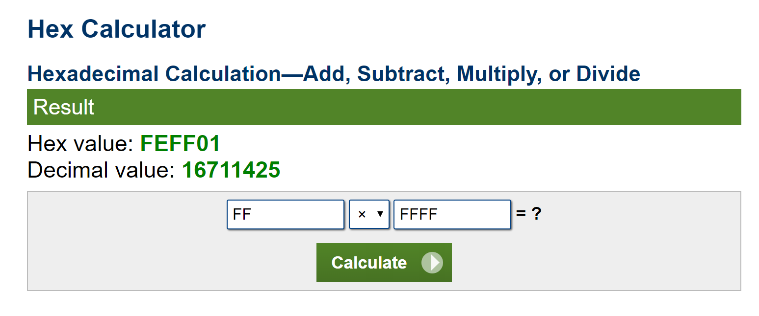 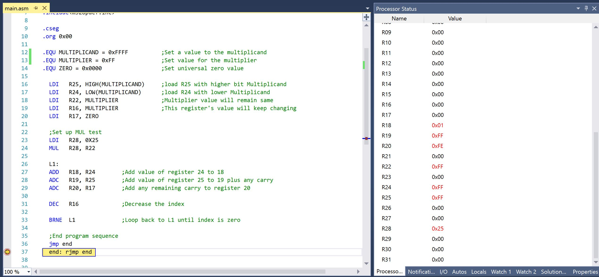

**This second screenshot shows the output of 2*(0x25)**

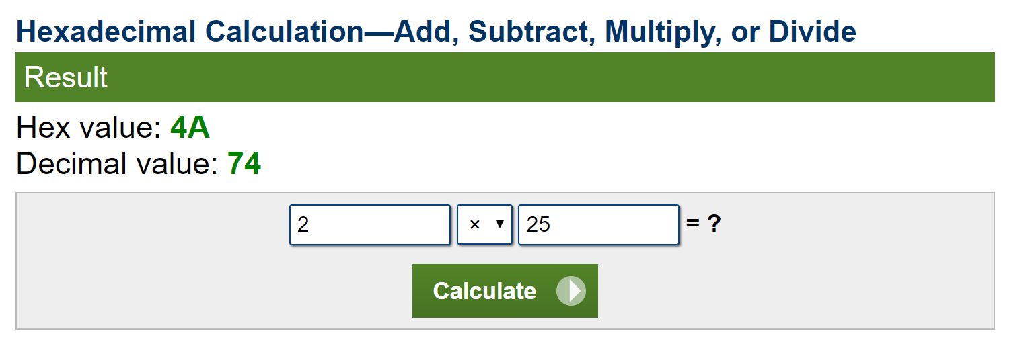 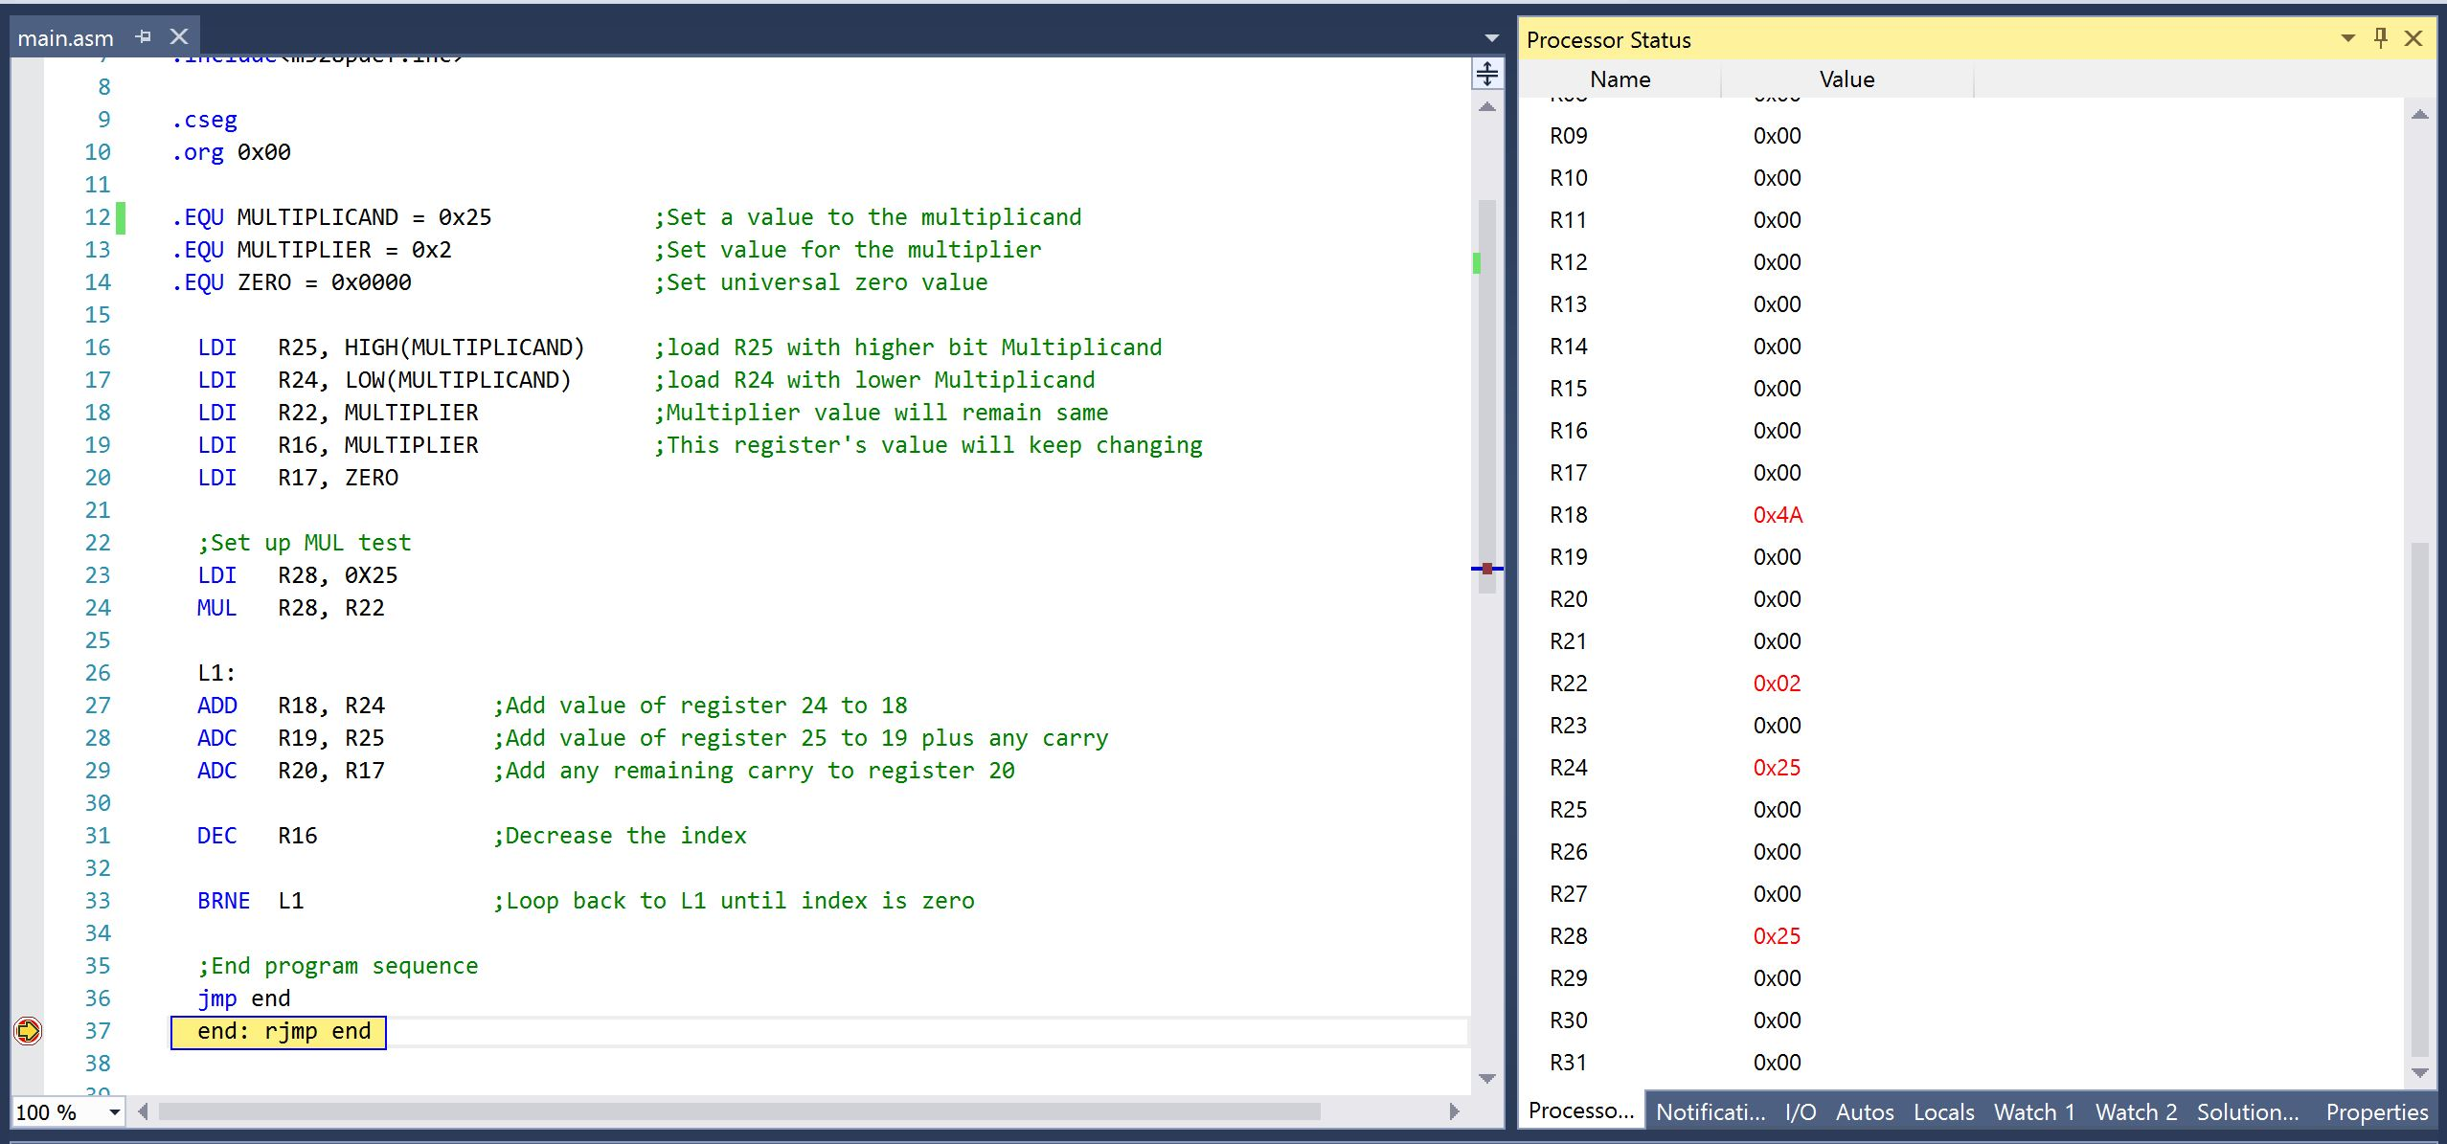

**The third screenshot tests the program versus the built-in MUL function, which produces the same product of $4A.**

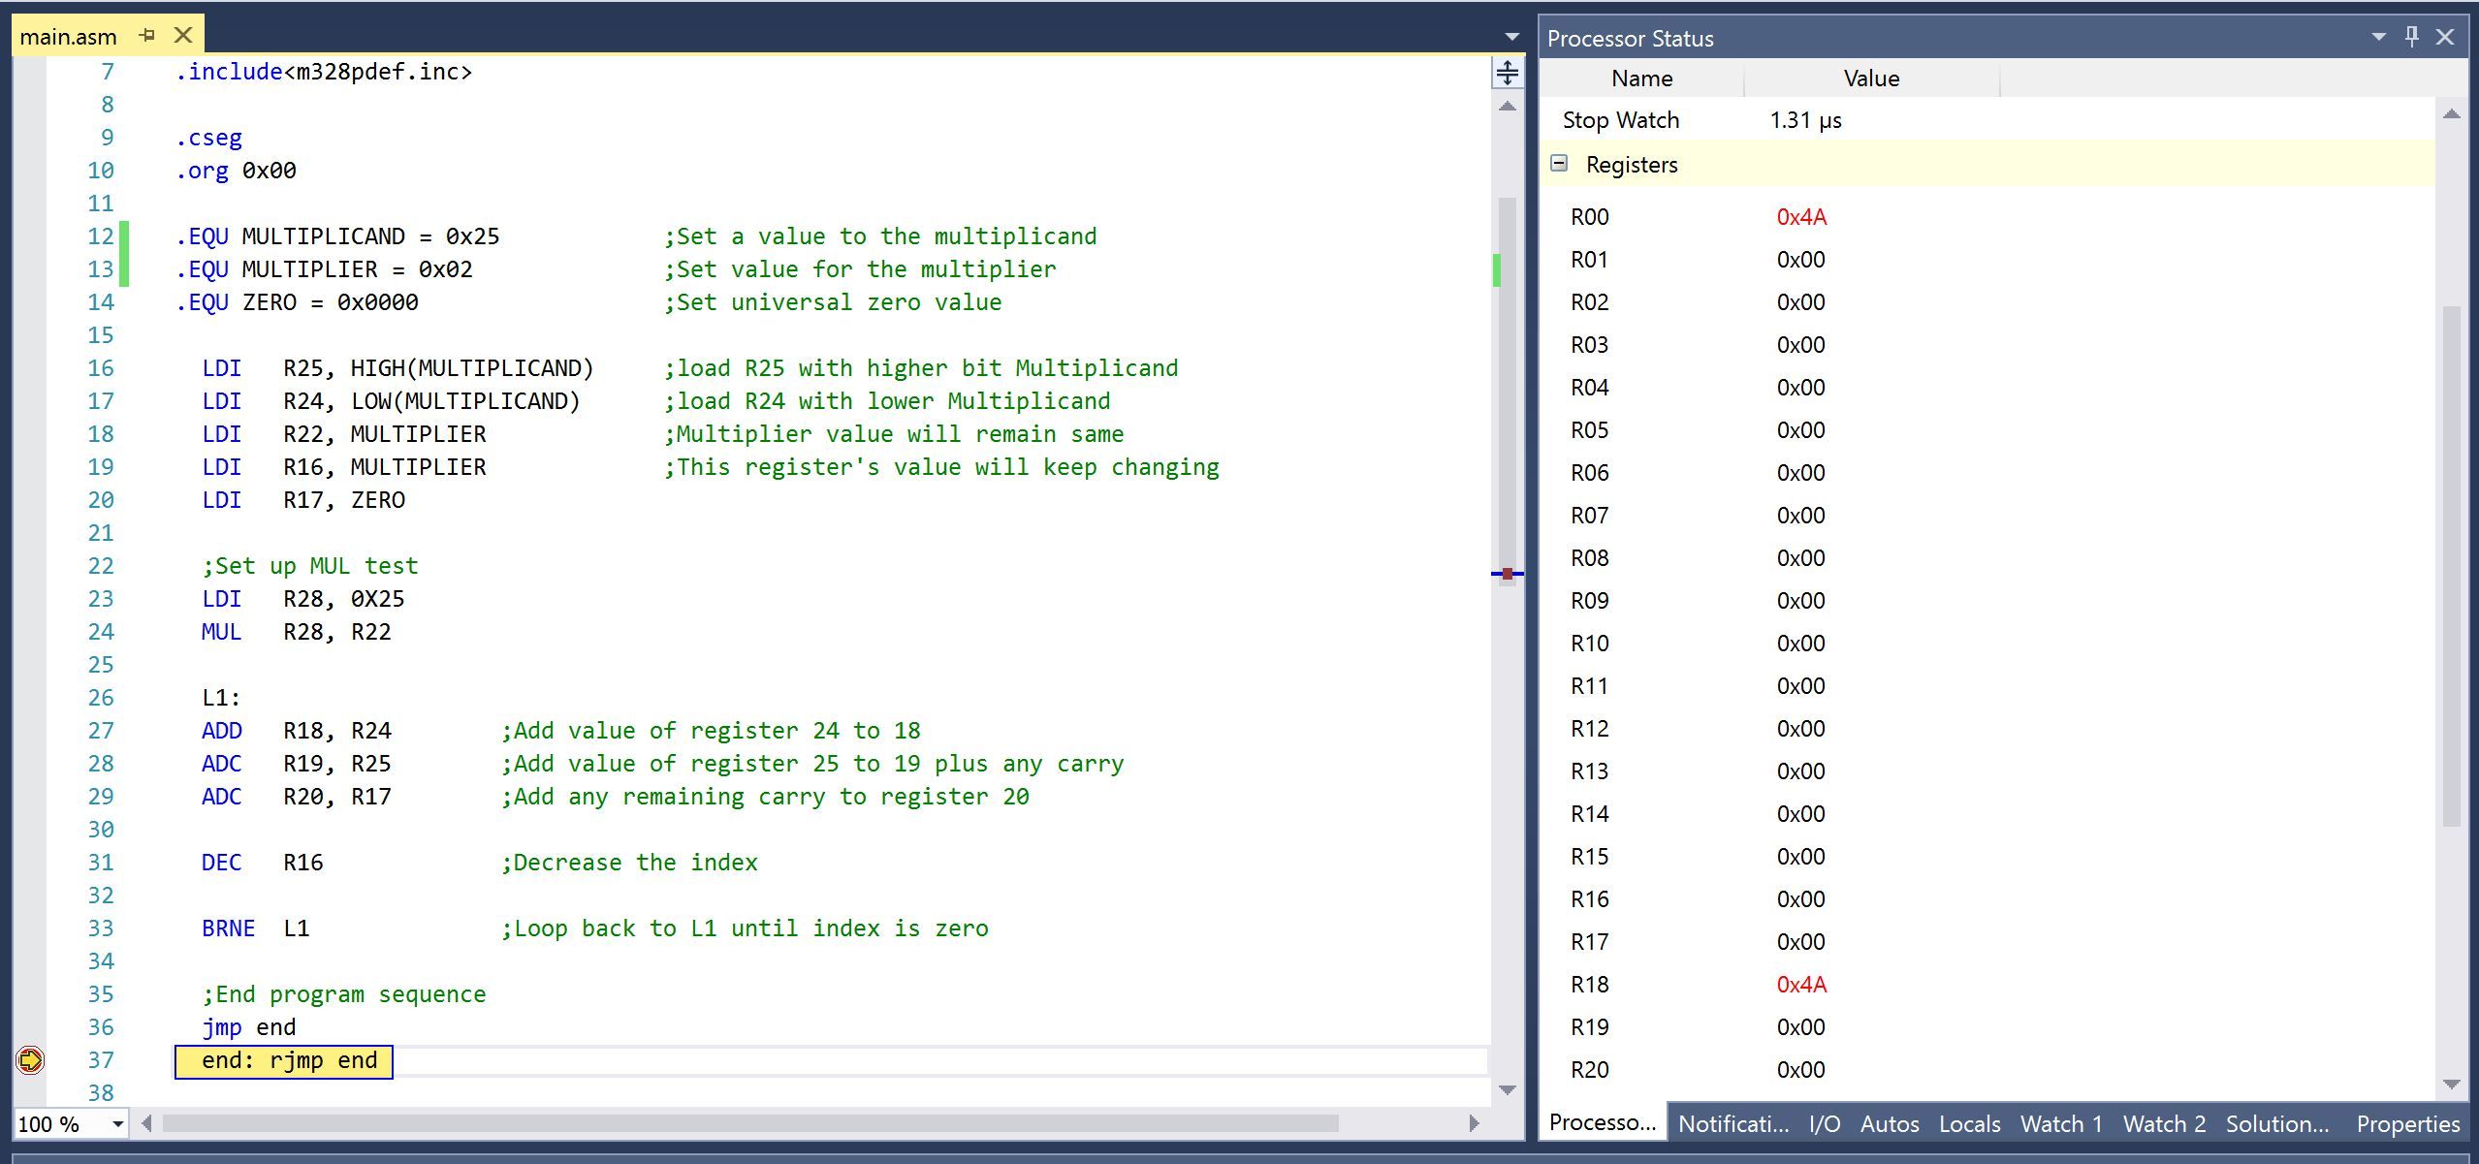

1. **SCREENSHOT OF EACH DEMO (BOARD SETUP)**

**N/A**

1. **VIDEO LINKS OF EACH DEMO**

https://youtu.be/s5nH4GjsNuw

1. **GITHUB LINK OF THIS DA**

**Student Academic Misconduct Policy**

<http://studentconduct.unlv.edu/misconduct/policy.html>

“This assignment submission is my own, original work”.

Cody McDonald