CPE301 – SPRING 2019

Design Assignment DA3A

Student Name: Cody McDonald

Student #: 5000382538

Student Email: mcdonc4@unlv.nevada.edu

Primary Github address: https://github.com/elev8rProcrastinator/submission_da.git

Directory: https://github.com/elev8rProcrastinator/submission_da/tree/master/DA3A

1. **COMPONENTS LIST AND CONNECTION BLOCK DIAGRAM w/ PINS**

AtMini xplained

FTDI USB to TTl communication

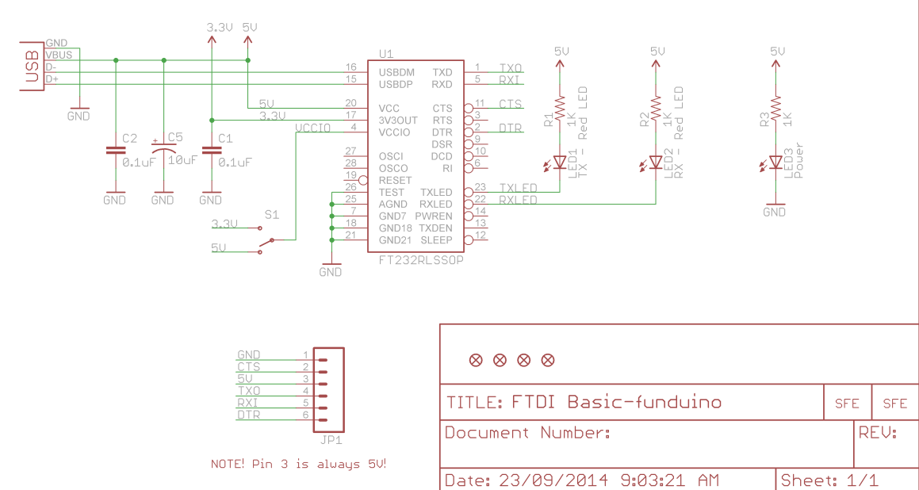

Block diagram with pins used in the Atmega328P

1. **INITIAL/MODIFIED/DEVELOPED CODE OF TASK 1/A**

/*

* CPE301_DA3A.c

*

* Created: 3/27/2019 7:10:08 PM

* Author : Cody McDonald

*/

#define *F_CPU* 16000000UL

#define BAUD 9600

#include <util/setbaud.h>

#include <avr/io.h>

#include <stdio.h>

#include <util/delay.h>

#include <avr/interrupt.h>

void USART_tx_data(char data); // Function to send integer/char

void USART_tx_string(char* StringPtr); // Function to send string

void USART_init(void); // Function to initialize the UART communication

char str_type[] = "String: "; // Declaring the string value on screen

char int_type[] = "Integer: "; // Declaring the integer value on screen

char float_type[] = "Floating Point: "; // Declaring the floating point value on screen

char line[] = "\n"; // Used to create the next line

char string[] = "I love eggs"; //String[] is the variable to output into terminal

char output[20]; // Allocating memory space to contain the float value

volatile float adc_temp = 100.00; // Sets the float value

int main(void)

{

TCCR1B |= 5; // Sets prescaler to 1024

TIMSK1 = (1 << TOIE1); // Enables overflow flag

TCNT1 = 49911; // Set top of timer for a delay of 1 second

USART_init(); // Initializes the analog to digital functions as well as OVF interrupt

sei(); //enable interrupts

while(1); //infinite loop

}

ISR (TIMER1_OVF_vect)

{

USART_tx_string(line); // go to next line

USART_tx_string(str_type); // Label the string

USART_tx_string(string); // prints string

USART_tx_string(line); // creates next line

USART_tx_string(int_type); // Label the integer

USART_tx_data('8'); // prints value a numerical value

USART_tx_string(line); // creates next line

USART_tx_string(float_type); // Label the FLoating Point

*snprintf*(output, sizeof(output), "%f\r\n", adc_temp); // output everything

USART_tx_string(output); // transmits outs to UART

USART_tx_string(line); // creates next line

TCNT1 = 49911; // reset top of counter

}

//Function to initialize UART

void USART_init( void )

{

UBRR0H = 0;

UBRR0L = *F_CPU*/16/BAUD - 1; // Used for the BAUD prescaler

UCSR0C = _BV(UCSZ01) | _BV(UCSZ00); /* 8-bit data */

UCSR0B = _BV(RXEN0) | _BV(TXEN0); /* Enable RX and TX */

}

//create function to send character data

void USART_tx_data(char data)

{

while (!(UCSR0A & (1 << UDRE0))); // Set proper modes for UARRT

UDR0 = data; // grabs the value given from data

}

//create function to send strings

void USART_tx_string(char *StrPtr)

{

while ((*StrPtr != '\0')){ // loop until end of line

while (!(UCSR0A & (1 << UDRE0))); // loop until UDRE0 is high

UDR0 = *StrPtr; // Store value intp UDR0

StrPtr++; // increase to next position

}

}

1. **DEVELOPED MODIFIED CODE OF TASK 2/A from TASK 1/A**

N/A – there was no modified code

1. **SCHEMATICS**

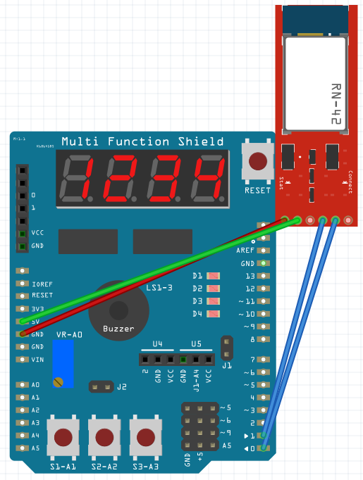

1. **SCREENSHOTS OF EACH TASK OUTPUT (ATMEL STUDIO OUTPUT)**

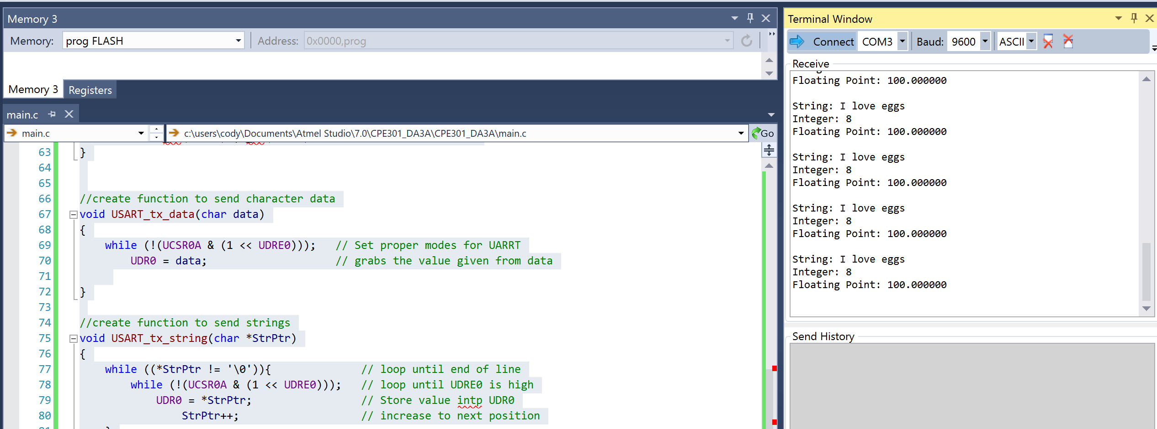

Figure :Screenshot of Atmel output

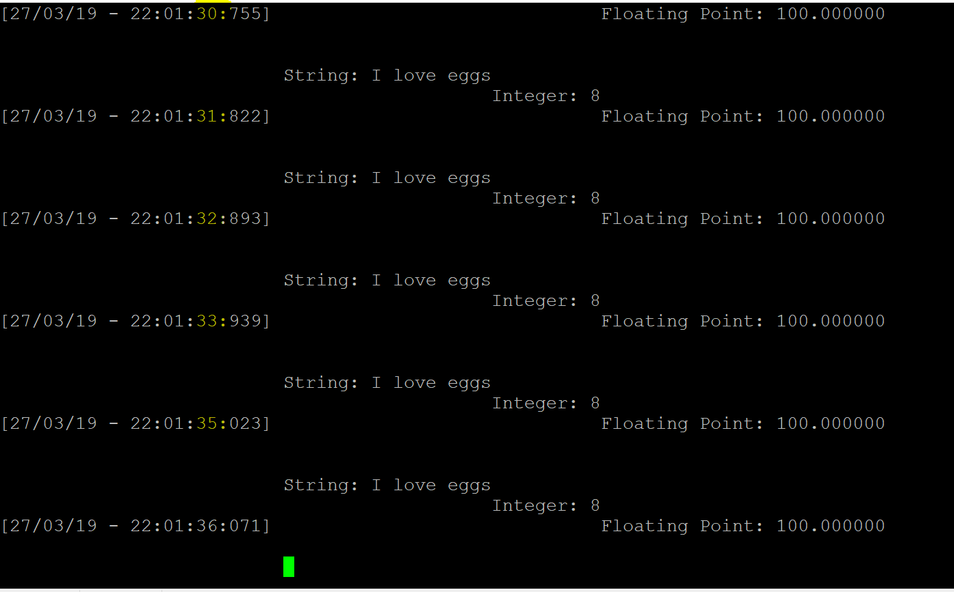

Figure : Screenshot of PuTTy output

1. **SCREENSHOT OF EACH DEMO (BOARD SETUP)**

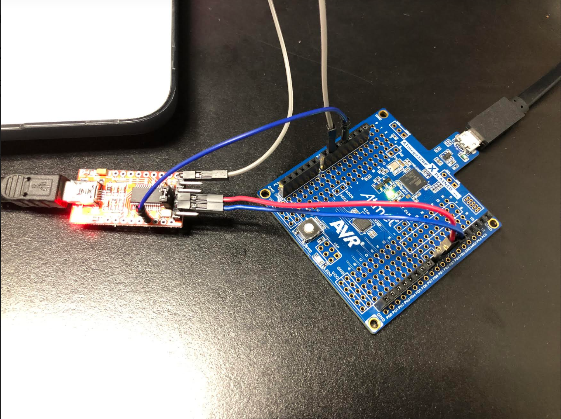

1. **VIDEO LINKS OF EACH DEMO**

<https://www.youtube.com/watch?v=wlVayFI1Ag0>

1. **GITHUB LINK OF THIS DA**

https://github.com/elev8rProcrastinator/submission_da/tree/master/DA3A

**Student Academic Misconduct Policy**

<http://studentconduct.unlv.edu/misconduct/policy.html>

“This assignment submission is my own, original work”.

Cody McDonald