CPE301 – SPRING 2019

Design Assignment DA3A

Student Name: Cody McDonald

Student #: 5000382538

Student Email: mcdonc4@unlv.nevada.edu

Primary Github address: https://github.com/elev8rProcrastinator/submission_da.git

Directory: https://github.com/elev8rProcrastinator/submission_da/tree/master/DA3B

1. **COMPONENTS LIST AND CONNECTION BLOCK DIAGRAM w/ PINS**

AtMini xplained

FTDI USB to TTl communication

LM35 temperature sensor

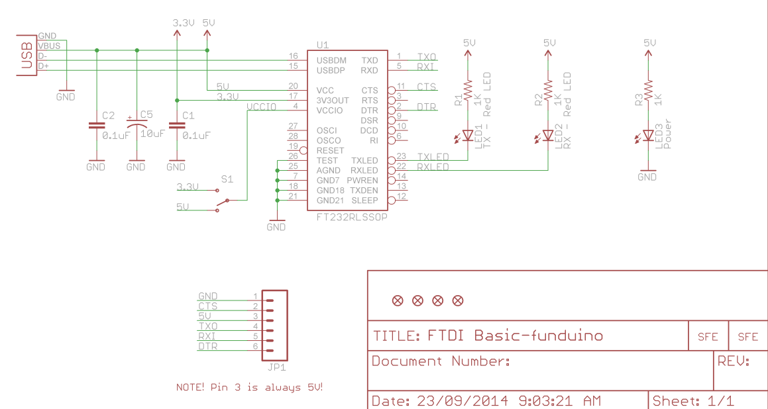

Block diagram with pins used in the Atmega328P

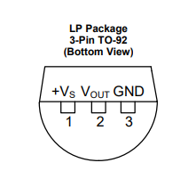

Figure : LM35 pin list

1. **INITIAL/MODIFIED/DEVELOPED CODE OF TASK 1/A**

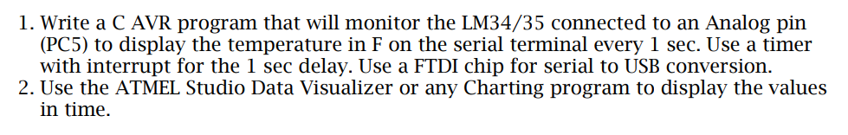

/*

* The program reads the LM34 temperature of the MCU using ADC and sends it to the PC.

* If you put your finger on the MCU, the number increases.

*

*/

#define *F_CPU* 16000000UL

#define BAUD_RATE 9600

#include <avr/io.h>

#include <util/delay.h>

void usart_init ();

void usart_send (unsigned char ch);

int main (void)

{

usart_init ();

/** Setup and enable ADC **/

ADMUX = (0<<REFS1)| // Reference Selection Bits

(1<<REFS0)| // AVcc - external cap at AREF

(0<<ADLAR)| // ADC Left Adjust Result

(1<<MUX2)| // Analog Channel Selection Bits

(0<<MUX1)| // ADC5 PC5

(1<<MUX0);

ADCSRA = (1<<ADEN)| // ADC ENable

(0<<ADSC)| // ADC Start Conversion

(0<<ADATE)| // ADC Auto Trigger Enable

(0<<ADIF)| // ADC Interrupt Flag

(0<<ADIE)| // ADC Interrupt Enable

(1<<ADPS2)| // ADC Prescaler Select Bits

(0<<ADPS1)|

(1<<ADPS0);

while (1)

{

ADCSRA|=(1<<ADSC); //start conversion

while((ADCSRA&(1<<ADIF))==0);//wait for conversion to finish

ADCSRA |= (1<<ADIF);

int a = ADCL;

a = a | (ADCH<<8);

a = (a/1024.0) * 5000/10;

a = (a*2)+32; //equation to convert celsius to farenheit. can't use used 2 instead of 9/5

usart_send((a/100)+'0');

a = a % 100;

usart_send((a/10)+'0');

a = a % 10;

usart_send((a)+'0');

usart_send('\r');

*_delay_ms*(1000);

}

return 0;

}

void usart_init (void)

{

UCSR0B = (1<<TXEN0);

UCSR0C = (1<< UCSZ01)|(1<<UCSZ00);

UBRR0L = *F_CPU*/16/BAUD_RATE-1;

}

void usart_send (unsigned char ch)

{

while (! (UCSR0A & (1<<UDRE0))); //wait until UDR0 is empty

UDR0 = ch; //transmit ch

}

void usart_print(char* str)

{

int i = 0;

while(str[i] != 0)

usart_send(str[i]);

}

1. **DEVELOPED MODIFIED CODE OF TASK 2/A from TASK 1/A**

N/A – there was no modified code

1. **SCHEMATICS**

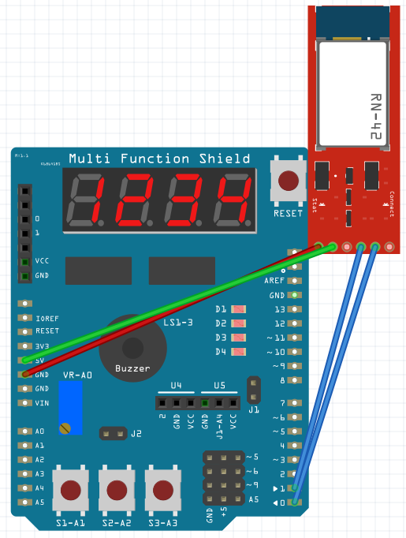

1. **SCREENSHOTS OF EACH TASK OUTPUT (ATMEL STUDIO OUTPUT)**

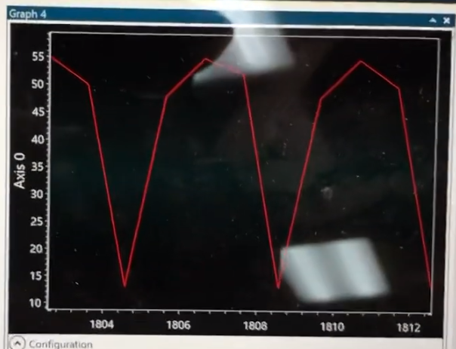

Figure :Temparture sensor readings in time

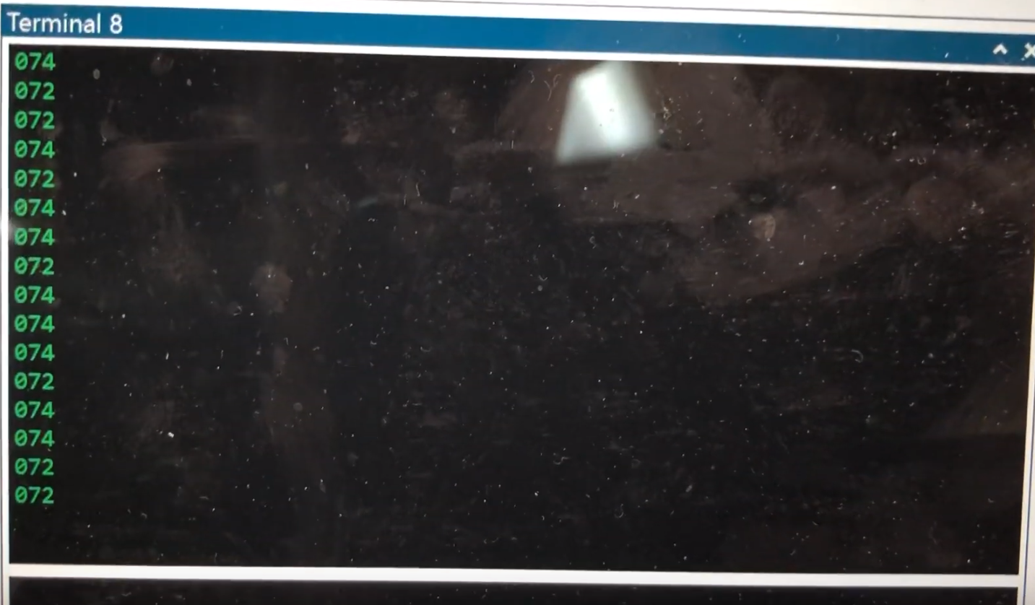

Figure : Temperatures read from the terminal

1. **SCREENSHOT OF EACH DEMO (BOARD SETUP)**

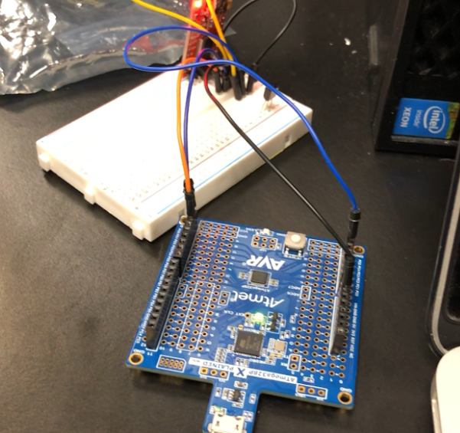

Figure :Set up to read from LM35 sensor

1. **VIDEO LINKS OF EACH DEMO**

**https://youtu.be/u4hgoxbDR34**

1. **GITHUB LINK OF THIS DA**

https://github.com/elev8rProcrastinator/submission_da/tree/master/DA3B

**Student Academic Misconduct Policy**

<http://studentconduct.unlv.edu/misconduct/policy.html>

“This assignment submission is my own, original work”.

Cody McDonald