CPE301 – SPRING 2019

Design Assignment DA4A

Student Name: Cody McDonald

Student #: 5000382538

Student Email: mcdonc4@unlv.nevada.edu

Primary Github address: https://github.com/elev8rProcrastinator/submission_da.git

Directory: https://github.com/elev8rProcrastinator/submission_da/tree/master/DA4A

Submit the following for all Labs:

1. In the document, for each task submit the modified or included code (only) with highlights and justifications of the modifications. Also, include the comments.
2. Use the previously create a Github repository with a random name (no CPE/301, Lastname, Firstname). Place all labs under the root folder ESD301/DA, sub-folder named LABXX, with one document and one video link file for each lab, place modified asm/c files named as LabXX-TYY.asm/c.
3. If multiple asm/c files or other libraries are used, create a folder LabXX-TYY and place these files inside the folder.
4. The folder should have a) Word document (see template), b) source code file(s) and other include files, c) text file with youtube video links (see template).

1. **COMPONENTS LIST AND CONNECTION BLOCK DIAGRAM w/ PINS**

Atmini Xplained

Multi-shield:

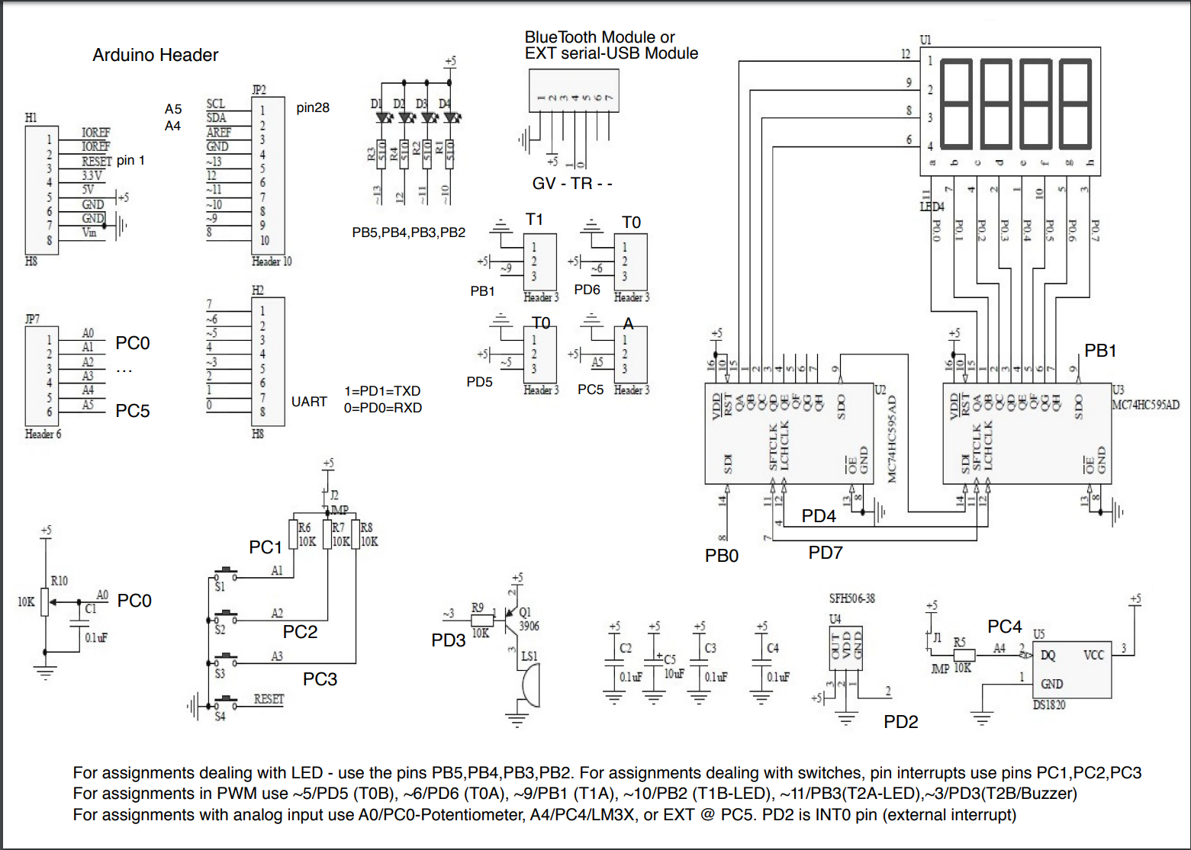

DC Motor

1. **INITIAL/MODIFIED/DEVELOPED CODE OF TASK 1/A**

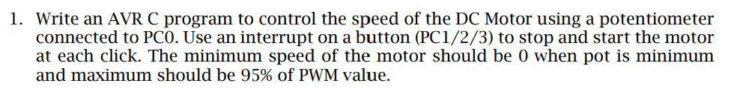

/*

* CPE301_DA4A_V2.c

*

* Created: 4/13/2019 2:29:12 PM

* Author : Cody

*/

//include header file

#define *F_CPU* 16000000UL

#include <avr/io.h>

#include <avr/interrupt.h>

#include <util/delay.h>

//Global variables

volatile unsigned int ADC_Val; // holds value of ADC

int flag = 0; // used to toggle

int main(void){

//Set DDR's

DDRB |= (1<<PB1)|(1<<PB5); //PB1 and PB5 as outputs PB5 is the first LED

DDRC = 0; //PORTC as input

PORTB = 0; //reset portb to low

PORTC |= (1<<PC1); //set PC1 high

// Initialize Timer 1

TCCR1A |= (1<<COM1A1)|(1<<COM1B1)|(1<<WGM11); // Fast PWM, Non-inverted mode

TCCR1B |= (1<<WGM13)|(1<<WGM12)|(1<<CS11); // Pre-scaler set to 8

ICR1 = 9999; // Top of timer1 set to 9999

// Set interrupts

PCICR = (1<<PCIE1); //Enable PCINT

PCMSK1 = (1<<PCINT9); //Set interrupt for PC1

//Set up ADC

ADMUX = (1<<REFS0); // PC0 is input for ADC

ADCSRA |= (1<<ADEN) | (1<<ADPS2) | (1<<ADPS1) | (1<<ADPS0); // enable ADC, system clock used for ADC

ADCSRB = 0x0; // free running mode

DIDR0 = 0x1; // Filter out any digital signals

sei(); //Enable interrupts

while (1); //infinite loop

}

//ISR for PC1

ISR(PCINT1_vect){

*_delay_ms*(500); //Debounce delay. Button needs to be held to toggle

if(!(PINC & (1 << PINC1))){

while(!(PINC & (1 << PINC1))){

if(flag == 1){

PORTB |= (1 << PORTB1) | (1 << PORTB5); //turn on OC1A and LED off

ADCSRA |= (1 << ADSC); // start conversion

while((ADCSRA&(1<<ADIF))==0){ // wait for conversion to finish

ADC_Val = ADC & 0x03FF; // we only need first 10 bits

OCR1A = 10*ADC_Val; // Calculate duty cycle

}

}

else if(flag == 0){

OCR1A = 0; //reset

PORTB &= ~(1 << PORTB1);

PORTB &= ~(1 << PORTB5); //turn off OC1A and LED on

}

}

flag ^= 1; //toggle

}

}

1. **DEVELOPED MODIFIED CODE OF TASK 2/A from TASK 1/A**

N/A There was no modified code

1. **SCHEMATICS**

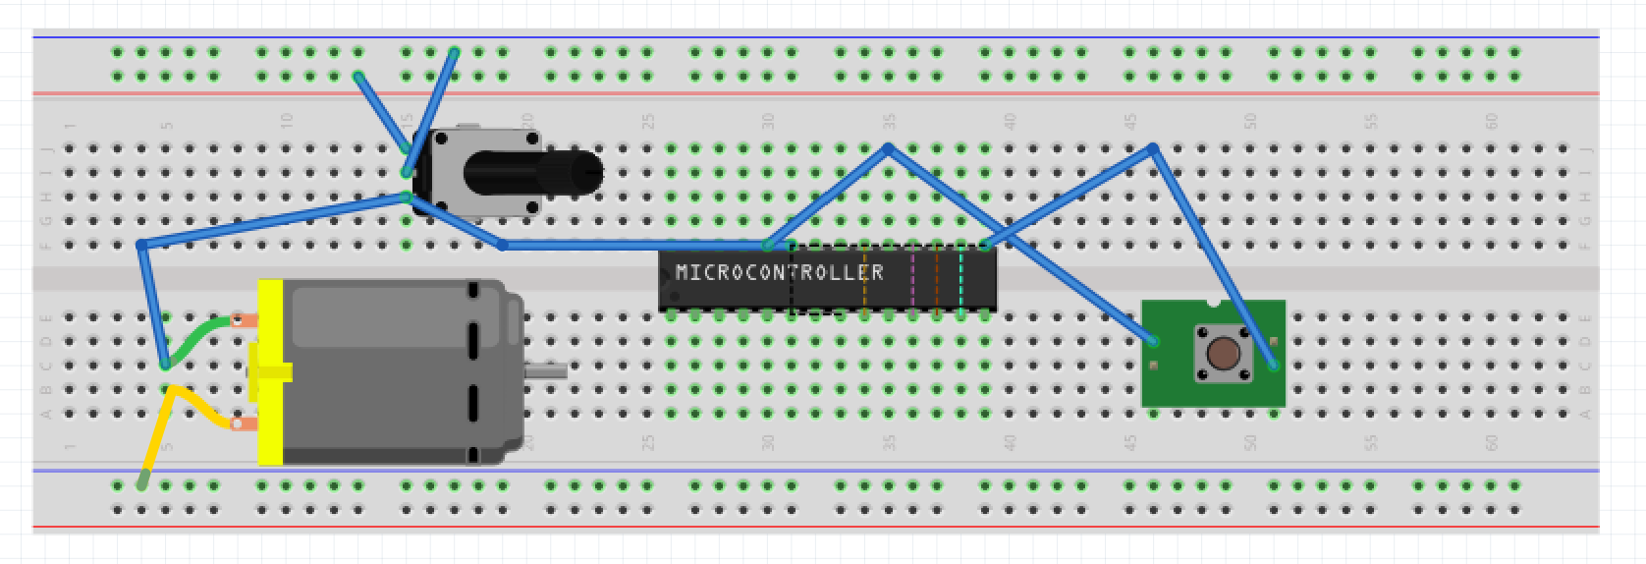

1. **SCREENSHOTS OF EACH TASK OUTPUT (ATMEL STUDIO OUTPUT)**

This design assignment had nothing to could’ve been output in ATMEL. View the youtube link below to view the demonstration of this assignment

1. **SCREENSHOT OF EACH DEMO (BOARD SETUP)**

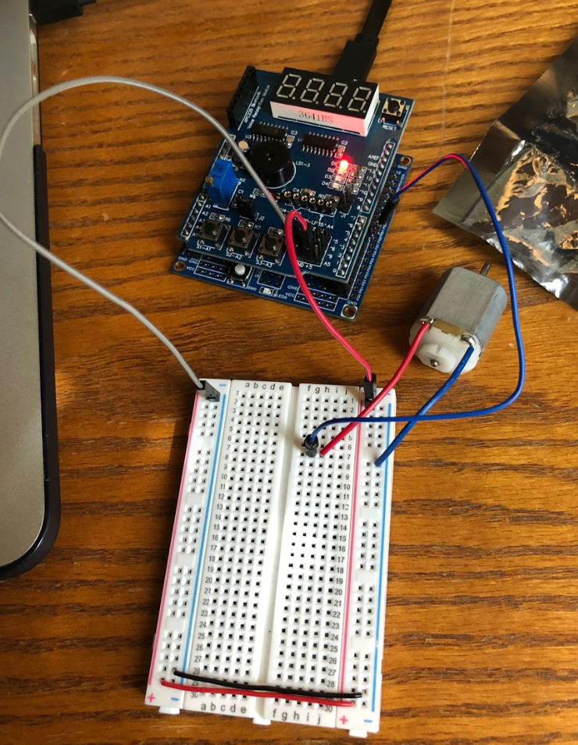

1. **VIDEO LINKS OF EACH DEMO**

https://youtu.be/5JJbQOJfGKg

1. **GITHUB LINK OF THIS DA**

https://github.com/elev8rProcrastinator/submission_da/tree/master/DA4A

**Student Academic Misconduct Policy**

<http://studentconduct.unlv.edu/misconduct/policy.html>

“This assignment submission is my own, original work”.

Cody McDonald