CPE301 – SPRING 2019

Design Assignment DA4B

Student Name: Cody McDonald

Student #: 5000382538

Student Email: mcdonc4@unlv.nevada.edu

Primary Github address: https://github.com/elev8rProcrastinator/submission_da.git

Directory: https://github.com/elev8rProcrastinator/submission_da/tree/master/DA4B

Submit the following for all Labs:

1. In the document, for each task submit the modified or included code (only) with highlights and justifications of the modifications. Also, include the comments.
2. Use the previously create a Github repository with a random name (no CPE/301, Lastname, Firstname). Place all labs under the root folder ESD301/DA, sub-folder named LABXX, with one document and one video link file for each lab, place modified asm/c files named as LabXX-TYY.asm/c.
3. If multiple asm/c files or other libraries are used, create a folder LabXX-TYY and place these files inside the folder.
4. The folder should have a) Word document (see template), b) source code file(s) and other include files, c) text file with youtube video links (see template).

1. **COMPONENTS LIST AND CONNECTION BLOCK DIAGRAM w/ PINS**

Atmini Xplained

Servo Motor

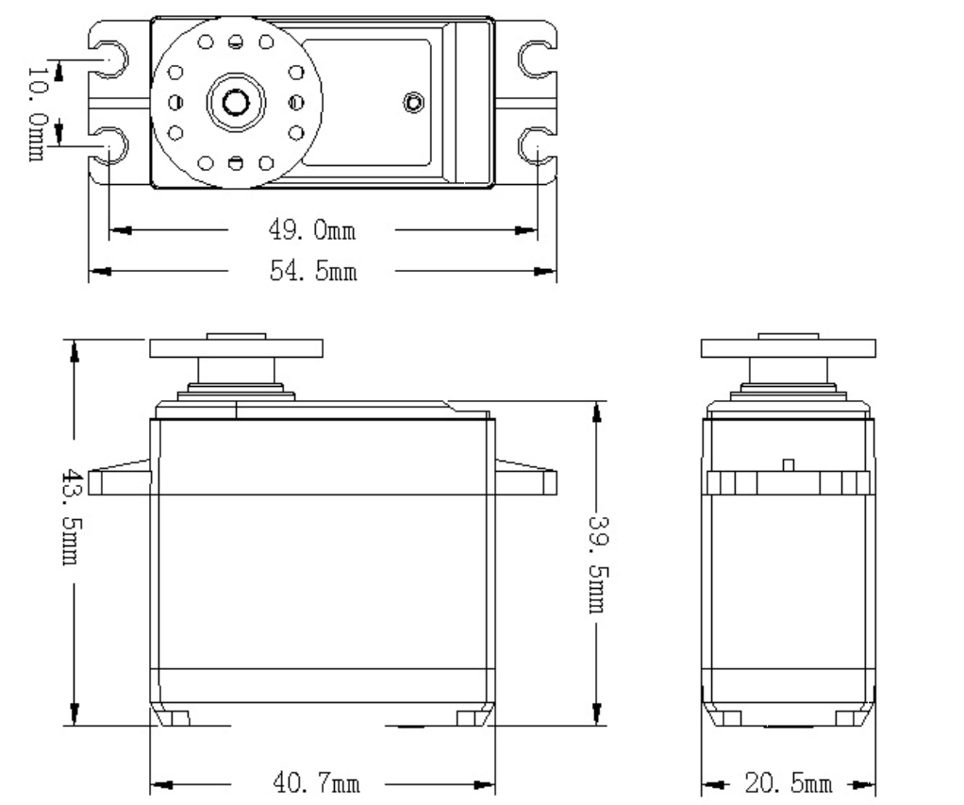

Stepper Motor

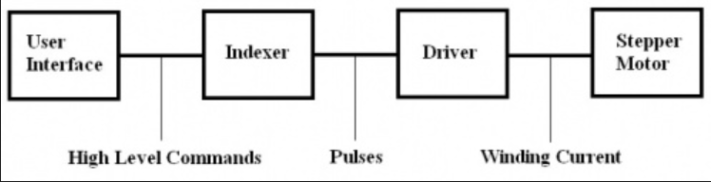

Stepper motor driver

50K potentiometer

1. **INITIAL/MODIFIED/DEVELOPED CODE OF TASK 1/A**



/*

* CPE310L_lab7_exp1.c

*

* Created: 4/12/2019 12:14:49 PM

* Author : Cody

*/

#define *F_CPU* 16000000UL

#include <avr/io.h>

#include <avr/interrupt.h>

#include <util/delay.h>

volatile unsigned int ADCVal;

void ADC_init();

void timer_init();

int main(void){

// initialize ADC

ADC_init();

//set timer

TCCR1B |=(1<<WGM12)|(1<<CS11); //CTC MODE prescaler = 8

// set DDR's

DDRB = 0xFF; //all outputs

DDRC = 0; //all input

PORTB = 0; //start at 0

while(1){

ADCSRA|=(1<<ADSC);

while ((ADCSRA&(1<<ADIF))==0); //wait until done converting

ADCVal = ADC & 0x03FF; //take only 10 bits

OCR1A = 10*ADCVal; //scale for proper delay

//procedure for PB0

PORTB |= (1<<PB0);

while(!(TIFR1 & (1<<OCF1A))); //wait until timer flag is set. repeat

TIFR1 |= (1<<OCF1A);

PORTB &= ~(1<<PB0);

while(!(TIFR1 & (1<<OCF1A)));

TIFR1 |= (1<<OCF1A);

//procedure for PB1

PORTB |= (1<<PB1);

while(!(TIFR1 & (1<<OCF1A)));

TIFR1 |= (1<<OCF1A);

PORTB &= ~(1<<PB1);

while(!(TIFR1 & (1<<OCF1A)));

TIFR1 |= (1<<OCF1A);

//procedure for PB2

PORTB |= (1<<PB2);

while(!(TIFR1 & (1<<OCF1A)));

TIFR1 |= (1<<OCF1A);

PORTB &= ~(1<<PB2);

while(!(TIFR1 & (1<<OCF1A)));

TIFR1 |= (1<<OCF1A);

//procedure for PB3

PORTB |= (1<<PB3);

while(!(TIFR1 & (1<<OCF1A)));

TIFR1 |= (1<<OCF1A);

PORTB &= ~(1<<PB3);

while(!(TIFR1 & (1<<OCF1A)));

TIFR1 |= (1<<OCF1A);

}

}

void ADC_init(void){

DIDR0 = 0x1;

ADMUX = (1<<REFS0); //input is PC0

ADCSRA |=(1<<ADEN)|(1<<ADPS2)|(1<<ADPS1)|(1<<ADPS0);

ADCSRB = 0x0;

}

1. **INITIAL/MODIFIED/DEVELOPED CODE OF TASK 2/A**



/*

* CPE301_DA4B_task2.c

*

* Created: 4/20/2019 9:33:09 PM

* Author : Cody

*/

#define *F_CPU* 16000000L

#include <avr/io.h>

#include <util/delay.h>

volatile unsigned int ADCVal;

int main(void) {

//Set DDR's

DDRB = 0xFF; // Set port B as output

//Set ADC

DIDR0 = 0x1;

ADMUX = (1<<REFS0); //input pc0

ADCSRA |=(1<<ADEN)|(1<<ADPS2)|(1<<ADPS1)|(1<<ADPS0);

ADCSRB = 0x0;

TCCR1B = (1<<WGM13)|(1<<WGM12)|(1<<CS11)|(1<<CS10); //fast PWM mode and prescaler = 64

TCCR1A = (1<<COM1A1)|(1<<WGM11); // Non-inverting PWM

ICR1 = 2500; // Top of counter

//Main body loop

while (1)

{

ADCSRA |= (1 << ADSC); //start ADC conversion

while((!ADCSRA) &(1<<ADIF)); // Wait for conversion

OCR1A = ADC/2 ; //Set pwm with ADCValue

}

}

1. **DEVELOPED MODIFIED CODE OF TASK 2/A from TASK 1/A**

N/A There was no modified code

1. **SCHEMATICS**

Refer to board demos for connections of the motors and drivers to the pins on the microcontroller

1. **SCREENSHOTS OF EACH TASK OUTPUT (ATMEL STUDIO OUTPUT)**

This design assignment had nothing to could’ve been output in ATMEL. View the youtube link below to view the demonstration of this assignment

1. **SCREENSHOT OF EACH DEMO (BOARD SETUP)**

**Task 1**

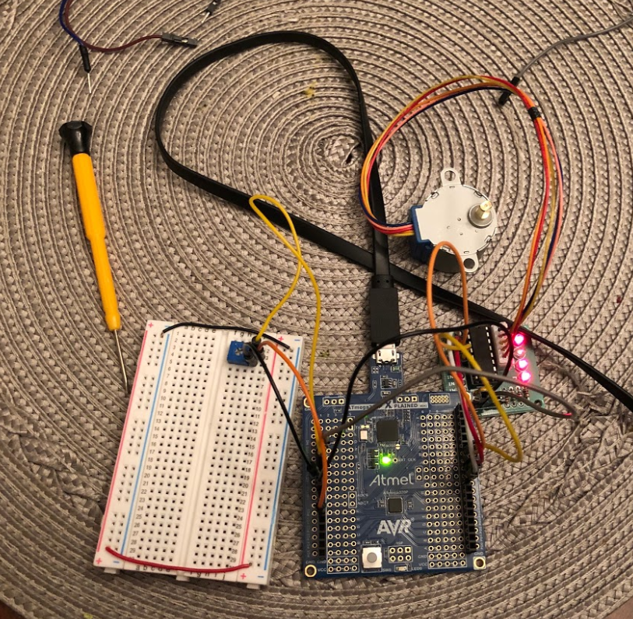

**Task2**

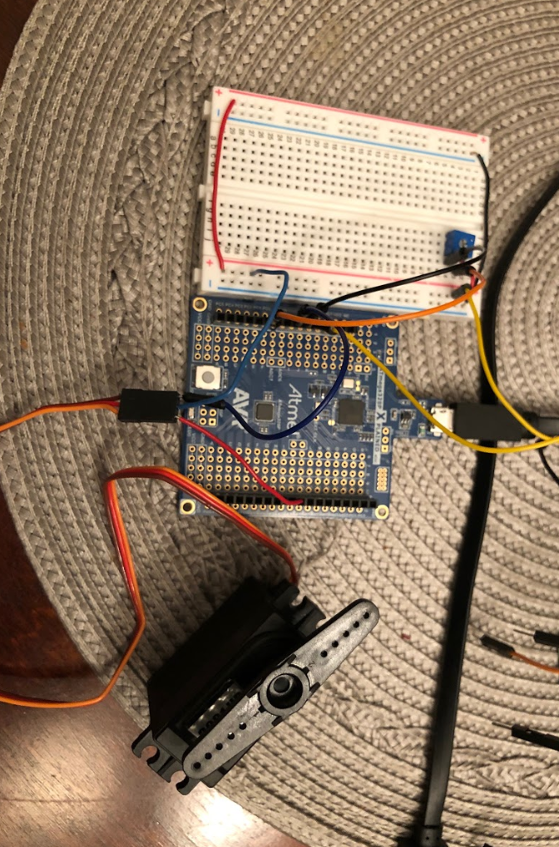

1. **VIDEO LINKS OF EACH DEMO**

**Task1:**

[**https://youtu.be/rJCKwL2PpfI**](https://youtu.be/rJCKwL2PpfI)

**Task2:**

**https://youtu.be/Vz7Zk6x1j0Y**

1. **GITHUB LINK OF THIS DA**

https://github.com/elev8rProcrastinator/submission_da/tree/master/DA4B

**Student Academic Misconduct Policy**

<http://studentconduct.unlv.edu/misconduct/policy.html>

“This assignment submission is my own, original work”.

Cody McDonald