Adaptive Multi-Site Stimulation Control Using RL in an MDP
Learning sequential stimulation policies under state-dependent EEG response dynamics
Final Project Submission — Locked-Results Draft
Fatih Karatay and Cody Moxam
EN.705.741.8VL Reinforcement Learning
7 April 2026
Draft aligned to the locked result set and current figure package

Abstract
We study a finite-horizon Markov Decision Process (MDP) for adaptive multi-site stimulation in which an agent selects among four stimulation sites to maximize cumulative reward derived from stochastic EEG responses. The key sequential mechanism is that patient responsiveness changes over time as a function of stimulation history, moving between baseline, receptive, and non-receptive states. This makes future rewards depend on earlier actions and turns site selection into a genuine sequential control problem rather than a static bandit. Across three response-separation settings, two episode horizons, and three switching-cost levels, Value Iteration provides the optimal benchmark while Monte Carlo Control, Q-Learning, Expected SARSA, and Double Q-Learning serve as model-free comparators. In the locked result set, higher reward separation produces faster convergence and substantially better final return; switching cost reduces switching frequency but also increases time spent in the non-receptive state; and the learned policies develop nontrivial site-sequencing behavior that preserves favorable responsiveness. At the representative setting horizon=10 and c_switch=0.0, Value Iteration achieves mean final return 5.235 in high separation, while the strongest model-free method (Expected SARSA) reaches 4.674 and remains closest to optimal across all three separation regimes.

1. Introduction
Brain stimulation selection is often framed as a question of which site is best. In a static formulation, however, that problem can collapse into a bandit-like choice among fixed reward distributions. Our project instead studies a setting in which the immediate reward from stimulating a site depends on the current patient responsiveness state, and the responsiveness state itself changes stochastically as a function of the stimulation sequence. In this formulation, actions influence future state occupancy and therefore future reward, so the task is properly cast as reinforcement learning.
The agent must choose among four stimulation sites while balancing three competing goals: exploiting high-value sites, avoiding non-receptive degradation from over-stimulation, and switching strategically despite an explicit switching penalty. We compare Monte Carlo Control, Q-Learning, Expected SARSA, and Double Q-Learning against a model-based Value Iteration benchmark. The locked results now emphasize a representative long-horizon slice (H=10, c_switch=0.0) plus dedicated switching-cost analyses across c_switch ∈ {0, 0.1, 0.25}.

2. Methods

2.1 MDP formulation
We formulate the task as a finite-horizon, fully observed MDP with state s_t = (current site, patient state, t). The action space consists of four stimulation choices {S1, S2, S3, S4}. Patient responsiveness can be in one of three discrete states {baseline, receptive, non-receptive}, and each action produces an EEG observation in {favorable, neutral, unfavorable}.
Reward is +1, 0, or -1 for favorable, neutral, or unfavorable observation respectively, minus an optional switching penalty when the agent changes stimulation site. Repeated stimulation makes it more likely that the patient drifts into the non-receptive state, whereas switching promotes recovery toward baseline. This coupling between action history and future state occupancy is the key reason the problem is sequential rather than bandit-like.

2.2 Algorithms
We evaluate five algorithms: Monte Carlo Control (on-policy, first-visit), Q-Learning (off-policy temporal-difference control), Expected SARSA (on-policy temporal-difference control), Double Q-Learning (reduced maximization bias), and Value Iteration (model-based optimal benchmark).

2.3 Experimental setup
Experiments were run over a full-factorial design consisting of three response-separation settings (high, moderate, low), two episode horizons (5 and 10), three switching-cost levels (0, 0.1, 0.25), and five algorithms, for 90 total configurations. Model-free methods were averaged over 10 random seeds, and the current locked run uses 5000 training episodes per model-free configuration. The paper figures focus primarily on the long-horizon no-cost setting (H=10, c_switch=0.0), with dedicated switching-cost plots showing how behavior changes as c_switch increases.

2.4 Evaluation criteria
We evaluate learned behavior using average episodic return, convergence speed / learning curves, switching frequency versus switching cost, patient-state occupancy, site visit frequency, gap to the Value Iteration benchmark, and the stability comparison between Q-Learning and Double Q-Learning.

2.5 MDP summary
Component | Definition
State | (current site, patient state, t)
Actions | {S1, S2, S3, S4}
Patient states | {baseline, receptive, non-receptive}
Observations | {favorable, neutral, unfavorable}
Reward | +1 / 0 / -1 with optional switching cost

3. Results

3.1 Learning performance improves with reward separability
Figure 1 shows a clear ordering across response-separation settings. In high separation, the temporal-difference methods climb rapidly and stabilize near mean episode return 4.6–4.7, Monte Carlo settles lower near 4.1, and the Value Iteration benchmark sits above them at roughly 5.24. In moderate separation, the same ranking persists but compresses downward around 3.1–3.3 for the stronger model-free methods and about 3.9 for Value Iteration. In low separation, all methods flatten near 1.8–2.0, with the benchmark around 2.34.
This is strong support for H1: clearer reward structure improves both learnability and asymptotic performance. The high-separation curve also highlights that Monte Carlo remains systematically behind the temporal-difference methods, whereas Q-Learning, Expected SARSA, and Double Q-Learning cluster closely together once the environment becomes sufficiently informative.
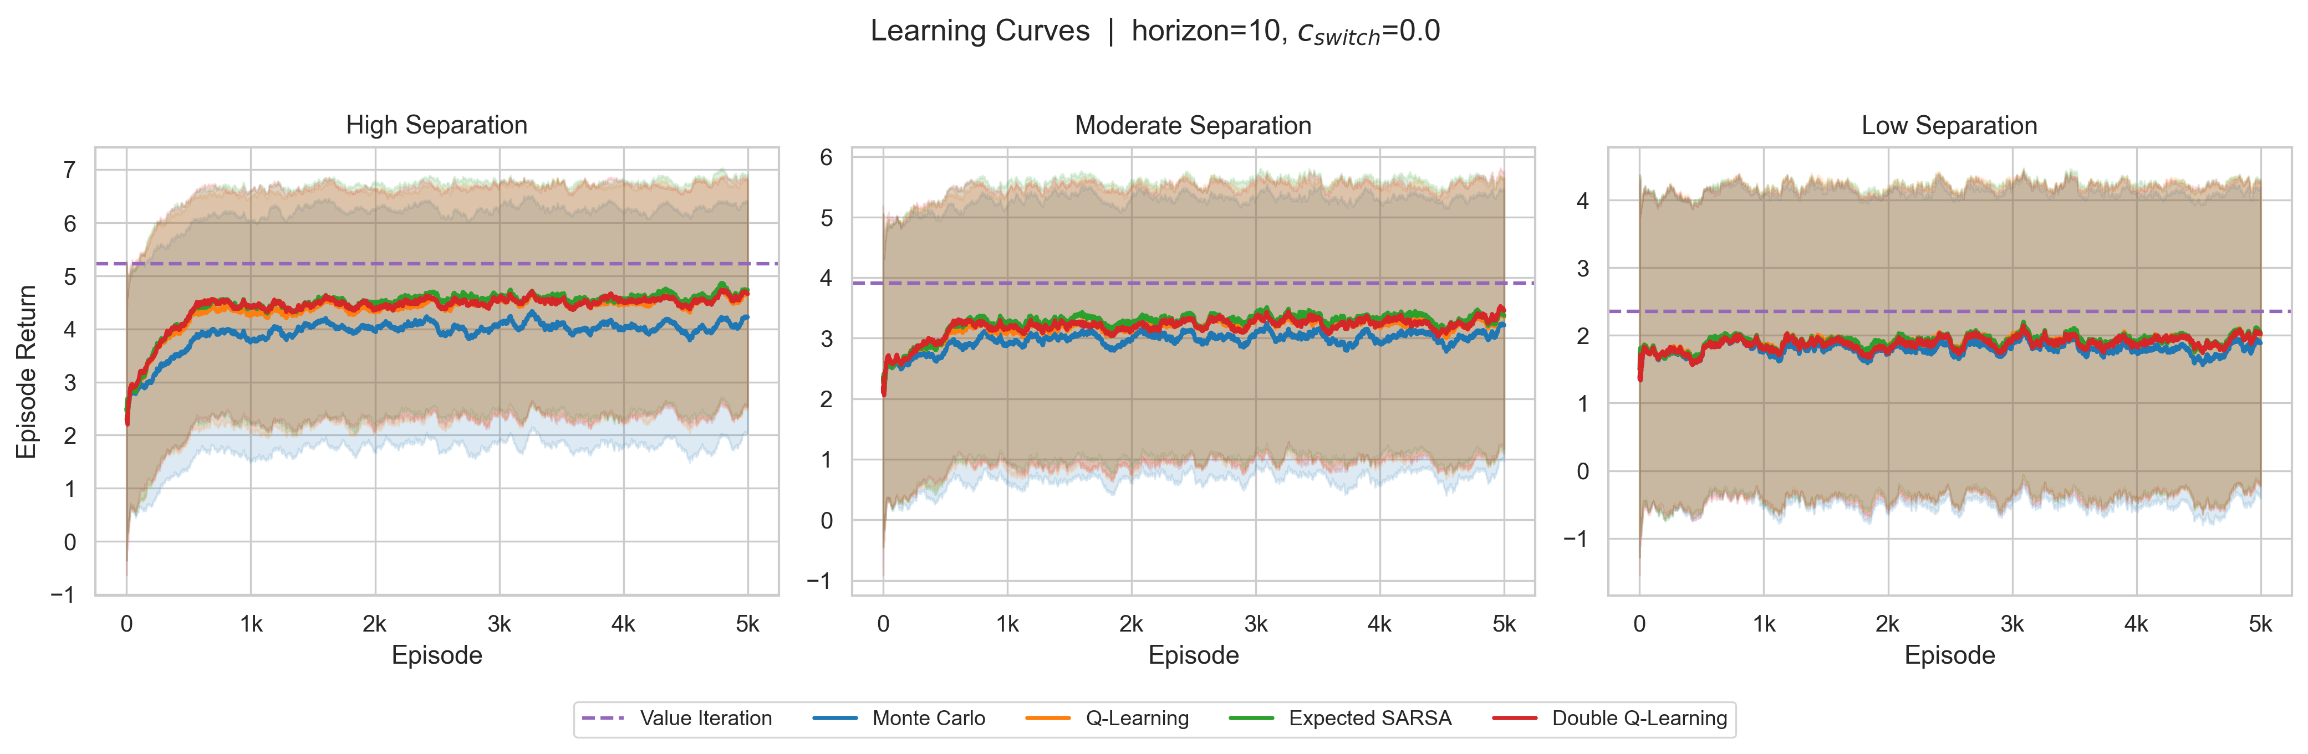
Figure 1. Learning curves for horizon=10 and c_switch=0.0. As separation increases from low to moderate to high, all methods converge to stronger final return. Value Iteration remains the upper-bound benchmark, while Expected SARSA, Double Q-Learning, and Q-Learning form the strongest model-free cluster.

3.2 Final cross-setting performance and gap to optimal
The heatmap in Figure 2 quantifies the cross-setting pattern. Value Iteration reaches 5.235 in high separation, 3.880 in moderate separation, and 2.340 in low separation. Among model-free methods, Expected SARSA is strongest in all three settings with mean final return 4.674, 3.323, and 1.965 respectively. Q-Learning and Double Q-Learning sit very close behind, while Monte Carlo trails the rest of the field.
These numbers show that the moderate setting is still learnable and materially easier than the low-separation case, even though it falls well short of the high-separation regime. They also provide a concrete reference point for H4: the model-based benchmark remains meaningfully above every model-free method, but the strongest model-free learners close a large portion of that gap.
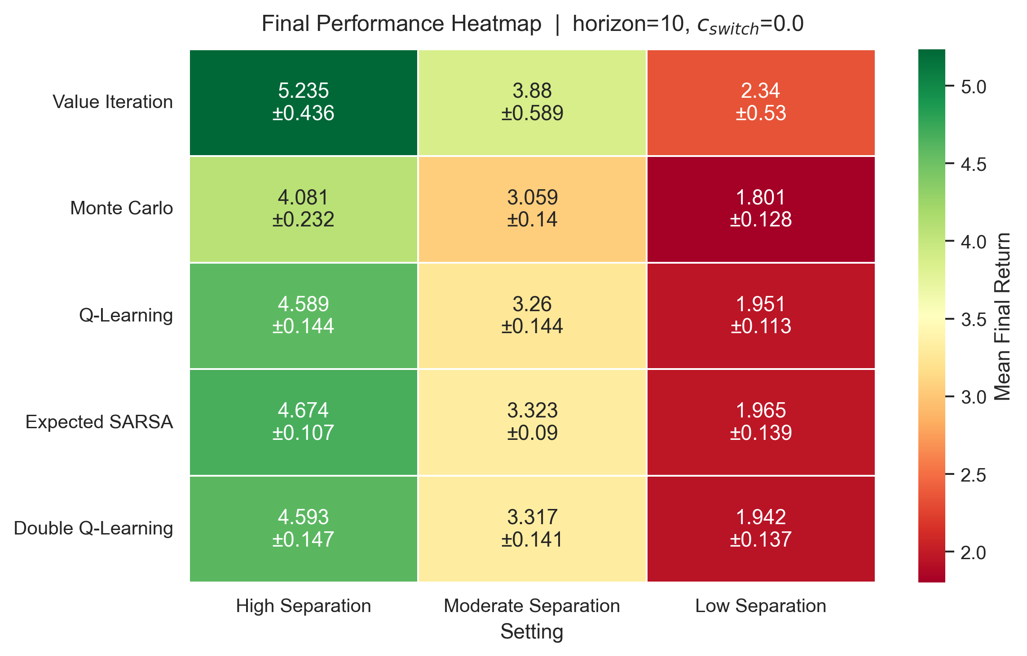
Figure 2. Mean final return heatmap for horizon=10 and c_switch=0.0. Value Iteration is best in every setting, while Expected SARSA is the strongest model-free method across the high, moderate, and low separation regimes in the locked result set.

3.3 Switching cost shapes policy behavior
Figure 3 isolates one of the most interesting patterns in the locked run. In the high-separation setting, increasing switching cost monotonically reduces switching frequency for every model-free method. For example, Q-Learning drops from about 0.51 to 0.30 switches per step as c_switch rises from 0.0 to 0.25; Expected SARSA drops from about 0.46 to 0.27; and Double Q-Learning drops from about 0.47 to 0.28.
At the same time, the fraction of steps spent in the non-receptive state increases. Q-Learning rises from about 0.205 to 0.273 non-receptive occupancy, Expected SARSA from about 0.214 to 0.275, and Double Q-Learning from about 0.218 to 0.278. This gives H2 strong support while also clarifying the mechanism: paying less switching cost by staying put can worsen state degradation, so good policies must balance both effects rather than blindly minimizing one term.
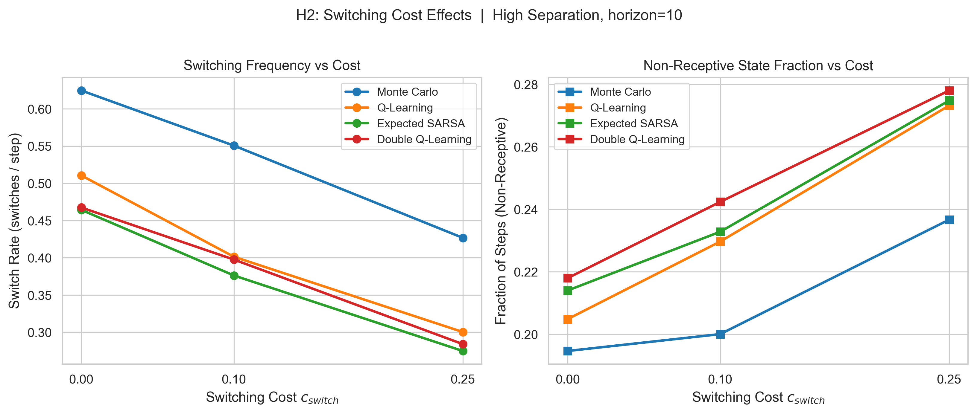
Figure 3. High-separation switching-cost effects at horizon=10. As c_switch increases, switch frequency falls for every algorithm, while time spent in the non-receptive state rises. The locked run therefore shows an explicit control tradeoff between avoiding switching penalties and avoiding state degradation.

3.4 Agents learn state-aware occupancy patterns
Figure 4 shows that all algorithms spend most of the episode in baseline and receptive states, with a smaller but still meaningful fraction in the non-receptive state. In the locked run, combined baseline plus receptive occupancy stays around 0.79–0.84 across the plotted settings. Value Iteration is consistently the most protective with respect to the non-receptive state, reaching approximately 0.177 in high separation, 0.177 in moderate separation, and 0.160 in low separation.
This pattern supports H5. Strong performance does not come from repeatedly exploiting a single site without regard to state. Instead, the better policies manage the patient-state trajectory so that high-value responses can be sustained over time.
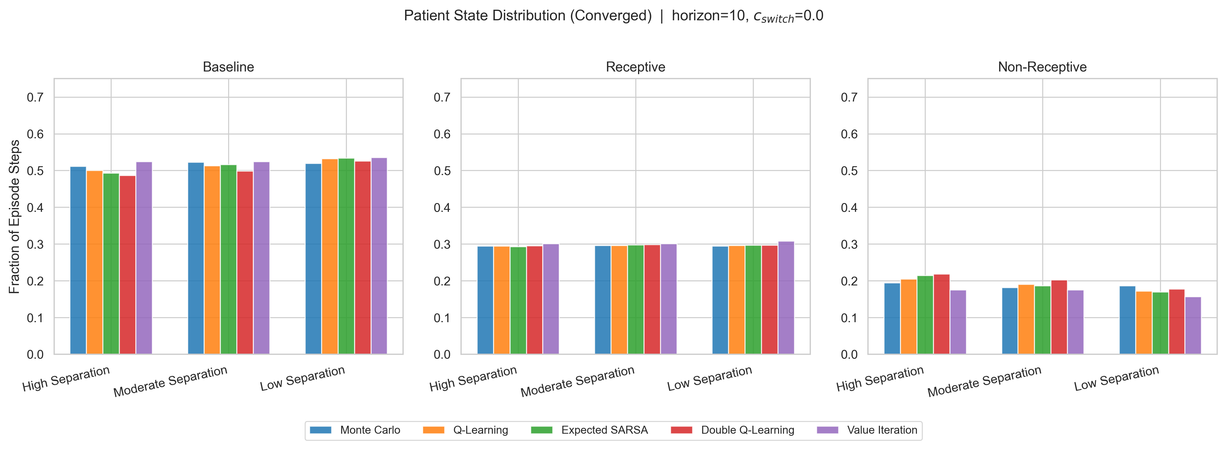
Figure 4. Converged patient-state occupancy for horizon=10 and c_switch=0.0. Across algorithms and settings, baseline plus receptive states account for the majority of episode time, while Value Iteration consistently spends the least time in the non-receptive state.

3.5 Site preference reflects reward structure
Figure 5 shows that all algorithms discover a strong preference for S1 in the high-separation setting. Value Iteration places about 77% of converged actions on S1 and almost never uses S3. The temporal-difference methods also concentrate heavily on S1, ranging from roughly 0.67 to 0.71, while Monte Carlo is more diffuse with only about 0.53 allocated to S1 and noticeably larger shares left for S2 and S4.
This confirms that the policies are not behaving randomly. They are exploiting a structured preference induced by the reward and transition model, while still reserving some probability mass for switching when the state trajectory makes it worthwhile.
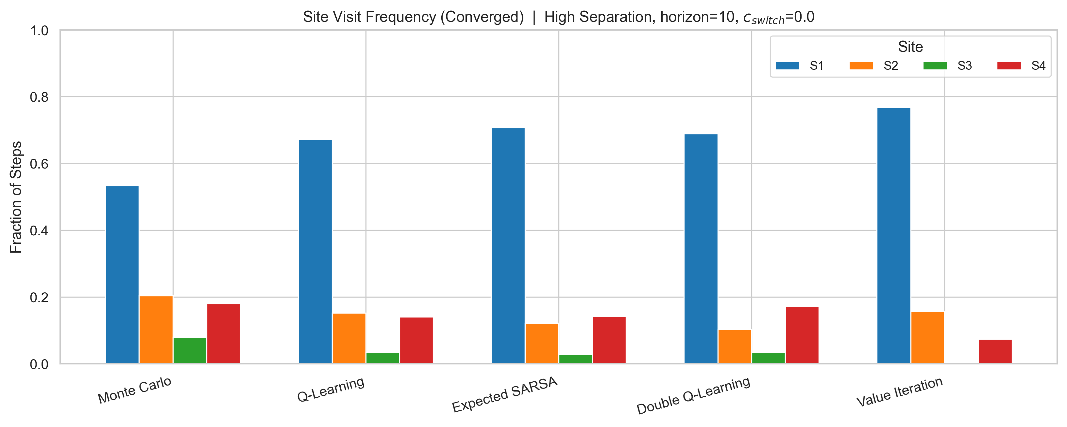
Figure 5. Converged site visit frequency in the high-separation setting at horizon=10 and c_switch=0.0. Every method concentrates primarily on S1, but Monte Carlo spreads visits more broadly across the other sites while Value Iteration is the most aggressively concentrated on S1.

3.6 Benchmark gap and stability comparison
Figure 6 shows that Expected SARSA is the closest model-free method to the Value Iteration benchmark in every separation regime. Its gap is approximately 0.56 in high separation, 0.56 in moderate separation, and 0.38 in low separation. Q-Learning and Double Q-Learning are very close behind, whereas Monte Carlo remains substantially further from optimal with gaps above 0.8 in the high and moderate settings.
This benchmark comparison is useful for H4 because it quantifies how much performance is still left on the table. Even when the model-free learners behave well, the optimal policy remains measurably better.
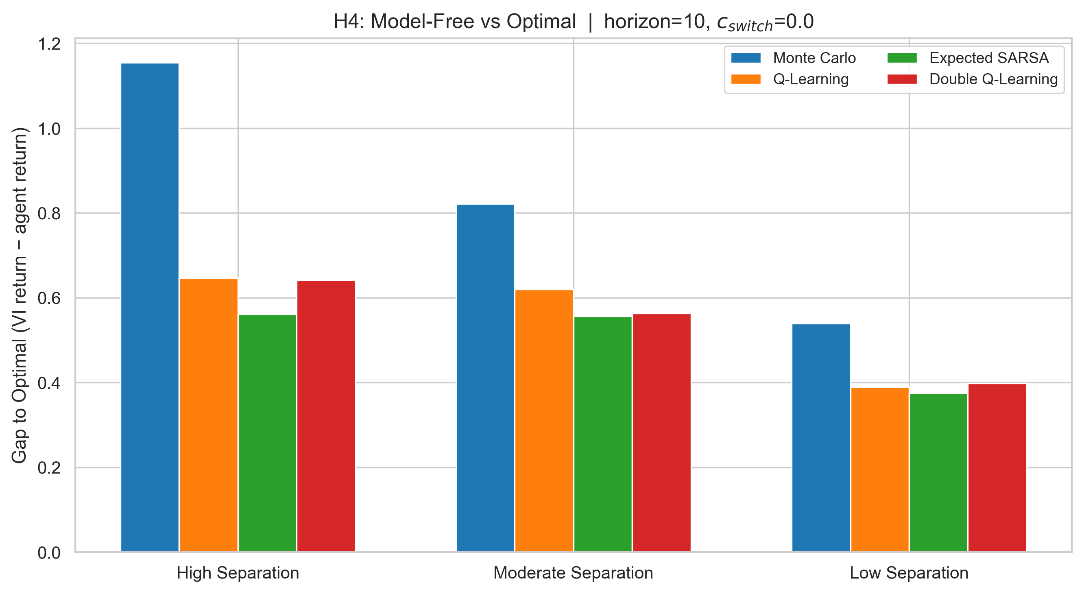
Figure 6. Gap to the Value Iteration benchmark for horizon=10 and c_switch=0.0. Expected SARSA has the smallest optimality gap across all three separation settings in the locked result set, while Monte Carlo remains the furthest from optimal.

3.7 Double Q-Learning shows only mixed stability benefits
Figure 7 compares the tail return distributions of Q-Learning and Double Q-Learning across the three separation settings. In high separation, the two methods are almost indistinguishable in both median and spread. In moderate separation, Double Q-Learning shows a modestly higher center than Q-Learning. In low separation, the pattern is again very close and does not indicate a strong or universal stability win for Double Q-Learning.
Accordingly, H3 receives only mixed support from the locked results. Double Q-Learning remains theoretically attractive as a reduced-maximization-bias alternative, but the empirical advantage is modest rather than dramatic in this experiment suite.
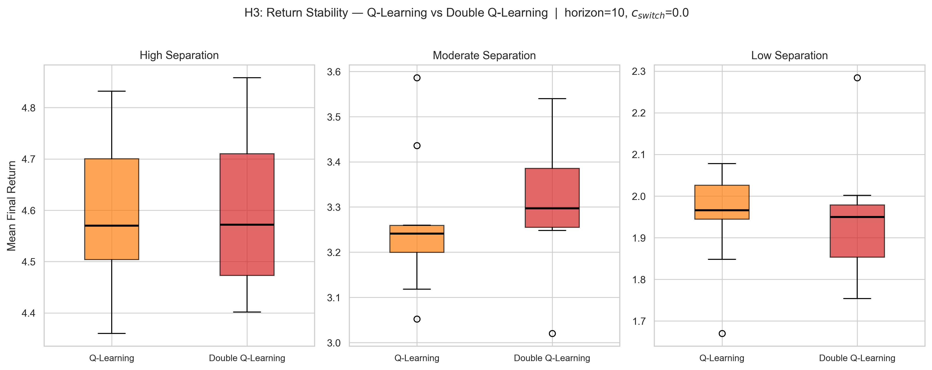
Figure 7. Tail mean-return distributions for Q-Learning and Double Q-Learning at horizon=10 and c_switch=0.0. The locked run shows only mixed evidence that Double Q-Learning is more stable: moderate separation favors Double Q-Learning slightly, while the high and low settings remain very similar.

4. Discussion
Overall, the locked result set reinforces the central claim of the project: once responsiveness becomes state-dependent and evolves stochastically with stimulation history, site selection is no longer a static action-choice problem. It becomes a sequential control problem in which performance depends on choosing when to stay, when to switch, and how to preserve favorable states.
The strongest evidence for this claim comes from the combination of results rather than any single plot in isolation. The learning curves and heatmap show that environment structure matters; the switching-cost plot shows that policies internalize c_switch; the occupancy and site-frequency plots show that the learned behavior is structured and state-aware; and the stability comparison provides an honest reminder that not every theoretical expectation emerges strongly in every representative setting.
A particularly useful locked-run insight is the tradeoff revealed in the switching-cost figure: reducing switching frequency can simultaneously increase non-receptive occupancy. That means better performance is not simply “switch less” or “switch more,” but rather “switch at the right times.” This is exactly the sort of temporal tradeoff that makes the environment an MDP rather than a bandit.

4.1 Hypothesis assessment
- H1 (Supported) — Higher reward separability improves learning and final return.
- H2 (Supported) — Increasing switching cost reduces switching frequency.
- H3 (Mixed) — Double Q-Learning is more stable than Q-Learning.
- H4 (Supported) — Value Iteration provides a useful upper-bound benchmark.
- H5 (Supported) — Agents learn state-aware sequential stimulation behavior.

5. Limitations
- The environment is a stylized simulation rather than a biophysically validated clinical model. Transition probabilities and EEG response distributions were engineered to create interpretable reinforcement-learning structure rather than calibrated from real data.
- The state and observation spaces are deliberately discrete. This is appropriate for a course project and keeps the analysis legible, but it limits direct clinical interpretation.
- The report emphasizes representative slices of the design space—primarily H=10, c_switch=0.0 plus switching-cost sweeps—rather than showing every configuration inline. The full locked result package still covers all 90 configurations.

6. Conclusion
We developed a finite-horizon MDP for adaptive multi-site stimulation control and compared Monte Carlo, Q-Learning, Expected SARSA, Double Q-Learning, and Value Iteration under state-dependent EEG response dynamics. The locked results show that reward separability strongly affects learnability, switching cost shapes sequential behavior, and model-free agents can approach—but not fully match—the optimal benchmark.
Most importantly, the project demonstrates that introducing responsiveness dynamics transforms stimulation-site selection into a genuine reinforcement-learning problem. The learned policies are not simply choosing a best site; they are managing temporal tradeoffs among exploitation, switching cost, and state degradation.

7. Reproducibility Note
All experiments in the locked package were produced through an end-to-end pipeline that runs the full factorial experiment suite, writes result artifacts, and exports figures for analysis. The draft therefore reflects a reproducible workflow rather than manual figure assembly.

Appendix A. Additional Diagnostic Figures
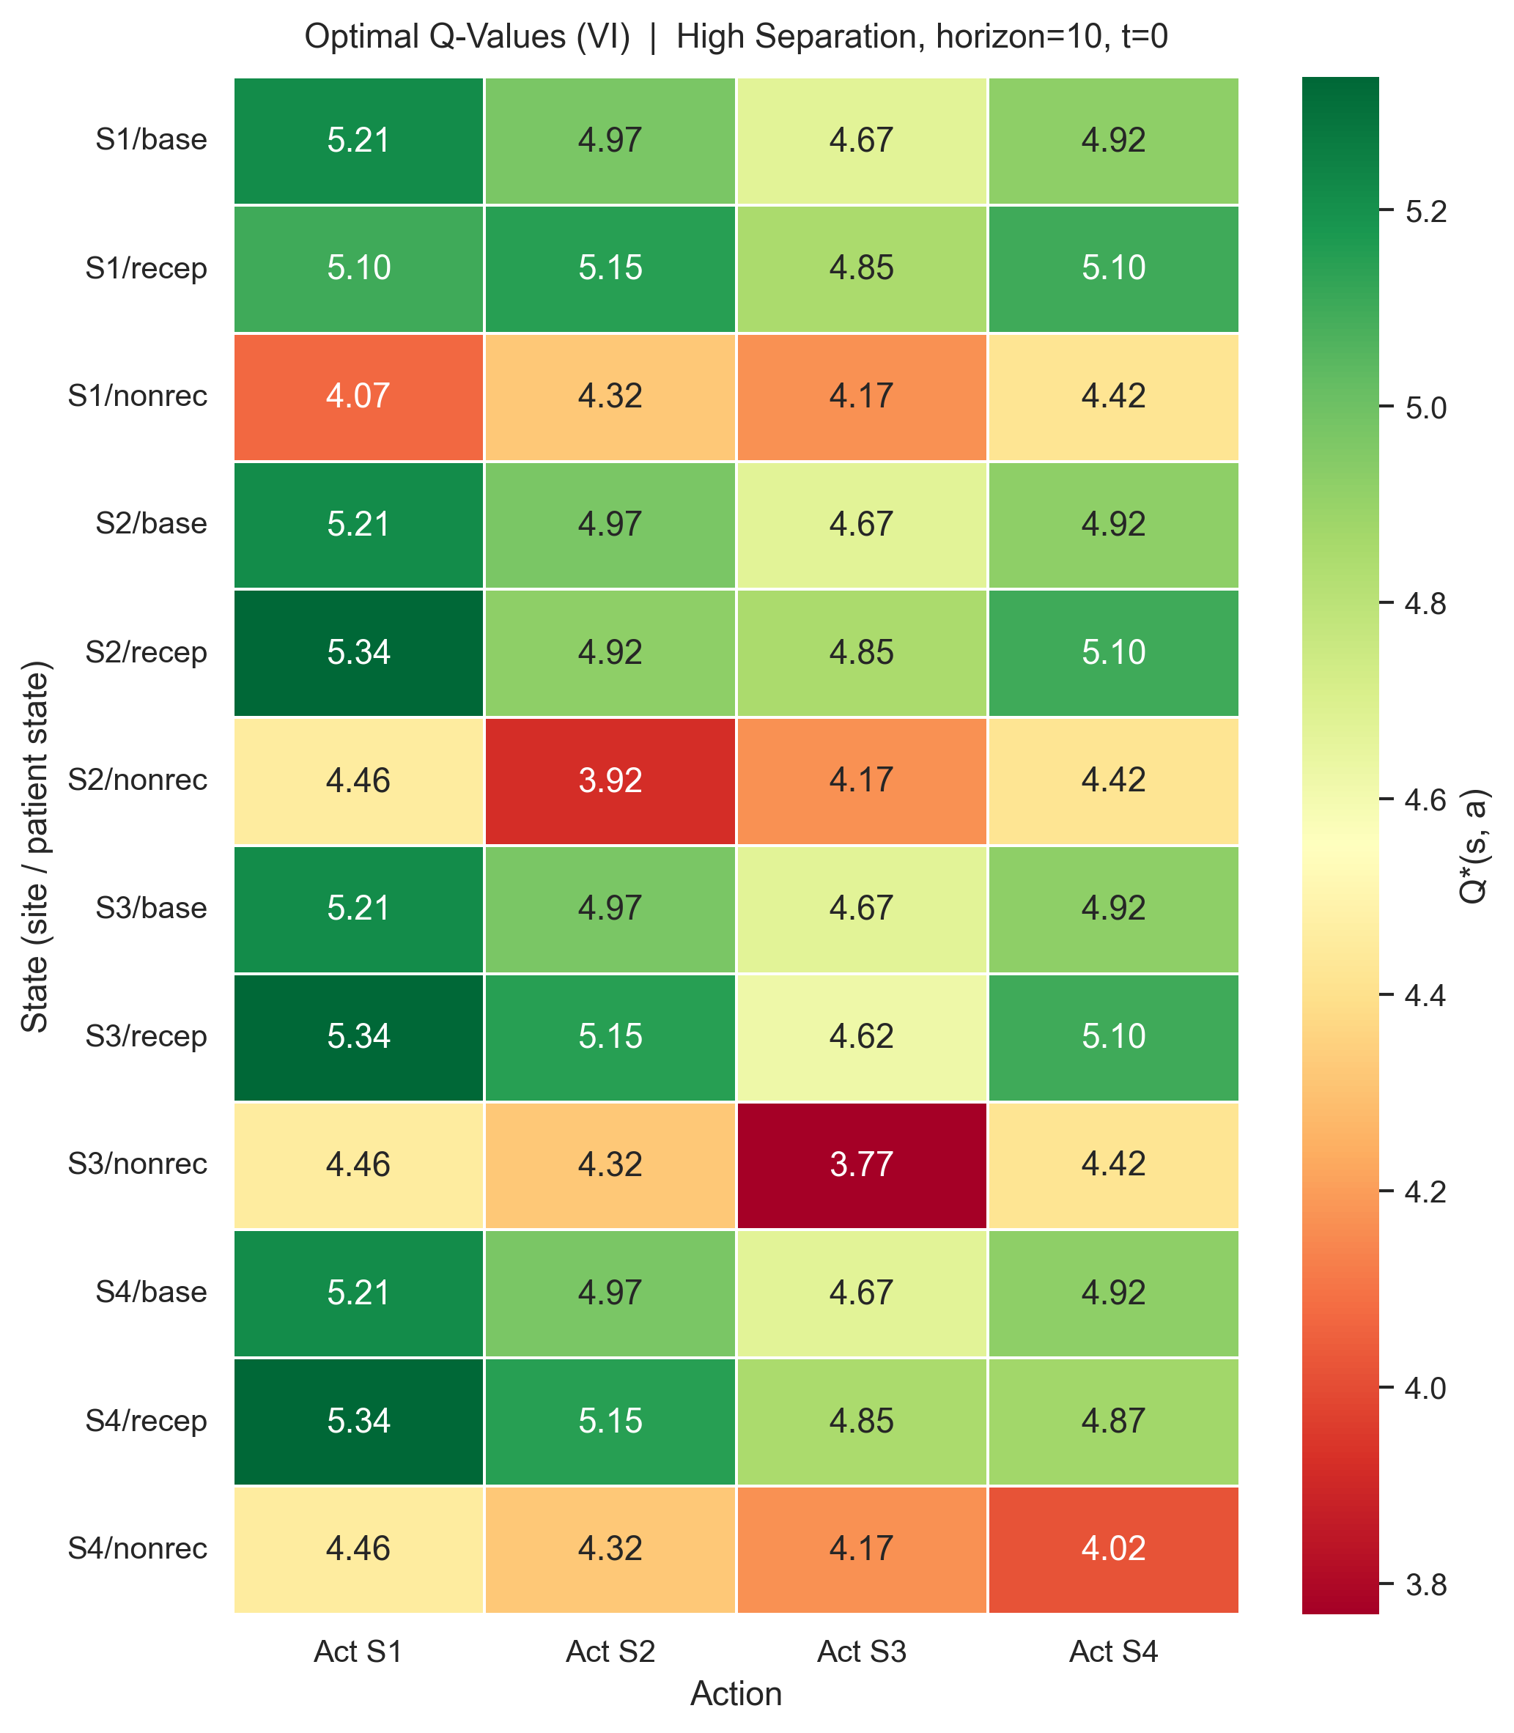
Figure A1. Optimal Q-value heatmap at t=0 in the high-separation setting (horizon=10). The optimal value surface favors S1 from most baseline rows, keeps S4 competitive in several states, and changes its preferred action in non-receptive states, confirming that the optimal policy is state-dependent rather than static.
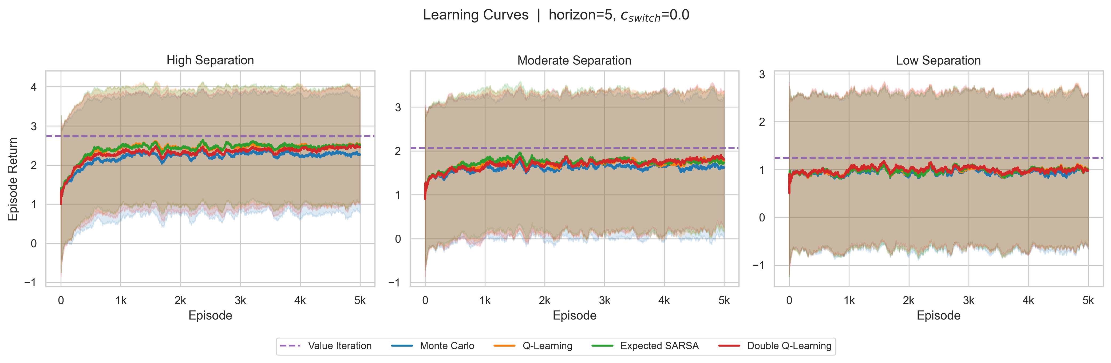
Figure A2. Learning curves for the short-horizon setting (horizon=5, c_switch=0.0). The same qualitative ranking holds as in the horizon=10 slice, but the achievable return scale is lower because the episode is shorter.
This draft was updated to match the locked results and figure package provided after the first submission draft.

