Final (Semester) Project
  - Presentation Share your results with the class
  - PowerPoint slides
  - Duration TBD
  - Either Week 13 (21 April) or Week 14 (28 April) Volunteer for Week 13 presentations via email to instructor NLT midnight tomorrow (Wednesday 8 April)
  - Week 13 presentations might have more time available
  - Week 13 presentations can take advantage of questions/feedback

  - Final Report Full technical paper (Abstract, Introduction, etc.)
  - Try to limit to 10 pages
  - Do not need to provide me access to your code (but you can if you wish)
  - Be on time! I will not accept submissions after 4 pm EDT on Tuesday 28 April

Feedback on Project Reports
- A few of the project papers that have been submitted are quite good. However, I have been disappointed by many of the other project papers
- The most serious deficiency noted is stating the one type of agent performs better than the other type of agent based simply on the difference between the observed performance measure (average episodic return), without considering the stochastic nature of the measure

RL Performance Measures are Random Variables
- Reinforcement learning agents are stochastic in nature
- Many reinforcement learning problems are also stochastic
- Consequently, the observed output can vary from agent to agent and situation to situation
- In other words, the output is a random variable
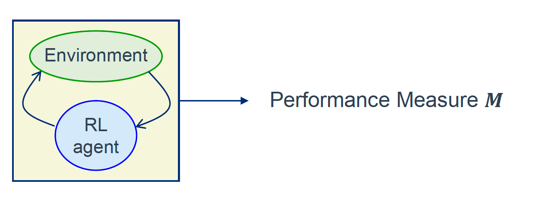
Random Variables
- An experiment has multiple outcomes 𝑥𝑖 _
- The sample space of a random variable 𝑿 _is the set of all possible experimental outcomes, 𝑋 _={𝑥1, 𝑥2, ⋯, 𝑥𝑖}
  - The value of a random variable is a mapping from the experiment outcome to a numerical outcome value. Thus, strictly speaking, a random variable is not a (conventional) variable at all, but is really a function which maps outcomes to outcome values

  - The different outcomes have different probabilities
  - If the same experiment is repeated infinitely many times, then the frequency with which different values of 𝑿 occur defines the probability distribution 𝑝 (𝑿 ) of 𝑿
Results as Samples from Probability Distributions
  - The episodic return for a given agent/environment is a random variable 𝑴 _with a probability distribution The distribution of 𝑴 _is a function of the a_g_e_n_t_’s_ _policy (and other factors)

- Consequently, the value of 𝑴 for a given agent and episode is an experimental outcome that was sampled from a probability distribution set in part by that agent’s policy
  - If you observe another agent, using the same algorithm and parameters and trained using the same number of episodes, you will probably obtain a different value of 𝑴 _
  - If you suspend training and have the same agent experience the same episode again, you will probably obtain a different value of 𝑴 _

  - As the agent trains, its policy changes and consequently so does the distribution of 𝑴
Comparing the Performances of Multiple Agents
- The episodic return for a given agent and environment is a random variable 𝑴 _with a probability distribution 𝑝 _𝑴 _
- The episodic return for a second agent in the same environment is a random variable 𝑵 _with a probability distribution 𝑝 _𝑵 _
- When you observe the value sampled from 𝑝 _𝑴 _and compare it to the value sampled from 𝑝 _𝑵 _, how do you know if any difference between the values results from true differences between the distributions or if the differences are just due to random chance?
- Answer: perform an appropriate statistical test

Averaging Across Agents
- By using multiple (identical) agents, the average of the episodic returns can be computed
  - This has three advantages: As the number of agents increases, the sample mean will tend toward the population mean
  - As the number of agents increases, the variance of the sample mean distribution will decrease
  - As the number of agents increases, the Central Limit Theorem states that the form of the distribution will tend toward a normal distribution

  - If you are going to determine a value for the performance measure and it is not constant across episodes, you should also average across several episodes Training should be suspended for the episodes that are being averaged, so that each agent is not changing its policy during the measurement

Additional Comments (1)
  - If you are using references, cite the relevant items in the text Citation:

“E_a_c_h_ _work cited in the text must appear in the reference list, and each work in the reference list must be c_i_t_e_d_ _i_n_ _t_h_e_ _t_e_x_t_._” _(_A_m_e_r_i_c_a_n_ _P_s_y_c_h_o_l_o_g_i_c_a_l_ _A_s_s_o_c_i_a_t_i_o_n_,_ _2_0_2_0_,_ _p_._ _2_5_7_)_ _
  - Reference:

American Psychological Association. (2020). Publication manual of the American Psychological Association (7th ed.). https://doi.org/10.1037/0000165-000
- Note: the examples above are from the APA standard. There are other standards – make sure you use the correct one (i.e., the one specified by the journal/conference)
- If you are citing from a book or lengthy document, include the page number(s). Don’t make the reader search through the whole book.
- If you copy text, a picture, a plot, or a figure from somewhere, cite it.
Additional Comments (2)
- Use pictures as appropriate to clarify descriptions, especially to describe tasks that are not commonly-known problems or approaches
- Be ready to justify statements made (with the possible exception of those in the discussion section)
- Be careful with making assumptions about convergence. The algorithm has converged when the policy stops changing during training. That means that no Q value is changed (tabular RL) or that no function parameter is changed (approximate RL) during subsequent episodes
- Performance measures need to be clearly and unambiguously stated and explained
- The first mention of figures or tables should occur in text preceding the figures or tables themselves.
Additional Comments (3)
- The first few episodes for a naïve agent are generally random and not very meaningful. If you plot them, the more meaningful later episodes will get compressed against the top of the plot.
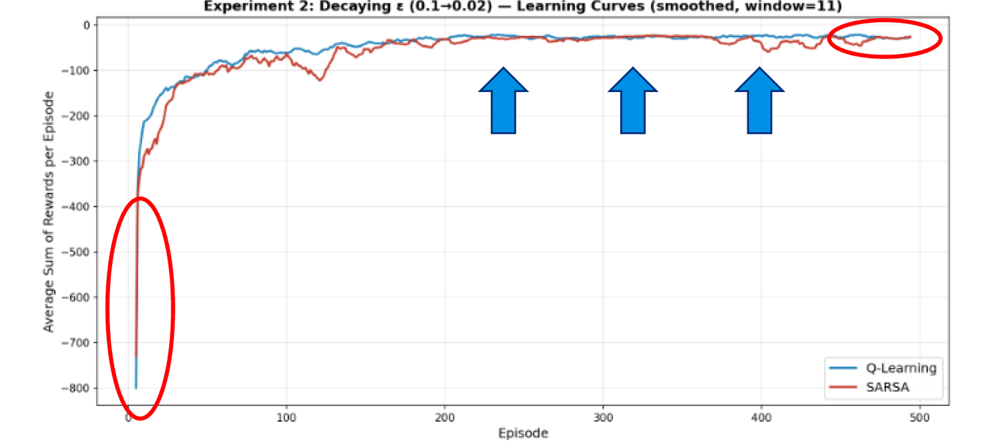
- This plot accompanied the statement: “Q-learning outperformed SARSA in this setting, …”. If so, the plot doesn’t seem to provide much evidence to support this.
Additional Comments (4)
  - Hypotheses are unambiguous, testable, declarative statements. Prepare for them by defining terms in the preceding text
  - If you want to describe why you have chosen that particular hypothesis, do so in the text leading up to the statement of the hypothesis
  - Do not include anything in the hypothesis statement that you do not intend to formally prove, such as causality Ex: Q-learning outperforms SARSA because it is an on-policy algorithm

  - Governing propositions are logic entities consisting of definitions, axiomata, and assumptions Definitions are used to provide clarity
  - Axiomata are accepted without proof
  - Assumptions will need to be validated later

Additional Comments (5)
- Discuss data analysis methods, particularly statistical methods, in the methods section
- Standard tests and approaches do not need to be explained (avoid unnecessary tutorials), but the reasons for using a particular test, if not obvious, can be helpful
  - Avoid using a plethora of tests if not justified by the problem Unnecessary tests give the impression that you don’t know what you are doing

  - Review the slides that were posted earlier in the course about preparing technical papers. If you have additional questions, please see me.

