Slide 1

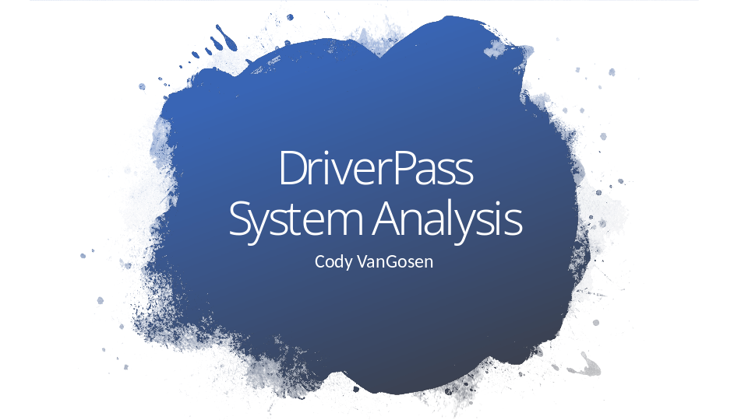

Good day! Thank you for joining me today for the DriverPass System Analysis presentation. My name is Cody VanGosen, and I will be walking you through the design and structure of the DriverPass system. This system is aimed at enhancing how users prepare for their driving tests by integrating functionalities such as online practice tests, lesson scheduling, and progress tracking. Let’s get started by looking at the requirements of the system.

Slide 2

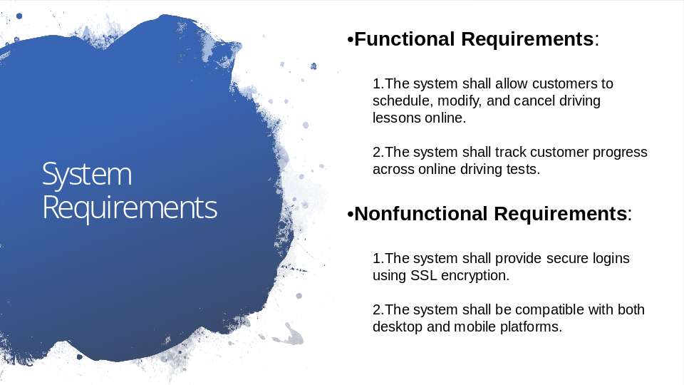

The DriverPass system has both functional and nonfunctional requirements that drive its core functionality. Functionally, the system must allow customers to easily schedule and manage their driving lessons, as this feature is central to DriverPass’s goal of improving test preparation. Additionally, it tracks progress across the online tests to give users insights into how well they’re preparing for the actual driving test.For the nonfunctional requirements, we have focused on security and accessibility. For instance, SSL encryption ensures that sensitive data, such as user credentials, remains secure during transmission. Similarly, ensuring compatibility across both desktop and mobile platforms means users can access the system regardless of the device they are using. This accessibility supports DriverPass’s mission to provide a seamless user experience across different technologies.

Slide 3

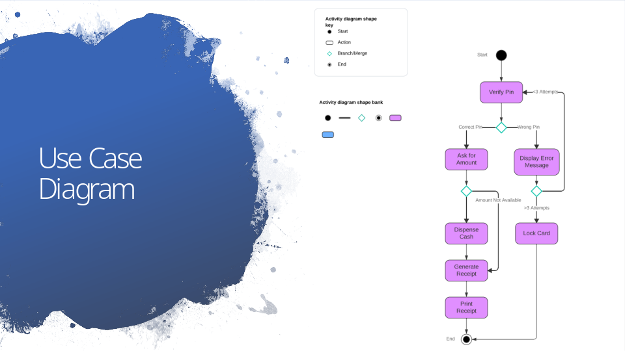

This diagram illustrates how the different types of users interact with the system. To explain this clearly, we have several categories of users—customers, administrators, office staff, and IT administrators. Each type of user interacts with the system in unique ways. For example, customers are able to schedule lessons, take practice tests, and track their progress, while administrators and office staff manage lesson schedules and customer data. This diagram also shows how we’ve structured the system to meet DriverPass’s needs by allowing users to perform key actions, like booking a lesson or reviewing test results, without needing any technical expertise.

Slide 4

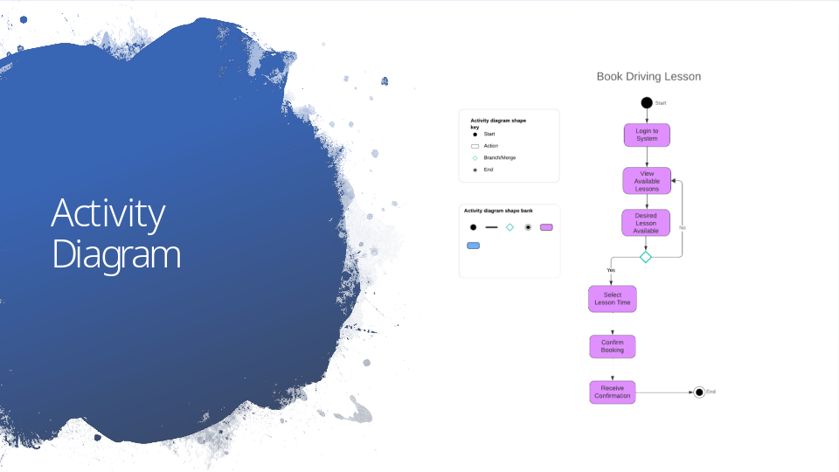

This diagram breaks down the steps involved in booking a driving lesson—a key function for DriverPass users. The process begins with the user logging in, selecting an available lesson, and confirming their booking. The system checks for any conflicts to ensure no overlapping lessons are scheduled. This clear step-by-step flow guarantees that customers can easily manage their lessons without worrying about scheduling issues. Additionally, it’s designed to be simple and intuitive, which reduces the likelihood of errors or user frustration, thus enhancing the overall user experience.

Slide 5

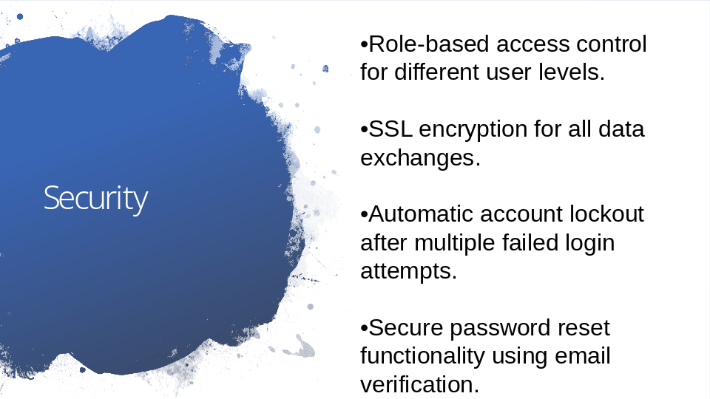

Security is one of the most important elements of this system, especially since users will be inputting sensitive information. The system employs role-based access control, which ensures that only the right people, such as administrators or office staff, can access certain features. All user data, including login credentials, will be securely transferred using SSL encryption to prevent unauthorized access. We’ve also built in an automatic account lockout feature to protect against brute-force hacking attempts. If someone tries to guess a password too many times, the account will lock, adding an extra layer of security. Lastly, in the event a user forgets their password, they can reset it through a secure email verification process. Each of these measures is designed to protect both the customers and the integrity of the system.

Slide 6

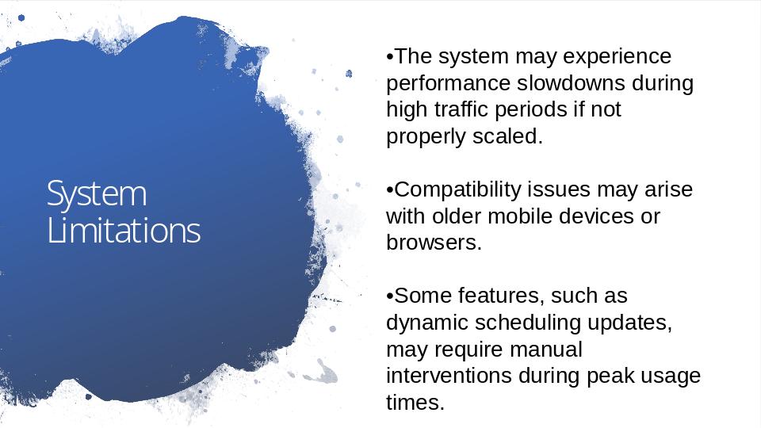

While the DriverPass system is designed to handle a wide range of tasks, there are some limitations to be aware of. First, if the system experiences a high volume of traffic, such as during peak testing or scheduling times, it may slow down if not scaled properly. This is something that can be addressed with additional server resources over time. Another potential limitation is compatibility. While the system is designed for modern browsers and devices, older mobile devices or web browsers may face some issues, though this would affect a small portion of users. Lastly, certain features like dynamic scheduling updates may require manual intervention if multiple users are scheduling lessons at the same time. This is another factor that could be improved in future updates. Overall, these limitations do not significantly detract from the system’s usability but are important to consider in long-term planning.

