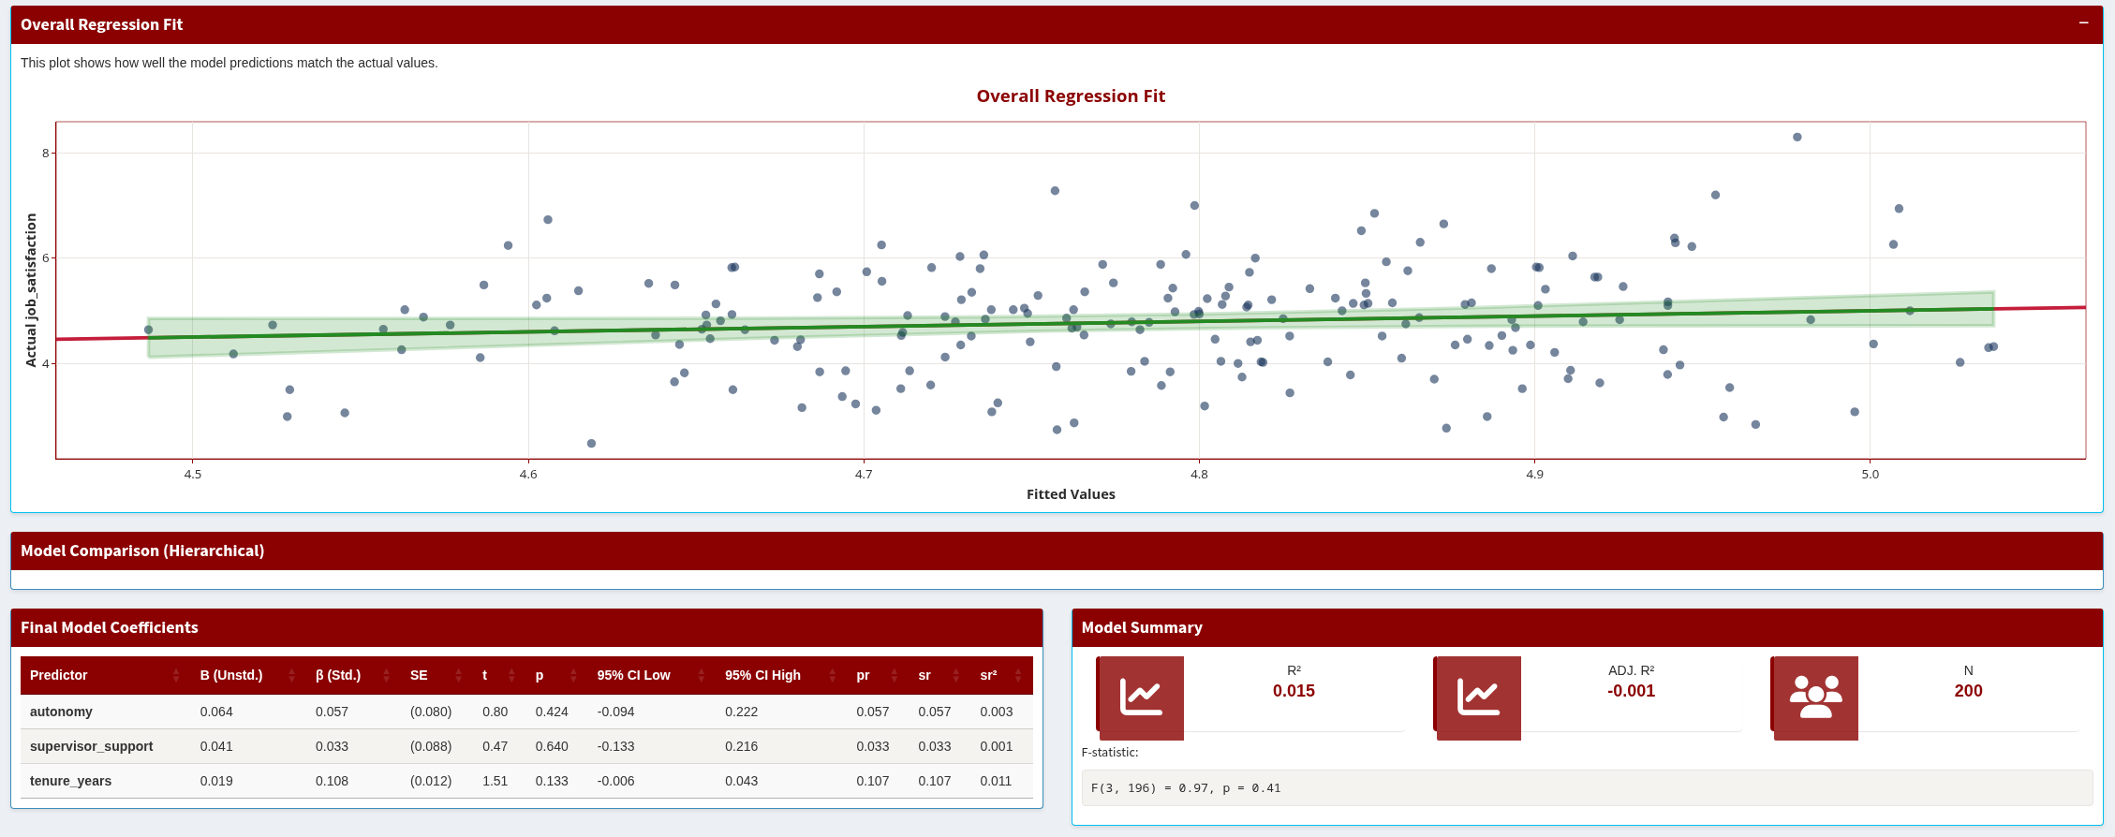
Hierarchical Regression Dashboard
User Guide & Application Documentation
Version 1.0 | March 2026

Table of Contents
1. Overview
2. Getting Started
3. Tab 1: Data Import
4. Tab 2: Variable Selection
5. Tab 3: Descriptive Statistics
6. Tab 4: Regression Analysis
7. Tab 5: Assumption Checks
8. Workflow Summary
9. Troubleshooting & FAQs
See companion document: Interpreting Tables & Output Guide

1. Overview
This application provides a point-and-click interface for conducting hierarchical multiple regression analysis. It is designed for I/O Psychology students, researchers, and professionals who need to run regression models but do not want to write R code directly.
The dashboard follows a five-step workflow that mirrors the typical regression analysis process taught in graduate-level statistics courses:
- Import your data (CSV, Excel, or SPSS)
- Select your dependent variable (DV) and organize independent variables (IVs) into hierarchical blocks
- Review descriptive statistics and correlations
- Run the hierarchical regression and inspect results
- Check regression assumptions with diagnostic tests and plots

Key Features
- Supports CSV (.csv), Excel (.xlsx, .xls), and SPSS (.sav) file formats
- Up to 5 hierarchical blocks for building nested regression models
- Automatic detection of variable types (continuous, categorical, identifier)
- Interactive Plotly visualizations with hover tooltips
- Comprehensive assumption testing with formal statistical tests and diagnostic plots
- Sample dataset included for learning and demonstration

Technical Stack
Component | Technology
Web Framework | R Shiny with shinydashboard
CSS Framework | AdminLTE (via shinydashboard) with custom Center of Organizational Effectiveness branding
Visualization | ggplot2 rendered through Plotly for interactivity
Statistical Engine | Base R lm(), car, lmtest, broom packages
Data Tables | DT package (DataTables.js wrapper)

2. Getting Started

Launching the Application
The application can be launched by running app.R from RStudio or from the R console. On first run, the pacman package manager will automatically install any missing dependencies.

Quick Start with Sample Data
The fastest way to explore the dashboard is with the built-in sample dataset:
- Click “Load Sample Data” in the left sidebar
- The app generates 200 simulated employee records with variables like job satisfaction, workload, autonomy, supervisor support, tenure, age, gender, and department
- You are automatically redirected to the Variables tab to begin building your model

Using Your Own Data
Navigate to Tab 1 (Data Import), click “Choose CSV, Excel, or SPSS File,” and upload your file. Requirements:
- The first row must contain column headers (variable names)
- Missing values should be coded as NA or left as blank cells
- Variables intended for regression must be numeric
- Categorical predictors (e.g., gender, department) are automatically dummy-coded by R’s lm() function

3. Tab 1: Data Import
This tab handles all data ingestion. It contains two main boxes and a data preview table.

Upload Data File (Left Box)
The file input widget accepts .csv, .xlsx, .xls, .sav, and .dta files. For Excel files with multiple sheets, a sheet selector dropdown appears automatically after upload. Column names are cleaned on import: converted to lowercase, special characters replaced with underscores, and duplicate underscores collapsed.

Data Summary (Right Box)
After successful import, this box displays:
- Row count: total number of observations in your dataset
- Column count: total number of variables
- Missing data summary: total missing cells and percentage

Data Preview
A scrollable, filterable table showing the first 100 rows of your data. Use the column filters at the top of each column to spot-check values. This table is powered by the DT (DataTables) package and supports searching and pagination.

4. Tab 2: Variable Selection
This is where you specify your regression model by selecting the DV and organizing predictors into hierarchical blocks.

Dependent Variable (DV)
The DV dropdown is populated with all continuous numeric variables detected in your data. Variables with 2 or fewer unique values are classified as categorical and excluded from DV options. The DV must be a continuous, numeric outcome variable (e.g., job satisfaction, performance rating, turnover intention) or a variable that is treated as continuous such as Likert items.

Hierarchical Blocks
Hierarchical regression enters predictors in sequential blocks to test whether adding new variables significantly improves model fit. The application supports up to 5 blocks.
- Block 1 is always visible. Click “Add Block” to reveal additional blocks.
- Each block’s dropdown shows all available variables (excluding the DV and the ID column).
- The “Reset” button hides blocks 2–5 and clears all selections.
- If the DV is changed after selecting predictors, any block that contained the old DV selection is automatically cleaned.
Note: In hierarchical regression, the order of blocks matters theoretically. Typically, control variables (e.g., demographics) go in Block 1, and your primary predictors of interest go in later blocks. This lets you test whether your key variables explain variance above and beyond the controls.

Variable Information Table
This table displays metadata for every variable in your dataset. It includes the variable name, detected R class, count and percentage of missing values, number of unique values, and the application’s suggested type classification (continuous, categorical, or identifier).

Model Specification Display
At the bottom of the tab, a green-highlighted panel shows the complete model formula. Each block’s formula is displayed separately, followed by the full model formula combining all blocks. This serves as a visual confirmation of your model before running the analysis.

5. Tab 3: Descriptive Statistics
This tab is populated automatically when you navigate to it, as long as you have selected a DV and at least one predictor. It computes statistics only for the variables in your model specification.

Continuous Variables Table
Displays standard descriptive statistics for all continuous variables in the model. See the companion Interpreting Tables guide for detailed column definitions.

Categorical Variables Section
For any variable classified as categorical, the app generates a frequency table showing each category’s count, percentage, and cumulative percentage.

Correlation Matrix Heatmap
An interactive heatmap displaying Pearson correlations among all numeric variables in the model. Cells are color-coded from red (negative) through white (zero) to navy (positive). Significance stars appear on each cell: * for p < .05, ** for p < .01, *** for p < .001. Hover over any cell for exact values.
Note: Review the correlation matrix before running regression. If any predictor pair has r > .80, multicollinearity may be an issue. The Assumptions tab will formally test this with VIF values.

6. Tab 4: Regression Analysis
Click the “Run Analysis” button at the top of this tab to execute the regression. The app fits all models, calculates change statistics, runs assumption checks, and then displays results. A progress bar indicates the current step.

Overall Regression Fit Plot
For models with one predictor, this shows a traditional scatter plot with the regression line. For multiple predictors, it displays a Fitted vs. Actual plot. In the fitted-vs-actual version, the red diagonal line represents perfect prediction; the green regression line shows the actual relationship. Points clustered tightly around the diagonal indicate good model fit.

Model Comparison (Hierarchical) Table
This table appears when you have 2 or more blocks. It shows each block’s coefficients side by side, plus model-level statistics (R², ΔR², F, ΔF) at the bottom. See the companion guide for detailed column interpretation.

Final Model Coefficients Table
This is the most detailed output table. It shows every predictor in the final (full) model with unstandardized coefficients (B), standardized coefficients (β), standard errors, t-values, p-values, 95% confidence intervals, partial correlations, semi-partial correlations, and unique variance contributions. See the companion guide for a thorough walkthrough of each column.

Model Summary
Info boxes display R², Adjusted R², and sample size (n) for the final model. Below these, the F-statistic with degrees of freedom and p-value is printed. For hierarchical models, these reflect the final model that includes all blocks.

R² Change Visualization
A bar chart showing the ΔR² (R-squared change) contributed by each block. Green bars indicate statistically significant changes (p < .05); gray bars indicate non-significant changes. The ΔR² value is printed above each bar.

Coefficient Plot
A forest-style plot showing each predictor’s unstandardized coefficient (B) as a point, with horizontal lines representing the 95% confidence interval. A dashed vertical line at zero serves as the reference; predictors whose confidence intervals do not cross zero are statistically significant. Red asterisks mark significant predictors (p < .05).

Partial Regression Plots
Also called Added Variable Plots, these show the unique relationship between each predictor and the DV after controlling for all other predictors. Each panel plots the partial residuals of one predictor against the partial residuals of the DV. The partial correlation (pr) is displayed in the subtitle. These plots require at least 2 predictors to be meaningful.

Note:
If you’ve selected a categorical variable as an IV, when you run the analysis here, there will be some errors and graphs that don’t load. The current version does not support categorical variables as predictors.

7. Tab 5: Assumption Checks
This tab runs automatically after the regression analysis completes. It tests the six key assumptions of OLS regression and provides both formal statistical tests and visual diagnostics.

Assumption Summary Table
A quick-reference table with one row per assumption showing pass/fail status and the key test statistic. A narrative summary below the table provides plain-language interpretation of each test.

Diagnostic Plots (Tabbed Panel)

Linearity Tab
Component + Residual Plots (also called partial residual plots). One facet per predictor. The red LOESS smoother should be approximately linear if the linearity assumption holds. Formal test: Rainbow test (p > .05 indicates linearity is met).

Normality Tab
Two plots: (1) A Normal Q-Q Plot of standardized residuals. Points should fall along the diagonal reference line. (2) A histogram of residuals with an overlaid density curve. The distribution should be approximately bell-shaped. Formal test: Shapiro-Wilk (p > .05 indicates normality).

Homoscedasticity Tab
Two plots: (1) Residuals vs. Fitted Values, where the red LOESS line should be flat and the spread of points should be roughly constant across the x-axis. (2) Scale-Location Plot showing the square root of absolute standardized residuals against fitted values. Formal test: Breusch-Pagan (p > .05 indicates constant variance).

Influential Cases Tab
Cook’s Distance bar chart with a red dashed threshold line at 4/n. Bars exceeding this line are labeled with their row number. Below the plot, a table lists all flagged observations with their Cook’s D, leverage, standardized residual, and studentized residual values.
Note: Assumption violations do not automatically invalidate your results, but they should be reported and addressed. Common remedies include transformations (e.g., log), robust standard errors (for heteroscedasticity), and sensitivity analyses excluding influential cases.

8. Recommended Workflow
- Import data or load the sample dataset
- Select your DV and organize IVs into theoretically meaningful blocks
- Check descriptive statistics: look for skewness, outliers, and high correlations
- Run the regression and inspect R², ΔR², coefficients, and significance
- Review assumption diagnostics; note any violations
- Iterate: adjust variable selection, consider transformations, re-run as needed

9. Troubleshooting & FAQs

Why is my variable not appearing in the DV dropdown?
The DV dropdown only shows continuous numeric variables. If your variable is stored as character/text or has very few unique values (≤6), it will be classified as categorical. Check the Variable Information table on Tab 2 to see how your variable was classified.

Why does the regression fail with “not enough complete cases”?
The application uses listwise deletion: any row with a missing value on any variable in the model is dropped. If your dataset has extensive missing data, the usable sample may be too small. Check the missing data summary on Tab 1 and consider imputation before importing.

Why are my categorical predictors showing strange coefficient names?
R’s lm() function automatically dummy-codes categorical variables. If you have a variable “department” with levels Engineering, HR, Marketing, and Sales, you will see coefficients like departmentHR, departmentMarketing, and departmentSales. The first level alphabetically becomes the reference category.

Why do I see 21 influential cases flagged?
The default Cook’s D threshold is 4/n, which for n = 200 is 0.02. This is a conservative threshold that flags roughly the top 10% of observations. Not all flagged cases are problematic; examine whether removing them changes your conclusions.

Can I export the results?
Tables displayed via can be copied in the traditional manner. Interactive Plotly charts have a camera icon in the toolbar that downloads the plot as a PNG.

