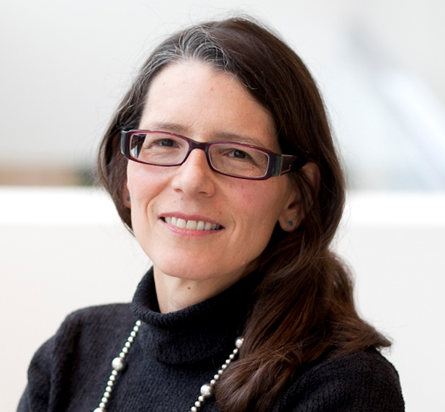**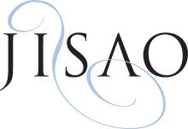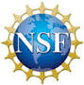******

*“Ocean science, policy, and conservation: A view from The PEW Charitable Trusts”*

**Wednesday,**

**January 15th 4:00pm**

**SAFS Auditorium (FSH 102)**

**Reception to follow**

**Dr. Rebecca Goldburg**

**Director, Ocean Science**

**The PEW Charitable Trusts**

**UW IGERT Program on Ocean Change**

**Winter 2014 Seminar Series**

To request disability accommodations, contact the University of Washington Disability Services Office at least 10 days in advance of the event at (206) 543-6450 or dso@u.washington.edu.

To request disability accommodations, contact the University of Washington Disability Services Office at least 10 days in advance of the event at (206) 543-6450 or dso@u.washington.edu.

To request disability accommodations, contact the University of Washington Disability Services Office at least 10 days in advance of the event at (206) 543-6450 or dso@u.washington.edu.

To request disability accommodations, contact the University of Washington Disability Services Office at least 10 days in advance of the event at (206) 543-6450 or dso@u.washington.edu.

To request disability accommodations, contact the University of Washington Disability Services Office at least 10 days in advance of the event at (206) 543-6450 or dso@u.washington.edu.

To request disability accommodations, contact the University of Washington Disability Services Office at least 10 days in advance of the event at (206) 543-6450 or dso@u.washington.edu.

To request disability accommodations, contact the University of Washington Disability Services Office at least 10 days in advance of the event at (206) 543-6450 or dso@u.washington.edu.

To request disability accommodations, contact the University of Washington Disability Services Office at least 10 days in advance of the event at (206) 543-6450 or dso@u.washington.edu.