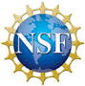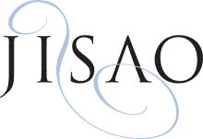

**February 12**

**Dr. Andrew Rosenberg**

Union of Concerned Scientists

“*Science, democracy and the changing ocean*”

**February 19**

**Dr. Ann Bostrom**

UW Evans School of Public Affairs

“*Ocean change: Information for action*”

**March 12**

**Dr. Ray Hilborn**

UW School of Aquatic and Fishery Sciences

“*Reflections on the robustness of different fisheries management systems to change*”

**January 15**

**Dr. Rebecca Goldburg**

The PEW Charitable Trusts

*“Ocean science, policy, and conservation:*

*A view from The PEW Charitable Trusts”*

**January 22**

**Dr. Brian Polagye**

UW Mechanical Engineering

“*Tidal energy and the environment:*

*Progress and challenges*”

**January 29**

**Sen. Kevin Ranker**

WA State Senate

“*Science, Policy, Politics, and Reality*”

**UW IGERT Program on Ocean Change**

**Winter 2014 Seminar Series**

**Wednesdays 4:00pm**

**January 15th – March 12th**

**SAFS Auditorium (FSH 102)**

**Reception to follow**

To request disability accommodations, contact the University of Washington Disability Services Office at least 10 days in advance of the event at (206) 543-6450 or dso@u.washington.edu.