Name: Jonathan Karamavros

ID#: 1071508

Assignment 2

Due Date: 10/12/2020

Submitted: 10/14/2020

Contents

Paper 1: A Stype-Based Generator Architecture for Generative adversarial Networks: 3

Paper 2: Steganographic Generative Adversarial Networks 5

## Normal GAN:

This network took the least time to train and also had the worst results. It would not train properly. The loss for the Generator increased infinitely. The Loss for the Discriminator became close to zero. The Generator did not seem to learn fast enough to fool the generator. Or maybe even learn properly at all. Below is the image produced by the generator.



## DC GAN:

The DCGAN had pretty good results. It takes a few hours to train on each dataset. Most of the MNIST digits look like numbers or similar to numbers. Some just look like squiggles. I also had good results with the Fashion-MNIST. The mostly look like the various clothing items. Some are a little bizarre looking. I did not have great results with the CIFAR-10. There are a few images that look like a car or a plane. But most of the images are not recognizable.

Figure : MNIST

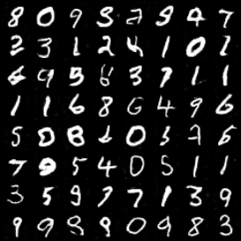

Figure 2: Fashion-MNIST

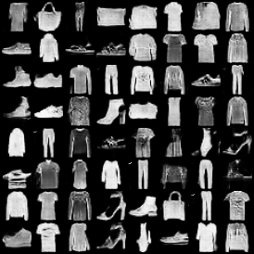

Figure 3: CIFAR-10

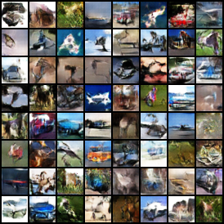

## WGAN with clipping:

Figure : MNIST

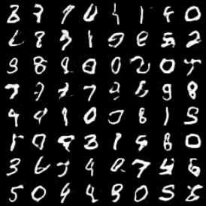

Figure 5: Fashion-MNIST

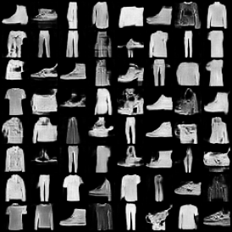

## WGAN with penalty:

Figure : MNSIT

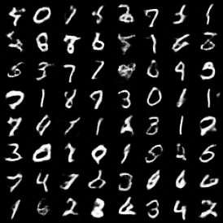

Figure 7: Fashion-MNSIT

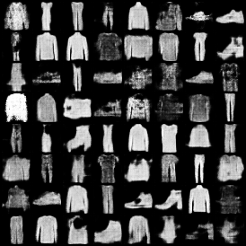

Figure 8: CIFAR-10

