Name: Jonathan Karamavros

ID#: 1071508

Assignment 2

Due Date: 10/12/2020

Submitted: 10/17/2020

Contents

Normal GAN: 3

DC GAN: 4

WGAN with clipping: 6

WGAN with penalty: 8

## Normal GAN:

This network took the least time to train and also had the worst results. It would not train properly. The loss for the Generator increased infinitely. The Loss for the Discriminator became close to zero. The Generator did not seem to learn fast enough to fool the generator. Or maybe even learn properly at all. Below is the image produced by the generator.



Figure : CIFAR-10 GAN

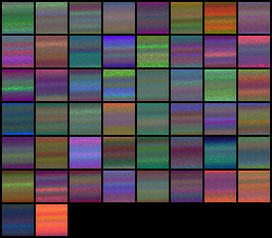

## DC GAN:

The DCGAN had pretty good results. It takes a few hours to train on each dataset. Most of the MNIST digits look like numbers or similar to numbers. Some just look like squiggles. I also had good results with the Fashion-MNIST. The mostly look like the various clothing items. Some are a little bizarre looking. I did not have great results with the CIFAR-10. There are a few images that look like a car or a plane. But most of the images are not recognizable.

Figure : MNIST DCGAN

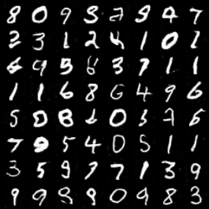

Figure : Fashion-MNIST DCGAN

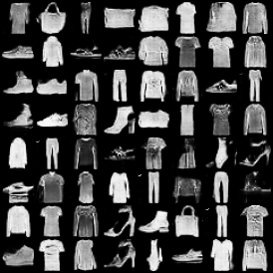

Figure : CIFAR-10 DCGAN

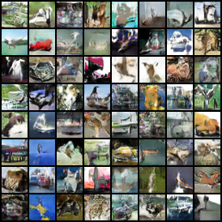

## WGAN with clipping:

The WGAN with clipping trained for 40000 generator iterations. This model took 8+ hours to train. I trained it on the MNIST and Fashion-MNIST datasets. I think it did marginally better than the DCGAN. Just about all of the numbers are recognizable. Some are very messy or blurry. The Fashion-MNSIT data was also marginally better in my opinion. Most pieces of clothing were recognizable and clear. The CIFAR-10 results were not great. All were very blurry and hard to recognize.

Figure : MNIST WGAN Clipping

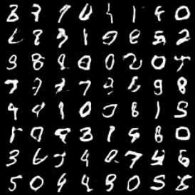

Figure : Fashion-MNIST WGAN Clipping

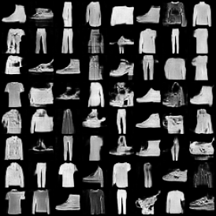

Figure : CIFAR-10 WGAN Clipping

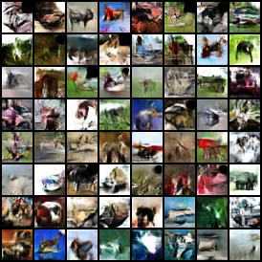

## WGAN with penalty:

This GAN I also trained for 40000 generator iterations. It took about 10 to 15 hours to train. There were fewer blurry numbers with this GAN but I think I could have stood to train it longer. Some of the numbers are not recognizable. I don’t think it performed particularly well on the Fashion-MNIST data either. But it performed the best for the CIFAR-10 dataset. Many of the generated images were recognizable as one of the data classes. None of them were perfect. I think my results would have improved if I had more training time.

Figure : MNSIT WGAN Penalty

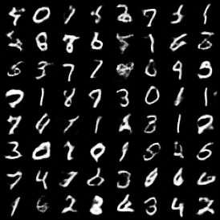

Figure : Fashion-MNSIT WGAN Penalty

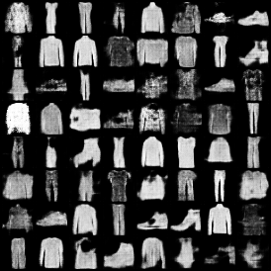

Figure : CIFAR-10 WGAN Penalty

