**Installation of Automation Anywhere 360**

**Sign Up Automation Anywhere 360:**

1. Click: <https://www.automationanywhere.com/products/enterprise/community-edition>.

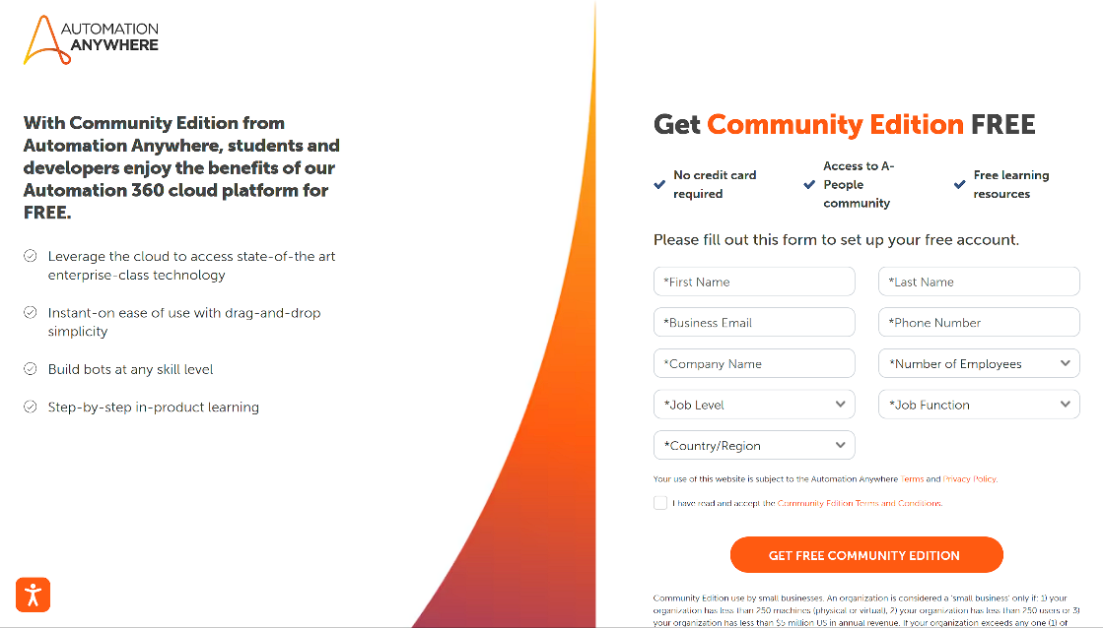

1. Fill the form and submit.

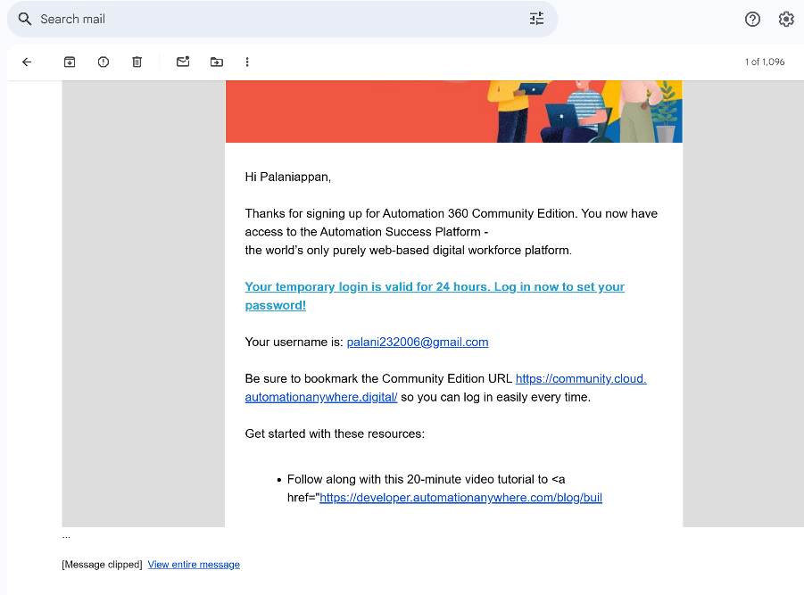

1. Verify your Sign Up through Email.

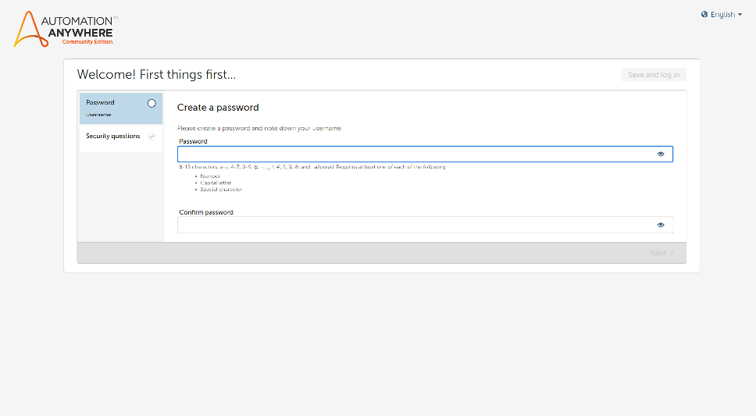

1. Create Your Password and Q&A for Account Recovery.

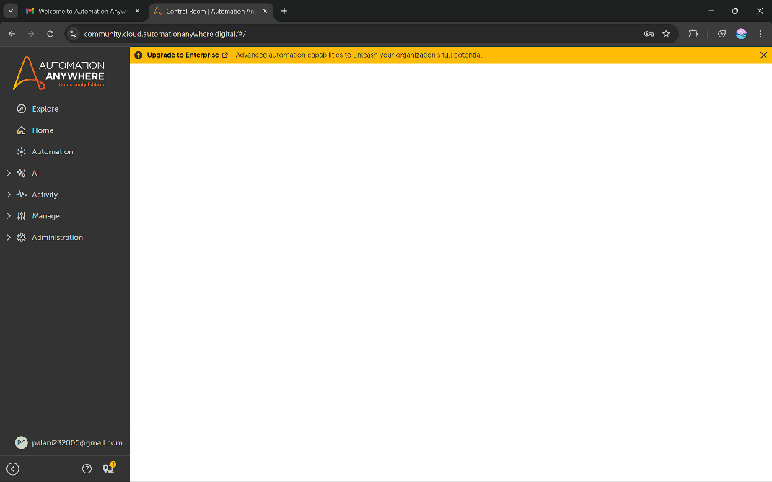

1. Hence Sign Up is Successful and you are logged in.

**Set Up Bot Agent to Your System:**

1. Log in to **CONTROL ROOM** in Automation Anywhere 360.

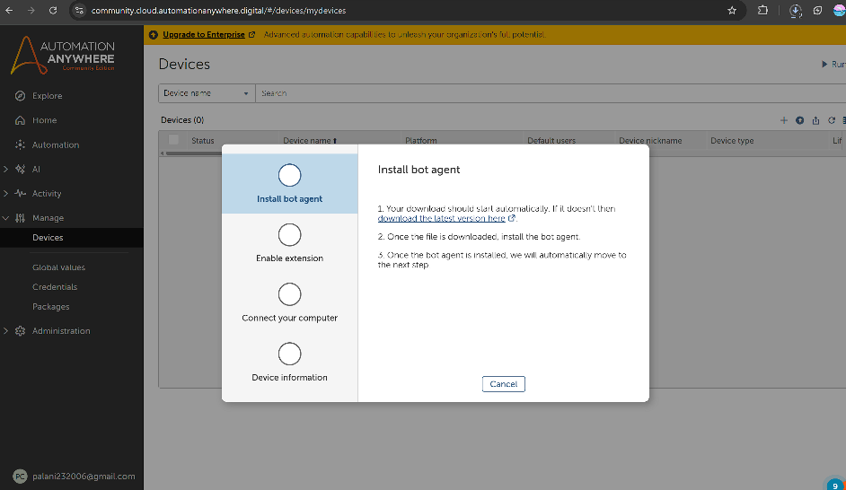

2. In the Left Rail,

**Manage > Devices > Connect Local Device** (‘+’ button will be available on right side of dashboard) **> Connect to My Computer.**

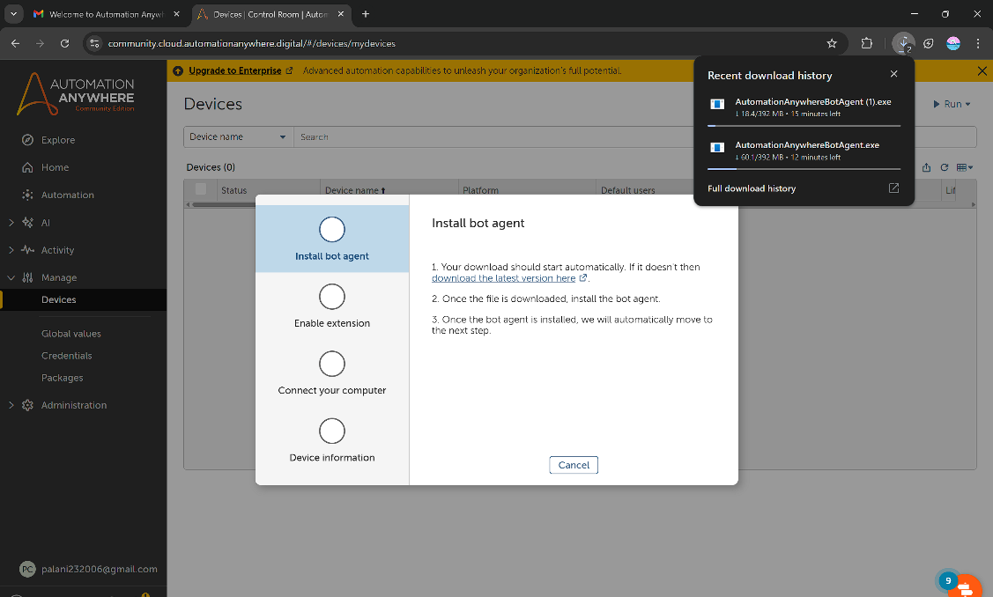

1. Once you Click, automatically the .exe starts to download.
2. Setup the Installed .exe file.
3. After Installation go back to control room and again click the ' + ' button >connect to my computer.
4. It Will Request You to Install and Add Automation Anywhere 360 Extension to your browser. Install and add it to Browser.

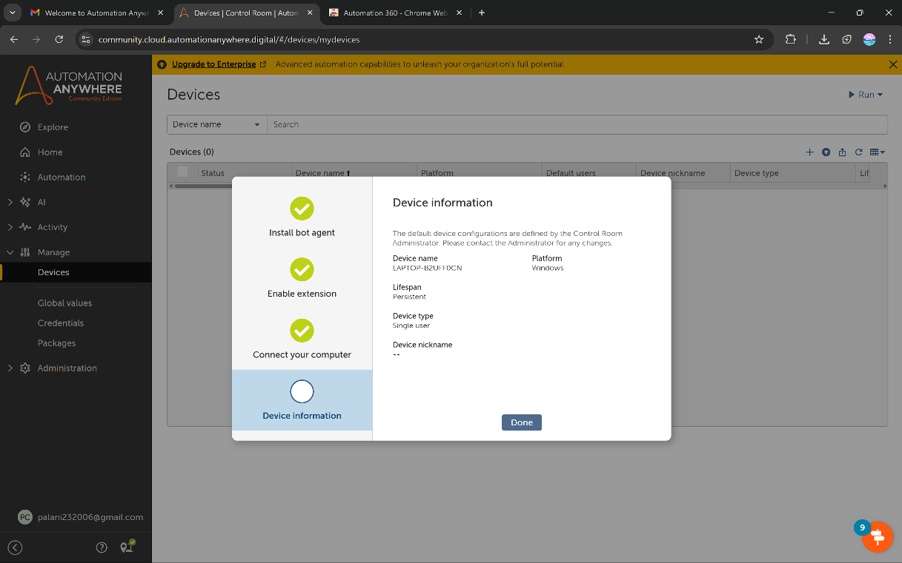

5. Now The Bot Agent has Connected successfully.

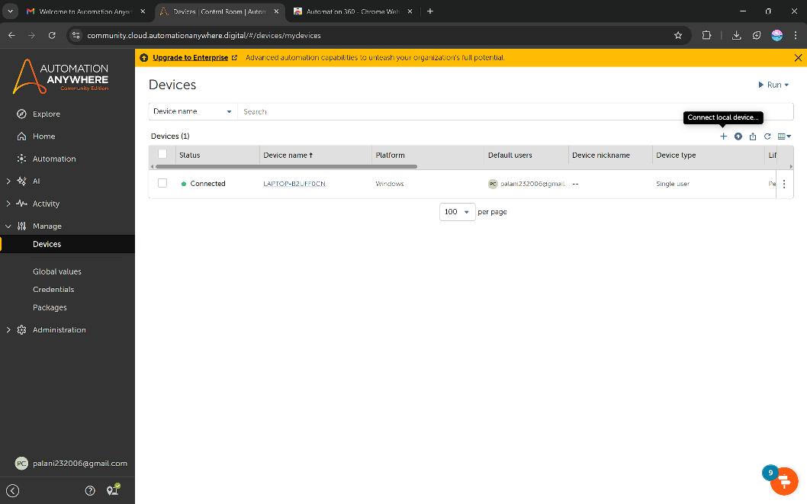

Now your Automation Anywhere 360 Setup is Successful.