**Project 7: Price Tracker Bot**

**Aim:**

To create a bot that tracks the current price of a Product available in an e-commerce website, once the Website price is lower than the price that the user finds affordable, an email is sent to the user.

**Solution Definition:**

* Create a **User Interface** so that users could provide their **email address**, **URL** of the Product in a website, and **price** under which the product seems to be affordable for the user.
* To provide liable backend to handle database handling, Mailing and Bot logic integration, I have used **Django** (Python Web Framework) as Backend and **SQLite** for DB handling.
* I have used **PyCharm** IDE for Programming.
* The Bot checks the price of the requested product in the requested website with constant intervals and once if the website price is under the affordable price of user, mail is sent to the user.

**Setting Up Django Project:**

1. To Install Django run ‘**pip install django**’ in CMD.
2. Run The bash “**django-admin startproject price_tracker**” in CMD to create The Django Project.
3. Go to your Project and Set up a **Virtual Environment.**
4. Run ‘**pip install django requests beautifulsoup4 schedule html5lib lxml’** this in CMD, to install all the required packages.

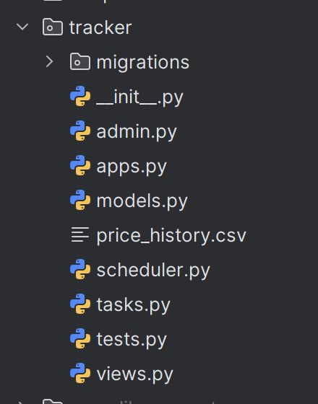

1. Set up an app to create a model and implement bot. Run ‘**django-admin startapp tracker**’.

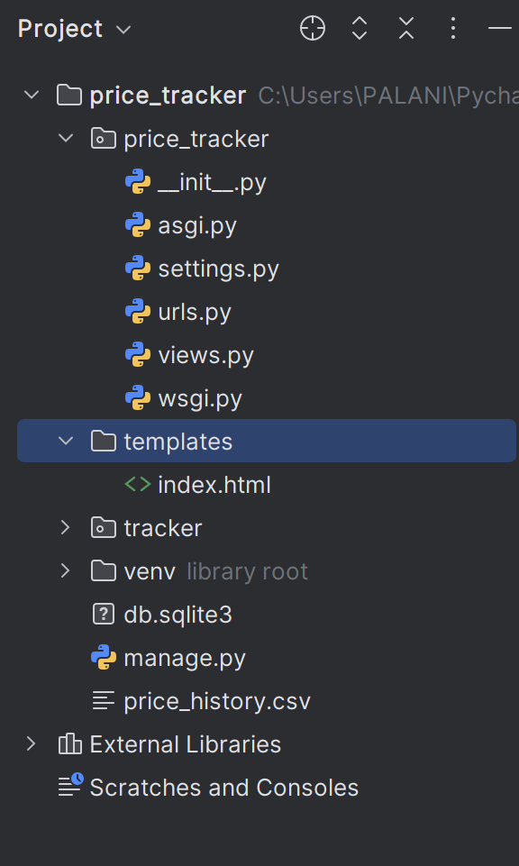

1. Create a Directory **templates** in the root to add html files.

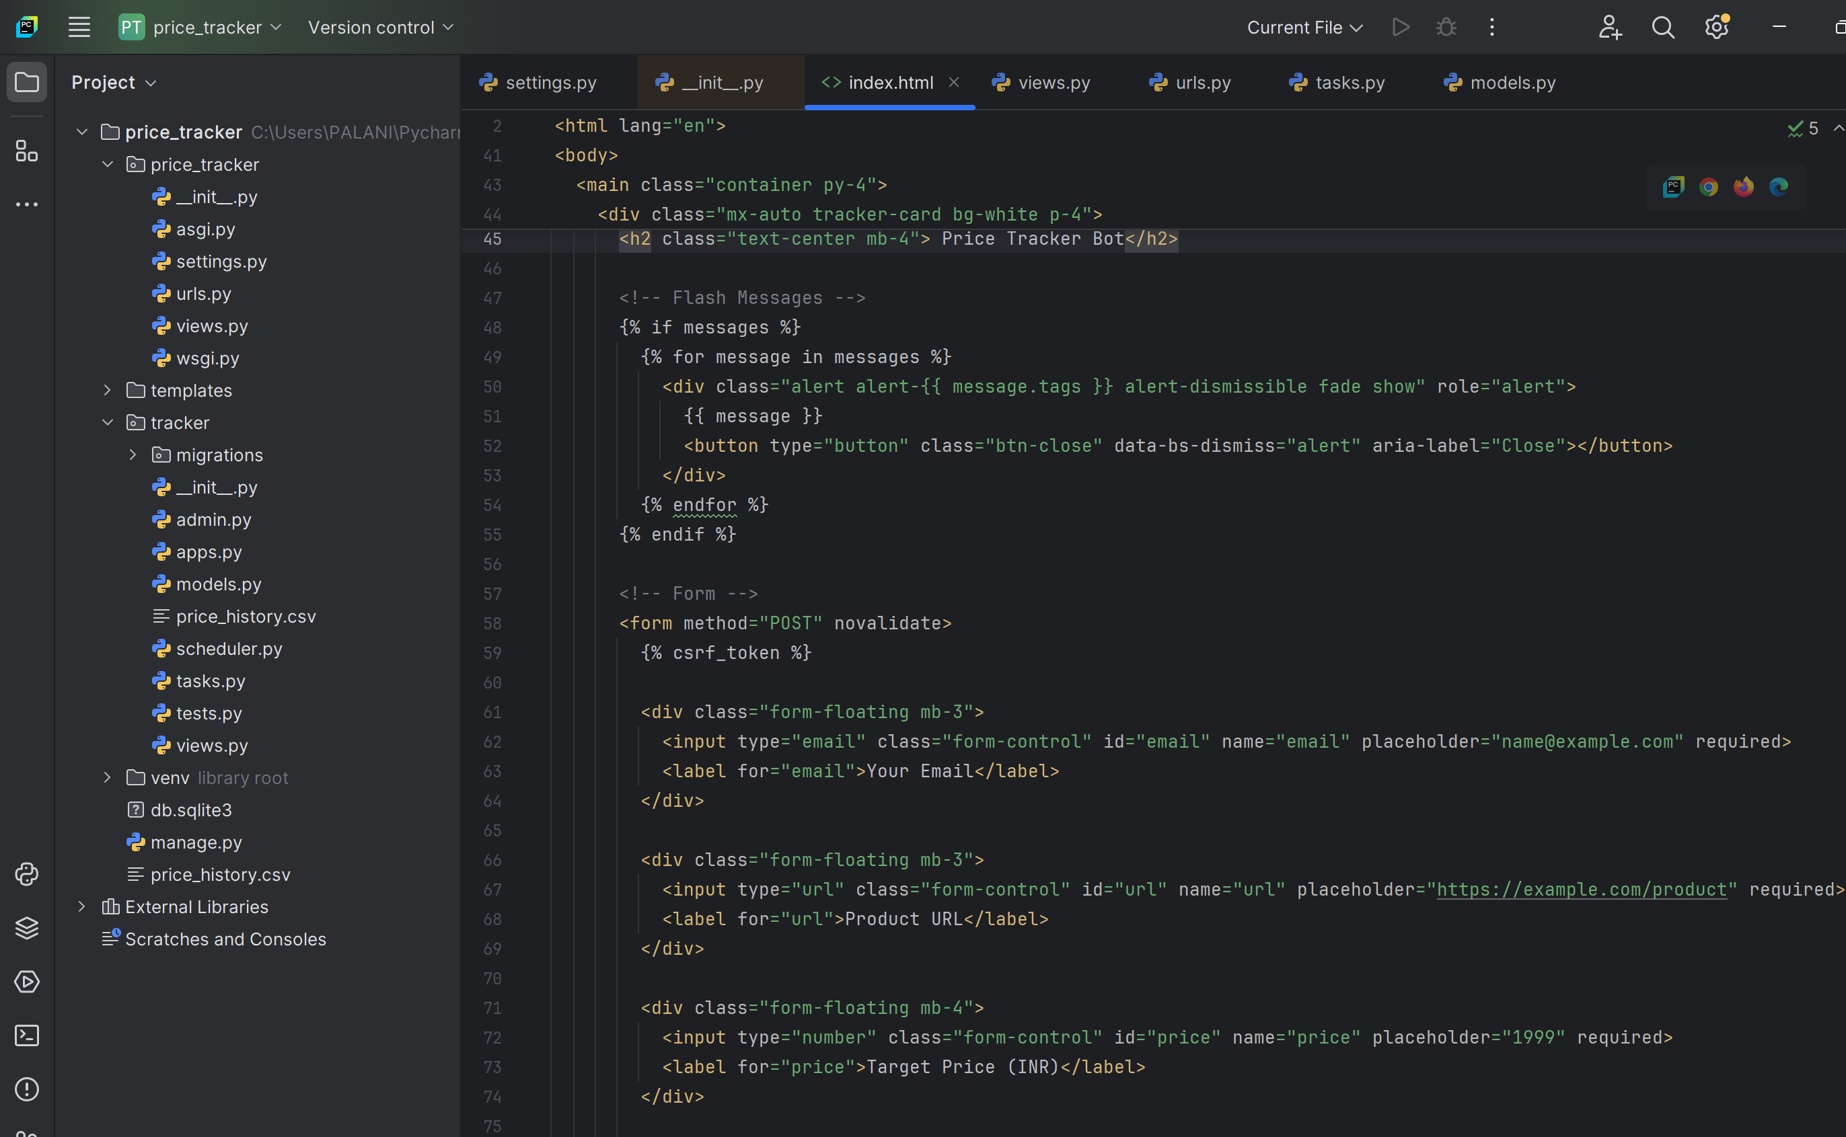

1. Create a new **HTML file** to provide User Interface.

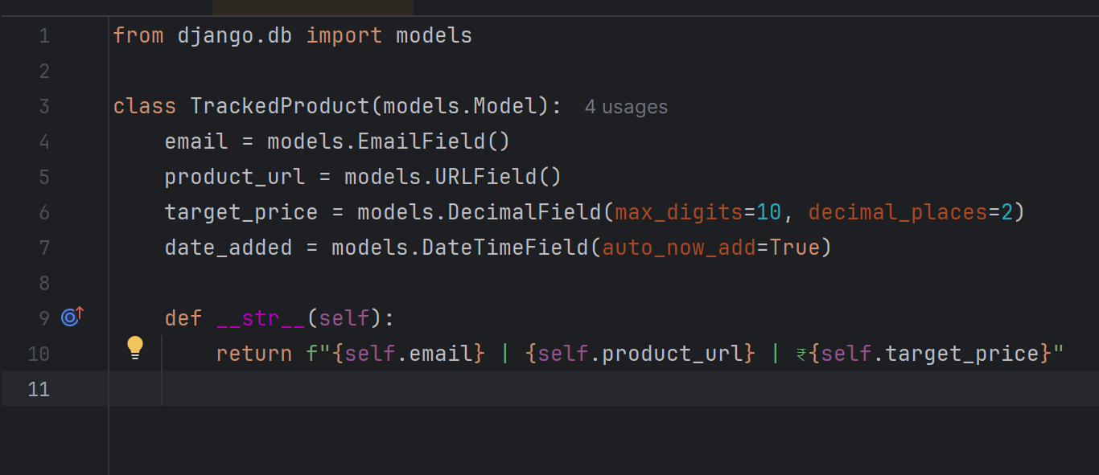

1. Now create a **model** in **models.py** available in tracker directory.

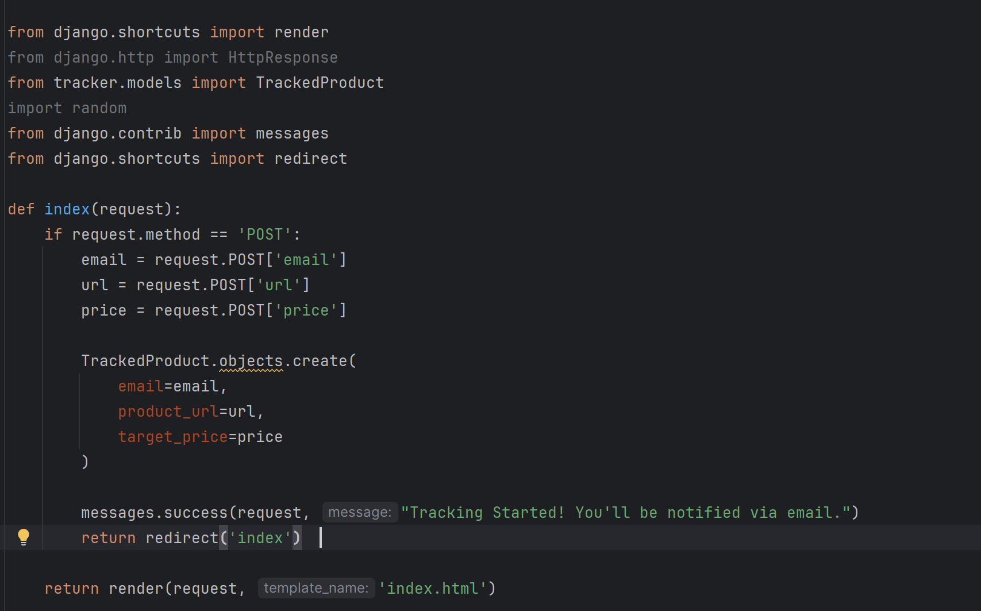

1. Create **views.py** in the Directory price_tracker (Not root directory) and implement logic to receive the user inputs and store in the created Model.

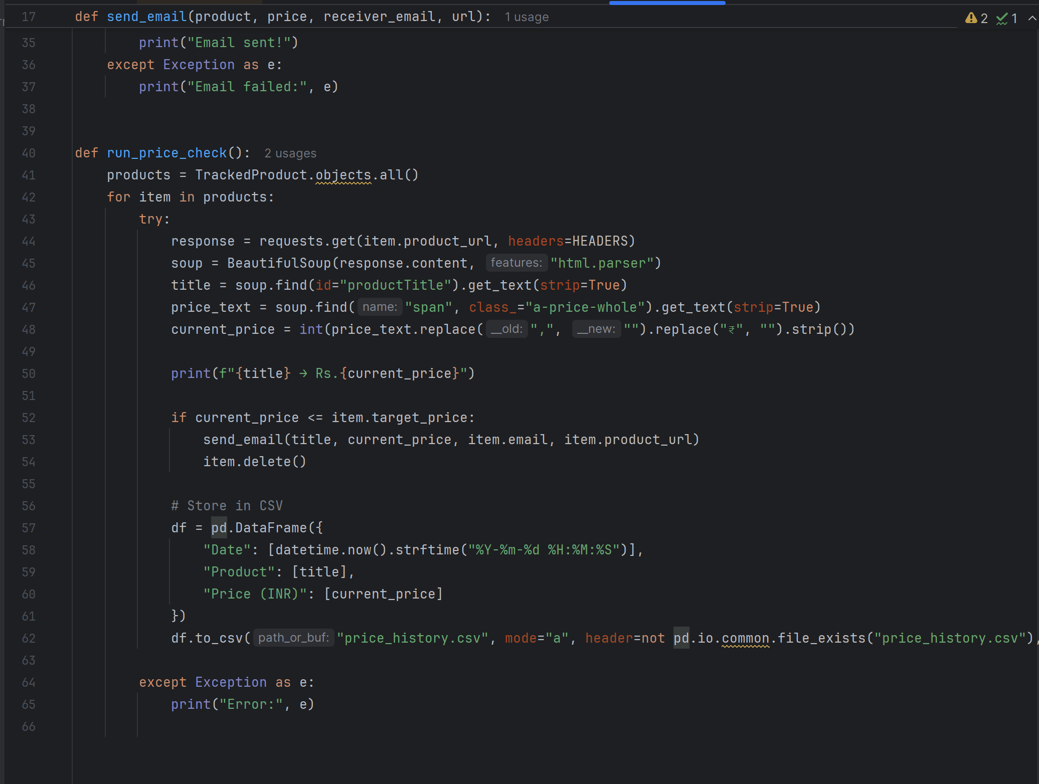

1. Create **tasks.py** inside the tracker directory, which implements the bot logic.

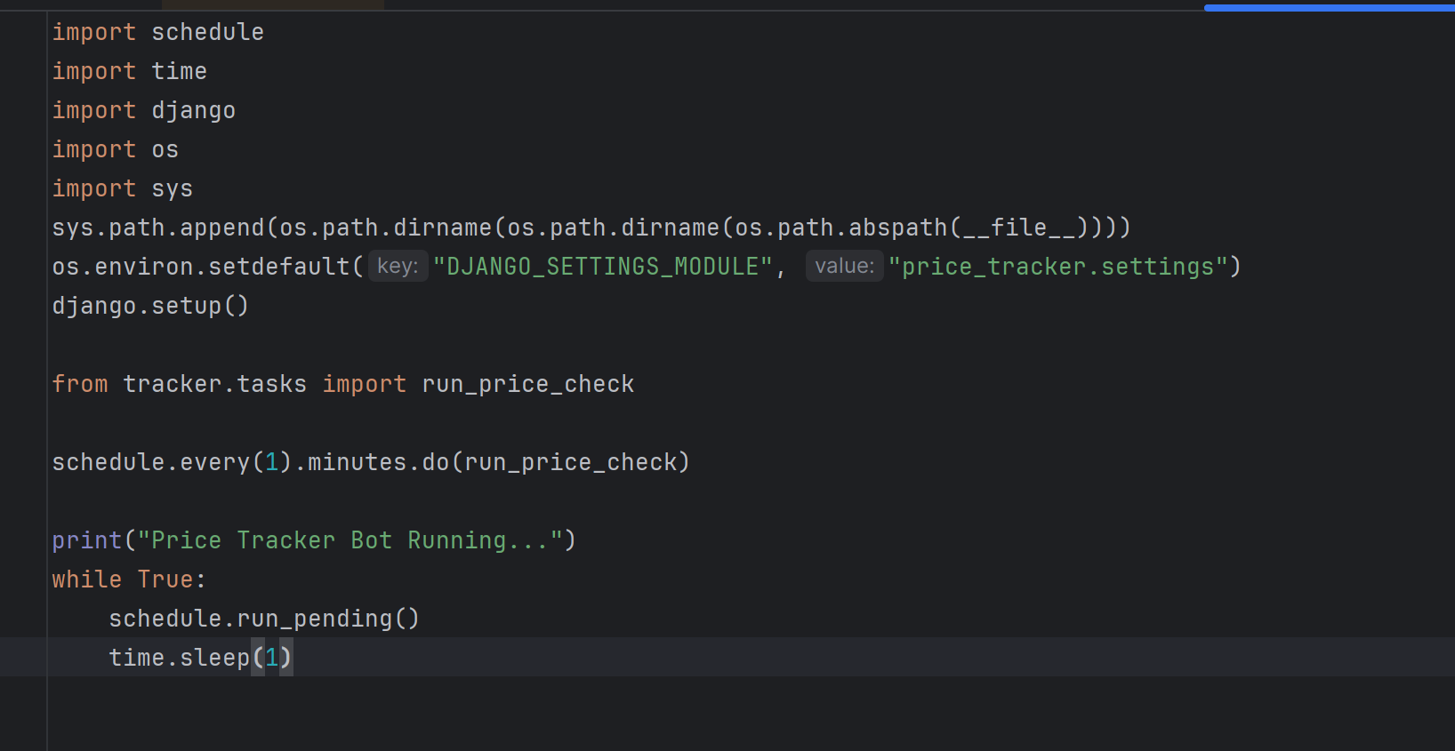

1. Create **scheduler.py** inside the tracker directory to Schedule the bot with constant interval. (In this Minutes is used only for testing purposes. On Production, the time interval would be 12hours).

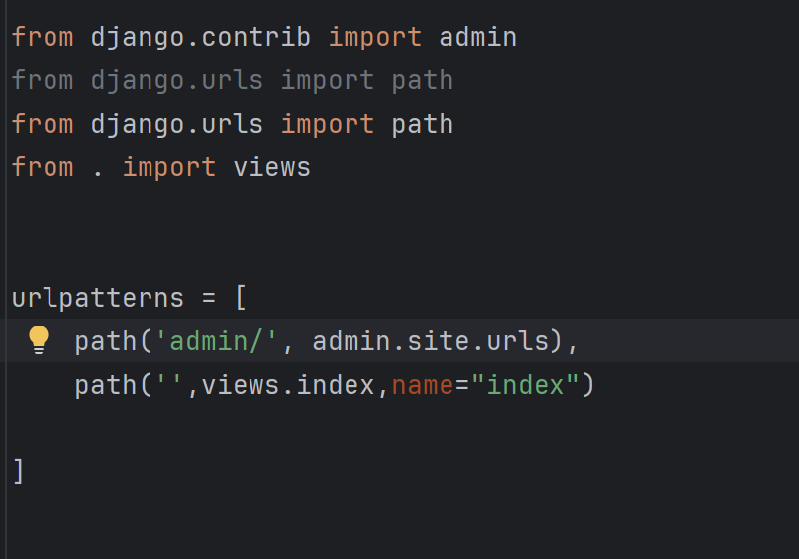

1. In **urls.py** add the path.

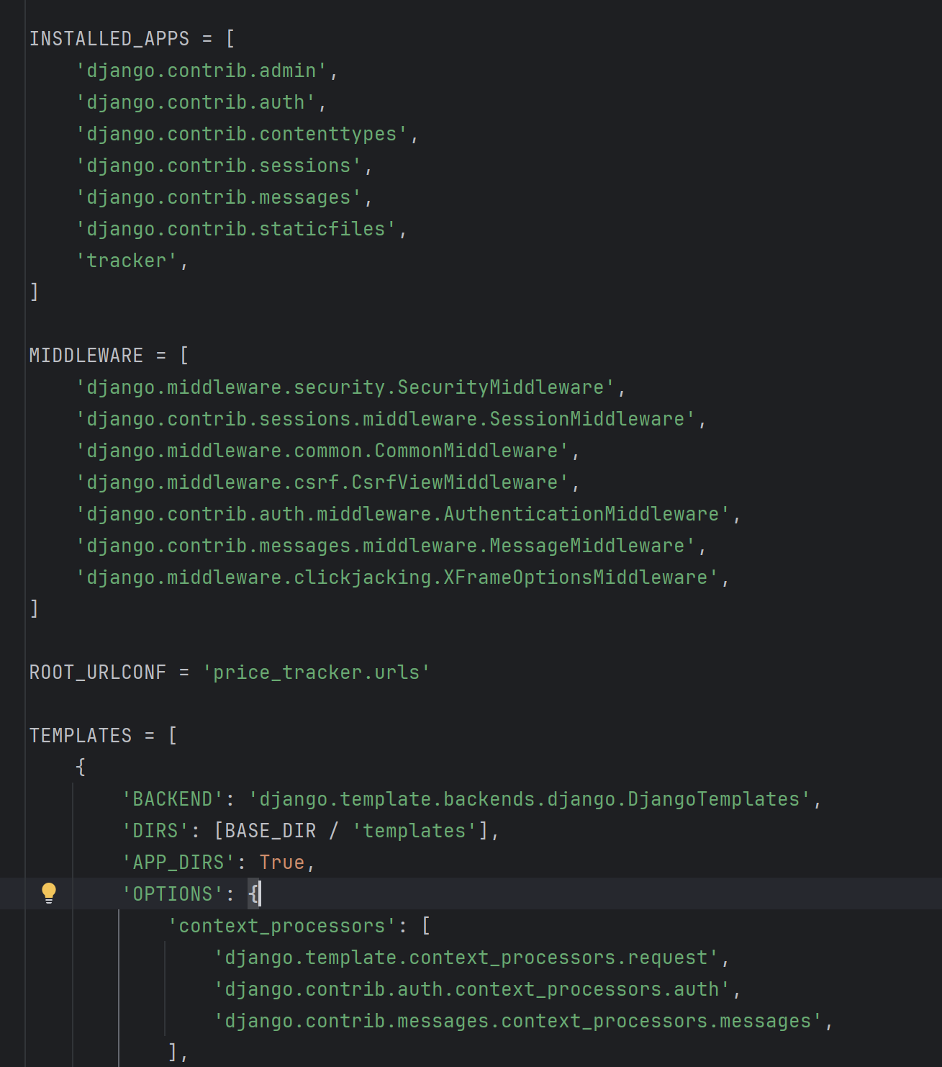

1. Modify **settings.py** accordingly. (Add tracker **to INSTALLED APPS**, in **TEMPLATES** add 'DIRS': [BASE_DIR / 'templates'])
2. Now to run the bot, open two terminals. In first**, run scheduler.py** and in another terminal, **run the Django project** to host the local server.

**Interface and Workings Behind the Interface:**

* **User Interface:**

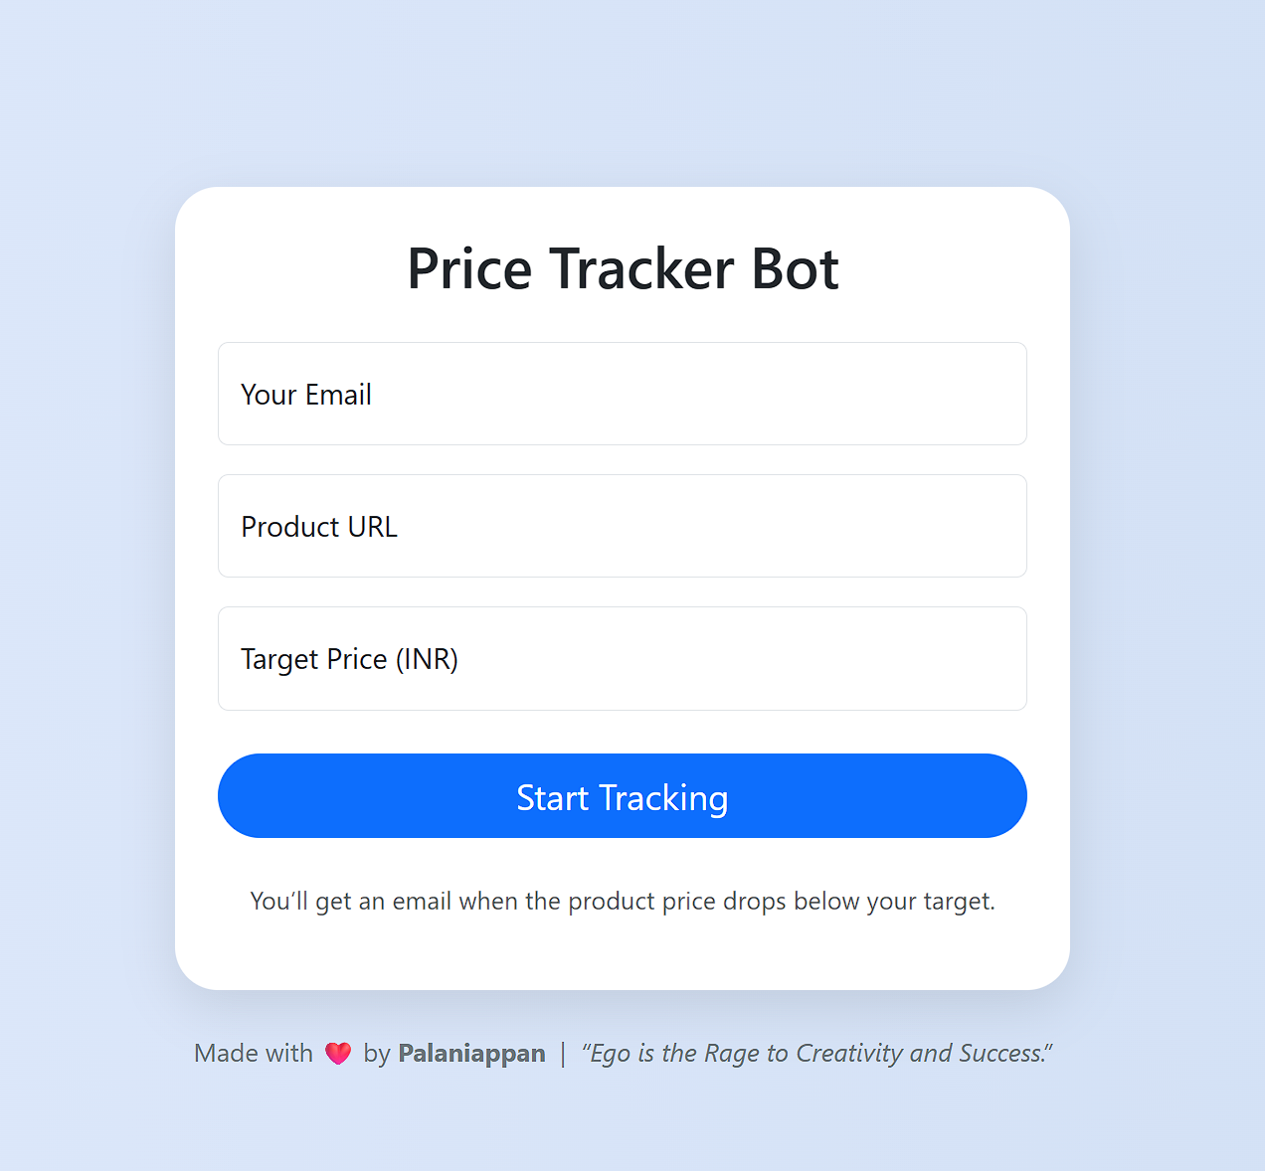

* **CSV File:**

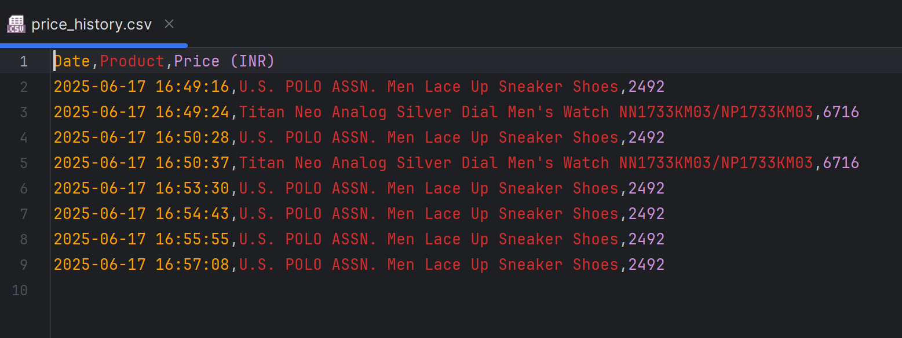

* **SQLite DB:**

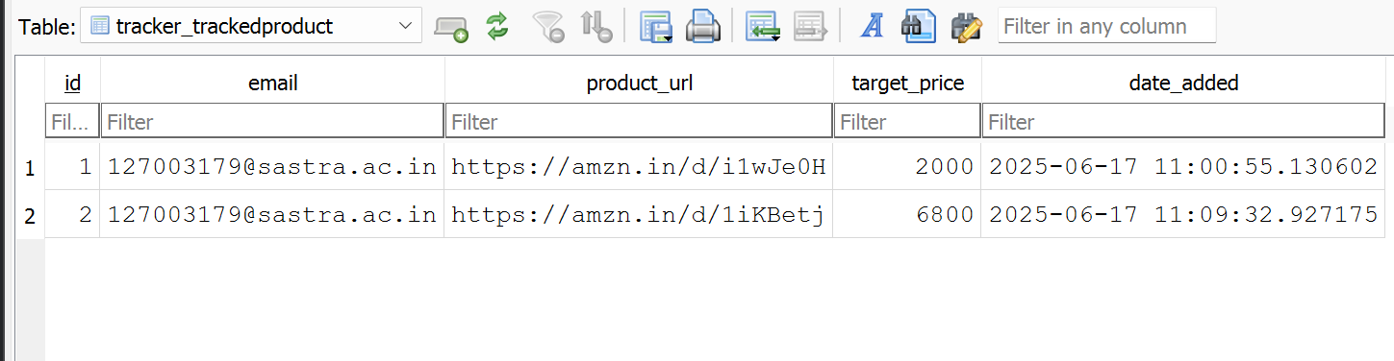

* **Bot:**

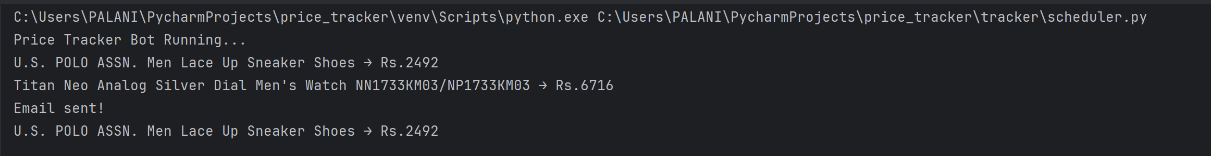

* **Mail Sent to the User:**

