1. Abstract
Blockchain is immutable data structure used to record participants and transactions, records added in block are time-stamped and agreed by participants which cannot be modified by anyone once added to block. Any owner of asset needs to have valid proof ownership accepted by concerned entities. Business Network created using DLT(Distributed Ledger Technology) provides solution to this. This Business network created using Distributed Ledger Technology also called Blockchain. It will let businesses keep their records in decentralized manner. Every node involving in the network will have identity and particular access grants. Nodes can make different transactions depending on their access grant types. End user will have interactable interface to communicate with other nodes i.e. participants. User will have facility to add their assets to blockchain make sells and keep track of exchanges very easily. We need to identify type of business networks, the objects and type of transactions. Model business requirements to fit on blockchain network. There is need to design an API to make network intractable, provide and user interface which should be easy to understand and there should be no need of technical knowledge to make transactions.

2. Introduction
Blockchain is immutable data structure in which transactions are added to the block if they verified either via proof of work or selective endorsement. Cryptography is used to secure contents within blockchain. Every transaction is timestamped when added to block. Every block produces a unique hash which is used in next block that creates link in hierarchical order between blocks. Blockchain can provide anonymity to users but in business applications identity is preferred. It allow us to create trusted distributed ledger across the different business models. Multiple networks of businesses can share same record. Participants can be customers, suppliers, banks etc. Markets created within network can be private(supply chains) or public(auctions). The key values blockchain business network provides shared ledger, smart contract, privacy, trust between participants etc. In business network, participants need to share data, records of exchange, proof of ownership etc. Traditionally each participating member maintains their own records and forward it to central authority to collect, distribute and verify. Currently data of businesses is growing so fast and big. Many partners share same kind of records but still keep different records thus increasing cost, complexity and errors. There is need to keep business records safe and accessible. Distributed ledger technology aims to solve these problems by letting us create a shared ledger on business network which is immutable, distributed, permission. It provides ability to keep all participants on track and updated. In the network the tangible(e.g. house) or intangible(e.g. mortgage) types of assets can be recorded. We are focusing on tangible assets in particular like vehicle. The network will provide record for companies, banks, consumers and government authorities. Real time access to data, trusted records, tamper proof, prevents fraudes, saves time are some benefits of making business network using DLTs.

3. Problem Statement
To create a distributed ledger for a business network to keep the records of the ownership of assets and provide a simple interactable user interface for end users.

4. Objectives
- To model network into required ledger keeping form.
- To add new types of assets, participants.
- To make law enforcement agency as participant with special permission in network.
- To make customer to customer / business to business transactions possible eliminating any intermediary.
- To provide facility to sell asset or auction it.
- To provide facility to identify participants.
- To provide a wallet.

5. Proposed System Architecture
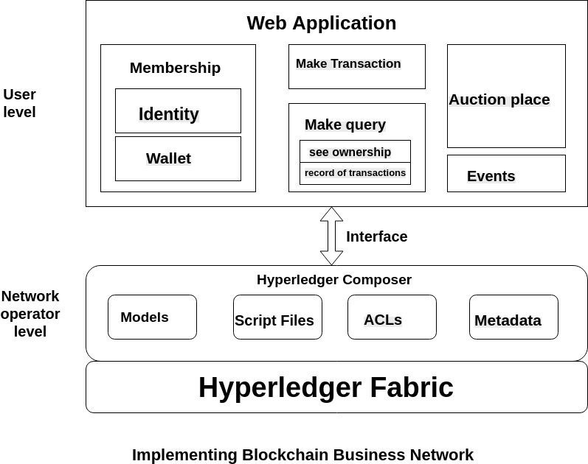
Fig 1: Proposed System Architecture

The proposed system architecture shown in fig.1 of Business network consists of two levels one is user level and another is network operator level. User level consists modules that let user interact with network. It is primarily web-based user interface. The user level is connected with network using interface. The network operator level includes composer and fabric of hyperledger. Composer is used to make changes into network behaviour and the fabric is used to create node in network.

6. Modules
6.1 Hyperledger Composer

1. Model Files
Hyperledger Composer includes an object-oriented modelling language that is used to define the domain model for a business network definition.​ Hyperledger Composer has its own​ modelling language (called CTO) used to model your business network.

2. Script Files
A Hyperledger Composer Business Network Definition is composed of a set of model files and a set of scripts. The scripts may contain transaction processor functions that implement the transactions defined in the Business Network Definition's model files.

3. ACL’S
Hyperledger Composer includes an access control language (ACL) that provides declarative access control over the elements of the domain model. By defining ACL rules, you can determine which users/roles are permitted to create, read, update or delete elements in a business network's domain model.

4. Metadata
The Bitcoin blockchain is being used to save arbitrary pieces of data. This can be done by using different techniques, a growing number of protocols embed metadata in the blockchain to certify and transfer the ownership of a variety of assets beyond currency.

6.2 Hyperledger Fabric
Hyperledger Fabric is an open source enterprise-grade permissioned distributed ledger technology (DLT) platform, designed for use in enterprise contexts, that delivers some key differentiating capabilities over other popular distributed ledger or blockchain platforms.

6.3 Web Application

1 .Membership
A membership site is a part of your online business where only members who subscribe can access the content you've placed.

1.1 . Identity
A digital identity has some additional attributes that Fabric uses to determine permissions, and it gives the union of an identity and the associated attributes a special name principal​.
1.2. Wallet
Blockchain wallet is a computer program that allows to monitor and conduct cryptocurrency.
2. Make Transactions
Participants can change ownership using transactions.

3. Make Query
User can see brief historical record of ownership transfer.

3.1. See Ownership
Only the people with the private key associated with the identity can prove they are the owner of particular asset. A Proof of Ownership is always attached to a piece of data. Certifying the ownership of a certain information in the blockchain also proves that this information existed at a certain time.
3.2. Record of Transaction
Previous records of transactions can be seen by participants.

4.Auction Place
The bidding can be seen and made through this module. Since auction is a live page. Buying and selling of goods/assets is publically available.

5. Events
Events module lets user know live occurence of transactions, success or failure of transaction and different auction place notifications can be viewed here.

7. System requirements

Hardware requirements
- Processor: Intel(R) Core(TM) i5-5200U CPU@2.20Ghz 2.19GHz
- System Type: 64-bit OS, x64-based processor.
- Edition: Windows 10 Home Single Language.

Software requirements
- Operating System: Windows xp & above or Linux.
- Web Browser.

Technology to be used

1. Blockchain
Hyperledger composer
Hyperledger fabric

2. World Wide Web
HTML, CSS, JavaScript
Node.js
REST API
YEOMAN
LOOPBACK

3. For Documentation
Markdown
HTML

8. Conclusion
The project is developed to share data, records of exchange, proof of ownership and keeps the data safe. The data cannot be editable except for the authorized party. There is also no need of a lot of space since the data is decentralized. Hence, it makes the network convenient.

9. References

Website Links
https://hyperledger-fabric.readthedocs.io/en/release-1.3/whatis.html https://hyperledger.github.io/composer/v0.19/introduction/introduction
https://blockgeeks.com/guides/what-is-blockchain-technology/

Group Members:

Roll No. Name Signature
54 Namrata Kumbhar
55 Rujuta Koli.
- Nargis Patwardhan
- Rutuja Jadhav
- Dnyaneshwar Raut
Date:

Place: Kolhapur

Prof. K. T. Mane Prof. A. S. Yadav Dr. G. A. Patil
(Guide) (DSMP Co-Ordinator) (H.O.D.)

