**Florida EMA - Dashboard User Guide**

This user guide’s purpose is to get emergency workers familiar with the EMA dashboard.

* This dashboard was designed to provide information quickly to emergency workers.
* Users can view both real-time and historical storm events.

**The Dashboard**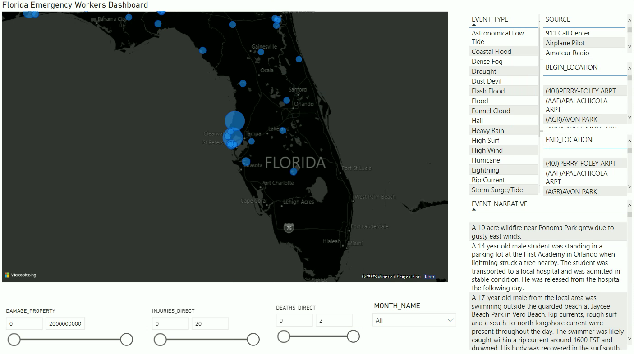

Looking at each component of the dashboard individually we can start with the map section. This map can give workers both a live and historical look of storm events in Florida. The size of the bubble represents the amount of property damage and also gives information on lives lost and the location of the event.

**The Map**

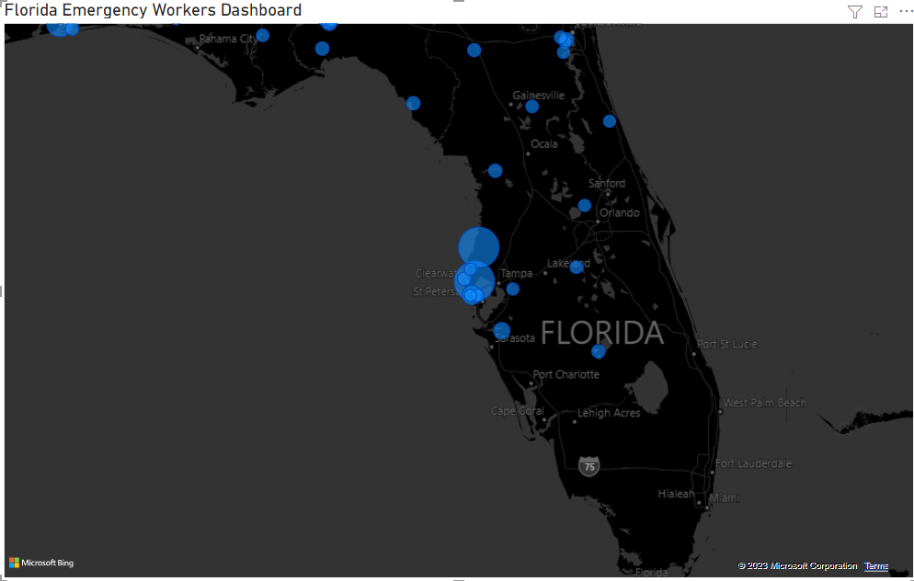

Next up, we have our sliders at the bottom that allows the worker to filter on specifics relating to property damages, injuries, and deaths. The view is real-time by default so that response actions to events can be taken. However, users can change the Month_Name filter to look at past storm events.

**Filter Section**

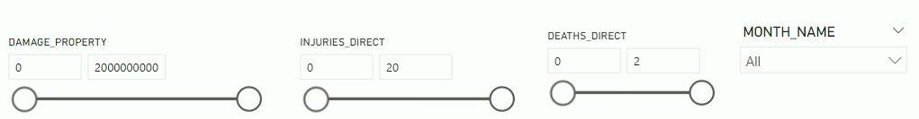

Finally, we have our information panel. This gives further information, such as the event type, the source, begin and end location, and the event details from the source. This is critical information that can be provided to the public and media.

**Information Pane**

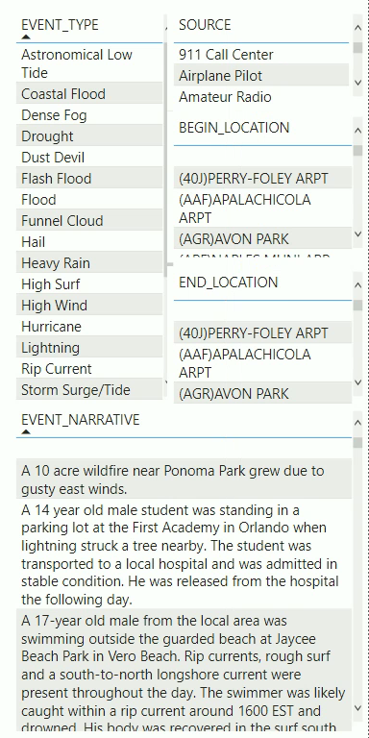

Drilling down into a specific bubble/event we can see that a tornado was reported by the NWS Storm Survey. This event had damage of $100k and no loss of life. You can report this information to the media along with the location information.

**Storm Event Bubble Pop-Up**

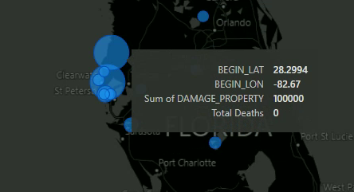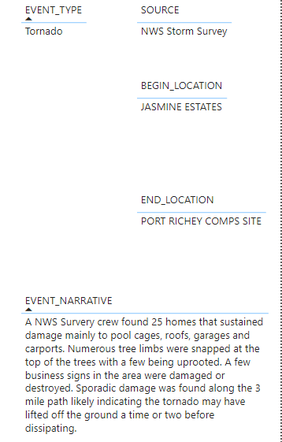

Feedback in this dashboard is captured by the chat button in the top right that allows for an easy way for workers to talk to the development team. Media and the public can also be reached from the agencies social media links. Language options can be chosen as well by using the down arrow button. Please reach out to the team for any changes or updates you would like to see implemented.

**Media and Public Communication, Settings and Feedback**



We thank you for using the dashboard and reading this user guide and look forward to the feedback you provide.