Final Project: Milestone Four - Webpage

Richard Snyder

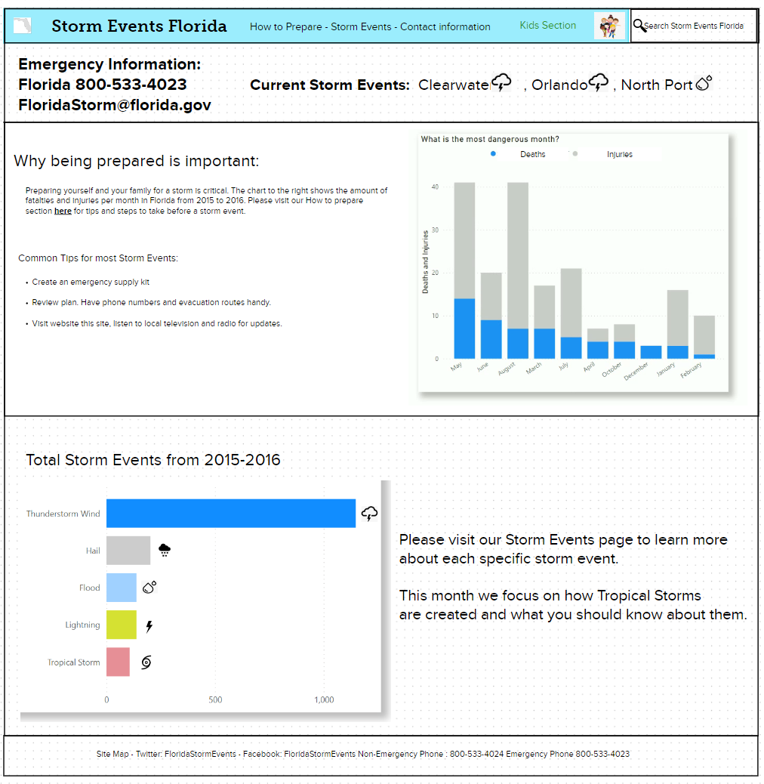

For the landing page I emphasized having the emergency information in the top left where a visitor would most likely look first. This would include a live moving ticker or current storm events to the left showing cities and what event they currently are facing. Next, we show why being prepared is critical with a bar graph of deaths and injuries. This will hopefully be the push needed for families to get their plan in place. At the bottom, we have the total number of storm events that occurred just as an interesting visual for visitors. We also have included an kids section at the top and a search function in the top right. These pages would easily translate to pamphlets which could have the same charts and information posted.

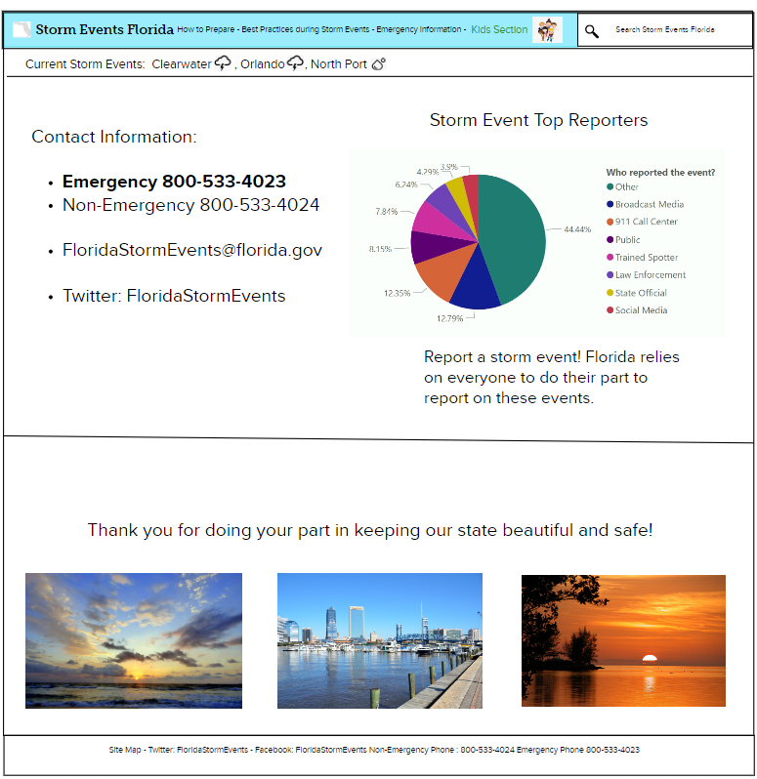

On the Emergency/Contact Information page we have phone numbers and contact information and include in interesting pie chart of who reports the most storm events in Florida. We have numerous feedback mechanics in place. This includes phone, email, and twitter.

Data source for all visuals: the National Centers for Environmental Information Storm Events Database 2015-2016