SMART INDIA HACKATHON | PS 26166 | ISRO
Lunar Image Registration Engine
Problem, solution, our idea and feature roadmap

Problem statement: Multi-modal, sun-angle and scale invariant image correspondence using Chandrayaan-2 optical images (OHRC, TMC-2, IIRS)
Team: 404 Craters Not Found
Members: Manya Madaan, Shruti, Ananya Krishna
Organisation: ISRO / Department of Space · Category: Software · Theme: Space Technology
Status as of: 23 September 2026
Code: github.com/coffeee27/PS_26166
Every number in this document marked as our result was measured on our own code. Published numbers from other work are labelled as prior work.
Contents
1. Executive summary 3
2. The problem 4
2.1 What ISRO is asking for 4
2.2 The cameras and their reference images 4
2.3 Why this is hard 4
3. Prior work and the gap we target 5
3.1 ISRO SAC comparative study (2025) 5
3.2 CNSFM (Remote Sensing, 2025) 5
3.3 The gap 5
4. Our idea 6
4.1 Four principles 6
4.2 Coarse to fine, in one sentence 6
5. Solution architecture 7
5.1 Registration pipeline 7
5.2 Honest accuracy metrics 7
5.3 System 8
6. Results so far 9
6.1 Real pair: Vikram landing site 9
6.2 Why model selection matters 9
6.3 Synthetic tests with a known answer 10
6.5 Honest limitations 10
6.6 Checklist against the problem statement 11
7. Differentiators 12
8. Feature roadmap: Tiers 1 to 4 13
Tier 1: Core engine (mandatory) 13
Tier 2: Differentiators 13
Tier 3: Research proof 13
Tier 4: Product (website) 14
Only if time allows 14
Decided not to do 14
9. Build log and next steps 15
9.1 What's new in this update (in simple words) 15
9.2 Completed steps 15
9.3 Next steps 15
10. Technology, credits and references 17
10.1 Open-source libraries used 17
10.2 Data 17
10.3 References 17

1. Executive summary
Chandrayaan-2 photos need to sit exactly on top of reference Moon images, such as NASA's LRO NAC, so that every crater lines up. ISRO wants this to work even when the sun angle, the camera and the level of detail are different, with sub-pixel accuracy and match points spread over the whole image.
We built a two-step engine: first a rough alignment, then a precise one. Our main rule is simple: accuracy must be measured, not claimed. Every error number we report is checked on parts of the image the model never saw, and the engine shows where the result can be trusted and where it cannot.
Measured on a real pair: Vikram landing site, Chandrayaan-2 OHRC vs LRO NAC (1 m per pixel)
Old SIFT + RANSAC baseline: 24 match points covering 25% of the image. It printed 1.04 px, but its honest error on unseen points is 1.26 px (1.26 m).
Our engine: 2,035 sub-pixel tie points covering 98% of the image, honest error 0.50 px (0.50 m), in about 30 seconds.
Quality check: ACCEPTED, sub-pixel ACHIEVED at the reference resolution.

The engine runs behind our web API, and the website now shows its real results. 41 automated tests check it. Every run gives an aligned image (also as a GeoTIFF that sits in the right place on the Moon map), a table of all match points, an overlay, a reliability heatmap and an error for each part of the image.
New in this update (23 September 2026)
More accurate: error went down from 0.59 px to 0.50 px, thanks to a new local correction for terrain bends.
Website uses real results: every screen now shows what the engine measured, not demo data.
New downloads: aligned GeoTIFF with map position, and a CSV table of every match point.
Reads Chandrayaan-2 archive files (PDS4): checked on a real IIRS file.
Clear rejection: images that do not show the same place are refused with a plain reason.
PROVE score: every run is now judged by five checks on measured values, each shown next to its limit, and reported as STRONG, MODERATE or WEAK. See section 4.3.
Seven demo pairs: the website loads a real pair, a height-map render, a 5 m zoom gap, a half-overlap pair and a non-overlapping pair that must be refused. See section 6.4.
Live deployment: the backend runs on Render and the website on Vercel, so the engine can be demonstrated without a local install.
Tests: 41 automated tests, up from 24. Full details in section 9.1.

2. The problem

2.1 What ISRO is asking for
Register a Chandrayaan-2 optical image (the source) onto a reference lunar image (the target), so that the same ground point sits at the same pixel in both. The registration must hold up when:
- The sun angle differs. Lunar images are dominated by shadows, and shadows move or even flip when the sun moves.
- The sensors differ (multi-modal). Different cameras, detectors and processing chains record the same terrain differently.
- The resolutions differ (scale). OHRC sees about 0.25 m per pixel, TMC-2 about 5 m and IIRS about 80 m.
Expected outputs are the registered image, the list of match points, and accuracy metrics: RMSE, inlier count and inlier ratio. The targets are sub-pixel accuracy of the source image and uniformly distributed match points.

2.2 The cameras and their reference images
Camera (Chandrayaan-2) | Detail per pixel | What it records | Typical reference
OHRC | ~0.25 m | Panchromatic, very high resolution strips | LRO NAC (~0.5 to 1.1 m)
TMC-2 | ~5 m | Panchromatic, fore / nadir / aft views for terrain height | SELENE TC (~10 m)
IIRS | ~80 m | Infrared spectrum, 0.8 to 5.0 µm | SELENE / other maps

2.3 Why this is hard
Challenge | What goes wrong | Everyday analogy
Illumination | Brightness patterns change when the sun moves; a crater can look like a dome. | A face lit from the left vs the right
Scale gap | Features visible at 0.25 m are blurred away at 1 m or 5 m. | Matching a street photo with a city map
Sensor gap | Different cameras give different contrast, noise and bit depth (8, 12, 16 bit). | Two phones photographing the same scene
Terrain relief | Craters and slopes shift differently between two viewing angles, so one flat transform cannot fit the whole image. | A crumpled poster vs a flat one
No answer key | There is no ground truth telling us the correct match for real image pairs. | An exam without an answer sheet
Honest measurement | Error measured on the same points used for fitting always looks better than reality. | Grading a student on questions they already saw

3. Prior work and the gap we target
We studied published lunar registration work before designing the engine. Two studies matter most. The numbers below are prior work, not our results.

3.1 ISRO SAC comparative study (2025)
A comparative study of registration methods on Chandrayaan-2 OHRC and LRO NAC images, with three of five authors from ISRO's Space Applications Centre, Ahmedabad (arXiv 2509.04775).
- On the polar OHRC–NAC pair, SIFT, ASIFT, AKAZE and RIFT2 gave no result; only SuperGlue registered it, with RMSE of 0.92 px (X) and 0.76 px (Y).
- OHRC was resampled to NAC resolution before matching, so this RMSE is in NAC pixels (~0.89 m), roughly 3 OHRC pixels.
- RMSE was computed on the matched control points after applying the fitted transform, i.e. on the fitting points, not on held-out points.
- A single 3×3 perspective transform was used for the whole image.

3.2 CNSFM (Remote Sensing, 2025)
Crater-neighbourhood structure matching for multi-illumination lunar images, tested on 321 image pairs (doi 10.3390/rs17132302).
- 100% matching success in two scenes, but 72.3% in the south-polar scene.
- The authors attribute failures to heavy shadowing, small overlap and low crater density.

3.3 The gap
What the problem statement asks | What prior work reports | What we do
Sub-pixel accuracy | Fitting-point RMSE at reference resolution | Error checked on image blocks the model never saw, in pixels and metres
Uniformly distributed match points | Not reported as a metric in the ISRO study (to be re-confirmed) | Points on a regular grid, a coverage and evenness score, and an error for every image cell
Robust to real terrain | One global homography | The engine tries a flat transform, curved fits and a local terrain correction, and keeps whichever predicts unseen blocks best
Trustworthy output | A single average number | Reliability heatmap and an automatic ACCEPT / REJECT decision with reasons

How we phrase it
Not "nobody has done this", but: "Building on ISRO SAC's 2025 study, we measure registration accuracy on held-out ground, show where it holds and where it fails, and move the target towards the source image's own resolution."

4. Our idea
Many teams will list the same algorithms. Our difference is not a secret algorithm; it is measured evidence built into the product.

4.1 Four principles
- Measure on unseen ground. Accuracy is the error on tie points the model never saw. Whole image blocks are left out together, because a close neighbour in the training points would otherwise hide over-fitting.
- Let the data pick the geometry. One flat transform cannot follow real lunar terrain. The engine tries several models, including a local correction for terrain bends, and keeps the one that predicts unseen blocks best. If two are close, it picks the simpler one.
- Show reliability, not just an average. An average error can hide a failed corner. We show error per region as a heatmap and per-cell table.
- Reject honestly. A registration that fails its checks is marked REJECTED with the reasons, instead of being shown as a success.

4.2 Coarse to fine, in one sentence
First line the images up roughly using matching features. Then measure the exact shift at a dense grid of points, to a fraction of a pixel. Finally fit the most trustworthy model to those points.

4.3 PROVE, and the sufficiency gate in front of it
Our judging layer is split in two, and the split is the idea. A gate first: five checks computed from the engine's own tie points, each comparing one measured number against a fixed limit, reported as STRONG, MODERATE or WEAK. They ask whether there is enough evidence, spread widely enough, to be worth judging. They cannot say the answer is correct, because a matcher that goes wrong the same way everywhere produces points that agree with each other and passes all five. We state that rather than leave it to be found. PROVE comes after the gate and takes only facts that came from outside the two images: P for Published coordinates (where the Moon says a point is, starting with the Vikram lander and extending to LOLA control points), R for Rendered terrain (a height model lit at each image's own Sun angle, which reads the shape of the ground instead of the brightness of the picture, so shadows that moved cannot fool it), O for Other mission (the same ground from a different agency, spacecraft, camera and processing chain), V for the Verdict, and E for the Exceptions it has to state. Anything that reads the two images is excluded by construction, because a check looking at the same pixels can be fooled by the same pixels. That rules out our leftover map, which re-measures the misalignment from the pixels by phase correlation: it is built, it runs on every registration and it is genuinely useful as a second opinion, but it reads the same shadows the matcher did, so we report it beside PROVE and do not call it proof. The three PROVE checks are specified in full and are the next build step.
Check | What it measures | Limit
Sub-pixel on unseen blocks | Hold-out RMSE in reference pixels | at most 1.0 px
Rough matches agree | MAGSAC++ inliers divided by all rough matches | at least 50%
Image covered by tie points | Share of the 8x8 grid that has tie points | at least 80%
Tie points spread evenly | Uniformity of the tie-point count per cell | at least 0.50
No weak regions | Share of cells whose hold-out RMSE is at most 1 px | at least 90%

All five passed is STRONG, three or four is MODERATE, fewer is WEAK. The limits were set by our team and are meant to be tuned on more image pairs; the website says so next to the score. On the Vikram pair the result is 5 of 5, STRONG. On the 5 m zoom-gap pair it is 4 of 5, MODERATE, because only 79% of the image cells are under 1 px where 90% is required.

5. Solution architecture

5.1 Registration pipeline
# | Stage | What happens | Why
1 | Read the files | Opens PNG, JPG, TIFF and GeoTIFF (8 or 16-bit) and Chandrayaan-2 PDS4 files. Keeps the full brightness range, marks missing pixels, and reads pixel size, map position and footprint from the file. | Real archive files are 16-bit and have empty areas. Reading them as 8-bit would lose detail.
2 | Match pixel size | Resizes the source so one pixel covers the same ground as one reference pixel, while keeping track of exact positions. | A crater must look the same size in both images before matching.
3 | Rough matching | Finds SIFT features in smaller copies of both images and pairs them up (RootSIFT, FLANN, ratio test 0.8, two-way check). Very long strips are shrunk more so this stays fast. | The old settings kept only 28 matches, all in one corner.
4 | Throw out bad matches | MAGSAC++ keeps only matches that agree on one alignment; at most 25 per grid cell are used for the rough fit. If fewer than 20 matches agree, the pair is rejected with a clear reason. | Wrong matches go, one busy area cannot take over, and unrelated images are never "aligned" by chance.
5 | Sub-pixel tie points | Places a point every 40 px where the two images overlap and fine-tunes each one by correlation to a fraction of a pixel. Flat or dark patches are skipped. | Many precise, evenly spread points. Error on test images: 0.044 px.
6 | Remove odd points | Points that are far off compared with the rest are dropped (median absolute deviation test). | Removes the occasional wrong correlation.
7 | Pick the best model | Tries a flat transform (homography), curved fits (polynomials, degree 2 to 5) and a curved fit plus a local terrain correction. Each is tested on 4×4 image blocks it never saw; the best wins, or the simpler one if within 2%. | Follows terrain and camera distortion without over-fitting.
8 | Second pass | Repeats steps 5 to 7 through the chosen model. | Improves points near the image edges.
9 | Outputs | Aligned image (PNG and GeoTIFF), CSV of all match points with their errors and map coordinates, overlay, error heatmap, match-line image, per-cell table and JSON report. | Everything a reviewer needs to check and reuse the result.

5.2 Honest accuracy metrics
Metric | What it means (in simple words)
Hold-out RMSE (px and m) | Average error of each tie point, predicted by a model that never saw its image block. This is the number we quote.
Fit RMSE | Error on the same points used for fitting. Shown only to explain why we do not trust it: the local model passes through its own points, so this is always 0.
Inlier count and inlier ratio | As defined in the problem statement: rough matches kept by MAGSAC++, and that number divided by all rough matches. Vikram pair: 1,548 of 1,724 = 89.8%.
Tie-point ratio | Tie points that passed every check, divided by grid points inside the overlap. Vikram pair: 2,035 of 2,147 = 94.8%. The website shows it under its own name, TIE-POINT RATIO, so it is not confused with the problem statement's inlier ratio.
Coverage | Share of the 8×8 image grid that has at least one tie point.
Uniformity | How evenly points are spread; 1 means perfectly even. Formula: 1 / (1 + coefficient of variation of the per-cell counts).
Per-cell RMSE | Error inside each of the 64 cells. Drives the reliability heatmap and the hexagon view.
Quality decision | ACCEPTED or REJECTED with reasons, plus sub-pixel ACHIEVED or NOT ACHIEVED, based on the honest error.
PROVE score | How many of the five PROVE checks the run passed, with the evidence level STRONG, MODERATE or WEAK. Each check is shown with its measured value and its limit. See section 4.3.

5.3 System
Layer | What it is
Engine | Python package backend/app/registration: reading files, matching, sub-pixel refinement, models, metrics, pipeline and outputs
API | FastAPI. POST /api/registration/analyze takes two uploaded images (pixel sizes optional). GET /api/samples lists real pairs stored on the server, and POST /api/registration/analyze-sample runs one. Returns match points, metrics, quality decision, a full report and links to every output file.
Web platform | React 19 + TypeScript + Vite + Tailwind. Landing page plus seven layers, all fed by real engine results: workstation, reliability heatmap, coverage hexagons, match lines, geometry and a report with downloads. English and Hindi (Hindi text for the newer parts not yet updated).
Tests | 41 automated tests using test images where the right answer is known, plus a script that measures accuracy on the real Vikram pair
Coordinates | Match points are given in reference pixels. If the reference is a GeoTIFF they also get map coordinates in metres (Vikram pair: polar stereographic Moon map), and the aligned GeoTIFF carries the same map position. Latitude and longitude are not computed yet.

6. Results so far

6.1 Real pair: Vikram landing site
2 km × 2 km areas around the Chandrayaan-3 landing site: Chandrayaan-2 OHRC (resized to 1 m, 8-bit) against the LROC NAC orthophoto (1 m, 16-bit). The LROC elevation model of the same area ranges from 502 to 555 m, which matches the published landing-site height of about 532 m and confirmed we read the data correctly.
 | SIFT + RANSAC baseline | Our engine
Rough matches found | 28 | 1,724
Good matches / tie points | 24 | 1,548 kept by MAGSAC++ (89.8%) → 2,035 sub-pixel tie points
Coverage (8×8) / evenness | 0.25 / 0.33 | 0.98 / 0.75
RMSE the script printed | 1.04 px (on its own points) | —
Honest error (unseen blocks) | 1.26 px = 1.26 m | 0.50 px = 0.50 m
Geometric model | One homography | Polynomial degree 4 + local terrain correction (picked automatically)
Run time | ~2 s | ~31 s (was ~9 s before the local correction)
Quality decision | — | ACCEPTED, sub-pixel ACHIEVED

6.2 Why model selection matters
Honest error of each model on the same 2,035 tie points:
Model | Hold-out RMSE (px) | Reading
Homography | 1.18 | Too stiff for terrain and camera distortion
Polynomial 2 | 0.86
Polynomial 3 | 0.64
Polynomial 4 | 0.61 | Best smooth curve
Polynomial 5 | 0.82 | Over-fits: looks good on random checks, caught by the block test
Polynomial 4 + local correction | 0.50 | Selected: also follows small local bends from craters and slopes

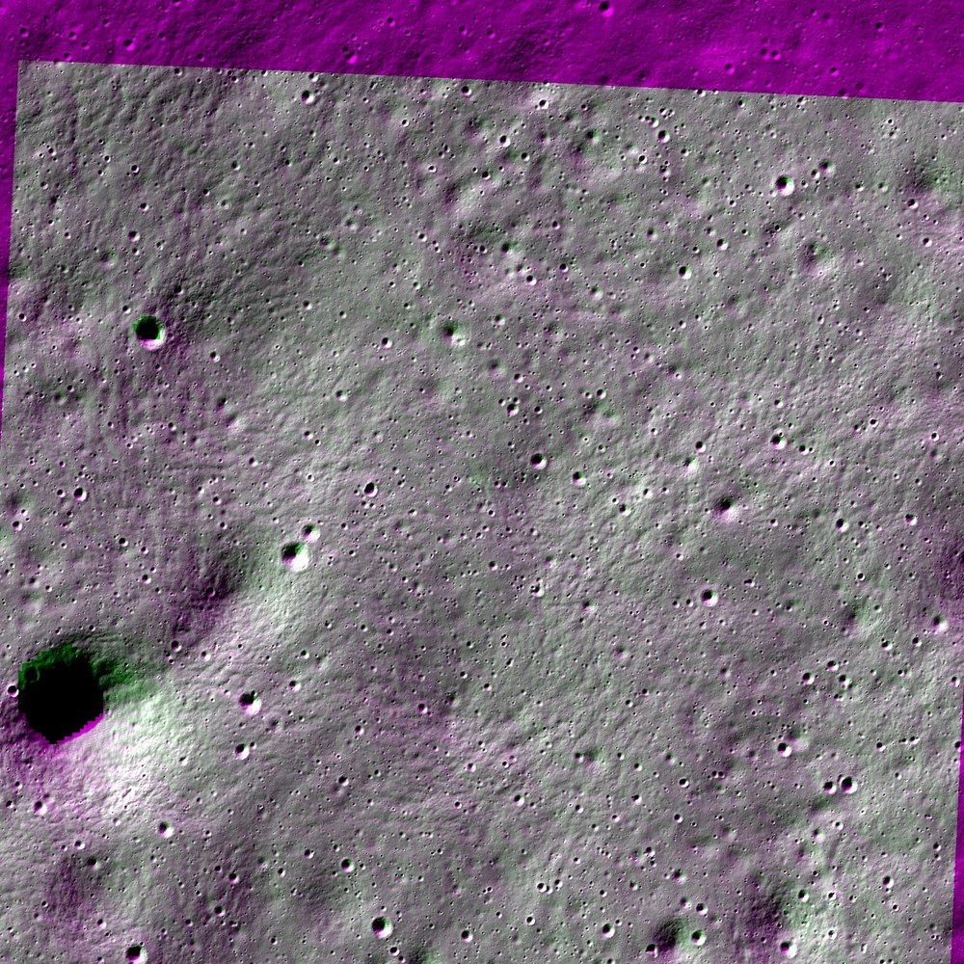  Overlay: NAC in magenta, aligned OHRC in green. Grey means they line up. | 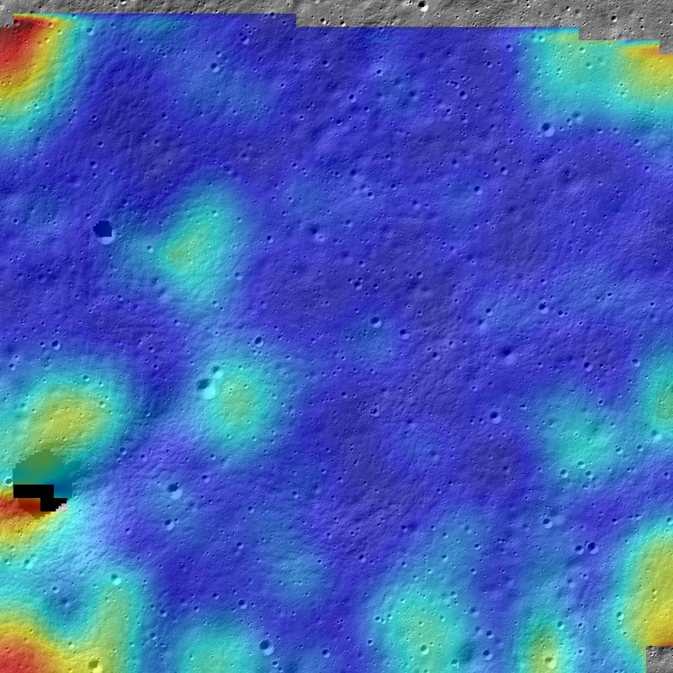  Reliability heatmap: blue ≈ 0 px, red ≥ 2 px error on unseen blocks.

Most of the image is blue, well under 0.5 px. The larger errors (about 1 to 2 px) sit mainly at the image edges and corners, where tie points have fewer neighbours, plus a few spots around craters and slopes. Terrain height is the main remaining cause, which an elevation-model correction can address.

6.3 Synthetic tests with a known answer
Test | Result
Sub-pixel refinement, shift + brightness change + noise | Mean error < 0.1 px; 0.044 px over 10 random rotation/scale/lighting cases
Non-linear distortion, full pipeline | Mean true error < 0.2 px, coverage > 90%
Source at 2× finer resolution | Recovered positions within 0.3 px after automatic resampling
Model selection | Picks a homography for flat perspective data, a polynomial for smooth bends, and the local correction only for sharp local steps (not for one small bump)
Hold-out checks | A model that memorises its points scores 0 fit error but > 20 px held-out; grouped hold-out exposes neighbour leakage
API | Real upload → sub-pixel result, all images, GeoTIFF and CSV. Unsafe file types and paths rejected. Unrelated images rejected with a plain reason.
File reading | 16-bit and compressed GeoTIFF, missing-data values, map position survives the round trip, PDS4 cube reads one band without loading the rest
Partial overlap | Tie points are only placed where the two images overlap

6.4 The seven demo pairs
The website can load seven prepared pairs, so a reviewer can see a good result, a borderline one and the engine refusing. All seven are built from the real Vikram landing-site data. Only the Vikram pair is two real camera images; the others are derived from that same real data to isolate one condition each, and the website says so
Demo pair | What it tests | What the engine does
Vikram landing site | Real Chandrayaan-2 OHRC against real LRO NAC, both at 1 m per pixel | ACCEPTED, 0.50 px, PROVE 5 of 5 STRONG
Photo vs height-map render | The same site, with one image rendered from the NASA height map | ACCEPTED, 0.49 px, PROVE 5 of 5 STRONG. Two very different-looking images still align.
Zoom gap: 5 m vs 1 m | OHRC shrunk to 5 m per pixel, about the detail of TMC-2 | ACCEPTED, 0.89 px, PROVE 4 of 5 MODERATE
Different Sun angle | The same height map rendered twice: a low Sun from the north-west against a high Sun from the north, 35 deg apart in direction and 60 deg in elevation. The correct answer is no movement at all, so the error shown is real accuracy. | ACCEPTED, 0.19 px, PROVE 5 of 5 STRONG
Different viewpoint | The same ground seen as if the camera had looked 20 deg off to the side, with a perspective stretch. The warp is known, so the error shown is real accuracy. | ACCEPTED, 0.27 px, PROVE 5 of 5 STRONG
Half overlap | Only the right half of the source overlaps the reference | ACCEPTED, 0.53 px, PROVE 5 of 5 STRONG. Tie points are placed only where the images really overlap.
Two different spots | Two 1 km areas of the site that do not overlap at all | REJECTED in under a second, with the reason in plain words

6.5 Honest limitations
- One real pair so far. Results on the ISRO study's equatorial and polar pairs are still to come.
- Reference resolution sets the limit. 0.50 m is sub-pixel at NAC's 1 m, but about 2 native OHRC pixels (~0.26 m each). We report metres and say how close we get, instead of promising 0.26 m.
- No independent answer key. The honest error is checked against our own correlation points. A steady shading bias would not show up in it; test images with a known answer and the ISRO pairs are the cross-check.
- Flipped shadows are not handled yet. This is our biggest gap. The Vikram pair has similar lighting (median correlation 0.90). The fine step copes with images that are brighter or darker, and with a Sun direction change of up to about 35 degrees, measured on rendered pairs. At a 40 degree change the engine refuses rather than return a wrong answer. Shadows that flip to the other side are still unsolved: shading agreement runs from +0.70 with the Sun on the same side to -0.68 with it on the opposite side.
- Scale needs the pixel size. Different resolutions work when pixel size is known (from the file or the form). Big size gaps without it are not tested yet.
- PDS4 upload. The engine reads PDS4 files, but the website upload does not accept them yet (a PDS4 product is a label plus a data file).
- Coordinates. Map coordinates are in metres only. Latitude and longitude are not computed yet, and not yet checked against a known point such as the Vikram lander.
- Speed. The local correction made a 2000 × 2000 pair take about 31 s instead of 9 s.

6.6 Checklist against the problem statement
# | What ISRO asks for | Status | Where we stand
1 | Find match points automatically | Done | 1,724 rough matches and 2,035 fine tie points on the Vikram pair
2 | Remove wrong matches | Done | MAGSAC++ plus a second test for odd points
3 | Align the source onto the reference | Done | Aligned PNG and GeoTIFF on the reference pixel grid
4 | Sub-pixel accuracy | Done | 0.50 px on unseen blocks (one real pair)
5 | Evenly spread match points | Done | 98% of the 8×8 grid covered, evenness 0.75
6 | Output the match points | Done | CSV and JSON, with map coordinates when the reference is a GeoTIFF
7 | RMSE, inlier count, inlier ratio | Partial | All computed and named correctly on the website: MAGSAC++ inliers (89.8%) and tie-point ratio (94.8%) are now shown as separate numbers
8 | Common coordinate system | Partial | Reference pixels and map metres; no latitude / longitude yet
9 | Different viewpoints | Partial | Flat, curved and local models work; rotations only tested up to 8°
10 | Different scale | Partial | Works when pixel size is known; big scale gaps without it not tested
11 | Different sun angle | Partial | Handles brighter or darker images, not flipped shadows. Biggest gap
12 | Works for any Chandrayaan-2 pair | Partial | One real pair so far; no TMC-2 pair yet; PDS4 not accepted by the upload form

7. Differentiators
# | Differentiator | Pitch line | Status
1 | Measured comparison with ISRO's own baseline | "ISRO SAC's 2025 study registered the polar pair only with SuperGlue, at NAC resolution. We measure on the same kind of pairs, on held-out points, and push towards OHRC resolution." | Partial
2 | Reliability heatmap | "We don't give one average number; we show how much to trust every part of the image." | Done
3 | Visible uniform coverage | "The problem statement asks for evenly spread points. We place them on a grid and prove it in the hexagon view." | Done
4 | Honest failure detection | "A bad registration is rejected automatically, with the reason." | Done
5 | Accuracy in pixels and metres | "Scientists think in metres, so we report both." | Done
Bonus | Failure map | "Where exactly do matching methods break as sun angle and scale change?" | Planned
6 | PROVE score | "Every run passes or fails five checks on numbers we measured, and we show each value next to its limit." | Done

Partial means part of it is built. Here, the ISRO study's image pairs still need to be downloaded and run.

8. Feature roadmap: Tiers 1 to 4
Status key: Done = built and tested · Partial = part built · Planned = not started.

Tier 1: Core engine (mandatory)
# | Feature | Status | Notes
1 | Image upload + API | Done | Engine behind /api/registration/analyze; per-job folders, file-type and size checks
2 | Data preparation: PDS4 / GeoTIFF, 16-bit, no-data | Done | GeoTIFF, 16-bit, compressed TIFF, missing data and pixel size done. PDS4 reader checked on a real Chandrayaan-2 IIRS file. Tie points limited to the overlap. (The upload form does not accept PDS4 yet.)
3 | Resolution alignment | Done | Source resampled to reference GSD with exact coordinate mapping
4 | Feature matching | Done | SIFT + RootSIFT + FLANN + two-way check. SuperGlue and LoFTR are not used; LightGlue only as a measured comparison later (Tier 3)
5 | Outlier removal: MAGSAC++ | Done | OpenCV USAC_MAGSAC
6 | Uniform distribution: grid balancing | Done | 8×8 balanced coarse inliers and a regular tie-point grid
7 | Sub-pixel refinement | Done | Iterative NCC + parabola; chosen after testing OpenCV and scikit-image phase correlation
8 | Local transform | Done | Polynomial degree 2–5 plus a local grid correction, chosen by the unseen-block test
9 | Outputs: registered image + match points | Done | Aligned image (PNG and GeoTIFF with map position), CSV of match points, overlay, heatmap, match-line image and JSON
10 | Metrics on held-out points | Done | Honest block error, coverage, evenness, pixels and metres, plus the PROVE score. The problem statement's inlier ratio and the tie-point ratio are shown separately on the website

Tier 2: Differentiators
# | Feature | Status | Notes
11 | ISRO baseline comparison on the study's equatorial and polar pairs | Planned | Needs the OHRC and NAC products downloaded and cropped
12 | Reliability heatmap from real errors | Done | Website shows the real error of every image cell
13 | Coverage hexagons from real tie points | Done | Website counts real tie points in each hexagon
14 | Failure detection: ACCEPT / REJECT + reasons | Done | Quality check uses the honest error; unrelated image pairs are refused with a plain reason
15 | Accuracy in pixels and metres | Done | Uses GSD from GeoTIFF or the upload form

Tier 3: Research proof
# | Feature | Status | Notes
16 | Synthetic tests with a known answer | Done | Shift, similarity, non-linear distortion, resolution change
17 | Benchmark table: SIFT vs LightGlue vs ours | Partial | SIFT baseline vs ours on the Vikram site done; LightGlue and ISRO pairs to add
18 | Failure map: sun angle × scale | Planned | Synthetic relighting from the DTM, confirmed on real pairs
19 | Shadow masking | Planned | Predict shadows from sun angle and DTM; mark matches there as unreliable

Tier 4: Product (website)
# | Feature | Status | Notes
20 | Landing page, seven analysis layers, English / Hindi | Done | Landing text rewritten in simple English with real images and Vikram numbers; Hindi landing text not updated yet
21 | Connect the website to the backend | Done | Uploads, the real sample pairs and all seven layers use engine results
22 | Before / after swipe slider | Planned | Uses the registered image
23 | Feature correspondence lines from real tie points | Done | Uses real tie points, coloured by their error

Only if time allows
- DTM-based orthorectification and relighting (the heatmap suggests terrain relief is the main remaining error)
- Crater-graph matching as a backup, only if experiments show a measured failure
- Vikram lander change-detection demo
- TMC-2 and IIRS pairs

Decided not to do
Idea | Why not
Hexagon feature-density consistency check | Feature counts differ between sensors and lighting even when alignment is perfect, so it would raise false alarms
Made-up quality scores such as "94/100" | Not measured; would not survive questions
Claiming a fine-tuned deep matcher | Only if trained and measured to beat the baseline
Matching cameras to each other (OHRC ↔ TMC) | Not what the problem statement asks
Using SuperGlue or LoFTR by default | SuperGlue's licence does not allow commercial use, both need PyTorch (and a GPU for big strips), and both were trained on Earth photos. We add LightGlue or LoFTR only if it clearly beats SIFT on a lunar pair with different lighting.

9. Build log and next steps

9.1 What's new in this update (in simple words)
- More accurate. The honest error on the Vikram pair went down from 0.59 px to 0.50 px (50 cm on the ground). Hills and craters bend the image a little differently in each place, so on top of the smooth overall fit the engine now adds a small local correction. It keeps that correction only because it predicts unseen parts of the image better.
- The website uses real results. No more demo data. You can upload two images or load the real Vikram pair, and every screen (heatmap, hexagons, match lines, geometry, report) shows what the engine actually measured.
- Ready-to-use files. Every run now saves the aligned image as a GeoTIFF that sits in the right place on the Moon map, and a CSV table with every match point, its error and its map position.
- Reads Chandrayaan-2 archive files. The engine opens PDS4 files directly and reads pixel size, footprint corners and wavelength from the label. For big spectral files it reads only the band it needs. Checked on a real IIRS file.
- Smarter about overlap. Match points are only placed where the two images really overlap, and very long strips are shrunk more for the rough step so they stay fast.
- Says clearly when it cannot work. If two images do not show the same place, or look too different, the engine stops and explains why in plain words instead of giving a wrong result. It needs at least 20 matches that agree.
- Simpler website text. The landing page now uses easy English, real Chandrayaan-2 and LRO images, and the real Vikram numbers. Planned work is listed under "Coming next".
- More tests. 41 automated tests, up from 24.

9.2 Completed steps
Step | What was built | Evidence
1 | Engine foundation: image loading (16-bit, GeoTIFF, PDS4 arrays), resolution alignment, sub-pixel refinement, hold-out metrics | 11 tests; 0.044 px synthetic refinement error
1b | Real-data fixes: compressed GeoTIFF, LROC no-data values, GSD and origin from tags | DTM elevation 502–555 m matches the published landing-site elevation
A | First honest number on the real pair; spatial-block hold-out | Baseline 1.26 px vs refined 0.64 px
2 | Coarse-to-fine pipeline: RootSIFT/FLANN/MAGSAC++, grid balancing, model selection, two passes | 0.59 px on the Vikram pair; 21 tests
3 | Engine behind the API with overlay, heatmap, tie-point image, per-cell statistics and safer uploads | 24 tests; real TIFF upload end to end
4 | Website connected to the engine: real sample pair, uploads, heatmap, hexagons, match lines, geometry page and a report with CSV / JSON export | Real Vikram run shown end to end in the browser; API tests for samples
5 | Tier 1 finished: local terrain correction, GeoTIFF and CSV export with map coordinates, PDS4 reader, tie points limited to the overlap | 0.50 px on the Vikram pair (was 0.59 px); real IIRS file read
6 | Landing page in simple English with real images and numbers; clear rejection of pairs that do not match | 41 tests; unrelated images refused

9.3 Next steps
- Step 7: make the engine work when the sun comes from a different side. First build a test pair with a different sun direction from the elevation model, then fix matching and fine-tuning for flipped shadows, and compare SIFT with LightGlue or LoFTR on it.
- Step 7b: tune the PROVE limits on more image pairs, so the limits are measured rather than chosen by us.
- Step 8: show the problem statement's inlier ratio on the website, and add latitude / longitude, checked against the Vikram lander position.
- Step 9: download and run the ISRO study's equatorial and polar OHRC–NAC pairs and publish the benchmark table; test big scale gaps and a TMC-2 pair.
- Step 10: PDS4 upload on the website, before / after swipe slider, failure map over sun angle and scale, shadow masking, and elevation-model correction if time allows.

10. Technology, credits and references

10.1 Open-source libraries used
Library | Used for
OpenCV | SIFT, FLANN, USAC MAGSAC++, template matching, image warping
NumPy | Numerical core of the engine
tifffile, imagecodecs | 16-bit and compressed (Geo)TIFF reading and writing
SciPy | Local terrain correction and smooth interpolation of the mapping
FastAPI, Uvicorn | Web API
pytest | Automated tests
React, TypeScript, Vite, Tailwind CSS, Three.js | Web platform

10.2 Data
- Chandrayaan-2 OHRC products, ISRO ISSDC PRADAN archive
- LRO LROC NAC orthophoto and DTM of the Chandrayaan-3 landing site, NASA / Arizona State University

10.3 References
- ISRO SAC comparative study of registration methods for Chandrayaan-2 OHRC and LRO NAC images, arXiv:2509.04775, 2025.
- CNSFM: crater-neighbourhood structure feature matching for multi-illumination lunar images. Remote Sensing 17(13):2302, 2025. doi:10.3390/rs17132302.
- D. G. Lowe. Distinctive image features from scale-invariant keypoints. IJCV 60(2), 2004.
- R. Arandjelović, A. Zisserman. Three things everyone should know to improve object retrieval. CVPR 2012.
- M. Muja, D. G. Lowe. Fast approximate nearest neighbors with automatic algorithm configuration. VISAPP 2009.
- D. Baráth, J. Noskova, M. Ivashechkin, J. Matas. MAGSAC++, a fast, reliable and accurate robust estimator. CVPR 2020.
- J. P. Lewis. Fast normalized cross-correlation. Vision Interface 1995.
- P.-E. Sarlin et al. SuperGlue: learning feature matching with graph neural networks. CVPR 2020.
Verify reference details (authors, titles) against the papers before the final submission.

