Air Quality Index (AQI) Analysis and Prediction
A Python-based project for exploring historical air pollution patterns and predicting the Air Quality Index (AQI). The repository contains
Two related workflows:
- Chandigarh-specific AQI analysis and prediction: it focuses on Chandigarh, with temporal/event-based analysis, pollutant relationships, regression-based AQI prediction, and AQI-category classification.
- Dynamic city-selection AQI prediction: it extends the prediction workflow to multiple cities in the available dataset. A user selects a city and date to obtain an AQI estimate and can explore interactive historical graphs for that city.

Table of Contents
- Project Objectives
- Dataset Requirements
- Libraries and Tools
- Workflow 1: Chandigarh-Specific Analysis and Prediction
- Workflow 2: Dynamic City-Selection Prediction
- Model Evaluation
- Project Flowcharts

Project Objectives
The project aims to:
- Combine historical AQI datasets into a consistent format.
- Clean missing or invalid AQI/date/city records and standardize city names.
- Explore how AQI varies over time and how it relates to measured pollutants.
- Examine seasonal patterns and selected calendar periods such as Lohri, Diwali, and paddy harvesting.
- Train machine-learning models to estimate AQI from historical patterns.
- Evaluate regression predictions with numerical error metrics.
- Classify AQI into categories in the Chandigarh workflow.
- Allow users to select a city and prediction date in the dynamic workflow.
- Visualise historical patterns through static or interactive graphs.

Dataset Requirements

Files used by the notebooks
The dynamic notebook reads these CSV files:
- city_day.csv: historical daily city-level AQI and pollutant data.
- aqi.csv: an additional AQI dataset. The code maps its columns area, date, aqi_value, and air_quality_status to the common names City, Date, AQI, and AQI_Bucket.
The Chandigarh-specific workflow also reads/writes prepared the following files:
- master_aqi_pipeline.csv
- chandigarh_temporal_features.csv
- X_features.csv
- y_target.csv

Required data fields
The combined data needs:
- City: city name
- Date: observation date
- AQI: numeric Air Quality Index value
For pollutant analysis, the dataset also contains columns such as:
- PM2.5, PM10
- NO, NO2, NOx, NH3
- CO, SO2, O3
- Benzene, Toluene, Xylene
The graph code checks which pollutant columns are available and can omit pollutant plots when the required columns are absent.

Libraries and Tools

Library/tool | Why it is used
Python | Main programming language
Jupyter Notebook / Google Colab | Interactive environment for running code, viewing graphs, and trying predictions
pandas | Reading CSV files, merging datasets, cleaning rows, grouping data, and calculating averages
NumPy | Numeric operations and calculations such as RMSE
scikit-learn | Data splitting, preprocessing pipelines, model training, and evaluation
RandomForestRegressor | RandomForestRegressor
LinearRegression | Regression baseline in the Chandigarh-specific workflow
DecisionTreeClassifier | Predicts AQI categories in the Chandigarh-specific workflow
OneHotEncoder | Represents city names as model-readable categorical features in the dynamic workflow
ColumnTransformer, Pipeline | Applies preprocessing and model steps in a consistent sequence
SimpleImputer | Handles missing feature values inside a model pipeline where configured
mean_absolute_error, mean_squared_error, r2_score | Measures regression performance
Matplotlib | Static plots in the analysis workflow
Seaborn | Statistical plots, including heatmaps, boxplots, scatter/regression plots, and bar charts
ipywidgets | City dropdown, date picker, year/pollutant selectors, and buttons in Jupyter/Colab
joblib | Saves and reloads a trained model to avoid retraining every time

Project Flowcharts

Flowchart 1 --- Chandigarh-specific analysis and prediction
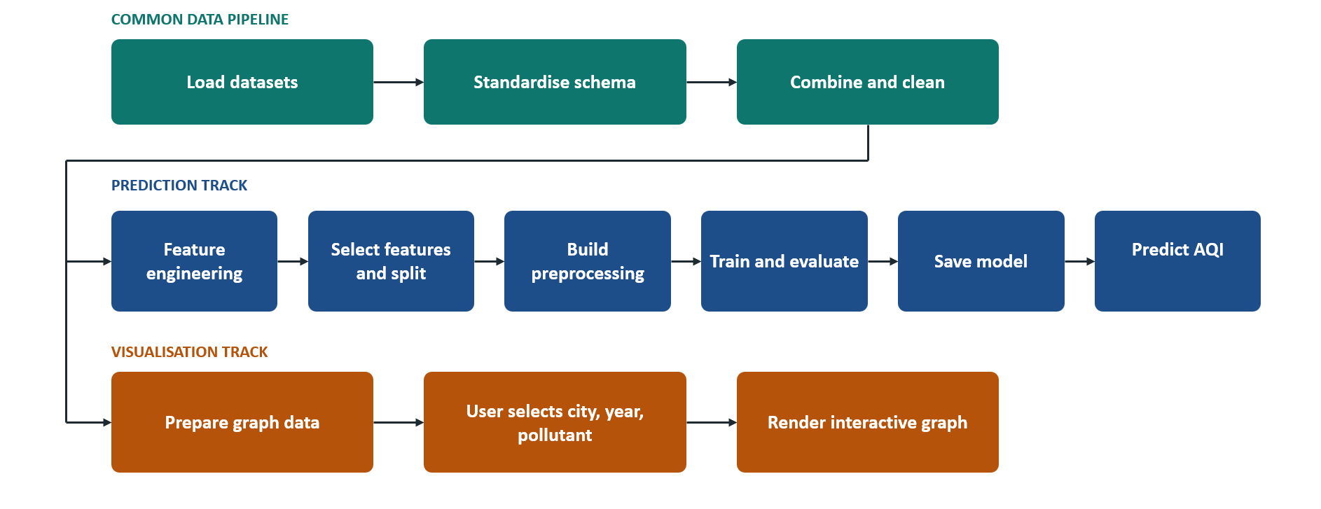

Flowchart 2 --- Dynamic city-selection prediction
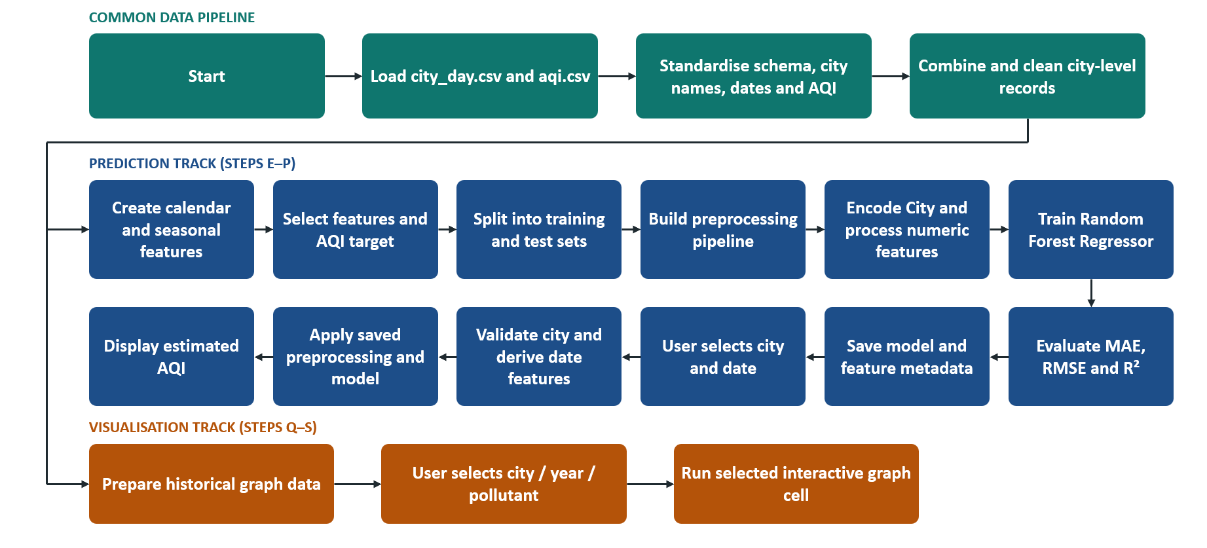

Workflow 1: Chandigarh-Specific Analysis and Prediction

A. Data compilation and feature engineering
The pipeline reads the source data, aligns column names, parses dates, standardizes city names, combines records, and removes unusable AQI rows. It then filters the data to Chandigarh and constructs temporal features.
Examples of engineered features include:
- Year, Month, Day: locate an observation within the calendar.
- Day of year and weekday: represent the position in the year and the day of the week.
- Season: group dates into seasonal periods for comparisons.
- Lohri indicator: marks January in the current implementation.
- Diwali-season indicator: marks October and November.
- Paddy-harvesting indicator: marks the period from 15 September through 30 November in the current implementation.
Indicators do not verify the actual date of a festival, local burning event, or agricultural activity in a particular year. The original preparation also applies chronological interpolation and edge filling to pollutant columns. This can help complete gaps for analysis, but interpolated values are estimates rather than measurements. For predictive modelling, imputation should be designed carefully to avoid information leakage from future observations into past predictions.

B. Exploratory data analysis
The Chandigarh plots investigate:
- Yearly average AQI.
- Monthly average AQI.
- Average AQI on weekdays versus weekends.
- Relationships between pollutant concentrations and AQI.
- Pollutant/AQI correlation heatmaps.
- Seasonal AQI distributions.
- AQI differences inside and outside selected Diwali and paddy-harvesting calendar windows.
- Winter/Lohri-related comparisons.
These are descriptive analyses. A correlation or difference between groups does not, by itself, prove that a particular pollutant, festival, or activity caused the observed AQI pattern.

C. Regression
The original Chandigarh workflow includes:
- Linear Regression as a simple baseline.
- Random Forest Regression to model non-linear relationships.

D. AQI-category classification
The workflow also includes a Decision Tree Classifier to predict AQI categories from the prepared features.

Workflow 2: Dynamic City-Selection Prediction
This version is designed to work with multiple cities represented in the merged dataset.

A. City/date prediction
The user supplies city from the available list and date of their choice.
The notebook derives the following features:
City
Year
Month
Day
DayOfYear
Weekday
Is_Lohri_Month
Is_Diwali_Season
Is_Paddy_Harvesting
This is a city/date-based estimate learned from historical patterns, not a prediction conditioned on known future PM2.5, PM10, NO₂, or other pollutant measurements.

B. Evaluation
The notebook reports:
- MAE (Mean Absolute Error): average absolute difference between predicted and observed AQI. Lower is better.
- RMSE (Root Mean Squared Error): penalizes larger errors more strongly. Lower is better.
- R²: compares the model against a simple mean-based baseline. Values closer to 1 generally indicate a better fit, while negative values can indicate poor performance.

Model Evaluation
For regression:
- MAE: average absolute prediction error in AQI units.
- RMSE: root mean squared error in AQI units.
- R²: proportion of variance explained relative to the test-set mean baseline.
For classification, review:
- Accuracy.
- Precision and recall for each AQI category.
- F1-score.
- Confusion matrix.
- Recall for high/severe AQI categories in particular.

