Microsoft Windows [版本 10.0.17134.345]

(c) 2018 Microsoft Corporation。保留所有权利。

C:\WINDOWS\system32>mysql -u root -p

Enter password: ******

Welcome to the MySQL monitor. Commands end with ; or \g.

Your MySQL connection id is 28

Server version: 8.0.12 MySQL Community Server - GPL

Copyright (c) 2000, 2018, Oracle and/or its affiliates. All rights reserved.

Oracle is a registered trademark of Oracle Corporation and/or its

affiliates. Other names may be trademarks of their respective

owners.

Type 'help;' or '\h' for help. Type '\c' to clear the current input statement.

mysql> use wangjiaren;

Database changed

mysql> show tables;

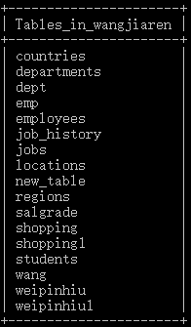

17 rows in set (0.12 sec)

mysql> desc departments;

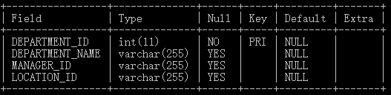

4 rows in set (0.10 sec)

mysql> select * from departments;

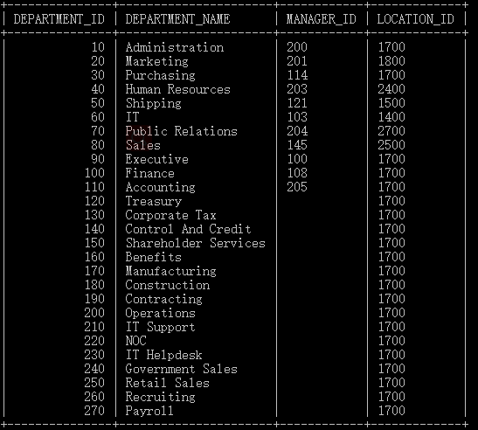

27 rows in set (0.00 sec)

mysql> select distinct MANAGER_ID from departments;

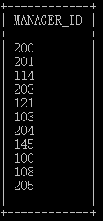

12 rows in set (0.00 sec)

mysql> select * from departments where MANAGER_ID>200 order by MANAGER_ID desc limit 2,3;

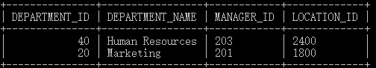

2 rows in set (0.12 sec)

mysql> select distinct MANAGER_ID from departments order by MANAGER_ID desc;

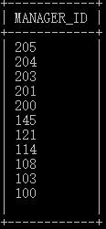

12 rows in set (0.01 sec)

mysql> select MANAGER_ID,sum(MANAGER_ID) from departments group by MANAGER_ID;

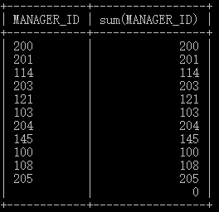

12 rows in set (0.00 sec)

mysql> desc countries;

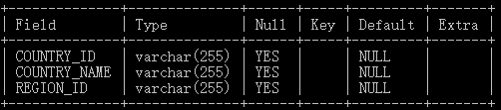

3 rows in set (0.09 sec)

mysql> alter table departments add REGION_ID varchar(255);

Query OK, 0 rows affected (1.00 sec)

Records: 0 Duplicates: 0 Warnings: 0

mysql> desc departments;

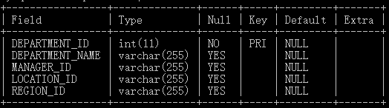

5 rows in set (0.00 sec)

mysql> select * from departments;

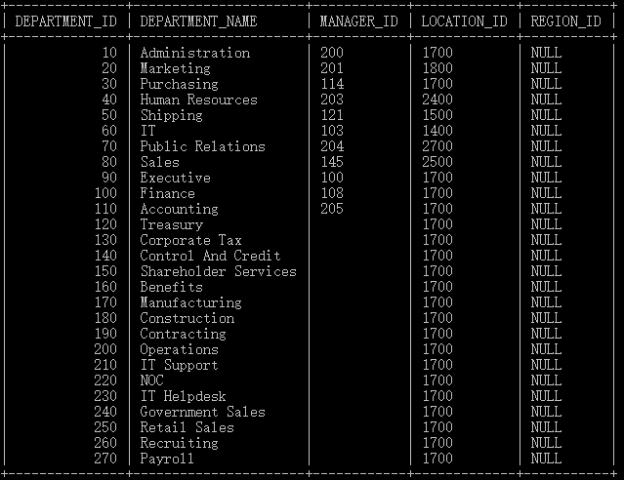

27 rows in set (0.00 sec)

mysql> select * from countries;

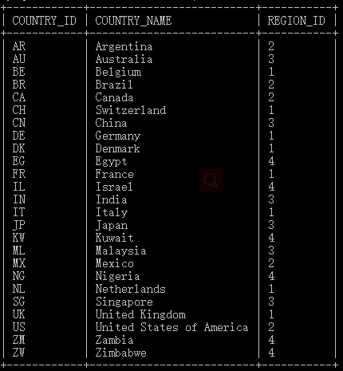

25 rows in set (0.00 sec)

mysql> select * from departments left join countries on departments. REGION_ID=countries. REGION_ID;

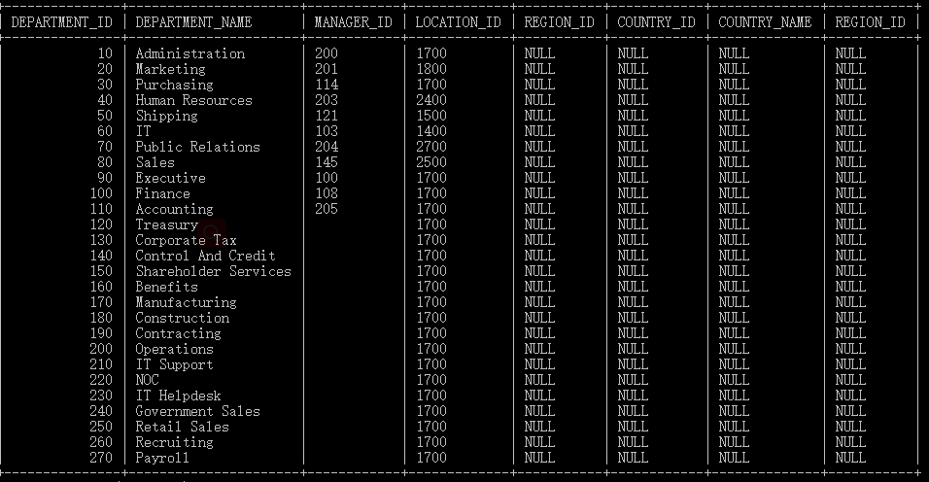

27 rows in set (0.00 sec)