Microsoft Windows [版本 10.0.17134.345]

(c) 2018 Microsoft Corporation。保留所有权利。

C:\WINDOWS\system32>mysql -u root -p

Enter password: ******

Welcome to the MySQL monitor. Commands end with ; or \g.

Your MySQL connection id is 39

Server version: 8.0.12 MySQL Community Server - GPL

Copyright (c) 2000, 2018, Oracle and/or its affiliates. All rights reserved.

Oracle is a registered trademark of Oracle Corporation and/or its

affiliates. Other names may be trademarks of their respective

owners.

Type 'help;' or '\h' for help. Type '\c' to clear the current input statement.

mysql> use wangjiaren;

Database changed

mysql> create table shoucangbiaodan (id int(6) auto_increment primary key

-> , name varchar(20)not null);

Query OK, 0 rows affected (0.68 sec)

mysql> alter table shoucangbiaodan add wupinming varchar(5);

Query OK, 0 rows affected (0.64 sec)

Records: 0 Duplicates: 0 Warnings: 0

mysql> alter table shoucangbiaodan add money varchar(5);

Query OK, 0 rows affected (0.40 sec)

Records: 0 Duplicates: 0 Warnings: 0

mysql> desc shoucangbiaodan;

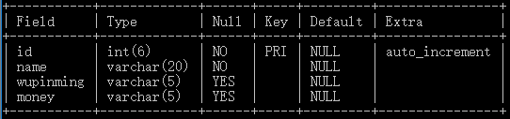

4 rows in set (0.39 sec)

mysql> alter table shoucangbiaodan add shoucang varchar(5);

Query OK, 0 rows affected (0.74 sec)

Records: 0 Duplicates: 0 Warnings: 0

mysql> alter table shoucangbiaodan drop shoucang;

Query OK, 0 rows affected (1.22 sec)

Records: 0 Duplicates: 0 Warnings: 0

mysql> desc shoucangbiaodan;

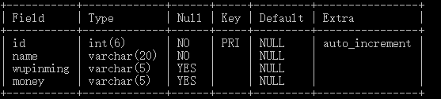

4 rows in set (0.00 sec)

mysql> insert into shoucangbiaodan(id,name,wupinming,money)

-> values(1,'wang','yifu',214),(2,'liu','bao',456);

Query OK, 2 rows affected (0.31 sec)

Records: 2 Duplicates: 0 Warnings: 0

mysql> alter table shoucangbiaodan add unique(name);

Query OK, 0 rows affected (0.79 sec)

Records: 0 Duplicates: 0 Warnings: 0

mysql> desc shoucangbiaodan;

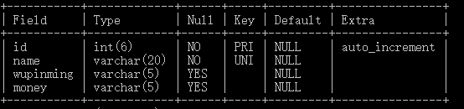

4 rows in set (0.00 sec)