Microsoft Windows [版本 10.0.17134.345]

(c) 2018 Microsoft Corporation。保留所有权利。

C:\WINDOWS\system32>mysql -u root -p

Enter password: ******

Welcome to the MySQL monitor. Commands end with ; or \g.

Your MySQL connection id is 40

Server version: 8.0.12 MySQL Community Server - GPL

Copyright (c) 2000, 2018, Oracle and/or its affiliates. All rights reserved.

Oracle is a registered trademark of Oracle Corporation and/or its

affiliates. Other names may be trademarks of their respective

owners.

Type 'help;' or '\h' for help. Type '\c' to clear the current input statement.

mysql> use wangjiaren;

Database changed

mysql> create table dianying (id int(11) auto_increment primary key,

-> name varchar(45)not null,nianfen varchar(4),danyan varchar(45),pinfen varchar(3)not null);

Query OK, 0 rows affected (0.74 sec)

mysql> desc dianying;

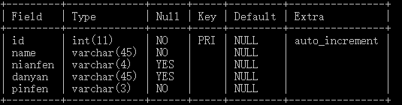

5 rows in set (0.01 sec)

mysql> insert into dianying(

-> id,name,nianfen,danyan,pinfen)

-> values(1,'xihongshishoufu',2018,'yanfei','8.3');

Query OK, 1 row affected (0.09 sec)

mysql> insert into dianying(

-> id,name,nianfen,danyan,pinfen)

-> values(2,'wobushiyanshen',2018,'muye','7.9');

Query OK, 1 row affected (0.27 sec)

mysql> select * from dianying;

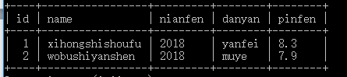

2 rows in set (0.00 sec)

mysql> select * from dianying where name like '%xi%' ;

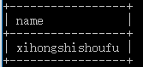

1 row in set (0.00 sec)

mysql> select danyan from dianying where danyan like '%y%' ;

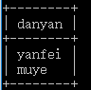

2 rows in set (0.00 sec)

mysql> select * from dianying where nianfen=2018;

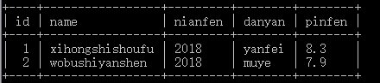

2 rows in set (0.15 sec)

mysql> select * from dianying where pinfen>8;

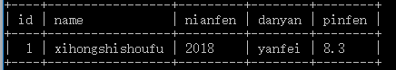

1 row in set (0.00 sec)