Microsoft Windows [版本 10.0.17134.407]

(c) 2018 Microsoft Corporation。保留所有权利。

C:\WINDOWS\system32>mysql -u root -p

Enter password: ******

Welcome to the MySQL monitor. Commands end with ; or \g.

Your MySQL connection id is 18

Server version: 8.0.12 MySQL Community Server - GPL

Copyright (c) 2000, 2018, Oracle and/or its affiliates. All rights reserved.

Oracle is a registered trademark of Oracle Corporation and/or its

affiliates. Other names may be trademarks of their respective

owners.

Type 'help;' or '\h' for help. Type '\c' to clear the current input statement.

mysql> use wangjiaren;

Database changed

mysql> create or replace view view_yonghubiao as

-> select * from yonghubiao;

Query OK, 0 rows affected (0.67 sec)

mysql> select * from view_yonghubiao;

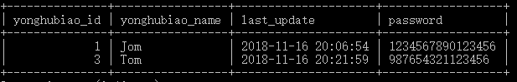

2 rows in set (0.10 sec)

mysql> create or replace view view_y_z(d1,d2) as

-> select yonghubiao.yonghubiao_name,zhuangbeibiao.zhuangbeibiao_name from yonghubiao,zhuangbeibiao;

Query OK, 0 rows affected (0.25 sec)

mysql> select * from view_y_z;

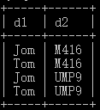

4 rows in set (0.13 sec)