**Project Wireless and Mobile Computing**

**GotRex Application**

**by**

**Naensinee   Soongsiri         5888165**

**Amonnat    Tengputtipong 5888202**

**Intukorn     Limpachaveng     5888261**

**ITCS424 – Wireless and Mobile Computing**

**Faculty of Information and Communication Technology  
Mahidol University  
2017**

**Overview of the project**

GotRex is a petting game for taking care the baby Got-Rex (Godzilla or Tyrannosaurus Rex). The users have to put their love and caring to their Got-Rex. Feed him/her and get him/her to bed. They can capture their T-rex moments and collect them in the users’ album or camera roll. Their baby Got-Rex can evolve into Tyrannosaurus Rex or Godzilla, which depends on how they take care on the Baby Got-Rex.

**Objective of the project**

GotRex application aims to be a learning application for a player to be responsible, happy and more observant.

First, the application will develop the player’s responsibility. There are two results after a player finish taking care of his or her pet. The first adult result on this application is the Tyrannosaurus, which means that the player have been taking good care on the baby. On the other hand, if the player is fail to take responsibility on baby, the result will be the Godzilla. Thus, these two results will teach the player to know that each characteristic result can be affected by how they treated on their baby.

Second, this application will use the advantage of the game play, in order to make a player feel relief from stress. This application will be suitable to be a time killer because a player can enjoy in doing various things with the virtual pet. Moreover, it can be another alternative choice for user who want to have a pet. As the research supported by U.S. Food and Drug Administration claimed that people who have a pet are quickly recover from stress than people who not have a pet.

Last, GotRex application can build up the observant characteristic on a player. As they have to observe how well of the baby so that they can take care of it without having the notification

**Tyrannosaurus Baby Got-Rex Godzilla**

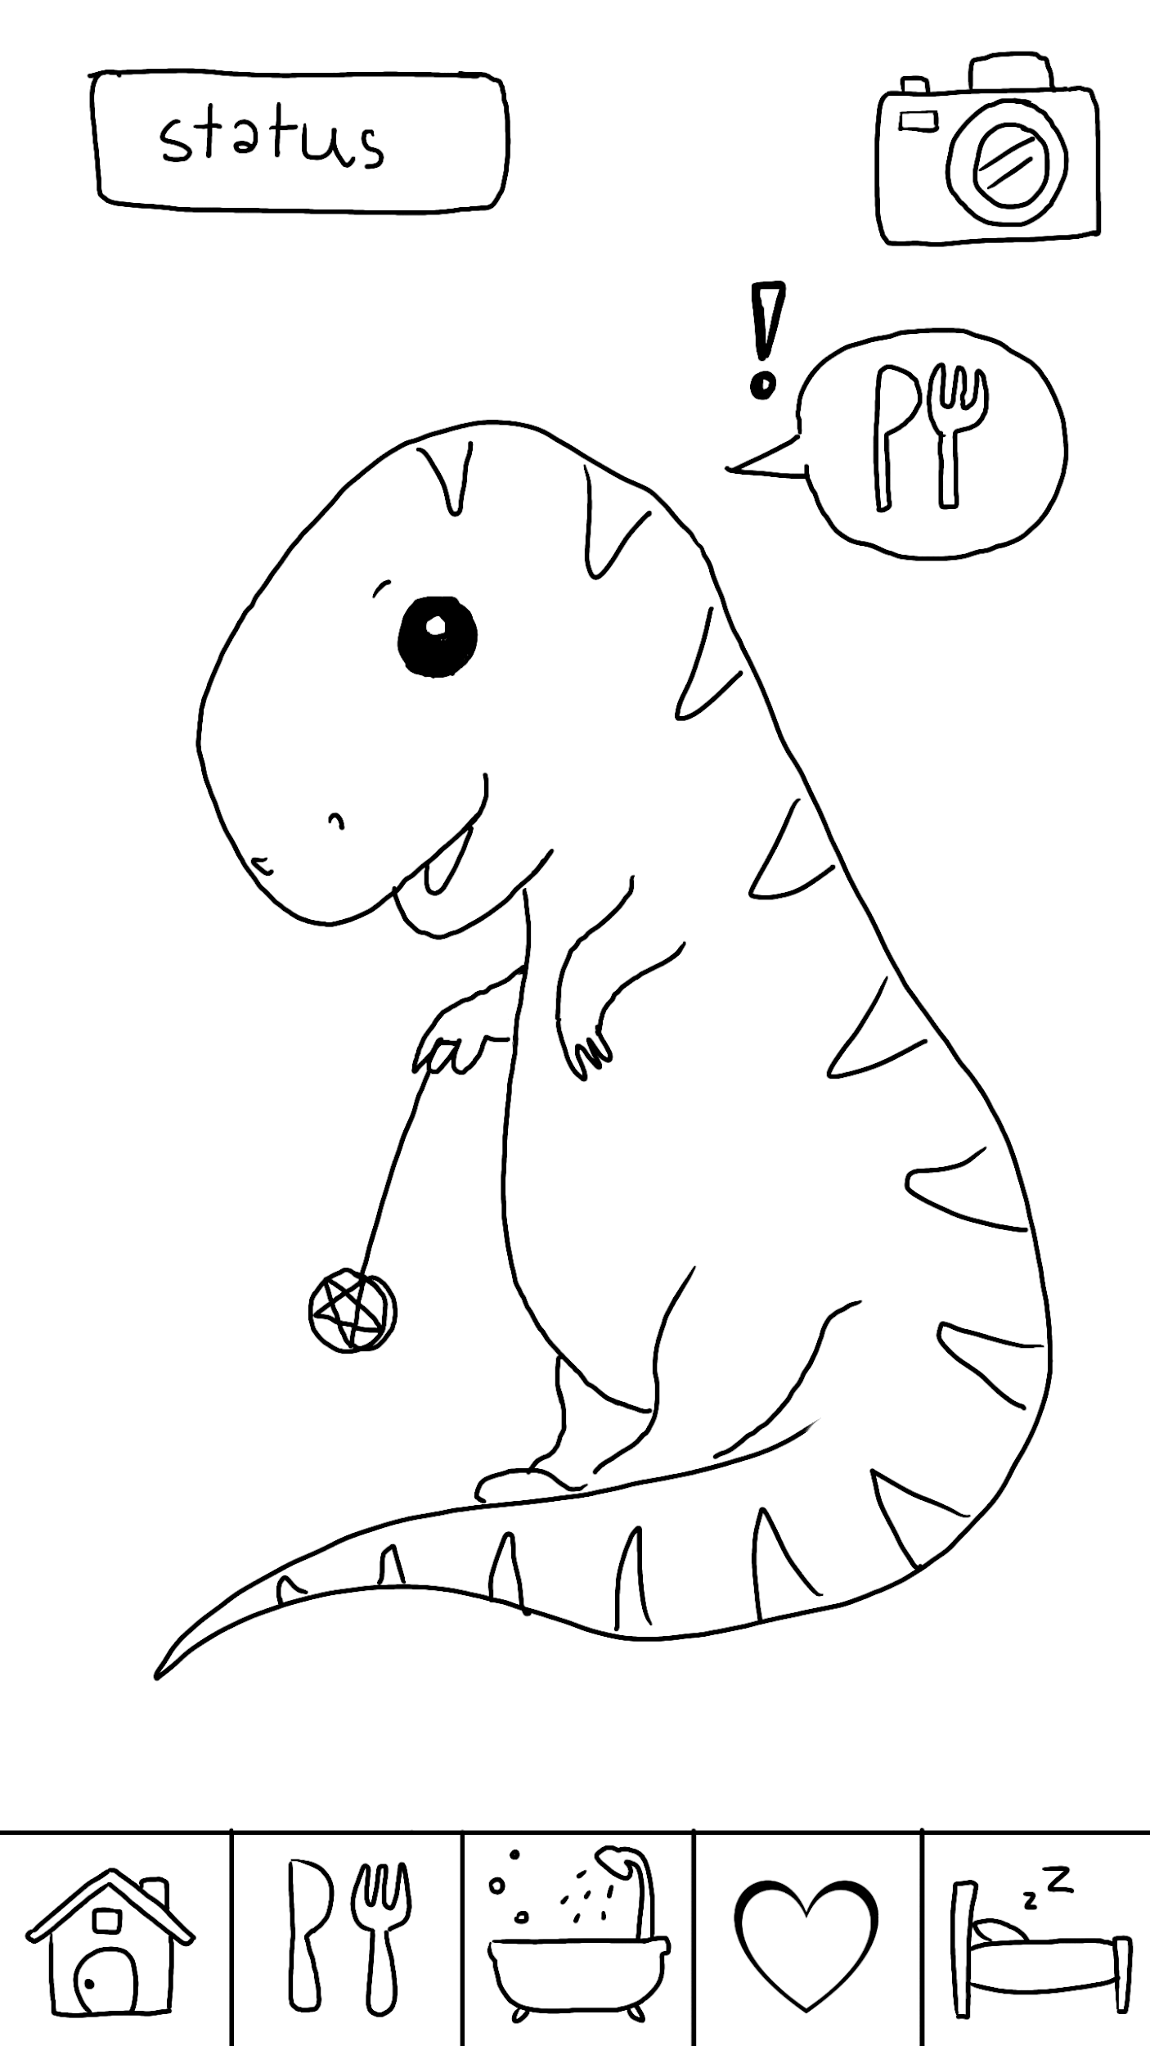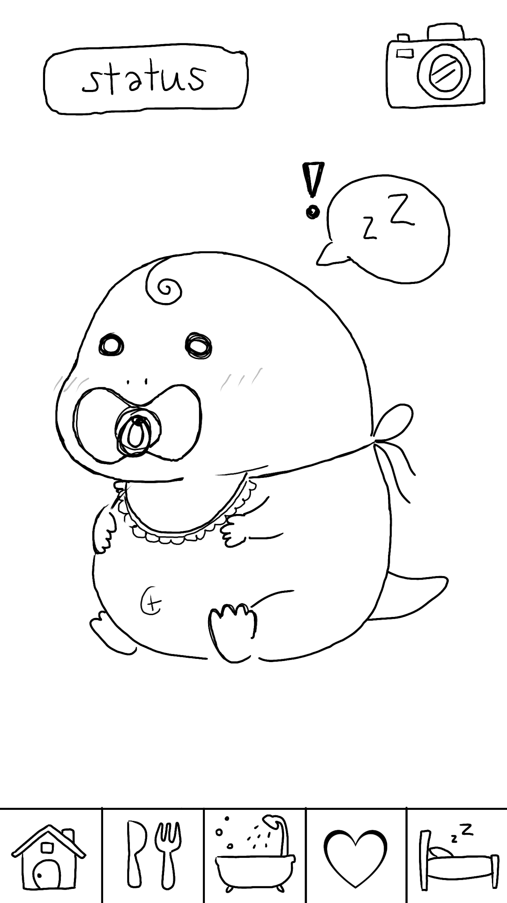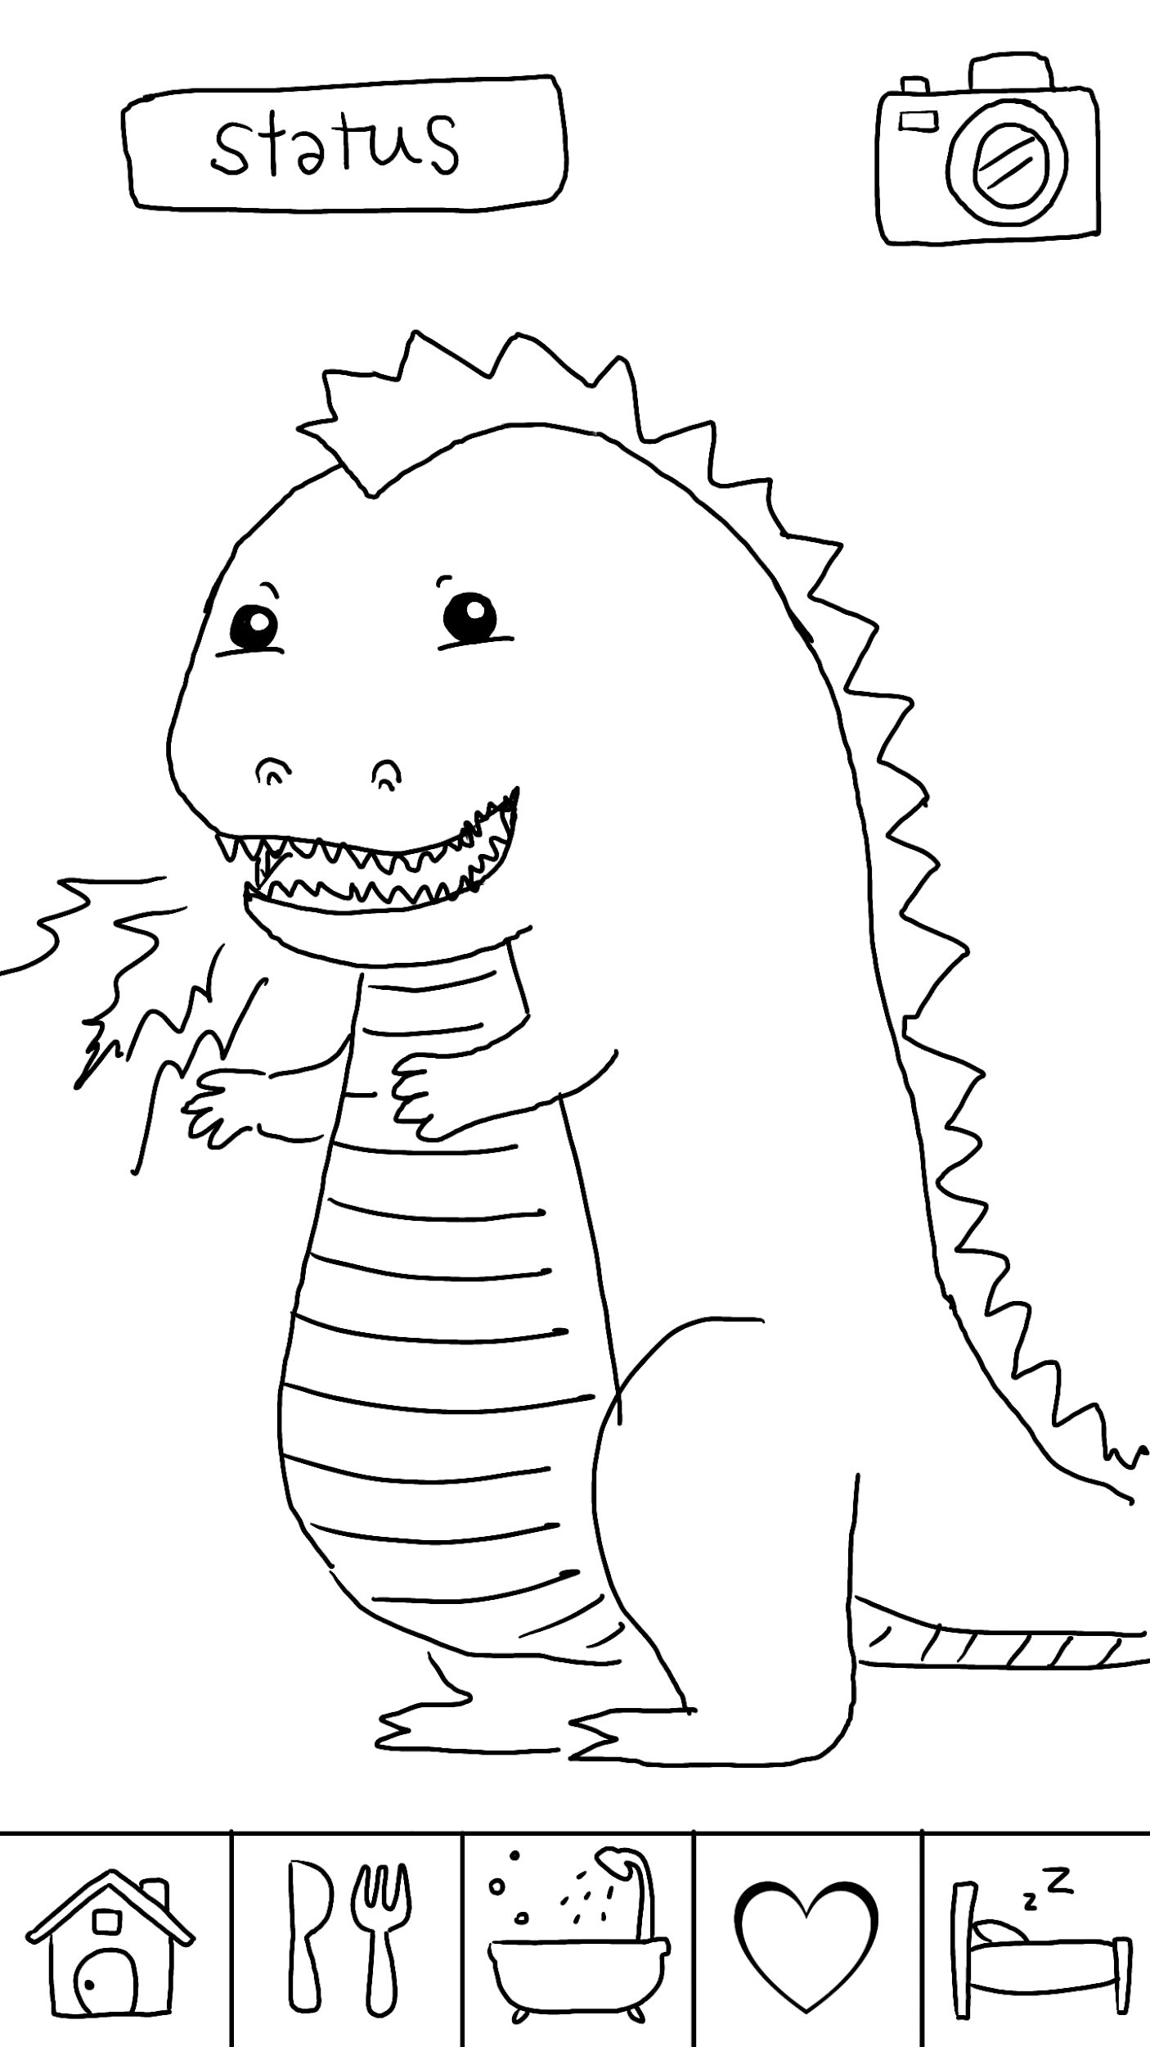

**Application design**

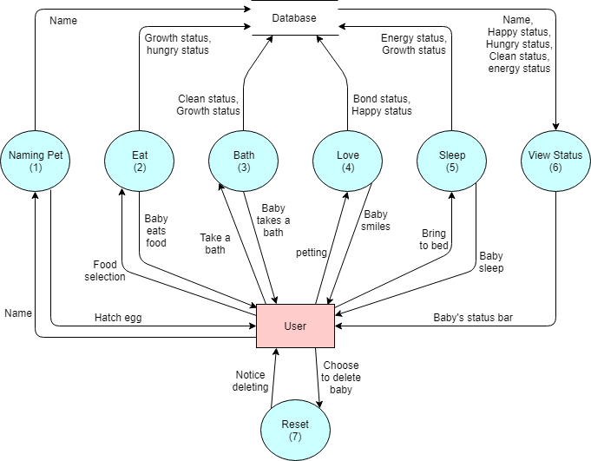

**System architecture**

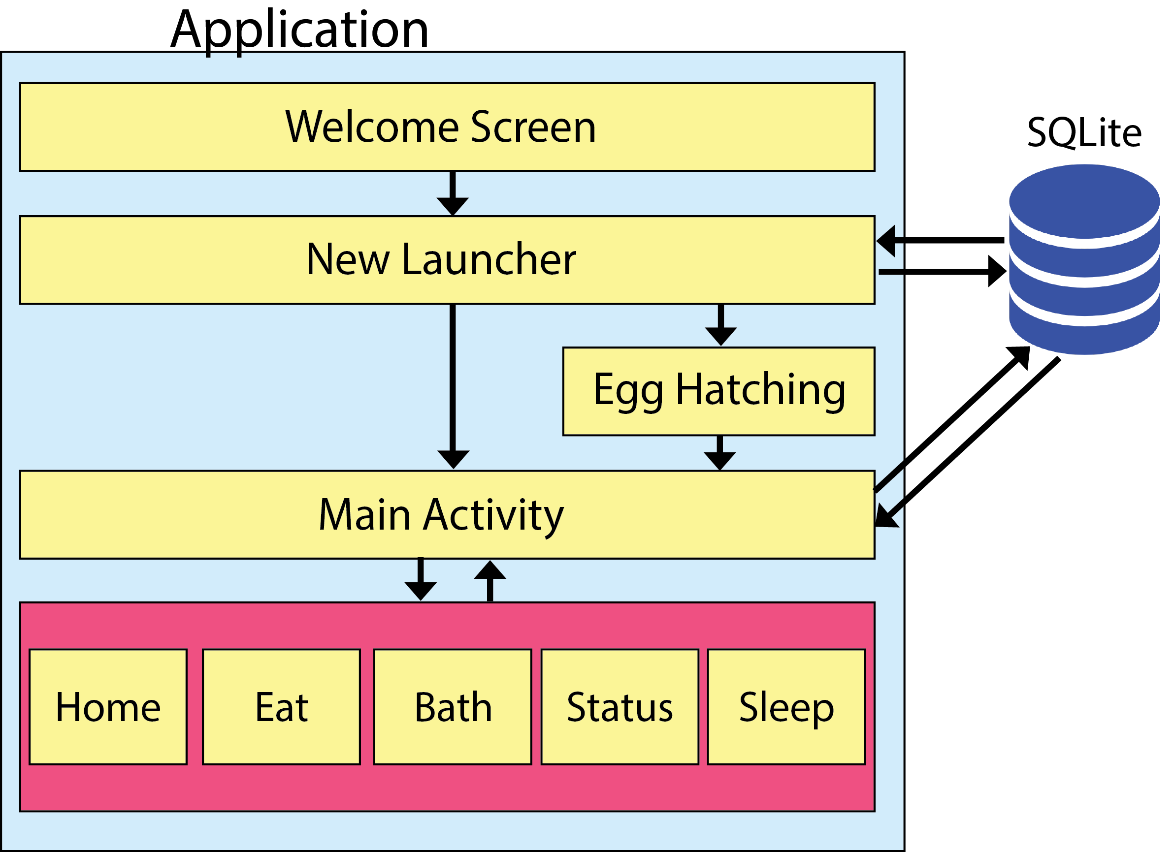

**Screenshots of at least one activity of your application.**

The image below is the welcome screen that always appear when the application start.

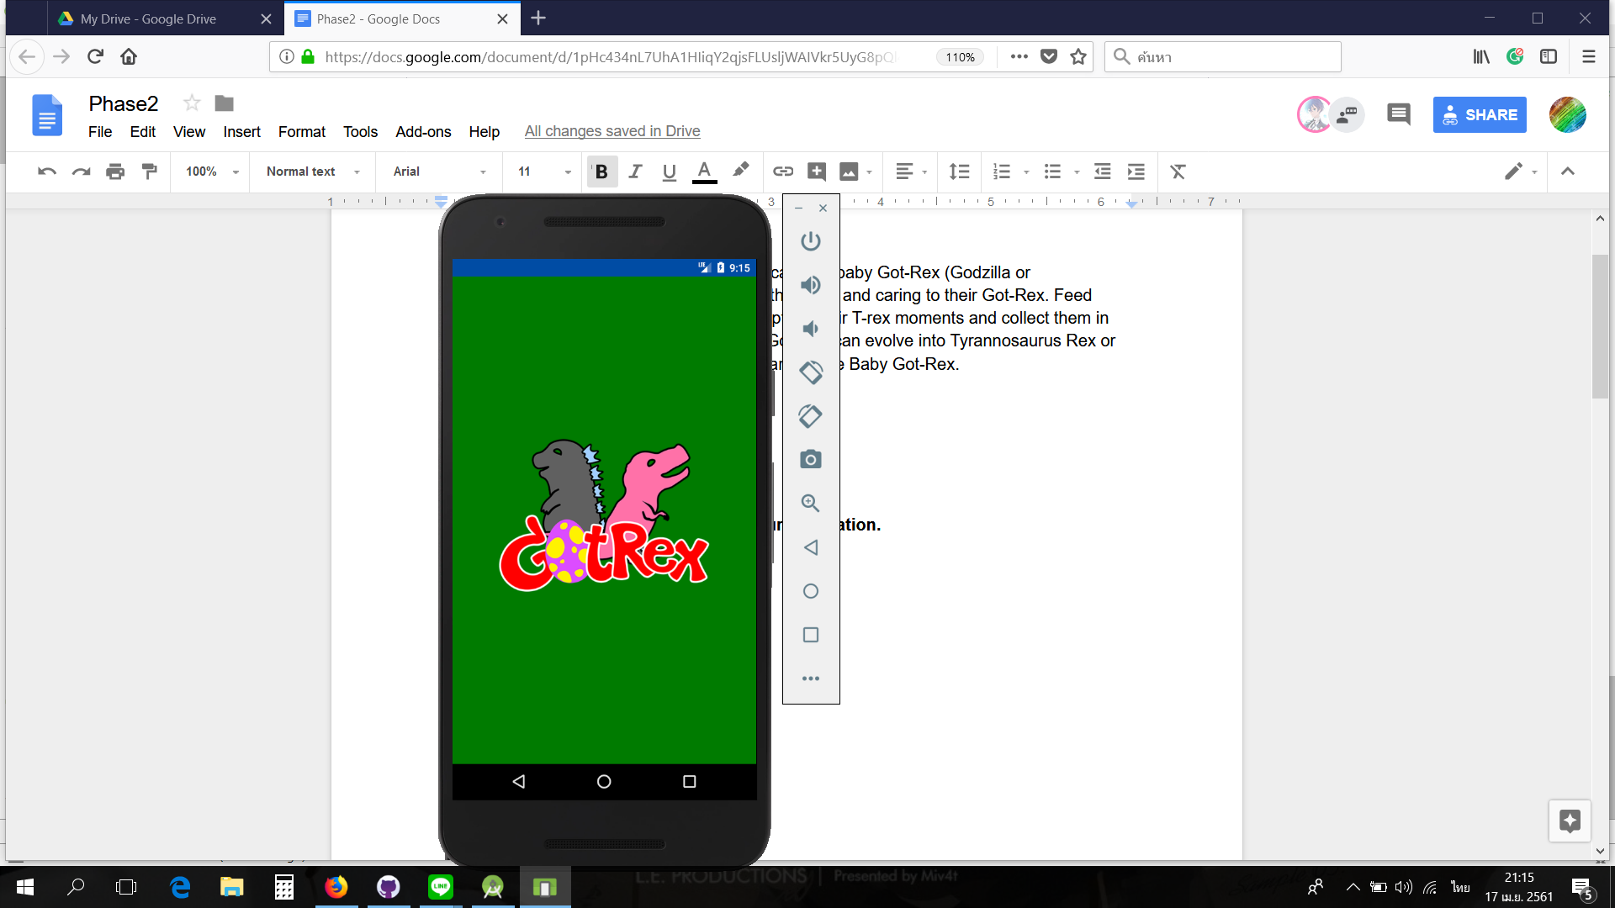

The ‘New Launcher’ activity that is used for the user to input the name of the baby.

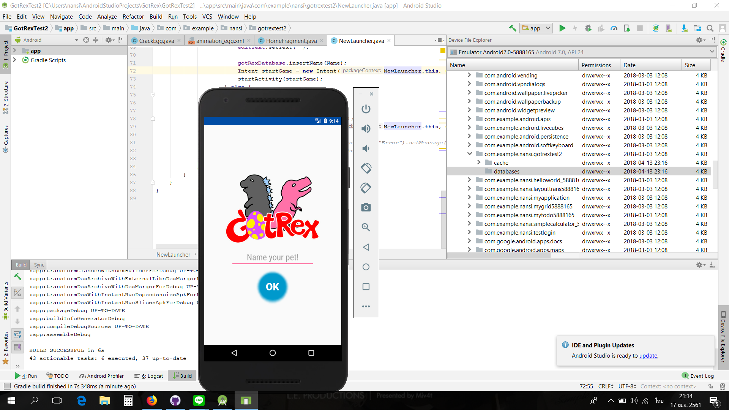

After naming the pet, the application will bring user to hatching egg page.

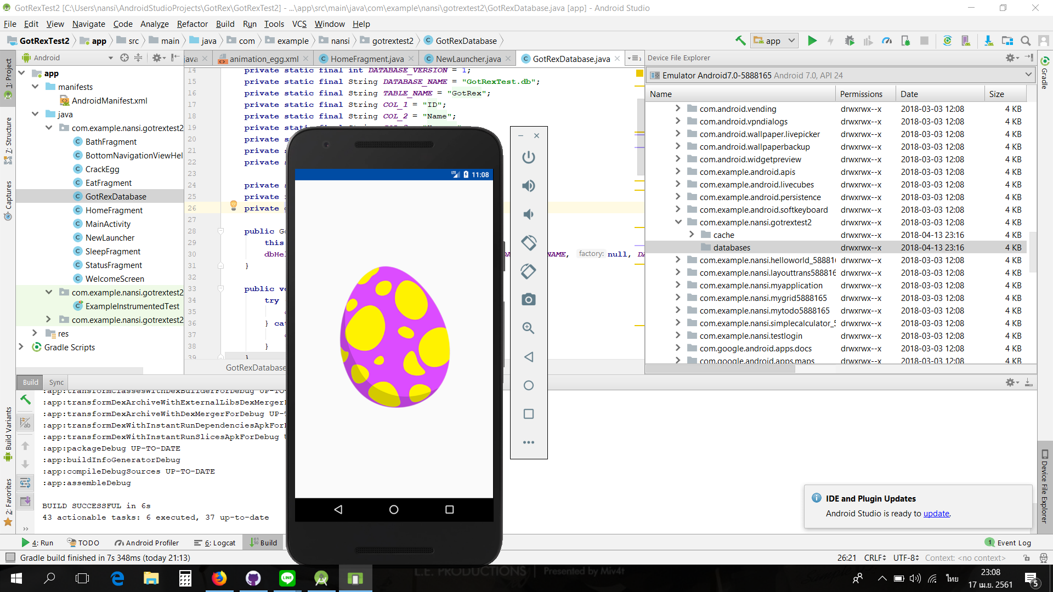

When the egg hatch, the application will navigate user into the ‘Main Activity’. *Main activity page* will let the user call other fragments by using bottom navigation tab.

Below here is the home page, the user can petting on it to add the baby’s happy value.

