

|  |  |
| --- | --- |
| **Web technologies | Front-End** | |
| Student(s’) name(s): | Bikulova Nazerke, Amanzhan Aida, Askarbek Marat |
| Teacher name: | Dariya Bissengaliyeva |
| Project name: | Profile Website |
| Project type: | Group |

**INTRODUCTION**

Our team was inspired by people creating vignettes to commemorate their high school (and other) years. After a short thought about how we could implement this idea, we came to the common decision to create a “Profile Website”. Now there is no need to keep the vignette in a far corner of the closet, because now we can easily go to the site and look, maybe even remember all the classmates. In the first assignment, we used HTML and CSS. In the second one, however, we'll add Bootstrap to that.

**MAIN PART (Practical) | Information about developers and their responsibilities.**

Our first project was about tables and pictures. Our site provides an opportunity not only to see all CS-2124 group members, but also to find out how old they are at the moment, what city they were born in, and their date of birth. We've created something along the lines of a calendar-helper analog for teachers and our classmates. In understanding the code, perhaps the most difficult thing was to deal with the scale and readability of the site, because of the limited time we did everything we could, although not quite accurately. As we are working on laptops, the default setting in Windows is 125% zoom, which made the site seem crooked. We fixed that error. Working with tables was also not easy because after each photo of a group member there had to be a title in the form of a link, when you click on it, it goes to the next page, where more information about us is given. Perhaps it was because we had not yet fully mastered the HTML language, but nevertheless, we were able to achieve the desired result. Another thing that made us think a little bit and slow down was trying to shift everything around the center. According to the native settings, every text, picture, table, yes anything, defaults to the left side of the site. And the difficulty is that it would seem align=" center" and there are no more problems. It turns out that it's not quite possible to do it that easily, so we decided it would be better to create a CSS class whose job is to center everything written. It really saved us a lot of time and extra lines.

Before starting, every creator needs a wireframe of the project that he is going to create. We created a wireframe using Canva. It is very simple and so easy to use. You can easily paste some details that help your work look good. We have 3 pages. We created 3 sketches, after started to write a code for our website.

About bootstrap. With bootstrap, you can use prepared templates that will make your work look more modern and organized. We used bootstrap buttons, also containers to divide our pages into sections. Containers help our site to look the same on different devices.

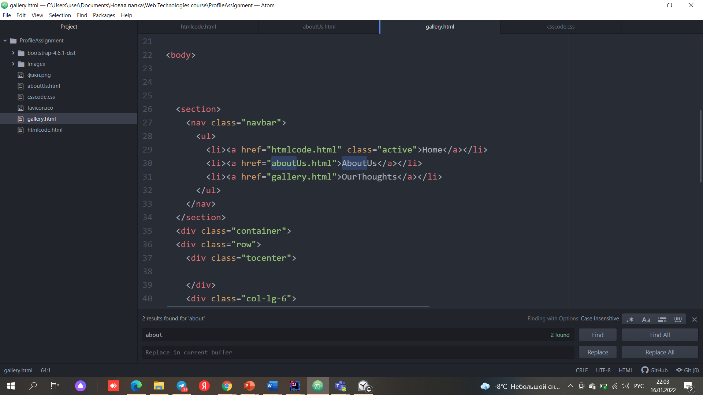

For the most part we all had equal responsibilities:

Aida was responsible for the idea, plan, wireframe and css coding.

Marat was responsible for the image containing of our website, also some bootstrap codes were advised by him.

Nazerke was responsible for HTML and including others code in one website.

Even though we tried to make our code clean and tidy, maybe because of our unexperincivness, it is structed in a little mess.

**PROGRESS [optional]**

|  |  |
| --- | --- |
| 10.01.2022 | Week 3 and 4 studies |
| 11.01.2022 | Learning Bootstrap |
| 12.01.2022 | Allocation of responsibilities |
| 13.01.2022 | Studying services for interface development |
| 14.01.2022 | Marking our coding’s for design |
| 16.01.2022 | Adding finishing details |