

Application

**SIM8950 Series Display Driver Development Guide**

Version: 1.00

Release Date: August 16, 2018



# About Document

## Document Information

|  |  |
| --- | --- |
| **Document** | |
| **Title** | SIM8950 Series Display Driver Development Guide |
| **Version** | 1.00 |
| **Document Type** | Application Note |
| **Document Status** | Released/Confidential |

## Revision History

|  |  |  |  |
| --- | --- | --- | --- |
| **Revision** | **Date** | **Owner** | **Status / Comments** |
| 1.00 | Aug 16, 2018 | Chuanzheng.xue | First Release |

## Related Documents

**This document applies to the following products:**

|  |  |  |  |
| --- | --- | --- | --- |
| **Name** | **Type** | **Size (mm)** | **Comments** |
| SIM8950 | Smart Module | 44.1*45.6*2.8 | N/A |

**Copyrights**

This document contains proprietary technical information which is the property of SIMCom Wireless. Copying of this document and giving it to others and the using or communication of the contents thereof, are forbidden without express authority. Offenders are liable to the payment of damages. All rights reserved in the event of grant of a patent or the registration of a utility model or design. All specification supplied herein are subject to change without notice at any time.

# Contents

About Document 2

Document Information 2

Revision History 2

Related Documents 2

Contents 3

1 Purpose of this document 4

2 Kernel panel bringup 4

2.1 Prerequisites 4

2.2 DSI panel bringup 4

2.2.1 Disable continuous splash in LK and kernel 4

2.2.2 Verify that the panel backlight is enabled 5

2.2.3 Prepare the dtsi files with the mandatory elements and panel 6

2.2.3.1 Fill the panel LCD information 8

2.2.3.2 Pack the ON/OFF commands 9

2.2.3.3 Set the MDSS DSI host parameters 11

2.2.3.4 Calculate the PHY timings 11

2.2.3.4.1 How to use the spreadsheet for DSI PHY timing calculation 12

3 Little Kernel (LK) Bringup 15

Contact 17

# 1 Purpose of this document

This document describes how to bringup the display panel in kernel and Little Kernel (LK) with

the Display Serial Interface (DSI) on the SIM8950 Android platform.

# 2 Kernel panel bringup

## 2.1 Prerequisites

Gather the following information from the panel specification and hardware schematic:

1. Panel parameters – Panel type, resolution, bpp, fps, porch values
2. Panel power-on sequence and signal duration for GPIO pins, for example RESET/IOVDD
3. Panel DSI initial command sequence and subsequent delay.
4. Bitclk needed to reach the target fps
5. GPIO connection between the host and panel including RESET, TE, and so on
6. Panel power supplies and voltages

## 2.2 DSI panel bringup

Bringup the Linux kernel first and then port it to the little kernel (LK) later. This chapter

describes the Linux kernel bringup.

Follow these steps for Linux kernel panel bringup:

1. Disable continuous splash in LK and Kernel.
2. Verify that panel backlight is enabled or turn it always ON during bringup.
3. Prepare the panel dtsi file.

Create the dtsi file in one of two ways:

◻ Use QTI’s GCDB parser

◻ Refer to one of the dtsi files located under kernel/arch/arm/boot/dts/qcom folder.

1. Include the panel DTSI in the platform device tree and select the panel DTSI that should be

picked up.

## 2.2.1 Disable continuous splash in LK and kernel

The continuous splash needs to be disabled in both LK and kernel at this point so that the kernel

begins settings from scratch.

1. Disable continuous splash in LK: Disable the Macro DISPLAY_SPLASH_SCREEN at

bootable/bootloader/lk/target/$(project)/rules.mk. Use the chipset rules.mk file specific to

the chipset that you are working on.

Example:

bootable/bootloader/lk/target/msm8953/rules.mk

-DEFINES += DISPLAY_SPLASH_SCREEN=1

+#DEFINES += DISPLAY_SPLASH_SCREEN=1

DEFINES += DISPLAY_TYPE_MIPI=1

DEFINES += DISPLAY_TYPE_DSI6G=1

2. Disable continuous splash in kernel: Make sure that panel node does not contain “qcom,cont-

splash-enabled” element. For the new panels being created, this element may not be

included, but be sure to check for it. Below is an example for reference.

Example:

--- kernel/msm-3.18/arch/arm/boot/dts/qcom/dsi-panel-nt35532-1080p-video-sim.dtsi

qcom,mdss-dsi-underflow-color = <0xff>;

qcom,mdss-dsi-border-color = <0>;

-qcom,cont-splash-enabled;

+//qcom,cont-splash-enabled;

## 2.2.2 Verify that the panel backlight is enabled

For bringup, to rule out backlight issues, it is recommended that the backlight be enabled all the

time, if possible.

1. The node shown below in panel dtsi file refers to the backlight type to be used. Set it as

shown below.

qcom,mdss-dsi-bl-pmic-control-type: A string that specifies the implementation of backlight control for this panel.

"bl_ctrl_pwm" = Backlight controlled by PWM gpio.

"bl_ctrl_wled" = Backlight controlled by WLED.

"bl_ctrl_dcs" = Backlight controlled by DCS commands.

other: Unknown backlight control. (default)

2. If backlight is PWM controlled, configure the PWM parameters also, as shown below.

qcom,mdss-dsi-bl-min-level = <1>;

qcom,mdss-dsi-bl-max-level = <255>;

qcom,mdss-dsi-bl-pmic-control-type = "bl_ctrl_pwm";

qcom,mdss-dsi-bl-pmic-pwm-frequency = <100>;

qcom,mdss-dsi-bl-pmic-bank-select = <0>;

## 2.2.3 Prepare the dtsi files with the mandatory elements and panel

Information:

It is important to hook in all the panel related information in this dtsi file so that the host will be

configured according to the panel requirements.

All panel “.dtsi” files are placed under the kernel\ msm-3.18\arch\arm\boot\dts\qcom\ folder.

The detailed documentation is found in kernel\msm-3.18\Documentation\devicetree\bindings\ fb\mdss-dsi-panel.txt file

The examples below show single dsi Video mode panel dtsi files. The steps for preparing the dtsi files start in Section 5.2.3.1.

Video mode panel .dtsi file example

&mdss_mdp {

dsi_nt35532_1080p_video: qcom,mdss_dsi_nt35532_1080p_video {

qcom,mdss-dsi-panel-name = "nt35532 1080p video mode dsi panel";

qcom,mdss-dsi-panel-controller = <&mdss_dsi0>;

qcom,mdss-dsi-panel-type = "dsi_video_mode";

qcom,mdss-dsi-panel-destination = "display_1";

qcom,mdss-dsi-panel-framerate = <60>;

qcom,mdss-dsi-virtual-channel-id = <0>;

qcom,mdss-dsi-stream = <0>;

qcom,mdss-dsi-panel-width = <1080>;

qcom,mdss-dsi-panel-height = <1920>;

qcom,mdss-dsi-h-front-porch = <100>;

qcom,mdss-dsi-h-back-porch = <80>;

qcom,mdss-dsi-h-pulse-width = <20>;

qcom,mdss-dsi-h-sync-skew = <0>;

qcom,mdss-dsi-v-back-porch = <16>;

qcom,mdss-dsi-v-front-porch = <16>;

qcom,mdss-dsi-v-pulse-width = <5>;

qcom,mdss-dsi-h-left-border = <0>;

qcom,mdss-dsi-h-right-border = <0>;

qcom,mdss-dsi-v-top-border = <0>;

qcom,mdss-dsi-v-bottom-border = <0>;

qcom,mdss-dsi-bpp = <24>;

qcom,mdss-dsi-color-order = "rgb_swap_rgb";

qcom,mdss-dsi-underflow-color = <0xff>;

qcom,mdss-dsi-border-color = <0>;

qcom,cont-splash-enabled;

qcom,mdss-dsi-on-command = [15 01 00 00 00 00 02 FF 01

15 01 00 00 00 00 02 FB 01

15 01 00 00 00 00 02 00 01

15 01 00 00 00 00 02 01 55

15 01 00 00 00 00 02 02 59

15 01 00 00 00 00 02 04 0C

15 01 00 00 00 00 02 05 2B

15 01 00 00 00 00 02 06 64

15 01 00 00 00 00 02 07 C6

15 01 00 00 00 00 02 0D 89

15 01 00 00 00 00 02 0E 89

15 01 00 00 00 00 02 0F E0

15 01 00 00 00 00 02 10 03

……

15 01 00 00 00 00 02 FB 01

15 01 00 00 00 00 02 D3 15

15 01 00 00 00 00 02 D4 10

15 01 00 00 00 00 02 D5 18

15 01 00 00 00 00 02 D6 B8

15 01 00 00 00 00 02 D7 00

15 01 00 00 00 00 02 55 80

05 01 00 00 78 00 02 11 00

05 01 00 00 32 00 02 29 00];

qcom,mdss-dsi-off-command = [05 01 00 00 32 00 02 28 00

05 01 00 00 78 00 02 10 00];

qcom,mdss-dsi-on-command-state = "dsi_lp_mode";

qcom,mdss-dsi-off-command-state = "dsi_lp_mode";

qcom,mdss-dsi-h-sync-pulse = <1>;

qcom,mdss-dsi-traffic-mode = "burst_mode";

qcom,mdss-dsi-lane-map = "lane_map_0123";

qcom,mdss-dsi-bllp-eof-power-mode;

qcom,mdss-dsi-bllp-power-mode;

qcom,mdss-dsi-lane-0-state;

qcom,mdss-dsi-lane-1-state;

qcom,mdss-dsi-lane-2-state;

qcom,mdss-dsi-lane-3-state;

qcom,mdss-dsi-panel-timings = [ee 38 26 00 6a 6c 2c 3c 2c 03 04 00];

qcom,mdss-dsi-t-clk-post = <0x02>;

qcom,mdss-dsi-t-clk-pre = <0x2c>;

qcom,mdss-dsi-dma-trigger = "trigger_sw";

qcom,mdss-dsi-mdp-trigger = "none";

qcom,mdss-dsi-bl-min-level = <1>;

qcom,mdss-dsi-bl-max-level = <255>;

qcom,mdss-dsi-reset-sequence = <1 20>, <0 2>, <1 20>;

qcom,mdss-dsi-panel-timings-phy-v2 = [24 1f 08 09 05 03 04 a0

24 1f 08 09 05 03 04 a0

24 1f 08 09 05 03 04 a0

24 1f 08 09 05 03 04 a0

24 1b 08 09 05 03 04 a0];

qcom,mdss-dsi-bl-pmic-control-type = "bl_ctrl_pwm";

qcom,mdss-dsi-bl-pmic-pwm-frequency = <100>;

qcom,mdss-dsi-bl-pmic-bank-select = <0>;

qcom,mdss-dsi-pwm-gpio = <&pm8953_mpps 4 0>;

qcom,panel-supply-entries = <&dsi_panel_pwr_supply>;

};

};

## 2.2.3.1 Fill the panel LCD information

■ Fill the panel LCD parameters either from the bridge IC vendor or the LCD vendor. You can

check the panel spec or check with the panel vendor for this information.

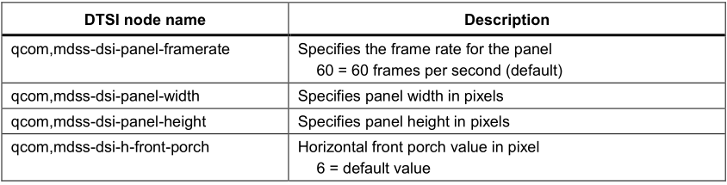

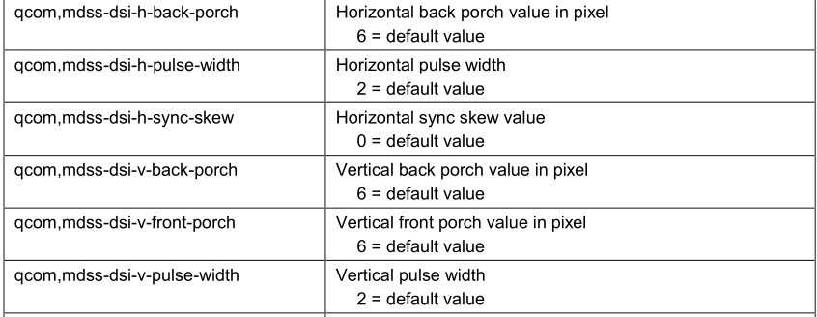

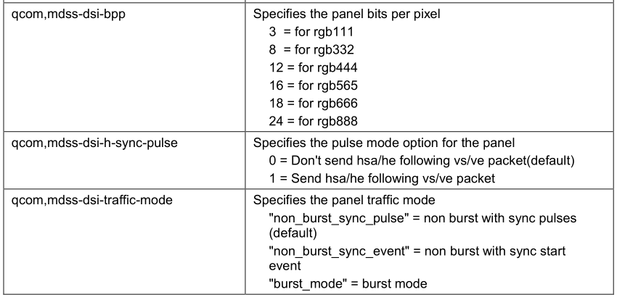

## 2.2.3.2 Pack the ON/OFF commands

Pack the panel ON commands and the state in which they need to be sent, high speed or low

power.

Panel ON and OFF commands need to be packed in a specific format. Please find the details

below for the below entries.

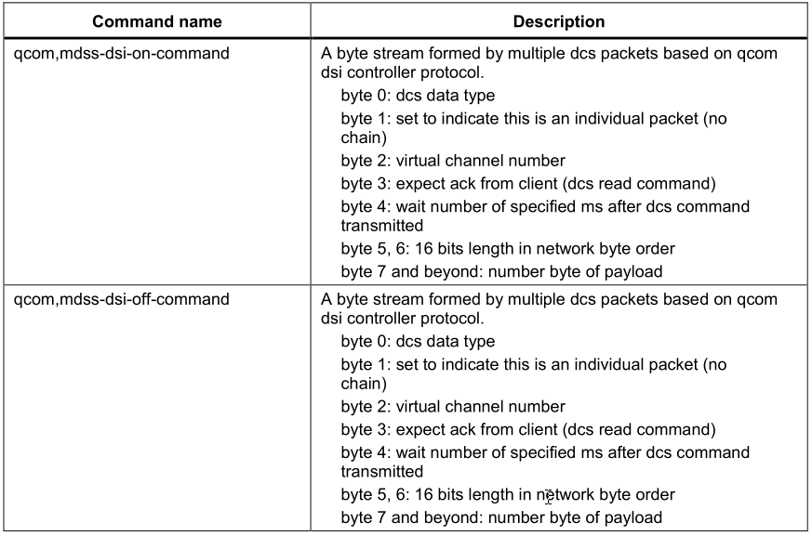

Example.

qcom,mdss-dsi-on-command = [39 01 00 00 00 00 04 b9 ff 83 94

39 01 00 00 00 00 0b B1 48 0f 6f 09 33 54 51 51 30 43

39 01 00 00 00 00 07 BA 63 03 68 6B B2 C0

39 01 00 00 00 00 07 B2 00 80 64 0c 06 2F

39 01 00 00 00 00 15 B4 19 74 19 74 19 74 01 0C 86 75 00 3F 19 74 19 74 09 74 01 0c

39 01 00 00 00 00 22 D3 00 00 07 07 00 00 12 10 32 10 01 00 01 32 13 C0 00 00 32 10 08 00 00 37 04 03 03 37 04 00 47 0c 40

39 01 00 00 00 00 2D D5 18 18 18 18 00 01 02 03 04 05 06 07 18 18 18 18 18 18 18 18 18 18 18 18 18 18 18 18 18 18 18 18 18 18 18 18 19 19 19 19 20 21 22 23

39 01 00 00 00 00 2d D6 18 18 19 19 07 06 05 04 03 02 01 00 18 18 18 18 18 18 18 18 18 18 18 18 18 18 18 18 18 18 18 18 18 18 18 18 19 19 18 18 23 22 21 20

39 01 00 00 00 00 03 B6 2f 2f

39 01 00 00 00 00 3b E0 00 02 08 0c 0e 11 14 11 24 32 41 40 4a 5a 5f 62 72 77 77 8b a2 52 53 5a 60 66 6e 7f 7F 00 02 08 0c 0e 11 14 11 24 32 41 40 49 5a 5f 62 71 76 77 8b a1 52 54 5b 61 67 73 7f 7F

39 01 00 00 00 00 02 CC 0b

39 01 00 00 00 00 03 C0 1F 31

39 01 00 00 00 00 02 D4 02

39 01 00 00 00 00 02 BD 01

39 01 00 00 00 00 02 B1 60

39 01 00 00 00 00 02 BD 00

39 01 00 00 00 00 08 BF 40 81 50 00 1A FC 01

05 01 00 00 78 00 02 11 00

05 01 00 00 14 00 02 29 00

];

qcom,mdss-dsi-off-command = [05 01 00 00 00 00 02 28 00

05 01 00 00 00 00 02 10 00];

NOTE: The incorrect DCS command format may stop display bringup in kernel.

Panel ON and OFF commands can be sent in Low power state or High speed state. Select the

state from the DTSI nodes shown in the table below.

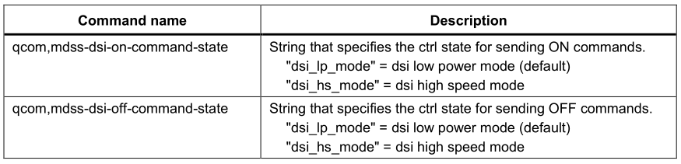

Example:

qcom,mdss-dsi-on-command-state = "dsi_lp_mode";

qcom,mdss-dsi-off-command-state = "dsi_hs_mode";

## 2.2.3.3 Set the MDSS DSI host parameters

Update the panel name/dsi0 or dsi1/panel-type/lanes enabled using the guidelines in the table below.

The dsi host parameters needed to update the configuration properties are shown in the following table.

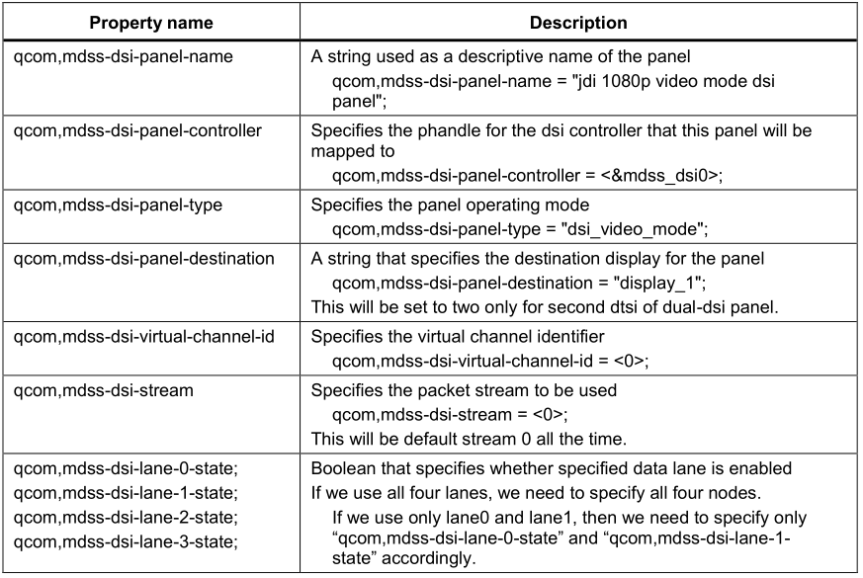

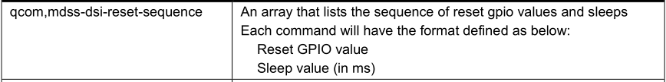

## 2.2.3.4 Calculate the PHY timings

1. Calculate the DSI PHY timings and Tclk-post and Tclk-pre values from the timing calculator

in the DSI Timing Parameters User Interactive Spreadsheet and update below entries.

PHY timing properties:

- qcom,mdss-dsi-panel-timings: An array of length 12 that specifies the PHY

timing settings for the panel.

- qcom,mdss-dsi-t-clk-post: Specifies the byte clock cycles after mode switch.

0x03 = default value.

- qcom,mdss-dsi-t-clk-pre: Specifies the byte clock cycles before mode switch.

0x24 = default value.

- qcom,mdss-dsi-panel-timings-phy-v2: An array of length 40 char that specifies the PHY version 2 lane timing settings for the panel.

2. Check with the bridge IC vendor to obtain a bridge IC PHY timing specification. The following steps describe how to calculate the panel timings and fill in host registers. The interactive Excel spreadsheet features macros that will auto-calculate the PHY timings needed.

## 2.2.3.4.1 How to use the spreadsheet for DSI PHY timing calculation

The panel requires the PHY value setup for bitclk in the DSI PHY register. The DSI Timing

Parameters User Interactive Spreadsheet (80-NH713-1) can be used to calculate the values automatically. Note that this can be used for only B-family chipsets that use the DSI6G DSI host design. You can download this from Docs and Downloads website.

To auto-calculate these values, follow the steps below.

1. Open the DSI and MDP Registers sheet. Enter panel resolution/porch values/fps/color

depth/lane numbers into the area circled in red in the example below.

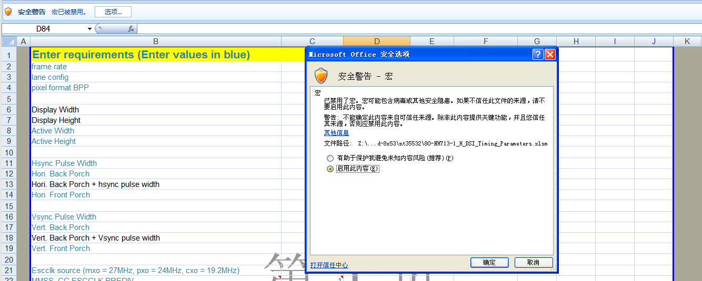

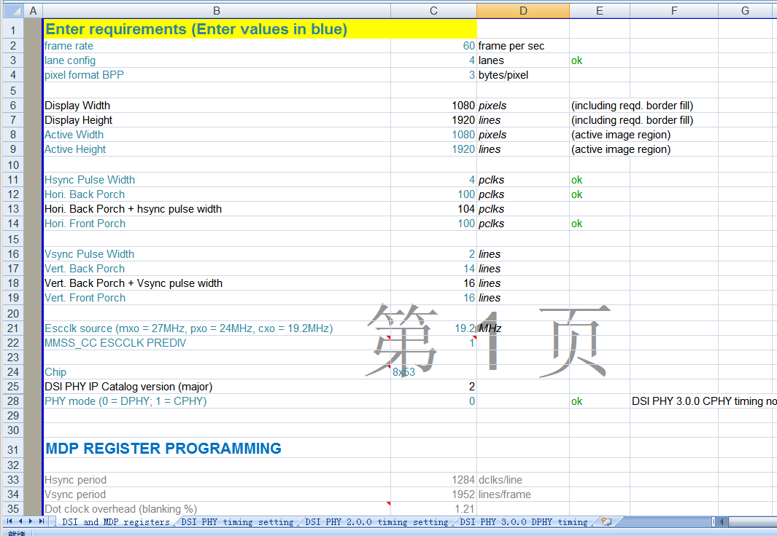

If spreadsheet says to change the porches to be multiple of 4 or make it even. Please change it

accordingly and also update the panel porch node. You can refer to the user instructions in the

excel sheet

2. Open the DSI PHY timing setting to see the calculated DSI-related clock rate in the blue

fields. A value of INVALID will appear in the Check for T_CLK_ZERO field. Press CTRL+J and CTRL+K to recalculate T_CLK_ZERO to VALID.

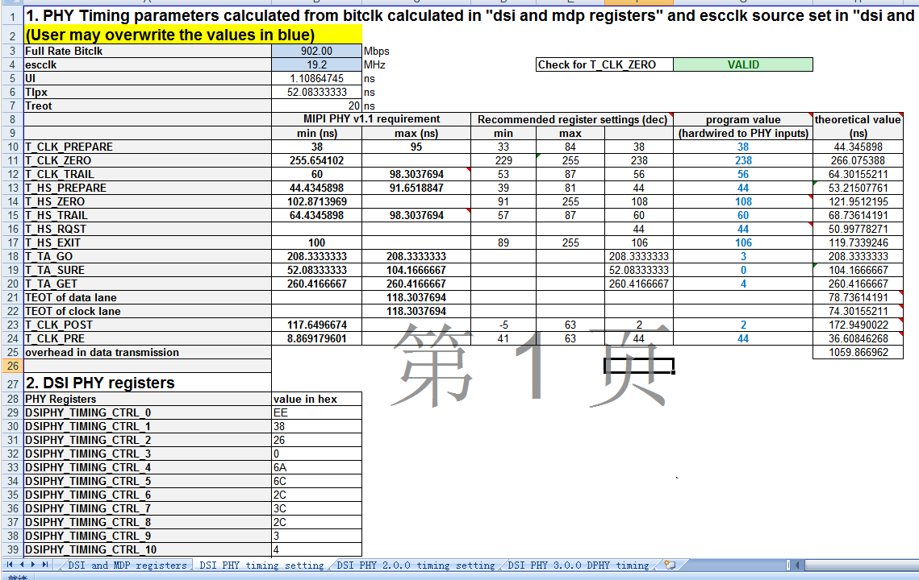

The spreadsheet will show the PHY value setup for bitclk, which the panel requires in the

“DSI PHY register.”and “DSI and MDP registers”.



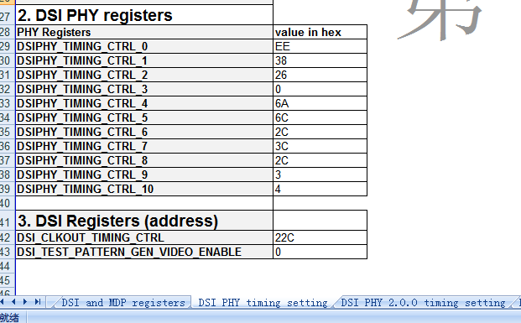

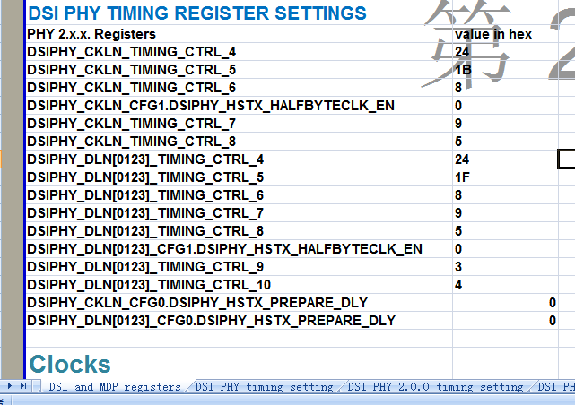

3. Update the Panel dtsi file “qcom,panel-phy-timingSettings” using the values listed above

obtained from the Excel worksheet.

Below is an example. Values are copied from above.

qcom,mdss-dsi-panel-timings = [ee 38 26 00 6a 6c 2c 3c 2c 03 04 00];

qcom,mdss-dsi-panel-timings-phy-v2 = [24 1f 08 09 05 03 04 a0

24 1f 08 09 05 03 04 a0

24 1f 08 09 05 03 04 a0

24 1f 08 09 05 03 04 a0

24 1b 08 09 05 03 04 a0];

Note:the last will always be “a0”.

The driver will then load those values at the D-PHY initial stage.

4. Copy the Program value for T_CLK_POST and T_CLK_PRE fields obtained from the Excel

worksheet into the panel dtsi. The values in the Excel worksheet are in decimal. Make sure

that they are converted to HEX before updating these two elements.

qcom,mdss-dsi-t-clk-post = <0x02>;

qcom,mdss-dsi-t-clk-pre = <0x2c>;

2.2.4 Select the panel

After creating the dtsi file, include that panel’s dtsi in the platform device tree and select the

panel.

Example:

kernel/ msm-3.18/arch/arm/boot/dts/qcom/$(project).dtsi

#include "dsi-panel-nt35532-1080p-video-sim.dtsi"

Tell the DSI host to pick the panel. Point “qcom dsi-pref-prim-pan” to the name of the

panel included in the panel’s dtsi file.

Example:

&mdss_dsi0 {

qcom,dsi-pref-prim-pan = <&dsi_nt35532_1080p_video>;

pinctrl-names = "mdss_default", "mdss_sleep";

pinctrl-0 = <&mdss_dsi_active &mdss_te_active>;

pinctrl-1 = <&mdss_dsi_suspend &mdss_te_suspend>;

# 3 Little Kernel (LK) Bringup

Once Kernel bringup is done, perform the following steps for little kernel (LK) bringup.

1. Create the panel header file. Do one of the following:

◻ Use the global component database (GCDB)

◻ Refer to one of the existing header files present in

bootable/bootloader/lk/dev/gcdb/display/include/ and copy the new file to the same

location.

2. After making the header file, include it in

bootable/bootloader/lk/target/msm8953/oem_panel.c and add

<Vendor>_<Resolution>_VIDEO/CMD_PANEL switch case on init_panel_data function.

3. We need to map the below data for your panel from the GCDB header file. Replace the below

function pointers with your generated file pointers.

Example:

#include "include/panel_nt35532_1080p_video_sim.h"

enum {

NT35532_1080P_VIDEO_PANEL,

}

static struct panel_list supp_panels[] = {

{"nt35532_1080p_video", NT35532_1080P_VIDEO_PANEL},

};

case NT35532_1080P_VIDEO_PANEL:

panelstruct->paneldata = &nt35532_1080p_video_panel_data;

panelstruct->paneldata->panel_with_enable_gpio = 1;

panelstruct->panelres = &nt35532_1080p_video_panel_res;

panelstruct->color = &nt35532_1080p_video_color;

panelstruct->videopanel = &nt35532_1080p_video_video_panel;

panelstruct->commandpanel = &nt35532_1080p_video_command_panel;

panelstruct->state = &nt35532_1080p_video_state;

panelstruct->laneconfig = &nt35532_1080p_video_lane_config;

panelstruct->paneltiminginfo

= &nt35532_1080p_video_timing_info;

panelstruct->panelresetseq

= &nt35532_1080p_video_reset_seq;

panelstruct->backlightinfo = &nt35532_1080p_video_backlight;

pinfo->mipi.panel_on_cmds

= nt35532_1080p_video_on_command;

pinfo->mipi.num_of_panel_on_cmds

= NT35532_1080P_VIDEO_ON_COMMAND;

pinfo->mipi.panel_off_cmds

= nt35532_1080p_video_off_command;

pinfo->mipi.num_of_panel_off_cmds

= NT35532_1080P_VIDEO_OFF_COMMAND;

memcpy(phy_db->timing,

nt35532_1080p_14nm_video_timings, MAX_TIMING_CONFIG * sizeof(uint32_t));

break;

int lcd_select(void)

{

//return HX8394F_720P_VIDEO_PANEL;

return NT35532_1080P_VIDEO_PANEL;

}

# Contact

**Headquarters**

Add: Floor 6, Building B, No.633 Jinzhong Road, Changning District, Shanghai P.R.China 200335

Tel: +86 21 3252 3424

Fax: +86 21 3252 3020

Email: simcom@sim.com

**Technical Support**

|  |  |  |
| --- | --- | --- |
| EMEA | APAC | America |
| **West Europe**  we-support@sim.com | **ASEAN**  asean-support@sim.com | **North America**  us-support@sim.com |
| **East Europe**  ee-support@sim.com | **Australia and New Zealand**  anz-support@sim.com | **Central and South America** la-support@sim.com |
| **Middle East**  me-support@sim.com | **Big China**  China-support@sim.com |  |
| **Africa**  af-support@sim.com |  |  |
|  |  |  |
|  |  |  |
|  |  |  |