SIM8950 Camera Driver Development Guide

说明：

以下适用于msm8953平台的android7及以下的camera驱动配置。yuv和raw格式的camera都在vendor下添加驱动，在dtsi中配置初始参数。

目录

1 添加sensor驱动 2

1.1供电和时钟配置（AVDD、DVDD、IOVDD、PWDN、RESET和MCLK） 2

1.2 Kernel Driver 2

GPIO配置 3

pinctrl配置 3

gpio配置 3

MCLK配置 3

PMIC配置 4

其他参数配置 4

1.3 用户空间驱动 4

添加sensor driver 5

配置基本驱动信息 5

ov8865_lib.h文件配置 5

msm8953_camera.xml 7

增加chromatix效果文件 8

2 添加AF Actuator驱动 8

2.1 内核中配置AF 8

2.2 用户空间添加AF驱动文件 9

3 添加EEPROM驱动 9

3.1 内核中eeprom配置 10

3.2 用户空间eeprom驱动 11

3 LED闪光灯配置 11

# 1 添加sensor驱动

## 1.1供电和时钟配置（AVDD、DVDD、IOVDD、PWDN、RESET和MCLK）

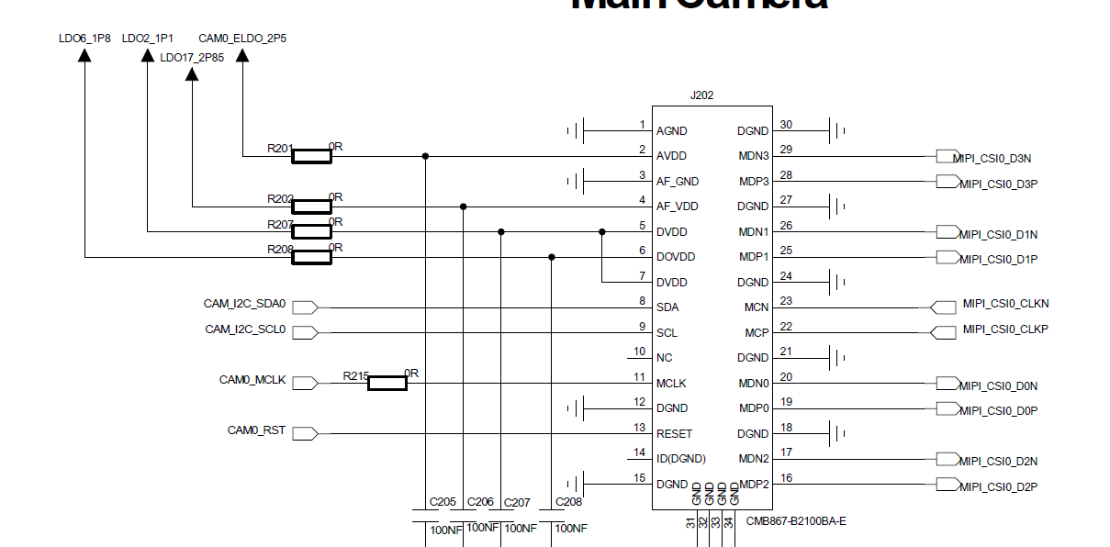

 Power supply: DVDD(1.1V), AVDD(2.5V), IOVDD(1.8V) (DOVDD), AFVDD(2.85V)(VCM)

 Reset: RESET

 Suspend: PWDN

 Clock: MCLK

 MIPI Data: MDP1 MDN1, MDP2 MDN2

 MIPI Clock: MCP MCN

 I2C: SDA SCL

以上是一个sensor能正常工作的基础配置，DVDD和PWDN有时需要根据IC的datasheet里的上电时序来决定需不需要。其中的供电电压需要根据IC的datasheet和实际的原理图接线来配置。

## 1.2 Kernel Driver

本节配置必须在kernel中创建，路径如下：

kernel\msm-3.18\arch\arm\boot\dts\qcom\msm8953-camera-sensor-mtp.dtsi；

以上的dtsi文件仅为参考文件，实际情况需根据当前使用的camera dtsi文件来配置。

### GPIO配置

#### pinctrl配置

配置gpio的上下拉状态（mclk必须配置）：

pinctrl-names = "cam_default", "cam_suspend";

pinctrl-0 = <&cam_sensor_mclk0_default

&cam_sensor_rear_default

&cam_sensor_rear_vana>;

pinctrl-1 = <&cam_sensor_mclk0_sleep &cam_sensor_rear_sleep

&cam_sensor_rear_vana_sleep>;

#### gpio配置

gpio配置需根据硬件原理图实际接线来配置，AVDD、DVDD或IOVDD此三路电源如果是gpio使能控制则需在此处配置对应的gpio。

gpios = <&tlmm 26 0>,

<&tlmm 40 0>,

<&tlmm 39 0>,

<&tlmm 2 0>;

qcom,gpio-reset = <1>;

qcom,gpio-standby = <2>;

qcom,gpio-vana = <3>;

qcom,gpio-req-tbl-num = <0 1 2 3>;

qcom,gpio-req-tbl-flags = <1 0 0 0>;

qcom,gpio-req-tbl-label = "CAMIF_MCLK0",

"CAM_RESET0",

"CAM_STANDBY0",

"CAM_VANA";

### MCLK配置

msm8953有三组MCLK，以下是配置的mclk0，实际情况需根据硬件原理图来配置。以下三项必须要配置。

clocks = <&clock_gcc clk_mclk0_clk_src>,

<&clock_gcc clk_gcc_camss_mclk0_clk>;

clock-names = "cam_src_clk", "cam_clk";

qcom,clock-rates = <24000000 0>;

### PMIC配置

以下四组LDO供电需根据原理图来配置ldo的选择，电压的范围，原理图上没使用的可不配置。

cam_vio-supply = <&pm8953_l6>;

cam_vdig-supply = <&pm8953_l2>;

cam_vaf-supply = <&pm8953_l17>;

cam_vana-supply = <&pm8953_l22>;

qcom,cam-vreg-name = "cam_vio", "cam_vdig", "cam_vaf",

"cam_vana";

qcom,cam-vreg-min-voltage = <0 1100000 2850000 2800000>;

qcom,cam-vreg-max-voltage = <0 1100000 2850000 2800000>;

qcom,cam-vreg-op-mode = <0 105000 100000 80000>;

### 其他参数配置

请参考代码中的txt文档，路径如下：

kernel/msm-3.18/Documentation/devicetree/bindings/media/video/msm-cci.txt

qcom,csiphy-sd-index = <0>;

qcom,csid-sd-index = <0>;

qcom,mount-angle = <270>;

qcom,sensor-position = <0>;

qcom,sensor-mode = <0>;

qcom,cci-master = <0>;

## 1.3 用户空间驱动

此部分添加分yuv和raw两种camera，yuv格式camera不需要添加chromatix配置。

**所有生成的.so文件都需要在device-vendor.mk配置，配置路径：**

**vendor\qcom\proprietary\common\config**

可以参考文档：

*80_NU323_2_Multimedia_Driver_Development_and_Bringup_Guide___Camera.pdf*

此文档是msm8909平台，对应msm8953平台参考均搜索以下参数关键字即可。

### 添加sensor driver

添加路径：

vendor\qcom\proprietary\mm-camera\mm-camera2\media-controller\modules\sensors\configs\msm8953_camera.xml

vendor\qcom\proprietary\mm-camera\mm-camera2\media-controller\modules\sensors\sensor\libs\ov8865

#### 配置基本驱动信息

此部分与msm8909相比，有一部分配置需要在xml中配置，有一部分还是在原来的结构中配置。

##### ov8865_lib.h文件配置

1、上下电时序中

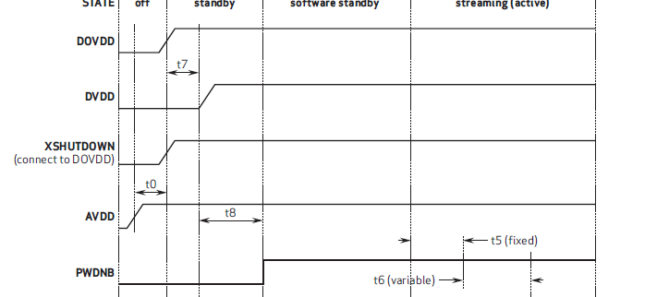

以上是ov8865上电时序图

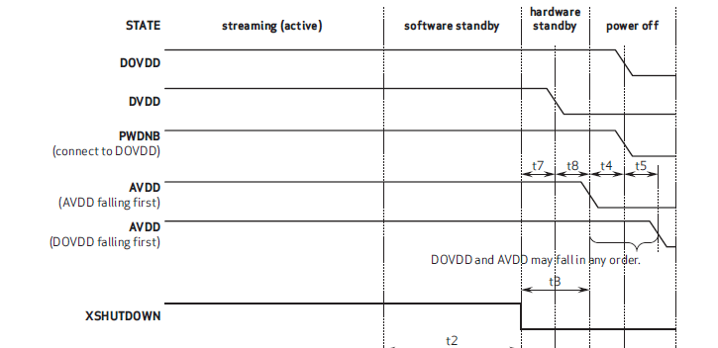

以上是ov8865下电时序图

1）电源供电类型seq_type有CAMERA_POW_SEQ_VREG和CAMERA_POW_SEQ_GPIO两种方式，取决于硬件连接，与dtsi中的LDO和gpio供电对应配置；

2）供电pin脚seq_val配置对应的camera pin脚名称；

3）config_val供电使能控制，如果seq_type是CAMERA_POW_SEQ_VREG，config_val只能配置0或1，如果seq_type是CAMERA_POW_SEQ_GPIO，config_val只能配置GPIO_OUT_LOW或GPIO_OUT_HIGH；

**.sensor_slave_info** =

{

.sensor_name = SENSOR_MODEL,

.slave_addr = 0x20, //camera i2c 地址

.i2c_freq_mode = SENSOR_I2C_MODE_FAST,

.addr_type = CAMERA_I2C_WORD_ADDR,

.sensor_id_info =

{

.sensor_id_reg_addr = 0x300b, //camera存储id的寄存器地址

.sensor_id = 0x8865, //camera id

},

.power_setting_array =

{

.power_setting_a = //上电时序

{

………

},

.size = 8,

.power_down_setting_a = //下电时序

{

……..

},

.size_down = 6,

},

}

2、分辨率及扫描速率配置

**.out_info_array** = {

};

此结构中配置了所支持的分辨率，参数含义可参考文档

*80_NU323_2_Multimedia_Driver_Development_and_Bringup_Guide___Camera.pdf*

3、lane参数配置

**.csi_params** =

{

.lane_cnt = 2, //使用lane的数量

.settle_cnt = 0xE,

.is_csi_3phase = 0,

},

##### msm8953_camera.xml

<CameraModuleConfig>

<CameraId>2</CameraId> /**对应dtsi中camera 0、1或2使用的节点**/

<SensorName>ov8865</SensorName>

………

<ModesSupported>1</ModesSupported> /**对应dtsi中的qcom,sensor-mode **/

<Position>FRONT</Position>

<MountAngle>270</MountAngle>

<CSIInfo> /**mipi参数使用的配置，可参考文档*80_NU323_2_Multimedia_Driver_Development_and_Bringup_Guide___Camera.pdf*\*\*/

<CSIDCore>2</CSIDCore>

<LaneMask>0x7</LaneMask>

<LaneAssign>0x4320</LaneAssign>

<ComboMode>0</ComboMode>

</CSIInfo>

………

</CameraModuleConfig>

#### 增加chromatix效果文件

效果文件添加路径：

vendor\qcom\proprietary\mm-camera\mm-camera2\media-controller\modules\sensors\chromatix\0310\chromatix_ov8865

配置效果文件路径：

vendor\qcom\proprietary\mm-camera\mm-camera2\media-controller\modules\sensors\configs\ ov8865_chromatix.xml

在msm8953_camera.xml中配置参数：

<ChromatixName>ov8865_chromatix</ChromatixName>

# 2 添加AF Actuator驱动

## 2.1 内核中配置AF

**配置文件路径：**

kernel\msm-3.18\arch\arm\boot\dts\qcom\msm8953-camera-sensor-mtp.dtsi

**配置节点：**

actuator0: qcom,actuator@0 {

cell-index = <0>;

reg = <0x0>;

compatible = "qcom,actuator";

qcom,cci-master = <0>;

cam_vaf-supply = <&pm8937_l17>;

qcom,cam-vreg-name = "cam_vaf";

qcom,cam-vreg-min-voltage = <2850000>;

qcom,cam-vreg-max-voltage = <2850000>;

qcom,cam-vreg-op-mode = <80000>;

};

**camera引用actuator功能和配置供电：**

qcom,camera@0 {

……..

qcom,actuator-src = <&**actuator0**>;

……..

cam_vaf-supply = <&pm8937_l17>;

qcom,cam-vreg-name = "cam_vio", "cam_vana", "**cam_vaf**";

qcom,cam-vreg-min-voltage = <0 2800000 **2850000**>;

qcom,cam-vreg-max-voltage = <0 2800000 **2850000**>;

qcom,cam-vreg-op-mode = <0 80000 **100000**>;

……..

}

## 2.2 用户空间添加AF驱动文件

**所有生成的.so文件都需要在device-vendor.mk配置，配置路径：**

**vendor\qcom\proprietary\common\config**

**驱动添加路径：**

vendor\qcom\proprietary\mm-camera\mm-camera2\media-controller\modules\sensors\actuator\libs\dw9714

**msm8953_camera.xml 中AF驱动调用配置：**

<CameraModuleConfig>

<CameraId>2</CameraId>

<SensorName>ov8865</SensorName>

**<ActuatorName>dw9714</ActuatorName>**

……..

<LensInfo> //AF对焦效果初始参数设置

<FocalLength>3.75</FocalLength>

<FNumber>2.2</FNumber>

<TotalFocusDistance>1.97</TotalFocusDistance>

<HorizontalViewAngle>62.7</HorizontalViewAngle>

<VerticalViewAngle>49.0</VerticalViewAngle>

<MinFocusDistance>0.1</MinFocusDistance>

</LensInfo>

</CameraModuleConfig>

# 3 添加EEPROM驱动

## 3.1 内核中eeprom配置

**配置文件路径：**

kernel\msm-3.18\arch\arm\boot\dts\qcom\msm8953-camera-sensor-mtp.dtsi

**配置节点：**

eeprom0: qcom,eeprom@0 {

cell-index = <0>;

compatible = "qcom,eeprom";

qcom,cci-master = <0>;

reg = <0x0>;

cam_vdig-supply = <&pm8937_l23>;

cam_vana-supply = <&pm8937_l22>;

cam_vio-supply = <&pm8937_l6>;

cam_vaf-supply = <&pm8937_l17>;

qcom,cam-vreg-name = "cam_vdig", "cam_vana", "cam_vio",

"cam_vaf";

qcom,cam-vreg-min-voltage = <1200000 0 2800000 2850000>;

qcom,cam-vreg-max-voltage = <1200000 0 2800000 2850000>;

qcom,cam-vreg-op-mode = <200000 0 80000 100000>;

pinctrl-names = "cam_default", "cam_suspend";

pinctrl-0 = <&cam_sensor_mclk0_default

&cam_sensor_rear_default>;

pinctrl-1 = <&cam_sensor_mclk0_sleep &cam_sensor_rear_sleep>;

gpios = <&tlmm 26 0>,

<&tlmm 36 0>,

<&tlmm 35 0>;

qcom,gpio-reset = <1>;

qcom,gpio-standby = <2>;

qcom,gpio-req-tbl-num = <0 1 2>;

qcom,gpio-req-tbl-flags = <1 0 0>;

qcom,gpio-req-tbl-label = "CAMIF_MCLK0",

"CAM_RESET0",

"CAM_STANDBY0";

status = "ok";

clocks = <&clock_gcc clk_mclk0_clk_src>,

<&clock_gcc clk_gcc_camss_mclk0_clk>;

clock-names = "cam_src_clk", "cam_clk";

qcom,clock-rates = <19200000 0>;

};

**camera引用actuator功能：**

qcom,camera@0 {

……..

qcom,eeprom-src = <&eeprom0>;

……..

}

## 3.2 用户空间eeprom驱动

**所有生成的.so文件都需要在device-vendor.mk配置，配置路径：**

**vendor\qcom\proprietary\common\config**

**驱动添加路径：**

vendor\qcom\proprietary\mm-camera\mm-camera2\media-controller\modules\sensors\eeprom\libs\sunny_8865

**msm8953_camera.xml 中EEPROM驱动调用配置**

<CameraModuleConfig>

<CameraId>2</CameraId>

<SensorName>ov8865</SensorName>

……..

**<EepromName>sunny_8865</EepromName>**

……..

</CameraModuleConfig>

# 3 LED闪光灯配置

**配置文件路径：**

kernel\msm-3.18\arch\arm\boot\dts\qcom\msm8953-camera-sensor-mtp.dtsi

**节点配置：**

led_flash0: qcom,camera-flash {

cell-index = <0>;

compatible = "qcom,camera-flash";

qcom,flash-type = <1>;

qcom,flash-source = <&pmi8950_flash0 &pmi8950_flash1>;

qcom,torch-source = <&pmi8950_torch0 &pmi8950_torch1>;

qcom,switch-source = <&pmi8950_switch>;

};

**camera引用LED功能：**

qcom,camera@0 {

……..

qcom,led-flash-src = <&led_flash0>;

……..

}