CSCI 5010 – Fundamentals of Data Communications

Lab 1

Internet Speed Test & Computer Command Prompt

University of Colorado Boulder

Department of Computer Science

Network Engineering

Professor Levi Perigo, Ph.D.

Summary

This lab is intended to be an overview of Internet speed testing technologies and scenarios, as well as basic Operating Systems (OS) (Windows and Mac) command prompt utilization. This lab will be a baseline for future exploration into these topics used throughout this course.

The questions in the lab are intentionally vague. The purpose of this is for you not only to research, investigate, and learn the technologies, but also become proficient at interpreting both non-technical and technical questions. Being able to research and discover answers on your own will be critical as you progress in your career.

Objective 1: Internet Speed Testers

There are various ways to test Internet connectivity speeds from your device. In this objective, you will utilize different applications and technologies to evaluate differences in speed tests.

1. Select three (at least one of the three should be from an ISP (i.e. Comcast)) free, online Internet speed test sites (*Note: be careful where you click on some sites, as there are often malicious adds on free testing sites*).
   1. Provide a screenshot of the results/summary page from each site. [**6 points**]

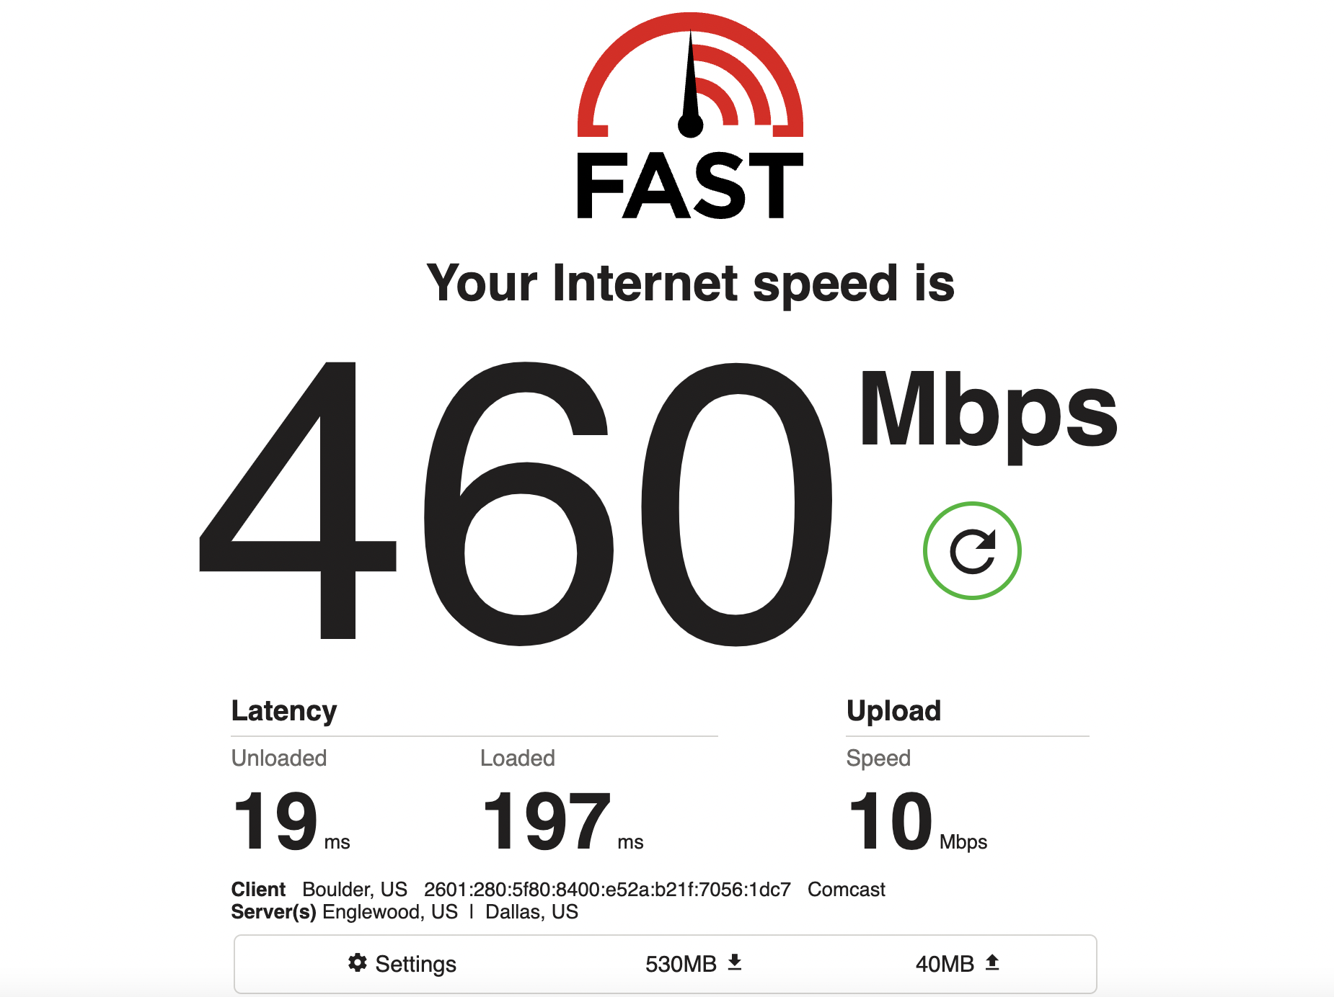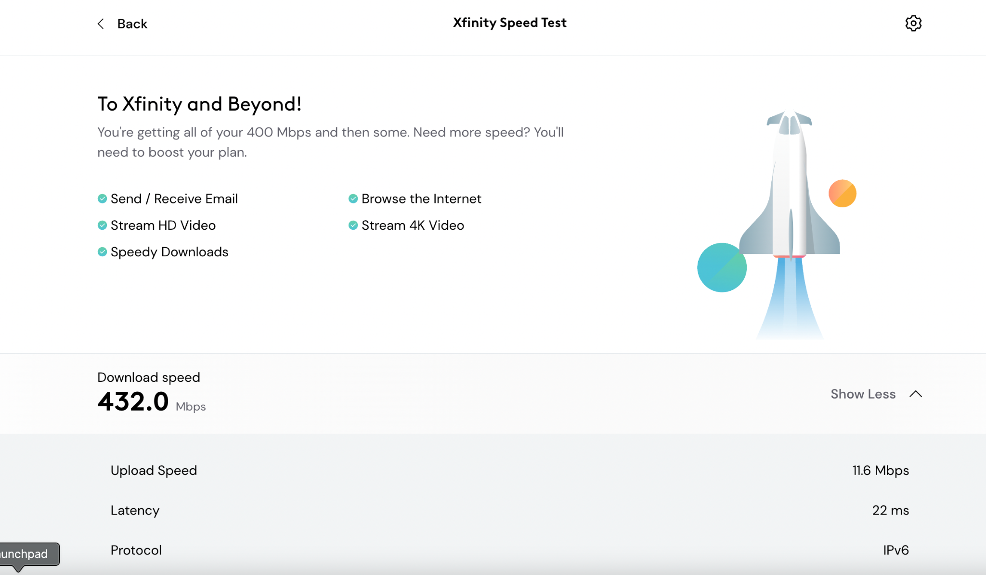

**fast.com Xfinity**

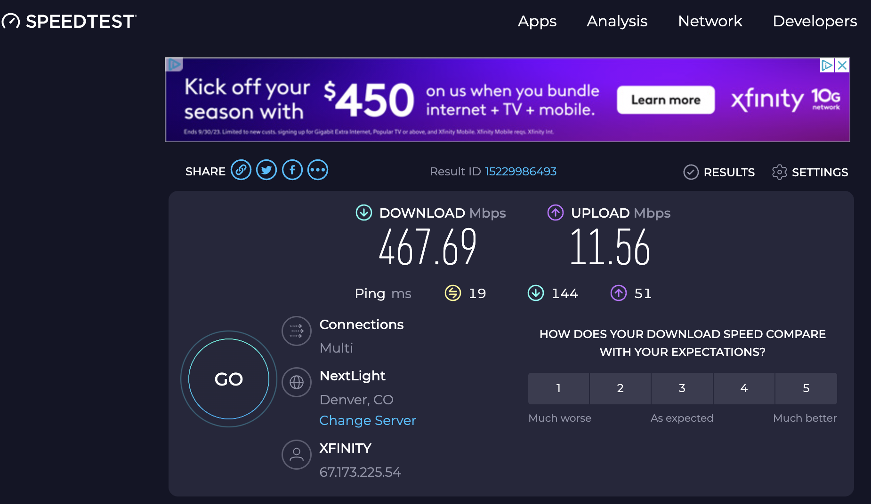

**speedtest.net**

* 1. Were the results from the various sites the same or different? Why? [**2 points**]

The three online speed tests resulted in slightly different results. This might be due to the different testing methodologies used by different sites, server locations, and network conditions. Also, the internet speed can fluctuate throughout the day due to bandwidth demands, so a single test may not be accurate.

1. Choose your favorite testing site, used previously, to use again.
   1. Find a location where you can use either a wired or wireless connection.
      1. Run the speed test on wireless. Provide a screenshot of the results. [**2 points**]

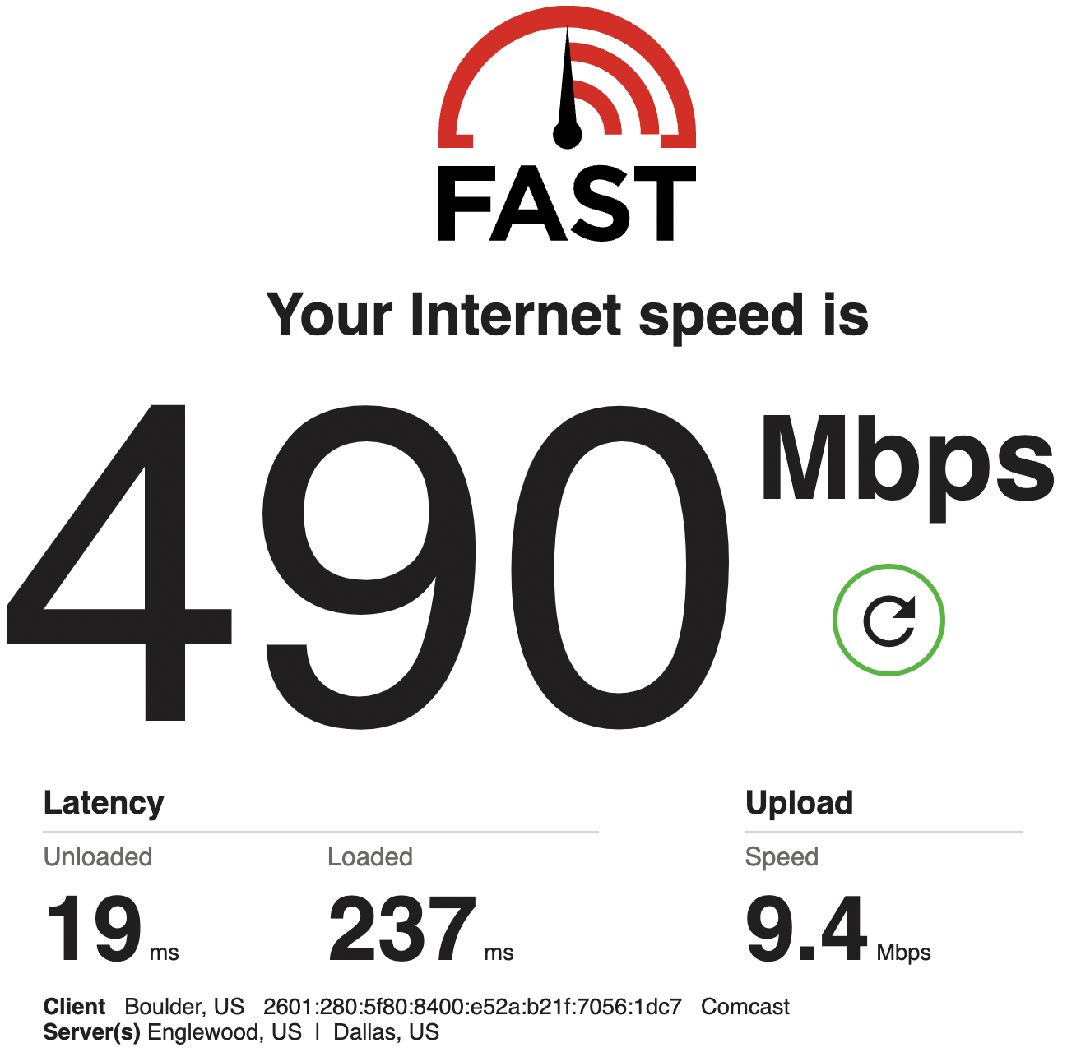

* + 1. Run the speed test on wired. Provide a screenshot of the results. [**2 points**]
    2. Were the results different? Why or why not? [**2 points**]

Unfortunately, I do not have a wired connection. However, a wired connection would be significantly faster than that of a wired connection as physical cables tend to be faster and more stable. Wireless connections rely on radio waves, potentially slowing speed and less stability due to signal interference.

* 1. Run the speed test at a different location (on campus, home, coffee shop). Were the results better or worse than your other tests? Why? [**2 points**]

I conducted speed tests at various locations: my home, a coffee shop (Starbucks), and my campus. The results showed significant variations. At home, I observed excellent download and upload speeds, reaching approximately 450 Mbps. In contrast, the coffee shop exhibited considerably lower speeds, approximately 15 Mbps, primarily due to shared resources among customers. On campus, the speeds were moderately better than at Starbucks but not as fast as at home, averaging around 100 Mbps. Notably, the campus benefits from a dedicated infrastructure for wireless connections, which contributes to its relatively better performance compared to coffee shops where Wi-Fi availability is not the primary focus. Additionally, the timing of these tests played a role in the results. I conducted the tests during peak hours at both the campus and Starbucks but during off-peak hours at home.

1. List three benefits of obtaining accurate Internet speed test results. [**5 points**]

* **Diagnosis and troubleshooting**: Accurate internet speed test results are important as they help in figuring out network performance issues. In a corporate, system or network administrators can make informed judgments to pinpoint the source of an issue, such as distinguishing between problems with the ISP link and those with the company's internal links. Similarly, in a home setup, if internet speeds consistently remain low, it could indicate potential concerns with the ISP or the influence of external interferences.
* **Planning**: Accurate speed tests can help businesses and organizations with planning the internet infrastructure. By regularly monitoring their internet speeds, they can determine whether their current internet infrastructure meets their needs. This information can be crucial when considering upgrades or expansions to accommodate a growing number of employees or increasing data demands.
* **Tracking and comparison:** Accurate speed results can help in tracking improvements. For instance, when you upgrade your network equipment or switch to a different ISP, accurate speed test results serve as benchmarks. You can then compare the results before and after the changes to evaluate whether your investment has positively impacted performance.

1. What are three best practices to obtain accurate Internet speed test results? [**5 points**]

* **Testing multiple times**: Internet speeds can vary depending on the time of day. To get accurate results, you should run speed tests at different times, including during peak usage hours and off-hours to best assess the results.
* **Try different test servers:** Check from various speed test applications like speedtest.net, fast.com, etc. Further, you could also try changing the geographic location of the test servers to see how changing the geographic location affects the internet speed. This aids in understanding how internet speed may vary for different online activities or when accessing content hosted in different regions.
* **Disable VPNs:** Disable all VPNs before checking internet speed. VPNs can influence the speed test outcomes because they establish a tunnel, and apply encryption and decryption processes, which consequently increases the round-trip time (RTT).

1. Explain the following concepts, and how they are used with speed tests? [**2 points each**]
   1. Ping (Latency) Test

A ping tests the latency between the host machine and the target or the destination and is measured in milliseconds. It tells how quickly the packets traverse from the host machine to the destination host and back. Latency is directly proportional to the response time. Lower latency, less response time. Higher latency, more response time. Ping uses ICMP (Internet Control Message Protocol). Ping tests in speed tests measure the time it takes for data packets to travel between your device and a server. This latency, measured in milliseconds (ms), indicates how responsive your internet connection is. It also helps in gauging the quality of internet connection. High ping times can lead to delays and lag in applications.

* 1. Download Test

A download test gauges how quickly data can be downloaded or received from the internet to the host computer. It represents the internet connection's downstream speed. Download tests are used in speed tests to check how quickly you can access online resources like web pages, videos, and files. The test downloads sample files from test servers while keeping track of download speeds. The data that is sent and received during the test typically includes benign small text or image files, or a combination of both but does not include any personal information.

* 1. Upload Test

An upload test measures the speed at which data can be sent or uploaded from the host machine to the servers. It represents the upstream speed of the internet connection. Upload tests are used in speed tests to check the quality of connection for activities like uploading files, video conferencing, etc. where you need to send data to remote servers. The host machine attempts to upload a test file to a test server to measure how long it takes for the file to be uploaded to the test server.

* 1. Is TCP or UDP used? Why?

Typically, most of the speed test sites use TCP to test the connection because

1. It is a reliable and error-correcting protocol, ensuring accurate speed measurements.
2. Most of the internet traffic uses TCP, making speed tests more relevant to typical online activities.
3. TCP typically exhibits slower performance compared to UDP. Therefore, conducting a speed test using TCP would provide results under worst-case conditions, while UDP is expected to yield significantly faster results.
4. If the results of your speed test is lower than what you expect/pay for from your ISP, list two things you could do to troubleshoot the connection/speed before you contact the ISP? [**2 points**]

Reboot the router by unplugging the power source, waiting for a few seconds, and then plugging it back in. Most of the time, a simple reboot resolves connectivity issues. If that doesn’t work I would check for any loose physical cables and plug them in securely.

Pause any bandwidth-intensive activities running on my machine, such as large file downloads, streaming, etc., and then test the speed. These activities consume bandwidth and affect the speed test results.

* 1. After troubleshooting, if you determine your Internet speed is lower than what you expect from your ISP, list three ways you could potentially boost your Internet speed, and explain each. [**6 points**]

**Upgrading Internet Plan**: I would get in touch with the ISP to explore the possibility of switching to a higher-speed internet package. ISPs provide a range of plans featuring diverse speeds and pricing options. This can enhance the download and upload speeds.

**Reducing Network Load**: I would configure my router's QoS policies to prioritize certain devices or applications, ensuring that critical activities get sufficient bandwidth and limit other not-so-important activities by allotting some bandwidth. This would also aid in organizing network data and avoid performance degrades. I would also pause bandwidth-heavy activities like automatic backups and large downloads during peak hours and schedule them to off-hours. Also, disconnecting devices that are not actively in use from the network can free up bandwidth.

**Mesh Wi-Fi System**: Mesh Wi-Fi systems have multiple access points that work together to provide seamless and widespread coverage. This can improve Wi-Fi speeds significantly. Access points can extend Wi-Fi coverage, reduce “dead zones”, and provide better internet speeds. This approach is especially helpful for ensuring consistent and fast Wi-Fi performance throughout the house.

Objective 2 – Command Prompt (Windows/Mac)

The command line, also known as cmd or shell, is used by system administrators to quickly interact with a machine, without having to click through numerous graphic menus. This objective will provide the useful commands that are needed for networking and information gathering on a computer, such as IP address, MAC address, default-gateway, DNS, ARP table, and IP connectivity.

1. Basic Networking Information
   1. Open the command prompt
      1. **Windows users:** The easiest way to achieve this in Windows is to type “cmd” + <enter> in the Windows search bar.

**Mac users:** Use the Finder to go to Applications > Utilities > Terminal.

What is another way you can find the command prompt on your windows/mac machine? List the steps. [**2 points**]

I use a Mac machine. The other way to launch a terminal is via the spotlight search.

* Press “command key” and spacebar key.
* Type “terminal” in the search bar and click Enter. Voila!
  + 1. Issue a single command that will indicate all of the following information. Provide a screenshot of the command output [**3 points**], as well as answer the following questions based on the output [**1 point each**]:

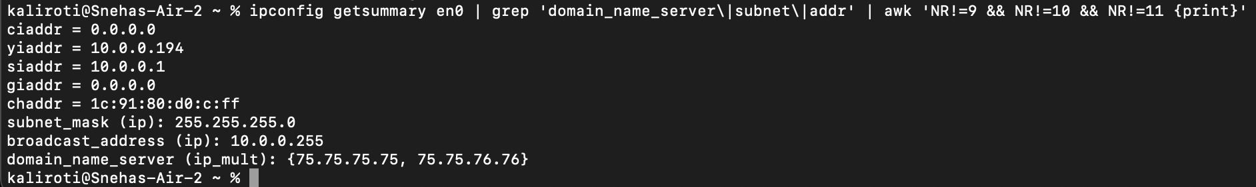

* + - 1. What is your machine’s IP address?

-> 10.0.0.194.

* + - * 1. Is it static or dynamic (DHCP)?

-> It is a Dynamic IP address as DHCP is enabled: 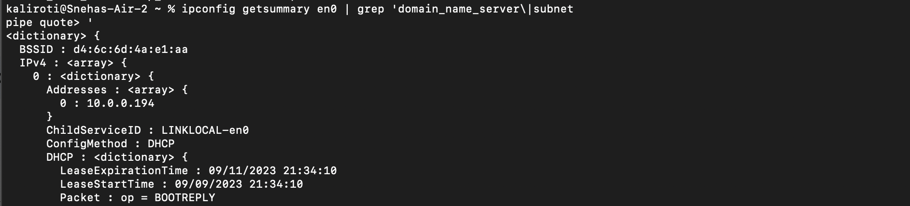

What is the difference between static/dynamic?

-> Static IP addresses are manually assigned and do not change automatically. It is permanently assigned to a machine.

-> Dynamic IP addresses are automatically assigned by DHCP servers. They are not permanent. They have a “lease” expiration date associated with them, post which, the machines would have to renew their IP addresses.

* + - * 1. What layer of the OSI model is an IP address?

Layer 3 - Network layer.

* + - * 1. Which NIC are you using (wired/wireless)? Indicate this.

I am using a wireless NIC. As seen in the screenshot, the en0 interface is used by mac os for wifi.

* + - 1. What is your machine’s default-gateway address?

Default gateway address: 10.0.0.1.

* + - * 1. What is the purpose of a default-gateway?

When an end host needs to send traffic outside of its network, it forwards that traffic to the default gateway, which then directs it to its intended destination on external networks, like the internet.

* + - 1. List the DNS server(s).

The DNS servers configured on my machine are 75.75.75.75 and 75.75.76.76.

* + - * 1. What is the purpose of a DNS server?

A DNS (domain name server) is used to resolve domain names (ex: google.com) to IP addresses that can be read by the machine (like 8.8.8.8). This simplifies user interaction as users don’t need to remember the IP addresses of the websites and machines can only understand IP addresses.

* + - 1. What is your MAC address of the NIC being used?

1c:91:80:d0:c:ff

* + - * 1. What layer of the OSI model is a MAC address?

Layer 2 - Data Link Layer

1. IP Connectivity
   1. Open the command prompt
      1. Ping [www.google.com](http://www.google.com). Provide a screenshot of the results [**2 points**], and answer the following questions based on the output [**1 point each**]:

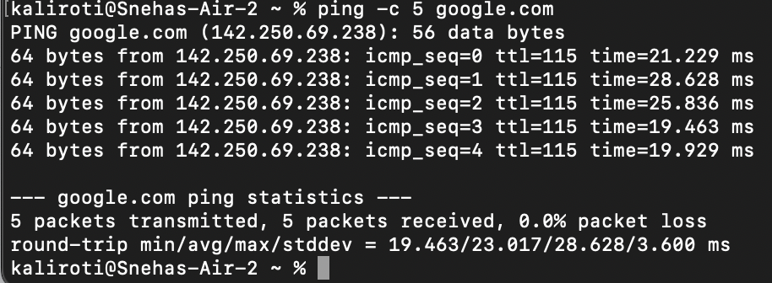

* + - 1. What is ping?

Ping is a command-line tool that is used to check round-trip time (RTT or latency) between a source machine and a destination machine.

* + - 1. What is the IP address of Google?

8.8.8.8 or 8.8.4.4 are the DNS servers of google. 142.250.72.36 is what my machine resolves for google.com. There are a range of IP addresses that google.com resolves to at a given point however, Google maintains 8.8.8.8 (prinary) and 8.8.4.4 (secondary) for public DNS.

* + - 1. What was the average round trip time for packets to reach Google’s server from your machine?

23.017 ms.

* + - 1. If you wanted to ping an IP address (or domain name) continuously, what parameter would you add to the ping command?

“ping -t” pings an IP address continuously.

* + - * 1. How would you stop this continuous ping?

You can stop this by sending a keyboard-interrupt, Ctrl+C.

* + 1. Using the IP address of Google (obtained above), type this in your Internet browser’s URL. Does this resolve to [www.google.com](http://www.google.com)? Why or why not? [**2 points**]

Typing 8.8.8.8 or 8.8.4.4 on a web browser does not directly resolve to google.com because it is a DNS server. It is used to resolve domain names to IP addresses. However, typing 142.250.72.36 would resolve to [www.google.com](http://www.google.com).

If you want to see how many Internet routers (hops) and the path your packet traverses to reach Google’s server, what command could you use? Provide a screenshot of the command and corresponding output. [**3 points**]

There are two ways to check the path a packet takes to reach a destination.

1. **traceroute**: It is a command-line utility built to trace the path of packets from a source machine to a destination machine.

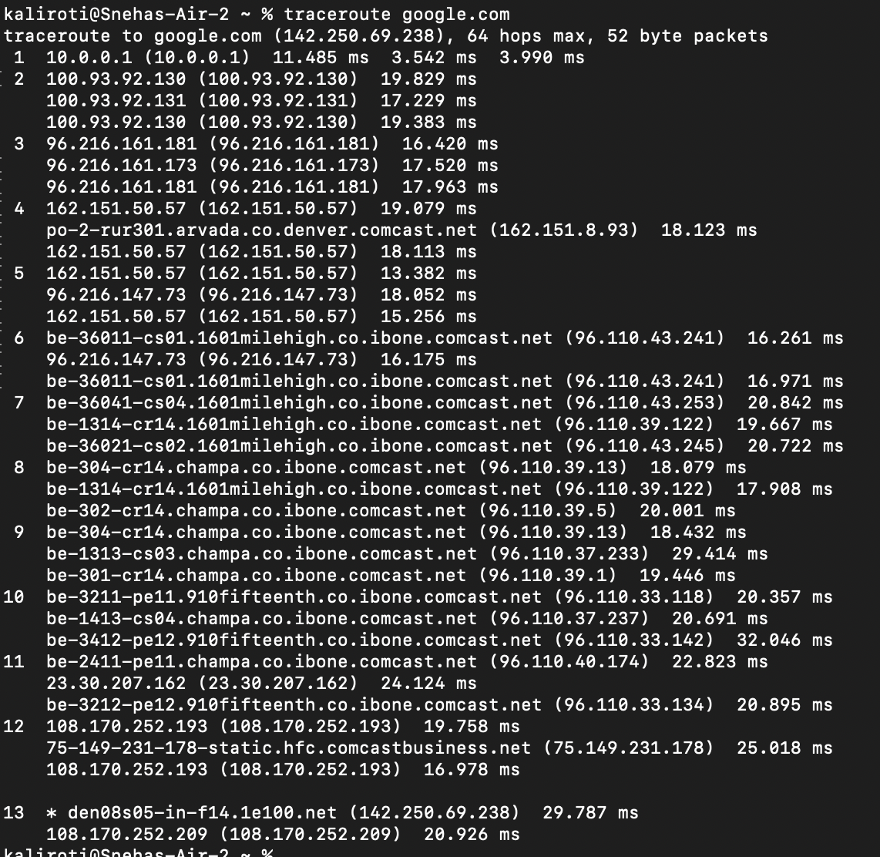

1. **mtr** (My traceroute): It’s a pretty-looking traceroute that continuously pings the destination host and checks for any packet losses, average, min, best, and worst pings at each path.

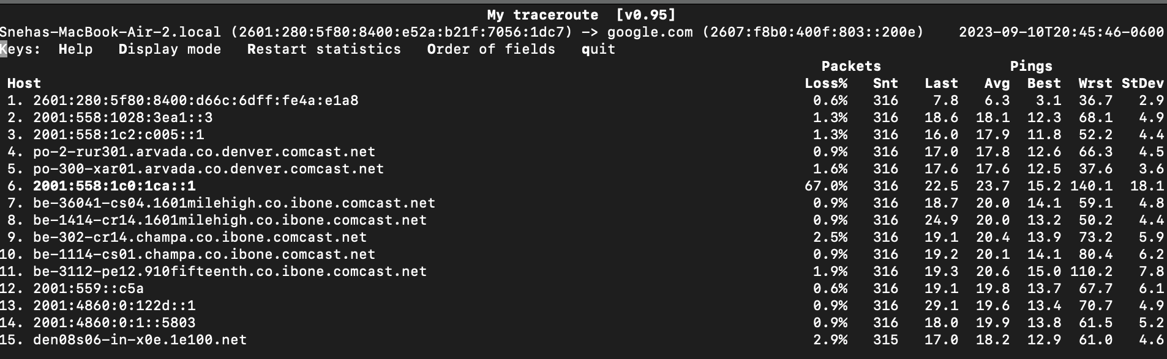

Total Score = ________________/68